|  |  |  |  |
| --- | --- | --- | --- |
| logo ngan.png | | **MINISTRY OF EDUCATION AND TRAINING** | |
| **FPT UNIVERSITY** | |
| **CAPSTONE PROJECT DOCUMENT** | |
| **BUILDING A WEBSITE SUPPORT THE ACTIVITIES “TIẾP SỨC MÙA THI” CAMPAIGN** | |
|  | |
| |  |  | | --- | --- | | **Group 22** | | | **Group Members** | |  |  | | --- | --- | | SE60769 | Nguyen Duy Khoa | | SE60687 | Le Nguyen Huu Tri | | 60358 | Nguyen Dinh Tuan | | 60325 | Tran Nguyen Kim Vinh | | 60339 | Nguyen Vinh Hien | | | **Supervisor** | Nguyen Trong Tai | | **Ext Supervisor** | N/A | | **Capstone Project Code** | TSMT | | |
| - Ho Chi Minh City, April 2014 - | |

# **TABLE OF CONTENTS**

**TABLE OF CONTENTS** 2

**TABLE OF FIGURE** 10

**1.** **REPORT NO.1: INTRODUCTION** 11

**1.1.** **Project Information** 11

**1.2.** **Acronym and Definition** 11

**1.3.** **Introduction** 11

**1.4.** **Overview of Existing Methods** 11

**1.5.** **Project Objective** 13

**1.6.** **Scope Definition** 13

**1.7.** **Main Project Success Criteria** 14

**1.8.** **Approach** 14

**1.9.** **Functions** 14

**1.9.1.** **Functions for guests** 14

**1.9.2.** **Functions for candidates** 14

**1.9.3.** **Functions for sponsors** 14

**1.9.4.** **Functions for charities** 14

**1.9.5.** **Functions for volunteers** 15

**1.9.6.** **Functions for system administration** 15

**1.10.** **Roles and Responsibility** 15

**2.** **REPORT NO.2: PROJECT MANAGEMENT PLAN (PMP)** 15

**2.1.** **Problem Definition** 15

**2.1.1.** **Name of this Capstone Project** 15

**2.1.2.** **Project Abstract** 15

**2.1.3.** **Project Overview** 16

2.1.3.1. The Current System 16

2.1.3.2. The Proposed System 16

2.1.3.3. Boundaries of System 16

2.1.3.4. Development Environment 17

**2.2.** **Project Organization** 17

**2.2.1.** **Software Process Model** 17

**2.2.2.** **Roles and Responsibilities** 19

**2.2.3.** **Tools and Techniques** 20

**2.3.** **Project Management Plan** 20

**2.3.1.** **Task** 20

2.3.1.1. Task 1: Initiating 20

2.3.1.2. Task 2: Planning 20

2.3.1.3. Task 3: Creating Software Requirement Specification 21

2.3.1.4. Task 4: Designing Database 21

2.3.1.5. Task 5: Designing User Interface 21

2.3.1.6. Task 6: Creating Software Design Description 22

2.3.1.7. Task 7: Creating Coding Framework 23

2.3.1.8. Task 8: Implementing 23

2.3.1.9. Task 9: Preforming System Testing 23

2.3.1.10. Task 10: Deployment and Input Initial Data 24

2.3.1.11. Task 11: Writing User’s Manual 24

**2.3.2.** **Task Sheet: Assignments and Timetable** 25

**2.4.** **Convention Rules** 25

**3.** **REPORT NO.3: SYSTEM REQUIREMENT SPECIFICATION (SRS)** 26

**3.1.** **User Requirement Specification** 26

**3.1.1.** **Guest Requirements** 26

**3.1.2.** **Authorized User Requirements** 26

**3.1.3.** **Candidate Requirements** 26

**3.1.4.** **Sponsor Requirements** 26

**3.1.5.** **Charity Requirements** 27

**3.1.6.** **Volunteer Requirements** 27

**3.1.7.** **Administrator Requirements** 27

**3.2.** **System Requirement Specification** 27

**3.2.1.** **External Interface Requirement** 27

3.2.1.1. User Interfaces 27

3.2.1.2. Hardware Interfaces 28

3.2.1.3. Software Interfaces 29

**3.2.2.** **System Features** 29

3.2.3.1. Overall Use case diagram 29

3.2.3.2. (Guest) Register 31

3.2.3.3. (Authorized User) Edit Profile 32

3.2.3.4. (Authorized) Logout 35

3.2.3.5. (Guest) View News 36

3.2.3.6. (Guest) Get New Feed 37

3.2.3.7. (Admin) Manage University 38

3.2.3.8. (Admin) Manage University – Add new university 38

3.2.3.9. (Admin) Manage University – Edit university information 40

3.2.3.10. (Admin) Manage Examination 41

3.2.3.11. (Admin) Manage Examination – Add new examination 42

3.2.3.12. (Admin) Manage Examination – Delete Examination 44

3.2.3.13. (Admin) Manage University Examination – Add new university examination 45

3.2.3.14. (Charity) Manage Charity Exam 47

3.2.3.15. (Charity) Manage Charity Exam – Add charity exam 47

3.2.3.16. (Charity) Manage Charity Exam – Edit Charity Exam 48

3.2.3.17. (Charity) Manage Car Charity 50

3.2.3.18. (Charity) Manage Car Charity – Add car 50

3.2.3.19. (Charity) Manage Car Charity – Edit car 52

3.2.3.20. (Charity) Manage Car Charity – Assign Car 54

3.2.3.21. (Charity) Manage Car Charity – Choose Car For Charity Exam 56

3.2.3.22. (Charity) Manage Car Charity – View Car Of Charity 57

3.2.3.23. (Charity) Manage Car Charity – Delete Car 58

3.2.3.24. (Charity) Manage Lodge Charity 59

3.2.3.25. (Charity) Manage Lodge Charity – Add lodge 60

3.2.3.26. (Charity) Manage Lodge Charity – Edit Lodge 61

3.2.3.27. (Charity) Manage Lodge Charity – Assign Lodge 63

3.2.3.28. (Charity) Manage Lodge Charity – View on map 65

3.2.3.29. (Charity) Mangage Lodge Charity – Add Room 66

3.2.3.30. Manage Lodge Charity – Edit Room 67

3.2.3.31. (Charity) Mange Lodge – Delete Room 69

3.2.3.32. (Charity) Manage Car 70

3.2.3.33. (Charity) Manage Car – Approve Car 70

3.2.3.34. (Charity) Manage Car – Denie Car 72

3.2.3.35. (Charity) Manage Car – Delete Car Out Of Charity Exam 73

3.2.3.36. (Charity) Manage Car – Display Route 74

3.2.3.37. (Charity) Manage Lodge 75

3.2.3.38. (Charity) Manage Lodge – Approve Lodge 76

3.2.3.39. (Charity) Manage Lodge – Denie Lodge 77

3.2.3.40. (Charity) Manage Lodge – Remove Lodge 78

3.2.3.41. (Charity) Manage Lodge – Delete Lodge Out Of Charity Exam 79

3.2.3.42. (Charity) Manage Lodge – View Lodge Detail 80

3.2.3.43. (Charity) Manual assign candidate to room 81

3.2.3.44. (Charity) Manual Assign Candidate to car or volunteer 84

3.2.3.45. (Charity) Manage Fund – Approve Fund 86

3.2.3.46. (Charity) Manage Volunteer – Approve Volunteer 87

3.2.3.47. (Charity) Manage Volunteer – Denie Volunteer 88

3.2.3.48. (Charity) Manage Volunteer – Remove Volunteer 90

3.2.3.49. (Charity) Manage Candidate – View Candiate 91

3.2.3.50. (Charity) View Statistics 92

3.2.3.51. (Charity) Manage Candiate – Assign to room 93

3.2.3.52. (Charity) Manage Candidate – Assign To Car 94

3.2.3.53. (Sponsor) Manage Sponsor’s Car 95

3.2.3.54. (Sponsor) Manage Sponsor’s Car – Add New Car 96

3.2.3.55. (Sponsor) Manage Sponsor’s Car – Edit Car 97

3.2.3.56. (Sponsor) Manage Sponsor’s Car – Delete Car 99

3.2.3.57. (Sponsor) Manage Sponsor’s Car – Sponsored Car 100

3.2.3.58. (Sponsor) Manage Sponsor’s Car – Sponsored All Car 102

3.2.3.59. (Sponsor) Manage Sponsor’s Car – Cancel Sponsored Car 104

3.2.3.60. (Sponsor) Manage Sponsor’s Funds 105

3.2.3.61. (Sponsor) Manage Sponsor’s Fund – Add New Funds 105

3.2.3.62. (Sponsor) Manage Sponsor’s Fund – Edit Fund 107

3.2.3.63. (Sponsor) Manage Sponsor’s Fund – Cancel Sponsored Fund 109

3.2.3.64. (Sponsor) Manage Lodge 110

3.2.3.65. (Sponsor) Manage Sponsor’s Lodge – View Lodge 110

3.2.3.66. (Sponsor) Manage Sponsor’s Lodge – View Details Lodge 111

3.2.3.67. (Sponsor) Manage Sponsor’s Lodge – View Google Map 112

3.2.3.68. (Sponsor) Manage Sponsor’s Lodge – Add New Lodge 113

3.2.3.69. (Sponsor) Manage Sponsor’s Lodge – Edit Lodge 115

3.2.3.70. (Sponsor) Manage Sponsor’s Lodge – Sponsored Lodge 117

3.2.3.71. (Sponsor) Manage Sponsor’s Lodge – Cancel Sponsored Lodge 119

3.2.3.72. (Sponsor) Manage Sponsor’s Lodge – View Room 120

3.2.3.73. (Sponsor) Manage Sponsor’s Lodge – Add New Room 121

3.2.3.74. (Sponsor) Manage Sponsor’s Lodge – Delete Room 123

3.2.3.75. (Sponsor) View Statistics 124

3.2.3.76. (Sponsor) Manage Sponsor’s Resource – Sponsored Resoure 125

3.2.3.77. (Sponsor) Manage Sponsor’s Resource – Sponsored Resource 127

3.2.3.78. (Volunteer) Register Charity Examination 129

3.2.3.79. (Volunteer) View Schedule 131

3.2.3.80. (Volunteer) View Map 132

3.2.3.81. (Volunteer) Add new post 133

3.2.3.82. (Volunteer) Edit post 134

3.2.3.83. (Volunteer) Delete post 135

3.2.3.84. (Candidate) Create Exam Paper 137

3.2.3.85. (Candidate) Join In Charity Exam 138

3.2.3.86. (Candidate) Invite Friend 139

3.2.3.87. (Candidate) Accept Group 140

**3.3.** **Software System Attributes** 141

3.3.1. Reliability 141

3.3.2. Availability 141

3.3.3. Security 141

3.3.4. Maintainability 141

3.3.5. Portability 141

3.3.6. Performance 141

**3.4.** **Entity Relationship Diagram** 142

**4.** **REPORT NO.4: SYSTEM DESIGN DESCRIPTION (SDD)** 143

**4.1.** **Design Overview** 143

**4.2.** **System Architectural Design** 143

**4.3.** **Component Diagram** 144

**4.4.** **Class diagram** 144

**4.5.** **Behavioral Diagrams** 146

**4.5.1.** **State Machine Diagram: The status transition of registering into a charity of candidate** 146

**4.5.2.** **State Machine Diagram: The status transition of car being sponsored** 146

**4.5.3.** **State Machine Diagram: The status transition of registering into charity of volunteer** 146

**4.5.4.** **Sequence diagram: Add Post (Admin)** 147

**4.5.5.** **Sequence diagram: Edit Post (Admin)** 148

**4.5.6.** **Sequence diagram: Delete Post (Admin)** 149

**4.5.7.** **Sequence diagram: View News (Admin)** 149

**4.5.8.** **Sequence diagram: Add University (Admin)** 150

**4.5.9.** **Sequence diagram: Edit University (Admin)** 151

**4.5.10.** **Sequence diagram: Delete University (Admin)** 152

**4.5.11.** **Sequence diagram: View University (Admin)** 152

**4.5.12.** **Sequence diagram: Delete University Examination (Admin)** 153

**4.5.13.** **Sequence diagram: View University Examination (Admin)** 153

**4.5.14.** **Sequence diagram: Add Examination Venue (Admin)** 154

**4.5.15.** **Sequence diagram: Edit Examination Venue (Admin)** 155

**4.5.16.** **Sequence diagram: View List Examination Venue (Admin)** 156

**4.5.17.** **Sequence diagram: Approve Friend Request (Candidate)** 156

**4.5.18.** **Sequence diagram: Ask To Join Group (Candidate)** 157

**4.5.19.** **Sequence diagram: Deny Friend’s Request (Candidate)** 157

**4.5.20.** **Sequence diagram: Invite to Group (Candidate)** 158

**4.5.21.** **Sequence diagram: Join in Charity Exam (Candidate)** 159

**4.5.22.** **Sequence diagram: Leave Charity Exam (Candidate)** 159

**4.5.23.** **Sequence diagram: Add Car (Charity)** 160

**4.5.24.** **Sequence diagram: Approve Car (Charity)** 161

**4.5.25.** **Sequence diagram: Approve Lodge (Charity)** 162

**4.5.26.** **Sequence diagram: Assign Car to Charity Exam (Charity)** 163

**4.5.27.** **Sequence diagram: Assign Lodge to Charity Exam (Charity)** 164

**4.5.28.** **Sequence diagram: Delete Lodge (Charity)** 165

**4.5.29.** **Sequence diagram: Denie Car (Charity)** 166

**4.5.30.** **Sequence diagram: Denie Lodge (Charity)** 167

**4.5.31.** **Sequence diagram: Edit Lodge (Charity)** 168

**4.5.32.** **Sequence diagram: Remove Car (Charity)** 169

**4.5.33.** **Sequence diagram: Add Car (Sponsor)** 170

**4.5.34.** **Sequence diagram: Edit Car (Sponsor)** 171

**4.5.35.** **Sequence diagram: Delete Car (Sponsor)** 172

**4.5.36.** **Sequence diagram: View Car (Sponsor)** 172

**4.5.37.** **Sequence diagram: Add Lodge (Sponsor)** 173

**4.5.38.** **Sequence diagram: Edit Lodge (Sponsor)** 174

**4.5.39.** **Sequence diagram: Delete Lodge (Sponsor)** 175

**4.5.40.** **Sequence diagram: View Lodge (Sponsor)** 175

**4.5.41.** **Sequence diagram: View Detail Lodge (Sponsor)** 176

**4.5.42.** **Sequence diagram: Add Room (Sponsor)** 176

**4.5.43.** **Sequence diagram: Delete Room (Sponsor)** 177

**4.5.44.** **Sequence diagram: View Fund (Sponsor)** 178

**4.5.45.** **Sequence diagram: View Statistic (Sponsor)** 179

**4.5.46.** **Sequence diagram: Sponsored Resource (Sponsor)** 180

**4.5.47.** **Sequence diagram: Cancel Sponsored Car (Sponsor)** 181

**4.5.48.** **Sequence diagram: Join Charity Examination (Volunteer)** 182

**4.5.49.** **Sequence diagram: Leave Charity Examination (Volunteer)** 182

**4.6.** **Database Design** 183

**4.6.1.** **Logical Database Design** 183

**4.6.1.1** **Accounts** 185

**4.6.1.2** **Articles** 185

**4.6.1.3** **Candidates** 185

**4.6.1.4** **Cars** 186

**4.6.1.5** **Categories** 186

**4.6.1.6** **CharitiesExams** 186

**4.6.1.7** **Charities** 187

**4.6.1.8** **Comments** 187

**4.6.1.9** **Districts** 188

**4.6.1.10** **Examinations** 188

**4.6.1.11** **ExaminationPapers** 188

**4.6.1.12** **Funds** 189

**4.6.1.13** **GroupRequest** 190

**4.6.1.14** **Groups** 190

**4.6.1.15** **Lodges** 190

**4.6.1.16** **ParticipantVolunteer** 191

**4.6.1.17** **Profiles** 192

**4.6.1.18** **Provinces** 192

**4.6.1.19** **Roles** 192

**4.6.1.20** **Rooms** 193

**4.6.1.21** **ScheduleExams** 193

**4.6.1.22** **Sponsors** 193

**4.6.1.23** **Universities** 194

**4.6.1.24** **UniversitiesExaminations** 194

**4.6.1.25** **Venues** 194

**4.6.2.** **Physical Database Design** 196

**4.7.** **Algorithms** 197

**4.7.1.** **Arrange candidates into room** 197

4.7.1.1. Criteria 197

4.7.1.2. Description 197

4.7.1.3. Workflow 197

**4.7.2.** **Arrange candidates into vehicle** 197

4.7.2.1. Criteria 197

4.7.2.2. Description 197

4.7.2.3. Workflow 198

**4.7.3.** **Routing ways for vehicle** 198

4.7.3.1. Criteria 198

4.7.3.2. Description 199

4.7.3.3. Workflow 199

**5.** **REPORT NO.5: SYSTEM IMPLEMENTATION & TEST (SIT)** 199

**5.1.** **Introduction** 199

**5.1.1.** **System Overview** 199

**5.1.2.** **Test Approach** 199

**5.2.** **Test Plan** 199

**5.2.1.** **Feature to be tested** 199

**5.2.2.** **Feature not to be tested** 200

**5.3.** **Test Cases** 201

**5.3.1.** **Admin Test Case** 201

5.3.1.1. Add an university 201

5.3.1.2. Add an university exam 201

**5.3.2.** **Volunteer Test Case** 202

5.3.2.1. Join and leave charity exam 202

**5.3.3.** **Charity Test Case** 202

**5.3.4.** **Candidate Test Case** 204

**5.3.5.** **Sponsor Test Case** 206

5.3.5.1. Delete a car 206

5.3.5.2. Sponsored Car 206

5.3.5.3. Cancel sponsored Car 207

5.3.5.4. Sponsored many cars 207

5.3.5.5. Sponsored lodge and room of lodge 208

5.3.5.6. Sponsored Resource 208

5.3.5.7. View statistic 210

**6.** **REPORT NO.6: SYSTEM USER’S MANUAL (SUM)** 212

**6.1.** **Installation Guide** 212

**6.1.1.** **Server Side** 212

**6.1.2.** **Client Side** 212

**6.2.** **User’s Guide** 212

**6.2.1.** **Minimum System Requirements** 212

**6.2.2.** **Guide for guests and authorized users** 212

6.2.2.1. Search charity’s information 212

6.2.2.2. View information detail of charity 213

6.2.2.3. Register an account 214

**6.2.3.** **Guide for members** 215

6.2.3.1. Log in to the system 215

6.2.3.2. Log out to the system 216

**6.2.4.** **Guide for candidates** 216

6.2.4.1. Register examination paper 216

6.2.4.2. Search lodges 216

6.2.4.3. Register into charities 216

6.2.4.4. View 216

**6.2.5.** **Guide for sponsors** 216

6.2.3.3. Home page 216

6.2.3.4. Manage Car 217

6.2.3.5. Sponsored Lodge 217

6.2.3.6. Sponsored Resource 218

**6.2.1.** **Guide for charities** 218

6.2.3.7. Home Page 218

6.2.5.1 Manage charity Exam 219

6.2.5.1 Details Charity exam 220

6.2.5.1 Assign Room 220

**6.3.** **APPENDIX** 220

Reference 221

# **TABLE OF FIGURE**

Figure 1 - Software Lifecycle Model 18

# **REPORT NO.1: INTRODUCTION**

## **Project Information**

* Project Name: **Building a website to support the activities “Tiếp sức mùa thi” campaign**
* Project Code: **TSMT**
* Product Type: **Website**
* Start Date: **Jan 7th, 2014**
* End Date: **Apr 24th, 2014**

## **Acronym and Definition**

|  |  |
| --- | --- |
| Acronym | Definition |
| TSMT | TSMT system |
| SAC | Student Assistance Center of Ho Chi Minh City |

## **Introduction**

“Tiếp sức mùa thi” campaign is a social program, which support candidates in taking the entrance examination into colleges. It was organized for the first time since 1996 in Ho Chi Minh City and then spread through the country. The meaningful of campaign to help candidate solve the difficult problems such as: travel, eating, accommodation, etc… in new environment.

Moreover, “Tiếp sức mùa thi” campaign also get huge attention of volunteers and charities. Charities want to donate lodges, vehicles and funds and volunteers want to contribute their effort to help candidates make the dream come true. But there is not any website or tool to let them do that. Or if having, those activities took place entirely in manually and generate redundant time.

For example, when charities and volunteers want to contribute, then they will contact with The Student Support Center to register their information and wait for responding. If problem occurs, the Student Support Center need time to handles, such as charity don’t support any more, lodge is full, volunteer is busy in the examination date, etc…

To candidates, who need to support, also register to The Student Support Center and wait to get acceptance. If successful, candidates will receive support or candidates still wait. Expectations and pressures from exams make candidates become fatigue and depression. And the worst thing is candidate will receive the results that don’t as they desire.

So that, to solve all problem, we create TMST system. With TSMT, volunteers and charities can register and submit their sponsor information. Candidates can register into charities and lodge, belong to the management of that charity. Then system suggest the planning of pickup candidates, assign candidates into rooms into lodges, assign vehicles to shuttle candidates between lodges and examination sites, display routes on map, search friends to make groups, view enrollment news, etc…

## **Overview of Existing Methods**

Currently, there are some website also support candidates such as: “tiepsucmuathi.com.vn”, “hotrosinhvien.vn”, but they are not same ideas with TSMT

* **Website “tiepsucmuathi.com.vn”**

In overview, this website is easy to use with interactive interface, same ideas with us. It allows candidate find lodge, view news, view benchmark of university, etc.... But unfortunately, most function are not implemented, user only view news and the latest post from October 18th, 2013.

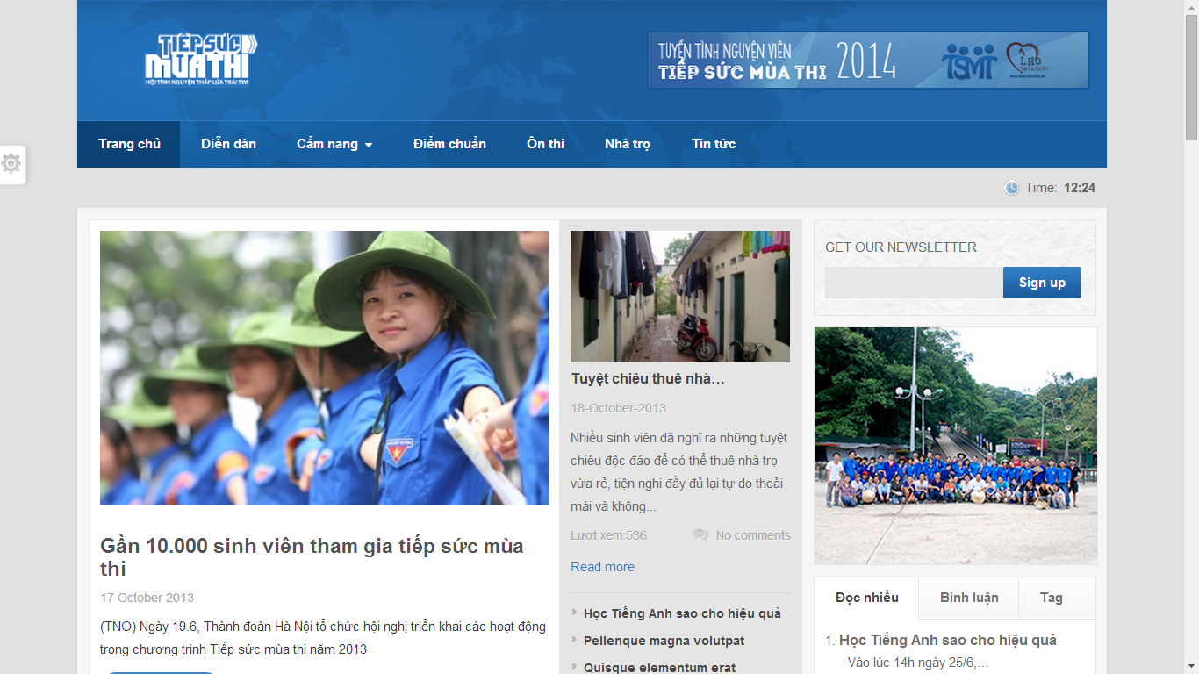

* **Advantages:**
  + Only support to candidates
  + Easy to view
* **Disadvantages:**
  + Most functions are not implemented.
  + Website is dead.
* **Website “hotrosinhvien.vn” of Student Assistance Center of Ho Chi Minh City**

That website support students, which are studying in universities, colleges. That provides student many information about lodge, scholarship, and jobs, etc…

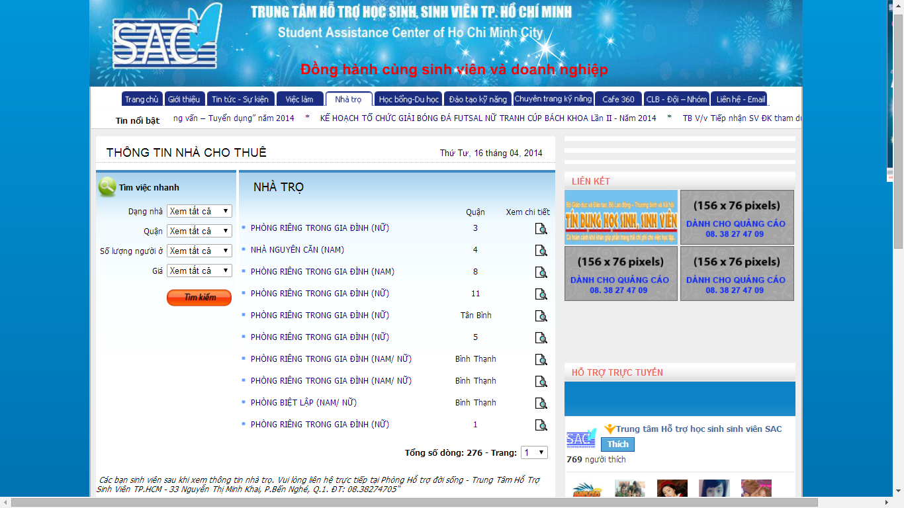

* **Advantages:**
* User can search lodges with detail information
* Providing many useful information for students in universities and colleges
* **Disadvantages:**
* Interface make user confuse because it is too many tabs.
* Not support for candidates
* Not automatically, for example, when user search lodges, then they want to choose that lodge and must contact with SAC to support.

## **Project Objective**

The project aims to develop a web-based application that

* Help volunteers and charities can register and submit their sponsor information.
* Help candidates can register and post their information and lodging request.
* The system can suggest the planning and scheduling for pickup candidates, sponsor management…

## **Scope Definition**

Following the description of project objectives, the scope of the project is constrained to the following statements:

* The users of the website should interact with the website itself through a friendly and attractive user interface.
* *For Candidates:* the website should provide functions such as: register their examination papers, find charities support, register into lodges, search friends, create groups, ask or invite friends into groups and view information about rooms, vehicles.
* *For Sponsor:* the website should allow to them create their sponsored information such as: information about lodge, vehicle, fund; give those resources to charities, and view statistic.
* *For Volunteer:* TSMT should allow them to register into charities; after charities assign candidate to pick up, they can view routes, candidate’s information
* *For Charity:* TMST should allow them to create their resources such as: lodge, vehicle; accept supported resources; assign candidates into rooms in lodges, vehicles; accept requests of volunteers.
* *For System Administrator:* TSMT should support them to monitor fundamental information about members, university, examination venue, examination schedule, and news.

## **Main Project Success Criteria**

The system meet all written specifications, be thoroughly tested and completed on time. Also, this project must be compatible with the current working process and model of FPT University.

## **Approach**

* Make survey to collect ideas from candidate, volunteer, charities which joined the campaign in the previous years.
* Use some current website to find out how it work.
* Brainstorm in our group.

## **Functions**

### **Functions for guests**

* Allow to register new account at TSMT system.
* Allow to view charities’ information, lodges
* Allow to view news about tips, lodges and new feeds.

### **Functions for candidates**

* Allow to manage their contest report cards in each exams.
* Allow to find and register into lodges, manage by charities, after registered contest report card in each exams.
* Allow to search friends, create groups, ask or invite friends to join group in each exams.
* Allow to view information about room in lodge, vehicle after charity assigned in each exams.

### **Functions for sponsors**

* Allow to manage information of their resources such as lodges, vehicles and funds.
* Allow to sponsor their resources to charities in each exams.
* Allow to view statistics about the status of using lodges, vehicles and funds.

### **Functions for charities**

* Allow to manage information about lodges, vehicles.
* Allow to register to assist and manage assistance in each exams.
* Allow to assign lodges, vehicles in each exams.
* Allow to manage volunteers, registered to support candidates.
* Allow to manage candidates, registered into lodges, sort rooms in lodges and vehicles.
* Allow to manage sponsored resources of sponsors.

### **Functions for volunteers**

* Allow to view charities’ information.
* Allow to register into charities to assist candidates in each exams.
* Allow to view route, view candidate’s information to shuttle during contest.

### **Functions for system administration**

* Allow to manage all relevant information about system.
* Allow to manage information about university, venue, and exams.
* Allow to manage news, manage categories.

## **Roles and Responsibility**

|  |  |  |  |  |
| --- | --- | --- | --- | --- |
| No. | Full Name | Role | Position | Contact |
| 1 | Nguyen Trong Tai | Supervisor | Instructor | TaiNT@fpt.edu.vn |
| 2 | Nguyen Duy Khoa | Developer, Tester | Team Leader | KhoaNDSE60769@fpt.edu.vn |
| 3 | Le Nguyen Huu Tri | Developer, Tester | Team Member | TriLNHSE60687@fpt.edu.vn |
| 4 | Tran Dinh Tuan | Developer, Tester | Team Member | TuanNDse60358@fpt.edu.vn |
| 5 | Tran Nguyen Kim Vinh | Developer, Tester | Team Member | VinhTNKSE60325@fpt.edu.vn |
| 6 | Nguyen Vinh Hien | Developer, Tester | Team Member | HienNVSE60339@fpt.edu.vn |

# **REPORT NO.2: PROJECT MANAGEMENT PLAN (PMP)**

## **Problem Definition**

### **Name of this Capstone Project**

|  |  |
| --- | --- |
| Official name | Building a website to support the activities “Tiếp sức mùa thi” campaign |
| Vietnamese name | Xây dựng website hỗ trợ các hoạt động cho chiến dịch “Tiếp sức mùa thi” |
| Abbreviation | TSMT |

### **Project Abstract**

The idea of the project is to develop a website that support candidates, which have difficult conditional in finding lodges in new environment, making group with friends, viewing support information. It also help sponsors manage their resources and assign them to charities in each exams, and know their resources are used how. It also helps volunteers know information about charities and register to assist in each exams. Finally, it help charities to manage all information about lodges, vehicles and volunteers and check all resources to support candidates in the best status.

### **Project Overview**

#### The Current System

There is not any current system, has same concept with TSMT. The “Tiếp sức mùa thi” campaign has some limitations like:

* Number of foundations are so much but they can’t find any easiest tools to support candidates. Currently, when foundations want to post their sponsor information, they must contact with SAC and wait for responding of SAC.
* The management completely done by hand, based on a lot of paperwork, applications, and so on that lead to errors in the summary, statistics and searching.
* The most limitations is candidates can’t find any useful information about lodges, especially, near examination venue, if found, they also couldn’t go there easily. When candidates go to consultant locations, candidates will register their information with counselors. And volunteers will pick up candidates to the registered lodges. If lodge unfortunately is full, volunteers will take candidates to go to another lodges that spends lots of time. So, the effect of external factors will make candidates can’t focus completely on preparing for the university entrance exam.

#### The Proposed System

With TSMT System, we give users a new system that integrated the current activities process of the “Tiếp sức mùa thi” campaign by automating some functions of the traditional process.

TSMT system should support:

* Candidate can register their examination pages in each exams, then find the lodges which nearest with the venue. Moreover, candidate can search friends in lodges, to make groups to review.
* Volunteer can find charities and register their information to ask to join in those charities
* Sponsor can search and sponsored their resources (lodges, vehicles, funds) for charities in each exams
* Charity can manage sponsored resources, assign those resource in each exams, manage candidates, assign candidates into rooms in lodges, vehicles to shuttle in during exams, manage volunteers and assign volunteer to support candidates.

#### Boundaries of System

* The main scope of this project is to provide an efficiently and easy-to-use website that facilitate manually process of the “Tiếp sức mùa thi” campaign.
* It manages users, allocates suitable roles for each kind of users.
* It is not designed for specific foundation, but for general structure management of all foundation.
* The website only support Vietnamese.

#### Development Environment

Below is the list of hardware and software requirement needed for the development environment of the project

**Hardware requirements:**

* Personal computers for developing with the minimum configuration: 2 Gb of RAM, 100Gb of hard disk, Core 2 Duo 2.0 Ghz;
* A server computer for testing with the minimum configuration: 4 Gb of RAM, 100Gb of hard disk, Core 2 Duo 2.0 Ghz;
* All computers must be connected to the internet.

**Software requirements:**

* Operating system: Windows 7 or above;
* Framework: .NET Framework 4.5;
* IDE: Visual Studio 2012;
* DBMS: SQL Server 2008 R2;
* Source Control: SVN, Google Code.
* Others: Software Ideas Modeler, StarUML, Microsoft Office 2013 (Word, Excel, Project, Visio)

## **Project Organization**

### **Software Process Model**

With the schedule of weekly reports for every stage, the software will be developed by using waterfall model which is very simple and require minimal resource for implementation. In the waterfall approach, the whole process of software development is divided into separate phases. These phases in the model are:

* Requirement specifications phase
* System and Software design
* Implementation and Unit Testing
* Integration and System Testing
* Operation and Maintenance

Requirement Specifications

System and Software Designs

Implementation and Unit Testing

Integration and System Testing

Operation and Maintenance

Figure 1 - Software Lifecycle Model

Stages of the software waterfall lifecycle model explained:

* **Requirement Analysis and Definition**: All possible requirements of the system to be developed are captured in this phase. The requirements are gathered from the end user at the start of the software development phase. These requirements are analyzed for their validity, and the possibility of incorporating the requirements in the system to be developed is also studied. Finally, a requirement specification document is created which serves the purpose of guideline for the next phase of model.
* **System and Software Design:** The requirement specifications from the first phase are studied in this phase and a system design is prepared. System design helps in specifying hardware and system requirements and also helps in defining the overall system architecture. The system design specifications serves the purpose of guideline for the next phase of the model.
* **Implementation and Unit Testing:** On receiving system design documents, the work is divided in modules/units and actual coding is started. Each unit is developed and tested for its functionality; this is referred to as unit testing. Unit testing mainly verifies if the modules/units meet their specifications.
* **Integration and System Testing:** Units from above phrase are integrated into a complete system during integration phase and tested to check if all modules/units coordinate with each other and the system as a whole behaves as per the specifications. After successfully testing the software, it is delivered to the customer.
* **Operation and Maintenance:** Generally, problems with the system developed (which are not found during the development life cycle) come up after its practical use starts, so the issues related to the system are solved after development of the system. Not all the problems come into picture directly but they arise from time to time and need to be solved; hence. This process is referred to as maintenance.

### **Roles and Responsibilities**

|  |  |  |  |
| --- | --- | --- | --- |
| No. | Full name | Roles in group | Responsibilities |
| 1 | Nguyen Trong Tai | Supervisor | * Give advices on business and technical problems * Review and approve of project documents and product deliverables * Assess the performance of team members |
| 2 | Nguyen Duy Khoa | Team Leader, Developer, Tester | * Distribute task to the other members * Create project management plan * Monitor the development process and review the deliverables * Work on system architecture and detailed designs * Implement * Prepare documents * Perform unit testing * Deploy the final product |
| 3 | Le Nguyen Huu Tri | Team Member, Developer, Tester | * Create project management plan * Design user interfaces * Work on detailed design * Implement * Prepare documents * Perform unit testing, system testing and integration test |
| 4 | Nguyen Dinh Tuan | Team Member, Developer, Tester | * Work on detailed design * Implement * Prepare documents * Perform unit testing, system testing and integration test |
| 5 | Tran Nguyen Kim Vinh | Team Member, Developer, Tester | * Work on detailed design * Implement * Prepare documents * Perform unit testing, system testing and integration test |
| 6 | Nguyen Vinh Hien | Team Member, Developer, Tester | * Work on detailed design * Implement * Prepare documents * Perform unit testing, system testing and integration test |

### **Tools and Techniques**

The tools that will be used to develop the system includes:

* Developing tools: Microsoft Visual Studio 2012, Microsoft SQL Server 2008 R2
* Modelling tools: Software Ideas Modeler, StarUML
* Document tools: Microsoft Office 2013 (Word, Excel, Power Point, Visio, Project)
* Source control tools: SVN, Google Code

## **Project Management Plan**

### **Task**

Below are all the major tasks that need to be performed sequentially during the development of the system.

#### Task 1: Initiating

|  |  |
| --- | --- |
| Task Name | Initiating |
| Descriptions | Perform research on real situation, user’s need research; decide upon the technology that will be used to develop the system |
| Deliverables | Report 1 – Project Introduction |
| Resources needed | 6 days |
| Dependencies and constraints | N/A |
| Risks | * Team members did not know each other in advance and have a little background in term of “Tiếp sức mùa thi” campaign * Some users may not agree to spend time for making surveys * Strange requirement from users * Lack of technologies or chosen technologies are not feasible |

#### Task 2: Planning

|  |  |
| --- | --- |
| Task Name | Planning |
| Descriptions | Create the project management plan; break the system into modules and assign tasks to each member. |
| Deliverables | Report 2 – Software Project Management Plan |
| Resources needed | 6 days |
| Dependencies and constraints | Task 1 has finished |
| Risks | * Team leader has no experience in managing software projects; all members are still not acquainted with the new technology. * Dividing modules and planning tasks maybe unbalance, and unreasonable |

#### Task 3: Creating Software Requirement Specification

|  |  |
| --- | --- |
| Task Name | Creating Software Requirement Specification |
| Descriptions | Discuss and agree upon the software requirements, what is to be developed and what is not; generate detailed descriptions of all the functions to be developed. |
| Deliverables | * Planning process has to be finished * Follow the Software Requirement Specification template |
| Resources needed | 12 days |
| Dependencies and constraints | Task 2 has finished |
| Risks | * Many aspects of the problem are still unclear to team members * All requirements come from team members, so conflicts may happen regularly * Misunderstand between user requirements and receiving information from designer may make designing and developing phrases be failed. |

#### Task 4: Designing Database

|  |  |
| --- | --- |
| Task Name | Designing database |
| Descriptions | Design the database based on the requirements collected, through three major steps: Conceptual, Logical, and Physical Design |
| Deliverables | ERD and the physical database with sample data |
| Resources needed | All team members; 4 days |
| Dependencies and constraints | Finish the requirement and specification phrase |
| Risks | Some of the requirements specified are not clear and cannot be translated into corresponding entities; little experience in organizing data. |

#### Task 5: Designing User Interface

|  |  |
| --- | --- |
| Task Name | Designing User Interface |
| Descriptions | * Design layouts for each page in system * Design style for each page in the system. * Design connection between all pages in the system * Define some basic JavaScript for each file |
| Deliverables | Prototype which includes:   * HTML pages * CSS files * JavaScript file |
| Resources needed | 6 days |
| Dependencies and constraints | * Finish the requirement specification task * User Interface must be friendly, easy to see and suitable with all functions in the system and topic of this project. * Display well in screen resolution 1024 x 768 |
| Risks | User interface may completely satisfy all dependencies and constrains above. |

#### Task 6: Creating Software Design Description

|  |  |
| --- | --- |
| Task Name | Creating Software Design Description |
| Descriptions | Agree upon the system architecture; Work on the detailed design of each module; decide which techniques are appropriate to which modules; design the user interfaces for users to interact with. |
| Deliverables | Report 4 – Software Design Description |
| Resources needed | 12 days |
| Dependencies and constraints | * Finish Software Requirement Specification report * Follow Software Design Description (SDD) report template |
| Risks | * Some functions are difficult to find an appropriate methods to implement; initial development environment setup is also difficult. * SRS may not detailed enough in other to meet business logic * Designing work is not good which lead to occur problem when implement, such as spending much effort for coding, maintain hard. |

#### Task 7: Creating Coding Framework

|  |  |
| --- | --- |
| Task Name | Creating Coding Framework |
| Descriptions | * Mapping the architecture design into source code * Create project solution files with: * Common classes * Common functions |
| Deliverables | ASP.NET MVC4 project and solution files |
| Resources needed | 4 days |
| Dependencies and constraints | * Finish Software Design Description (SDD) report * Follow coding convention |
| Risks | * Having bugs when coding framework * Team members do not understand thoroughly framework * Problem about coding skill which is not follow coding convention * Actual time may be more time than estimated time |

#### Task 8: Implementing

|  |  |
| --- | --- |
| Task Name | Implementing |
| Descriptions | Each team member implement all the functions that he or she was assigned and regularly check in the code to the SVN into Google Code; regularly validate that the implementation is consistent with the system and detailed designs. |
| Deliverables | The implemented website |
| Resources needed | All team members; 27 days |
| Dependencies and constraints | Task 7 has finished |
| Risks | * Some design documents contain errors; implementation is not always consistent with the system and detailed designs. * Team members do not understand thoroughly framework * Problem about coding skill which is not follow coding convention |

#### Task 9: Preforming System Testing

|  |  |
| --- | --- |
| Task Name | Performing System Testing |
| Descriptions | Create and perform appropriate test cases for all main functions; record the test results for later reference; fix all the bugs found during the testing sessions. |
| Deliverables | Report 5 – Software Test Documentation |
| Resources needed | 12 days |
| Dependencies and constraints | Task 8 has finished |
| Risks | Lack of test cases for some non-critical functions; not enough time to intensively test all the functions. |

#### Task 10: Deployment and Input Initial Data

|  |  |
| --- | --- |
| Task Name | Deployment and Input Initial Data |
| Descriptions | Deploy system and input initial data for TSMT system |
| Deliverables | Complete TSMT project source code, up-to-date documentations. |
| Resources needed | 8 days |
| Dependencies and constraints | Task 9 has finished |
| Risks | * Update all documentations may need more time than schedule. * Team members may not familiar with input consistent data for all tables in database. * The program is not running properly in real environment. * Cannot release before the deadline. |

#### Task 11: Writing User’s Manual

|  |  |
| --- | --- |
| Task Name | Writing User’s Manual |
| Descriptions | Writing a user’s manual to instruct the users, including guest, travelers, hotel owners, and system administrators, how to use the system. |
| Deliverables | Report 6 – User’s Manual |
| Resources needed | 4 days |
| Dependencies and constraints | Task 9 has finished |
| Risks | * Some of the functions are not consistent with the user requirements, causing the user’s manual to be inconsistent with the user requirements. * User’s manual may be not easy to understand with the customer. * Team members may be not familiar with crating user’s manual which leads to behind schedule. |

### **Task Sheet: Assignments and Timetable**

|  |  |  |  |  |
| --- | --- | --- | --- | --- |
| Task Name | Duration | Start Date | End Date | Resource |
| Initiating | 5 days | Mon 06/01/2014 | Fri  10/01/2014 | KhoaND, TriLNH, TuanND, VinhNTK, HienNV |
| Planning | 5 days | Mon 13/01/2014 | Fri  17/01/2014 | KhoaND, TriLNH |
| Creating Software Requirement Specification | 5.5 days | Mon 20/01/2014 | Fri  24/01/2014 | TuanND, VinhNTK, HienNV |
| Designing Database | 1.5 days | Fri  24/01/2014 | Mon  27/01/2014 | KhoaND, TriLNH |
| Designing User Interface | 3 days | Mon  10/02/2014 | Thu  13/02/2014 | TriLNH, TuanND, VinhNTK |
| Creating Software Design Description | 3 days | Fri  14/02/2014 | Tue  18/02/2014 | TriLNH, TuanND, VinhNTK, HienNV |
| Creating Coding Framework | 3 days | Wed  19/02/2014 | Fri  21/02/2014 | KhoaND, HienNV |
| Implementing | 27 days | Fri  28/02/2014 | Mon  07/04/2014 | KhoaND, TriLNH, TuanND, VinhNTK, HienNV |
| Performing System Test | 3 days | Tue  08/04/2014 | Thu  10/04/2014 | TriLNH, TuanND, VinhNTK, HienNV |
| Creating Software User’s Manual | 4 days | Fri 11/04/2014 | Wed  16/04/2014 | TriLNH, TuanND, VinhNTK |
| Deploying and Inputting Initial Data | 2 days | Thu  17/04/2014 | Fri  18/04/2014 | KhoaND, HienNV |

## **Convention Rules**

The implantation of the system must strictly follow all the standard coding and naming convention specified by Microsoft, which can be found at <http://msdn.microsoft.com/en-us/library/ff926074.aspx>

# **REPORT NO.3: SYSTEM REQUIREMENT SPECIFICATION (SRS)**

## **User Requirement Specification**

The system should allow types of actors, namely Guest, Candidate, Sponsor, Charity, Volunteer and Admin. And an abstract actor names Authorized User.

### **Guest Requirements**

A guest is an authenticated user of the website. He or she can:

* Search charity in each examinations
* View detail information of charity
* View news
* View news feeds
* View system statistics
* Register

### **Authorized User Requirements**

An authorized user (who logged on to the system with a valid email and password) can:

* Log in
* Log out
* Change password
* Reset password
* View and update detail account profile

Note: This actor is an abstract one and does not represent a real actor in practical

### **Candidate Requirements**

A candidate is an authorized user (see 3.1.2. Authorized User Requirement) and is given all the function of a guest (see 3.1.1. Guest Requirement). A candidate also has his or her own set of functions:

* Manage Examination Paper
* Register or unregister at charities
* Search friends which stay
* Invite friends, in the same lodge, for joining a group
* Ask to join a group
* Approve or deny a request

### **Sponsor Requirements**

A sponsor is an authorized user (see 3.1.2. Authorized User Requirement) and is given all the function of a guest (see 3.1.1. Guest Requirement). A sponsor also has his or her own set of functions:

* Manage vehicles of sponsor
* Manage lodges of sponsor
* Manage rooms of lodges of sponsor
* Manage funds
* Sponsored resources for charity
* View statistics for sponsor

### **Charity Requirements**

A charity is an authorized user (see 3.1.2. Authorized User Requirement) and is given all the function of a guest (see 3.1.1. Guest Requirement). A charity also has his or her own set of functions:

* Manage vehicles of charity
* Manage lodges of charity
* Manage room of lodges of charity
* Manage examinations which charity registered to support
* Manage candidates which registered to stay at a lodge of charity in each exams
* Manage volunteers which registered with charity to support candidates in each exams
* Manage resources in each exams include: vehicles, lodges, rooms, and resources which are sponsored (lodges, vehicles, funds).
* Assign rooms for candidates in each exams
* Assign vehicles for candidates to shuttle in during exams
* Manual assign rooms, vehicles for candidates who can’t assign into rooms, vehicles in automatic mode.
* View statistics for charity

### **Volunteer Requirements**

A volunteer is an authorized user (see 3.1.2. Authorized User Requirement) and is given all the function of a guest (see 3.1.1. Guest Requirement). A volunteer also has his or her own set of functions:

* Register to charities. In each exams, volunteer only can register a charity
* View route and view schedule to shuttle candidate during examination days
* Manage news

### **Administrator Requirements**

An administrator is an authorized user (see 3.1.2. Authorized User Requirement) and is given all the function of a guest (see 3.1.1. Guest Requirement). An administrator also has his or her own set of functions:

* Manage accounts
* Manage categories
* Manage posts
* Approve posts
* Manage information of universities
* Manage examination schedule
* Manage university – examination. It allows admin to create information about examination of university
* Manage examination venues in each exams

## **System Requirement Specification**

### **External Interface Requirement**

#### User Interfaces

* The TSMT website should adopt an attractive and user-friendly interface so that the users of the system can get a good experience browsing the site.
* The pages should be well linked together to promote
* Client postbacks should be limited wherever possible, in order to boost performance and ease of use
* The languages of TSMT website is Vietnamese.

#### Hardware Interfaces

* The TSMT website can be reached by personal computers that support Internet connection and web browsers. In order to get the best experience, the following conditions should be satisfied:
* 512 Kbps Internet connection or faster
* 1 gigahertz (GHz) processor or faster
* 1 gigabytes (GB) RAM or more.

#### Software Interfaces

|  |  |  |  |
| --- | --- | --- | --- |
| Software Name | Version | Cost | Provider |
| Web Browser   * Internet Explorer * Mozilla Firefox * Google Chrome | 9.0 or higher  27.0 or higher  34 | Free  Free  Free | Microsoft  Mozilla  Google |
| SQL Server Express | 11.1 | Free | Microsoft |
| .NET Framework | 4.5 | Free | Microsoft |

### **System Features**

#### Overall Use case diagram

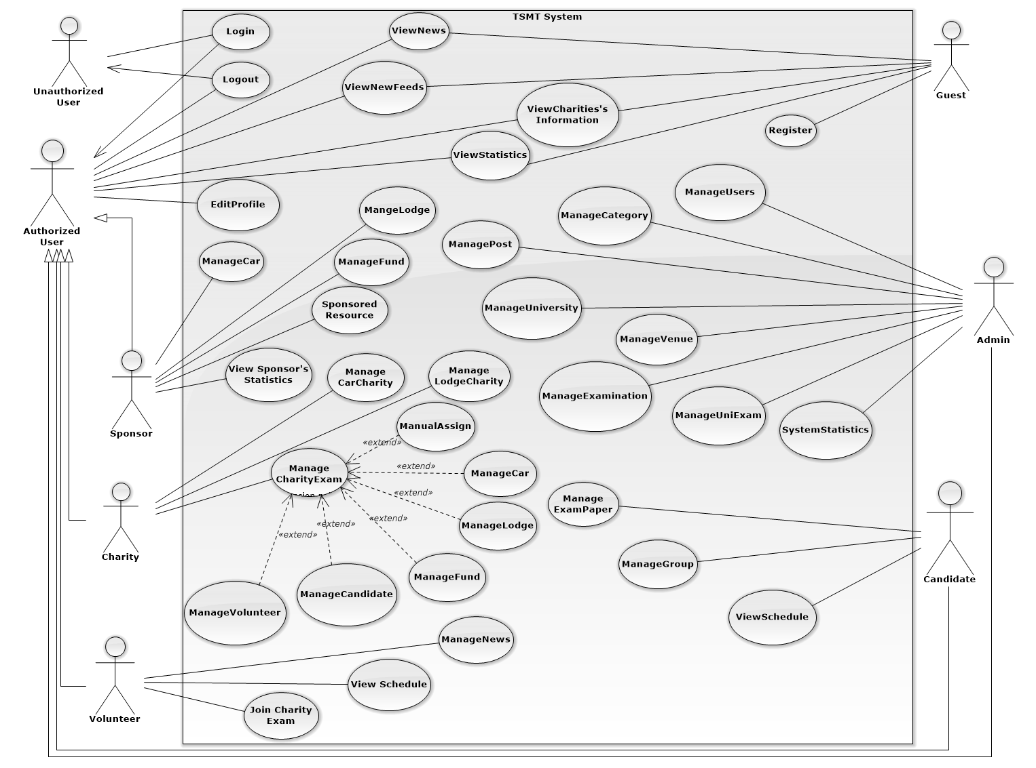Figure 2 - System Overview Usecase

#### (Guest) Register

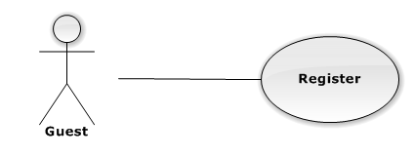

|  |  |  |  |  |
| --- | --- | --- | --- | --- |
| **USE CASE-UC001 SPECIFICATION** | | | | |
| **Use-case No.** | UC001 | **Use-case Version** | | 1.1 |
| **Use-case Name** | Register | | | |
| **Author** | Lê Nguyễn Hữu Trí | | | |
| **Date** | 15/02/2014 | **Priority** | Normal | |
| **Actor:**  Guest  **Summary:**  Guest can register new account  **Goal:**  It helps guest to register new account  **Triggers:**  Guest click “Đăng ký” on the homepage.  **Preconditions:**  The page is fully loaded  Guest link to TSMT page  **Post Conditions:**  *On success:* Message box will be shown “Bạn đã đăng ký thành công” and go to Homepage  *On failure:* An error message is displayed. The content of the error message will be specified in the Exception Scenario section based on the type of failure.  **Main Success Scenario:**   |  |  |  | | --- | --- | --- | | **Step** | **User Action** | **System Response** | | 1. | Click “tạo tài khoản” on the home page |  | | 2. |  | Display a table with profile information of User   * Tên đăng nhập: textbox (min length: 5, max length: 30, required). * Ngày sinh: textbox (min length: 5, max length: 30). * Giới tính: textbox (min length: 5, max length: 30). * Email: textbox (min length: 5, max length: 30, required). * Địa chỉ: textbox (min length: 5, max length: 50, required). * Điện thoại: textbox (min length: 5, max length: 30,). * Mật khẩu: textbox (min length: 5, max length: 30, required). | | 3 | Fills out the form with relevant values. |  | | 4 | Click “Tạo tài khoản” to create new account |  | | 5 |  | Show confirmation message: “Tạo tài khoản thành công” redirects the user to the home page of this role |   **Alternative Scenario: N/A**  **Exceptions:**   |  |  |  | | --- | --- | --- | | No | Actor Action | System Response | | 1 | No input in (“Tên Đăng Nhập”,“Mật khẩu”, “Email”, “Địa chỉ” textboxs | Show error message: “Vui lòng điền đầy đủ thông tin bên dưới” below Username/Password/Email/Address textbox. | | 2 | Username/Password not in range [5,30] | Show error message: “Tên Đăng Nhập/ Mật Khẩuphải từ 5 đến 30 kí tự” textbox. |   **Relationships: N/A**  **Business Rules: N/A** | | | | |

#### (Authorized User) Edit Profile

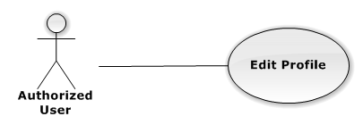

|  |  |  |  |  |
| --- | --- | --- | --- | --- |
| **USE CASE-UC003 SPECIFICATION** | | | | |
| **Use-case No.** | UC003 | **Use-case Version** | | 2.0 |
| **Use-case Name** | Edit Profile | | | |
| **Author** | Lê Nguyễn Hữu Trí | | | |
| **Date** | 15/02/2014 | **Priority** | Normal | |
| **Actor:**  Authorized User(sponsor, charity, candidate, volunteer, admin)  **Summary:**  Authorized user can edit the information need, to supplement incomplete information at registration step.  **Goal:**  It helps Authorized User to edit profile  **Triggers:**  Authorized User wants to edit profile.  Authorized User click “Edit Profile” on the individual menu which has “Edit” status  **Preconditions:**  The page is fully loaded  User log in with “Authorized User” role.( sponsor, charity, candidate, volunteer, admin)  Stay at Homepage.  **Post Conditions:**  *On success:* Message box will be shown “Bạn đã thay đổi thông tin cá nhân!” and go to Homepage  *On failure:* An error message is displayed. The content of the error message will be specified in the Exception Scenario section based on the type of failure.  **Main Success Scenario:**   |  |  |  | | --- | --- | --- | | **Step** | **User Action** | **System Response** | | 1. | Click “chỉnh sữa thông tin cá nhân” tab to view basic information |  | | 2. |  | Display a table with profile information of authorized User   * Tên: textbox (min length: 5, max length: 30, required). * Ngày sinh: textbox (min length: 5, max length: 30). * Giới tính: textbox (min length: 5, max length: 30). * Email: textbox (min length: 5, max length: 30, required). * Địa chỉ: textbox (min length: 5, max length: 50, required). * Điện thoại: textbox (min length: 5, max length: 30,). * Mật khẩu: textbox (min length: 5, max length: 30, required). | | 3 | Changes the existing information with relevant values. |  | | 4 | Click “Lưu” to Update information |  | | 5 |  | Show confirmation message: “Bạn có muốn lưu thông tin này?” with “Xác Nhận” button and “Hủy” button. [See Alternative 1] | | 6 | Click “Xác nhận” button to cancel update. |  | | 7 |  | Close info message box, update new information and back to Home page |   **Alternative Scenario:**   |  |  |  |  | | --- | --- | --- | --- | | **No** | **Step** | **User Action** | **System Response** | | 1. | 1. | Click “Hủy” button. |  | |  | 2. |  | Close info message box and back to Home page |   **Exceptions:**   |  |  |  | | --- | --- | --- | | No | Actor Action | System Response | | 1 | No input in (“Tên Đăng Nhập”,“Mật khẩu”, “Email”, “Địa chỉ” textboxs | Show error message: “Vui lòng điền đầy đủ thông tin bên dưới” below Username/Password/Email/Address textbox. | | 2 | Username/Password not in range [5,30] | Show error message: “Tên Đăng Nhập/ Mật Khẩu phải từ 5 đến 30 kí tự” textbox. |   **Relationships:**  Login  **Business Rules:**  All information must right to validate data. | | | | |

#### (Authorized) Logout

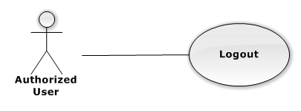

|  |  |  |  |
| --- | --- | --- | --- |
| **USE CASE-UC005 SPECIFICATION** | | | |
| **Use Case No.** | UC005 | **Use Case Version** | 2.0 |
| **Use Case Name** | logout | | |
| **Author** | Lê Nguyễn Hữu Trí | | |
| **Date** | 23/09/2013 | **Priority** | Normal |
| **Actor:** User (sponsor, charity, candidate, volunteer, admin).  **Summary:**   * User use this use case to logout system.   **Goal:**   * The user selects the option to log off of the TSMT website and is then redirected back to the Login page.   **Triggers:**   * The use case starts when the user selects the option to logout. * The user selects the option to logout. * The system informs the user of logging out. * The user confirms logging out. * The system redirects user back to the Login page.   **Preconditions:**   * User must logged in the system with the role is User (sponsor, charity, candidate, volunteer, admin).   **Post Conditions:**   * **Success**: User logout system and redirect to login page. * **Fail:** System will transfer to error page or still in current page.   **Main Success Scenario:**   |  |  |  | | --- | --- | --- | | Step | Actor Action | System Response | | 1 | The user selects log out. | The system will show a pop-up: Bạn có muốn thoạt khỏi hệ thống”   * Xác nhận: button * Hủy: button | | 2 | User select “Xác Nhận”.  [Alternative 1] | The system will clear user session and the user is logged out |   **Alternative Scenario:**   |  |  |  | | --- | --- | --- | | Step | Actor Action | System Response | | 1 | User selects Hủy. | User stay at current page. |   **Exceptions:** N/A  **Relationships:** Login  **Business Rules:** N/A | | | |

#### (Guest) View News

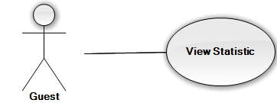

|  |  |  |  |  |
| --- | --- | --- | --- | --- |
| **USE CASE-UC008 SPECIFICATION** | | | | |
| **Use-case No.** | UC008 | **Use-case Version** | | 1.1 |
| **Use-case Name** | View statistic | | | |
| **Author** | Nguyễn Đình Tuấn | | | |
| **Date** | 12/5/2014 | **Priority** | High | |
| **Actor:** Guest  **Summary:**  This use case is about how to view statistic  **Goal:** Guest can viewstatistic  **Triggers:**  In “Home” page, guest clicks “Xem thống kê”.  **Preconditions:** The guest is already link to “Tiếp Sức Mùa Thi” website  **Post Conditions:**  *On success:* Guest can view statistic successful.  *On failure:* An error message is displayed. The content of the error message will be specified in the Exception Scenario section based on the type of failure.  **Main Success Scenario:**   |  |  |  | | --- | --- | --- | | **Step** | **User Action** | **System Response** | | 1. | In the Home page, guest clicks “ Xem thống kê” |  | | 2. |  | System will redirect to”View Statistic” with all news in the web | | 3. | In the View Statistic page, guest Chosse year to see this statistic |  | | 4. |  | The Map will display with all information of this year. |   **Alternative Scenario:** N/A  **Exceptions: N/A**  **Relationships: N/A**  **Business Rules:Guest must link to TSMT web** | | | | |

#### (Guest) Get New Feed



|  |  |  |  |  |
| --- | --- | --- | --- | --- |
| **USE CASE-UC009 SPECIFICATION** | | | | |
| **Use-case No.** | UC009 | **Use-case Version** | | 2.0 |
| **Use-case Name** | Get New Feed | | | |
| **Author** | Trần Nguyễn Kim Vinh | | | |
| **Date** | 12/5/2014 | **Priority** | High | |
| **Actor:** Guest  **Summary:**  This use case is about how to get new feed  **Goal:** Guest can get new feed  **Triggers:**  In “News” page, guest clicks “Xem tin tức từ trang báo khác”.  **Preconditions:** The guest is already link to “Tiếp Sức Mùa Thi” website  **Post Conditions:**  *On success:* Guest can get new feed successful.  *On failure:* An error message is displayed. The content of the error message will be specified in the Exception Scenario section based on the type of failure.  **Main Success Scenario:**   |  |  |  | | --- | --- | --- | | **Step** | **User Action** | **System Response** | | 1. | In the News page, guest clicks “ Xem tin tức từ trang báo khác” |  | | 2. |  | System will redirect to”Get New Feed” with all news in the web |   **Alternative Scenario:** N/A  **Exceptions: N/A**  **Relationships: N/A**  **Business Rules: N/A** | | | | |

#### (Admin) Manage University

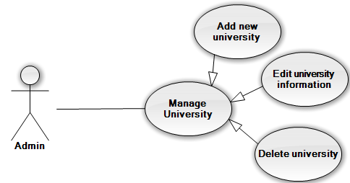

#### (Admin) Manage University – Add new university

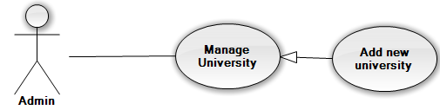

|  |  |  |  |  |
| --- | --- | --- | --- | --- |
| **USE CASE-UC010 SPECIFICATION** | | | | |
| **Use-case No.** | UC010 | **Use-case Version** | | 1.1 |
| **Use-case Name** | Add new university | | | |
| **Author** | Nguyễn Duy Khoa | | | |
| **Date** | 12/5/2014 | **Priority** | Normal | |
| **Actor:** Admin  **Summary:**  This use case allows admin can create new university.  **Goal:** Create new university in database.  **Triggers:**  In manage university page of admin, user click “Tạo mới”.  **Preconditions:** The user is already logged in with an account in admin role. The manage university is being display.  **Post Conditions:**  *On success:* A new university is added into database.  *On failure:* An error message is displayed. The content of the error message will be specified in the Exception Scenario section based on the type of failure.  **Main Success Scenario:**   |  |  |  | | --- | --- | --- | | **Step** | **User Action** | **System Response** | | 1. | Click button “Tạo mới” in dashboard of page. |  | | 2. |  | Displays a form that has the following items:   * “Tên trường” (textbox; required; min length 3; max length 100) * “Địa chỉ” (textbox; required; min length 3; max length 150) * “Mã trường” (textbox; required; min length 3; max length 50) * “Website” (textbox;not required; min length 3; max length 50) * “Số điện thoại” (textbox;not required) | | 3. | Fills out the form with relevant values. |  | | 4. | Clicks the button “Lưu lại”. |  | | 5. |  | Saves the new university information to the database, redirects the user to the manage university page. |   **Alternative Scenario: N/A**  **Exceptions:**   |  |  |  | | --- | --- | --- | | **No** | **User Action** | **System Response** | | 1. | Input same university code with an existing university in database  Click “Tạo” button. | Shows error message at start date: “Trường này đã được tạo”. | | 2. | Don’t input anything or input missing require fields? Click “Tạo” button. | Show error message at one or all require fields. |   **Relationships:** Manage university  **Business Rules:** Cannot add new university have name or university code as same as the university exist in database | | | | |

#### (Admin) Manage University – Edit university information

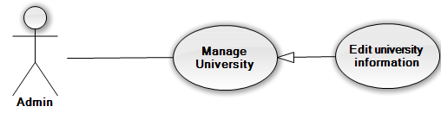

|  |  |  |  |  |
| --- | --- | --- | --- | --- |
| **USE CASE-UC011 SPECIFICATION** | | | | |
| **Use-case No.** | UC011 | **Use-case Version** | | 1.1 |
| **Use-case Name** | Edit university information | | | |
| **Author** | Nguyễn Duy Khoa | | | |
| **Date** | 12/5/2014 | **Priority** | Normal | |
| **Actor:** Admin  **Summary:**  This use case allows admin can edit existing university information.  **Goal:** Edited university information exist in database.  **Triggers:**  In manage university page of admin, user click button imaged as edit.  **Preconditions:** The user is already logged in with an account in admin role. The manage university is being display.  **Post Conditions:**  *On success:* The selected university is updated in database. The user redirected to manage university page.  *On failure:* An error message is displayed. The content of the error message will be specified in the Exception Scenario section based on the type of failure.  **Main Success Scenario:**   |  |  |  | | --- | --- | --- | | **Step** | **User Action** | **System Response** | | 1. | Click button edit at the row of university user want to edit in dashboard of page. |  | | 2. |  | Displays all information of the selected university and filled in form that has the following items:   * “Tên trường” (textbox; required; min length 3; max length 100) * “Địa chỉ” (textbox; required; min length 3; max length 150) * “Mã trường” (textbox; required; min length 3; max length 50) * “Website” (textbox;not required; min length 3; max length 50) * “Số điện thoại” (textbox;not required) | | 3. | Changes the existing information with relevant values. |  | | 4. | Clicks the button “Lưu”. |  | | 5. |  | Saves the university information to the database, redirects the user to the manage university page. |   **Alternative Scenario: N/A**  **Exceptions: N/A**  **Relationships:** Manage University  **Business Rules:** TO edit university information , that univerity must exist in the system. | | | | |

#### (Admin) Manage Examination

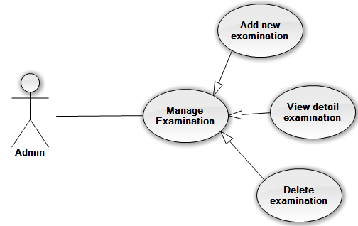

#### (Admin) Manage Examination – Add new examination

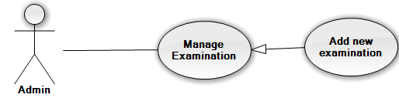

|  |  |  |  |  |
| --- | --- | --- | --- | --- |
| **USE CASE-UC013 SPECIFICATION** | | | | |
| **Use-case No.** | UC013 | **Use-case Version** | | 1.1 |
| **Use-case Name** | Add new examination | | | |
| **Author** | Nguyễn Duy Khoa | | | |
| **Date** | 12/5/2014 | **Priority** | Normal | |
| **Actor:** Admin  **Summary:**  This use case allows admin can create new examination.  **Goal:** Create new examination in database.  **Triggers:**  In manage examination page of admin, user click “Tạo mới”.  **Preconditions:**   * The user is already logged in with an account in admin role. * The manage examination is being display.   **Post Conditions:**  *On success:* A new examination is added into database.  *On failure:* An error message is displayed. The content of the error message will be specified in the Exception Scenario section based on the type of failure.  **Main Success Scenario:**   |  |  |  | | --- | --- | --- | | **Step** | **User Action** | **System Response** | | 1. | Click button “Tạo mới” in dashboard of page. |  | | 2. |  | Displays a form that has the following items:   * “Tên đợt thi” (textbox; required; max length 50) * “Ngày bắt đầu” (date time; required, require start date is date in future) * “Ngày kết thúc” (date time; required; end date must be larger than start date) | | 3. | Fills out the form with relevant values. |  | | 4. | Clicks the button “Tạo”. |  | | 5. |  | Saves the new examination information to the database, redirects the user to the manage examination page. |   **Alternative Scenario: N/A**  **Exceptions:**   |  |  |  | | --- | --- | --- | | **No** | **User Action** | **System Response** | | 1. | Input start date and end date same with existed examination.  Click “Tạo” button. | Shows error message at start date and end date: “Đợt thi này đã được tạo, Vui long tạo đợt thi khác” | | 2. | Input start date larger than end date Click “Tạo” button. | Shows error message at start date: “Ngày bắt đầu phải nhỏ hơn ngày kết thúc”. | | 3. | Input start date is a date in the past.  Click “Tạo” button. | Shows error message at start date: “Đợt thi phải bắt đầu từ trong tương lai”. | | 4. | Input end date is a date in the past.  Click “Tạo” button. | Shows error message at end date: “Ngày kết thúc phải là ngày trong tương lai”. | | 5. | Don’t input anything or input missing require fields? Click “Tạo” button. | Show error message at one or all require fields. |   **Relationships:**  Manage examination  **Business Rules:** Cannot add new examination have start date and end date as same as the examination exist in database | | | | |

#### (Admin) Manage Examination – Delete Examination

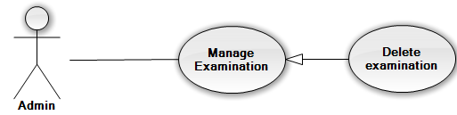

|  |  |  |  |  |
| --- | --- | --- | --- | --- |
| **USE CASE-UC015 SPECIFICATION** | | | | |
| **Use-case No.** | UC015 | **Use-case Version** | | 1.1 |
| **Use-case Name** | Delete examination | | | |
| **Author** | Nguyễn Duy Khoa | | | |
| **Date** | 12/5/2014 | **Priority** | Low | |
| **Actor:** Admin  **Summary:**  This use case allows admin can delete a selected examination.  **Goal:** Deleted selected examination from database.  **Triggers:**  In manage post page of admin, user click button delete at examination user want delete.  **Preconditions:**   * The user is already logged in with an account in admin role. * The manage examination is being display. * The selected examination never used in any university examination   **Post Conditions:**  *On success:* Examination is deleted from database.  *On failure:* An error message is displayed. The content of the error message will be specified in the Exception Scenario section based on the type of failure.  **Main Success Scenario:**   |  |  |  | | --- | --- | --- | | **Step** | **User Action** | **System Response** | | 1. | Click button delete on the row that contains the examination to be deleted. |  | | 2. |  | Shows a popup to ask the user to confirm the action. | | 3. | Click “Xác nhận” to continue to delete the examination. |  | | 4. |  | Marks the selected examination as deleted in the database and redirect to manage examination page. |   **Alternative Scenario:**   |  |  |  |  | | --- | --- | --- | --- | | **No** | **Step** | **User Action** | **System Response** | | 1. | 1. | Clicks on the button “Hủy bỏ”. |  | | 2. |  | Hides the popup message. |   **Exceptions: N/A**  **Relationships:** Manage examination  **Business Rules**: If an examination have used in a university examination, user cannot delete that examination | | | | |

#### (Admin) Manage University Examination – Add new university examination

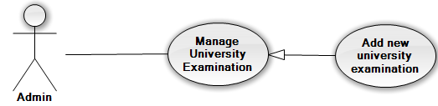

|  |  |  |  |  |
| --- | --- | --- | --- | --- |
| **USE CASE-UC016 SPECIFICATION** | | | | |
| **Use-case No.** | UC016 | **Use-case Version** | | 1.1 |
| **Use-case Name** | Add new university examination | | | |
| **Author** | Nguyễn Duy Khoa | | | |
| **Date** | 12/5/2014 | **Priority** | Normal | |
| **Actor:** Admin  **Summary:**  This use case allows admin can create new university examination.  **Goal:** Create new university examination in database.  **Triggers:**  In manage university examination page of admin, user click “Tạo mới”.  **Preconditions:**   * The user is already logged in with an account in admin role. * The manage university examination is being display. * Have one or more universities and examinations in database.   **Post Conditions:**  *On success:* A new university examination is added into database.  *On failure:* An error message is displayed. The content of the error message will be specified in the Exception Scenario section based on the type of failure.  **Main Success Scenario:**   |  |  |  | | --- | --- | --- | | **Step** | **User Action** | **System Response** | | 1. | Click button “Tạo mới” in dashboard of manage university examination page. |  | | 2. |  | Displays a form that has the following items:   * “Trường” (combo box; required) * “Kỳ thi” (combo box; required) | | 3. | Choose one university and one examination. |  | | 4. | Clicks the button “Tạo”. |  | | 5. |  | Saves the new university examination into the database, redirects the user to the manage university examination page. |   **Alternative Scenario: N/A**  **Exceptions:**   |  |  |  | | --- | --- | --- | | **No** | **User Action** | **System Response** | | 1. | Choose university and examination have the same information with existing university examination in database.  Click “Tạo” | Show popup message “Trường này đã có đợt thi này, vui lòng chọn đợt thi khác”. |   **Relationships:**  Manage examination  **Business Rules:** Cannot add new university examination have start date and end date as same as the examination exist in database | | | | |

#### (Charity) Manage Charity Exam

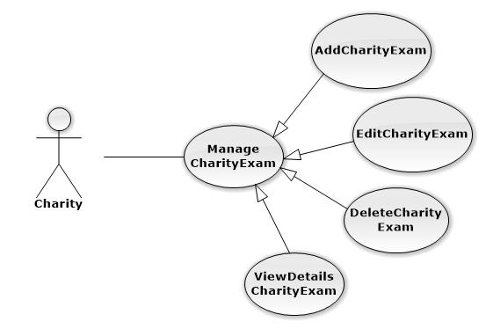

#### (Charity) Manage Charity Exam – Add charity exam

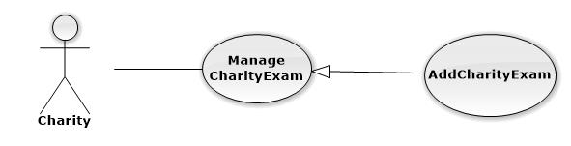

|  |  |  |  |  |
| --- | --- | --- | --- | --- |
| **USE CASE-UC018 SPECIFICATION** | | | | |
| **Use-case No.** | UC018 | **Use-case Version** | | 1.1 |
| **Use-case Name** | AddCharityExam | | | |
| **Author** | Nguyễn Vinh Hiển | | | |
| **Date** | 11/5/2014 | **Priority** | High | |
| **Actor:** Charity  **Summary:** This use case is about how Charity add charity exam  **Goal:** Add charity exam successful that volunteer, candidate and sponsor can interaction to.  **Triggers:** Charity click “Tạo” button to create new charity exam  **Preconditions:** User login into charity’s role  **Post Conditions:**  *On success:* New Charity Exam is displayed on charity exam’s table successfully  *On failure:* The error message is displayed  **Main Success Scenario:**   |  |  |  | | --- | --- | --- | |  | **User Action** | **System Response** | | 1. | User choose examination at “Kì thi” dropdownlist |  | | 2. |  | The examination that was chosen by the user at step 1 is displayed | | 3. | User click “Tạo” button |  | | 4. |  | _ The charity exam is added successful in the system  _ “Quản lí kì thi” page is displayed successfully with new charity exam in the table |   **Alternative Scenario:** N/A  **Exceptions:** When charity choose the examination that already have charity exam, the system will notify and require chosen again  **Relationships:** Manage Charity Exam  **Business Rules:** The name of charity exam must don’t existed. | | | | |

#### (Charity) Manage Charity Exam – Edit Charity Exam

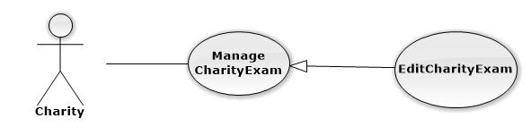

|  |  |  |  |  |
| --- | --- | --- | --- | --- |
| **USE CASE-UC019 SPECIFICATION** | | | | |
| **Use-case No.** | UC019 | **Use-case Version** | | 1.1 |
| **Use-case Name** | EditCharityExam | | | |
| **Author** | Nguyễn Vinh Hiển | | | |
| **Date** | 11/5/2014 | **Priority** | Normal | |
| **Actor:** Charity  **Summary:** This use case is about how Charity add charity exam  **Goal:** Add charity exam successful that volunteer, candidate and sponsor can interaction to.  **Triggers:** Charity click “Tạo kì thi” button on “Quản lí kì thi” page.  **Preconditions:** User login into charity’s role  **Post Conditions:**  *On success:* New Charity Exam is displayed on charity exam’s table successfully  *On failure:* The error message is displayed  **Main Success Scenario:**   |  |  |  | | --- | --- | --- | |  | **User Action** | **System Response** | | 1. | User choose examination at “Kì thi” dropdownlist |  | | 2. |  | The examination that was chosen by the user at step 1 is displayed | | 3. | User click “Sửa” button |  | | 4. |  | _ The charity exam is edited successful in the system  _ “Quản lí kì thi” page is displayed successfully with edited charity exam in the table |   **Alternative Scenario:** N/A  **Exceptions:** When charity choose the examination that already have charity exam, the system will notify and require chosen again  **Relationships:** Manage Charity Exam  **Business Rules:** This Exam has existed. | | | | |

#### (Charity) Manage Car Charity

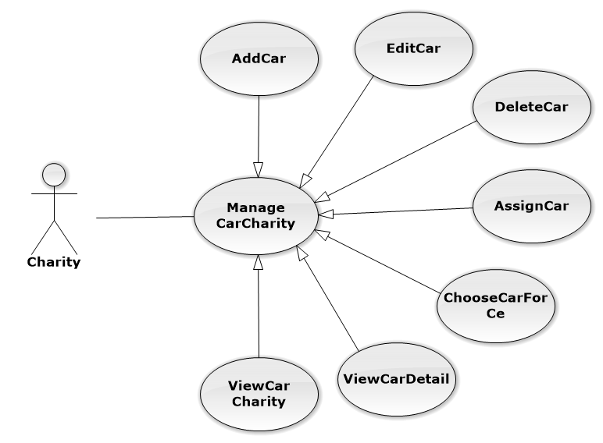

#### (Charity) Manage Car Charity – Add car

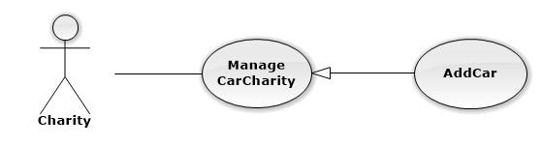

|  |  |  |  |  |
| --- | --- | --- | --- | --- |
| **USE CASE-UC021 SPECIFICATION** | | | | |
| **Use-case No.** | UC021 | **Use-case Version** | | 1.1 |
| **Use-case Name** | AddCar | | | |
| **Author** | Nguyễn Vinh Hiển | | | |
| **Date** | 11/5/2014 | **Priority** | High | |
| **Actor:** Charity  **Summary:** This use case is about how Charity add a new car  **Goal:** Add Car successful that charity can use to assign to charity exam  **Triggers:** Charity click “Tạo” button to create a new car.  **Preconditions:** User login into charity’s role  **Post Conditions:**  *On success:* New Car is displayed on charity’s car table successfully  *On failure:* The error message is displayed  **Main Success Scenario:**   |  |  |  | | --- | --- | --- | |  | **User Action** | **System Response** | | 1. | User fill information into textbox |  | | 2. |  | The information that user filled in step 1 is displayed exactly in textbox | | 3. | User click “Tạo” button |  | | 4. |  | _ The new car is added into the system successfully  _ “Quản lí xe của hội từ thiện” page is displayed successfully with new car in the table |   **Alternative Scenario:**   |  |  |  | | --- | --- | --- | |  | **User Action** | **System Response** | | 1. | User fill information into textbox |  | | 2. |  | The information that user filled in step 1 is displayed exactly in textbox | | 3. | User choose charity exam at “Kì thi” drop down list |  | | 4. | User click “Tạo” button |  | | 5. |  | _ The new car is added into the system successfully  _ “Quản lí xe của hội từ thiện” page is displayed successfully with new car in the table  _ The new car is assigned into charity exam successfully |   **Exceptions:**   |  |  |  | | --- | --- | --- | |  | **User Action** | **System Response** | | 1. | User fill character into “Số chỗ” textbox |  | | 2. |  | The error message is displayed | | 3. | User doesn’t fill into “Biển số xe” textbox |  | | 4. |  | The error message is displayed |   **Relationships:** Manage Car Charity  **Business Rules:** The numberplate of car to add new, must don’t the same with car exist in the system. | | | | |

#### (Charity) Manage Car Charity – Edit car

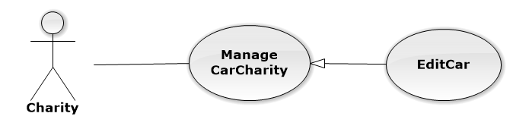

|  |  |  |  |  |
| --- | --- | --- | --- | --- |
| **USE CASE-UC022 SPECIFICATION** | | | | |
| **Use-case No.** | UC022 | **Use-case Version** | | 1.1 |
| **Use-case Name** | EditCar | | | |
| **Author** | Nguyễn Vinh Hiển | | | |
| **Date** | 11/5/2014 | **Priority** | Normal | |
| **Actor:** Charity  **Summary:** This use case is about how Charity edit a car  **Goal:** Edit car’s detail successfully  **Triggers:** Charity click “Sửa” button to edit a car.  **Preconditions:** User login into charity’s role  **Post Conditions:**  *On success:* The car with new detail is displayed on charity’s car table successfully  *On failure:* The error message is displayed  **Main Success Scenario:**   |  |  |  | | --- | --- | --- | |  | **User Action** | **System Response** | | 1. | User fill information into textbox |  | | 2. |  | The information that user filled in step 1 is displayed exactly in textbox | | 3. | User click “Suwar” button |  | | 4. |  | _ The car is edited successfully  _ “Quản lí xe của hội từ thiện” page is displayed successfully with a car in the table |   **Alternative Scenario:**   |  |  |  | | --- | --- | --- | |  | **User Action** | **System Response** | | 1. | User fill information into textbox |  | | 2. |  | The information that user filled in step 1 is displayed exactly in textbox | | 3. | User choose charity exam at “Kì thi” drop down list |  | | 4. | User click “Sửa” button |  | | 5. |  | _ The car is edited into the system successfully  _ “Quản lí xe của hội từ thiện” page is displayed successfully with new car in the table  _ The car is assigned into charity exam successfully |   **Exceptions:**   |  |  |  | | --- | --- | --- | |  | **User Action** | **System Response** | | 1. | User fill character into “Số chỗ” textbox |  | | 2. |  | The error message is displayed | | 3. | User doesn’t fill into “Biển số xe” textbox |  | | 4. |  | The error message is displayed |   **Relationships:** Manage Charity  **Business Rules:** To edit car, this car must exist on system. | | | | |

#### (Charity) Manage Car Charity – Assign Car

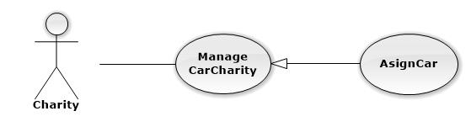

|  |  |  |  |  |
| --- | --- | --- | --- | --- |
| **USE CASE-UC023 SPECIFICATION** | | | | |
| **Use-case No.** | UC023 | **Use-case Version** | | 1.1 |
| **Use-case Name** | AssignCar | | | |
| **Author** | Nguyễn Vinh Hiển | | | |
| **Date** | 11/5/2014 | **Priority** | Normal | |
| **Actor:** Charity  **Summary:** This use case is about how Charity assign a car  **Goal:** Assign car to charity exam successfully  **Triggers:** Charity click “Chọn” button to assign a car to charity exam  **Preconditions:** User login into charity’s role  **Post Conditions:**  *On success:* The car is assigned to the charity exam successfully, this charity can use a car for candidate  *On failure:* The error message is displayed  **Main Success Scenario:**   |  |  |  | | --- | --- | --- | |  | **User Action** | **System Response** | | 1. | User choose charity exam at “Kì thi” drop down list |  | | 2. |  | The charity exam that user chose in step 1 is displayed exactly in textbox | | 3. | User click “chọn” button |  | | 4. |  | _ The car is assigned successfully  _ “Quản lí xe của hội từ thiện” page is displayed successfully with a car were assigned |   **Alternative Scenario: N/A**  **Exceptions: N/A**  **Relationships:** Manage Charity | | | | |

#### (Charity) Manage Car Charity – Choose Car For Charity Exam

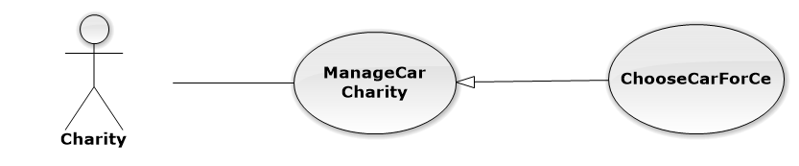

|  |  |  |  |  |
| --- | --- | --- | --- | --- |
| **USE CASE-UC024 SPECIFICATION** | | | | |
| **Use-case No.** | UC024 | **Use-case Version** | | 1.1 |
| **Use-case Name** | ChooseCarForCe | | | |
| **Author** | Nguyễn Vinh Hiển | | | |
| **Date** | 11/5/2014 | **Priority** | Normal | |
| **Actor:** Charity  **Summary:** This use case is about how Charity assign a cars to charity exam  **Goal:** Assign cars to charity exam successfully  **Triggers:** Charity click “Chọn” button to assign cars to charity exam  **Preconditions:** User login into charity’s role  **Post Conditions:**  *On success:* Cars is assigned to the charity exam successfully, this charity can use cars for candidate  *On failure:* The error message is displayed  **Main Success Scenario:**   |  |  |  | | --- | --- | --- | |  | **User Action** | **System Response** | | 1. | User choose cars by click on checkbox at the beginning of each car |  | | 2. | User click “chọn” button |  | | 3. |  | _ The cars is assigned successfully  _ “Quản lí xe của hội từ thiện” page is displayed successfully with cars were assigned |   **Alternative Scenario: N/A**  **Exceptions: N/A**  **Relationships:** Manage Car Charity | | | | |

#### (Charity) Manage Car Charity – View Car Of Charity



|  |  |  |  |  |
| --- | --- | --- | --- | --- |
| **USE CASE-UC026 SPECIFICATION** | | | | |
| **Use-case No.** | UC026 | **Use-case Version** | | 1.1 |
| **Use-case Name** | ViewCarCharity | | | |
| **Author** | Nguyễn Vinh Hiển | | | |
| **Date** | 11/5/2014 | **Priority** | Normal | |
| **Actor:** Charity  **Summary:** This use case is about how Charity view all of cars  **Goal:** View all of cars with detail successfully  **Triggers:** N/A  **Preconditions:** User login into charity’s role  **Post Conditions:**  *On success:* Cars and car’s detail is displayed successfully on table with number plate, charity exam, total slot, available slot  *On failure:* The error message is displayed  **Main Success Scenario:**   |  |  |  | | --- | --- | --- | |  | **User Action** | **System Response** | | 1. | User click on “Quản lý xe của tổ chức” icon |  | | 2. |  | _ The cars and the detail of the car is displayed successfully on table |   **Alternative Scenario: N/A**  **Exceptions: N/A**  **Relationships:** Manage Car Charity  **Business Rules:** Have any cars in system | | | | |

#### (Charity) Manage Car Charity – Delete Car

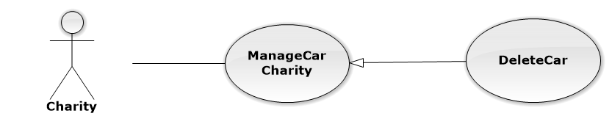

|  |  |  |  |  |
| --- | --- | --- | --- | --- |
| **USE CASE-UC027 SPECIFICATION** | | | | |
| **Use-case No.** | UC027 | **Use-case Version** | | 1.1 |
| **Use-case Name** | DeleteCar | | | |
| **Author** | Nguyễn Vinh Hiển | | | |
| **Date** | 11/5/2014 | **Priority** | Normal | |
| **Actor:** Charity  **Summary:** This use case is about how Charity delete the car  **Goal:** Delete the car successfully  **Triggers:** Charity click “Xóa” icon at the same row of the car.  **Preconditions: _**User login into charity’s role  _ The car that charity want to delete mustn’t used before  **Post Conditions:**  *On success:* The car is delete successfully and fade out the table  *On failure:* N/A  **Main Success Scenario:**   |  |  |  | | --- | --- | --- | |  | **User Action** | **System Response** | | 1. | User click “Xóa” icon at the same row of the car |  | | 2. |  | System display popup to confirm | | 3. | User click “Xác nhận” to delete |  | | 4. |  | The car is faded out of the table and no longer exist at the system |   **Alternative Scenario:** N/A  **Exceptions:** N/A  **Relationships:** Manage Charity  **Business Rules:** Delete Car when don’t use this car for any exam | | | | |

#### (Charity) Manage Lodge Charity

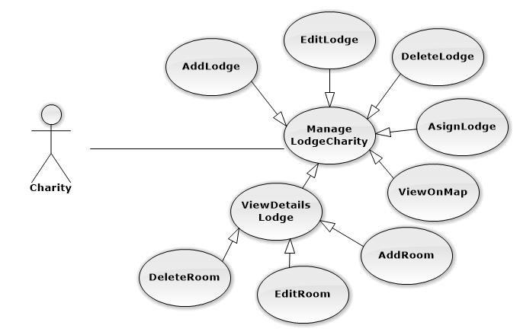

#### (Charity) Manage Lodge Charity – Add lodge

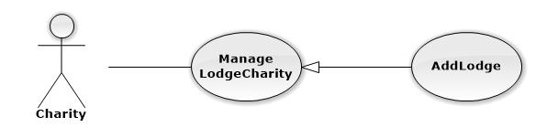

|  |  |  |  |  |
| --- | --- | --- | --- | --- |
| **USE CASE-UC028 SPECIFICATION** | | | | |
| **Use-case No.** | UC028 | **Use-case Version** | | 1.1 |
| **Use-case Name** | AddLodge | | | |
| **Author** | Nguyễn Vinh Hiển | | | |
| **Date** | 11/5/2014 | **Priority** | High | |
| **Actor:** Charity  **Summary:** This use case is about how Charity add a new lodge  **Goal:** Add lodge successful that charity can use to assign to charity exam  **Triggers:** Charity click “Tạo” button to create a new lodge.  **Preconditions:** User login into charity’s role  **Post Conditions:**  *On success:* New lodge is displayed on charity’s lodge table successfully  *On failure:* The error message is displayed  **Main Success Scenario:**   |  |  |  | | --- | --- | --- | |  | **User Action** | **System Response** | | 1. | User fill address into textbox |  | | 2. |  | The suggest address is displayed | | 3. | User choose the address of suggest address and click “Tạo” button |  | | 4. |  | _ The new lodge is added into the system successfully  _ “Quản lí nhà của hội từ thiện” page is displayed successfully with new lodge in the table |   **Alternative Scenario:**   |  |  |  | | --- | --- | --- | |  | **User Action** | **System Response** | | 1. | User drab place icon into the place of lodge |  | | 2. |  | The suggest address is displayed | | 3. | User choose the address of suggest address and click “Tạo” button |  | | 4. |  | _ The new lodge is added into the system successfully  _ “Quản lí nhà của hội từ thiện” page is displayed successfully with new lodge in the table |   **Exceptions:**   |  |  |  | | --- | --- | --- | |  | **User Action** | **System Response** | | 1. | User not fill address into “Địa chỉ” textbox |  | | 2. |  | The error message is displayed |   **Relationships:** Manage Lodge Charity  **Business Rules:** Add lodge with the address of lodge not existed. | | | | |

#### (Charity) Manage Lodge Charity – Edit Lodge

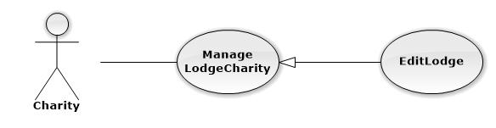

|  |  |  |  |  |
| --- | --- | --- | --- | --- |
| **USE CASE-UC029 SPECIFICATION** | | | | |
| **Use-case No.** | UC029 | **Use-case Version** | | 1.1 |
| **Use-case Name** | EditLodge | | | |
| **Author** | Nguyễn Vinh Hiển | | | |
| **Date** | 11/5/2014 | **Priority** | High | |
| **Actor:** Charity  **Summary:** This use case is about how Charity edit an exist lodge  **Goal:** Edit lodge successful that charity can use to assign to charity exam  **Triggers:** Charity click “Sửa” button to edit lodge.  **Preconditions:** User login into charity’s role  **Post Conditions:**  *On success:* The lodge is edited and displayed on charity’s lodge table successfully  *On failure:* The error message is displayed  **Main Success Scenario:**   |  |  |  | | --- | --- | --- | |  | **User Action** | **System Response** | | 1. | User fill address into textbox |  | | 2. |  | The suggest address is displayed | | 3. | User choose the address of suggest address and click “Sửa” button |  | | 4. |  | _ The lodge is edited into the system successfully  _ “Quản lí nhà của hội từ thiện” page is displayed successfully with edited lodge in the table |   **Alternative Scenario:**   |  |  |  | | --- | --- | --- | |  | **User Action** | **System Response** | | 1. | User drab place icon into the place of lodge |  | | 2. |  | The suggest address is displayed | | 3. | User choose the address of suggest address and click “Sửa” button |  | | 4. |  | _ The lodge is edited into the system successfully  _ “Quản lí nhà của hội từ thiện” page is displayed successfully with edited lodge in the table |   **Exceptions:**   |  |  |  | | --- | --- | --- | |  | **User Action** | **System Response** | | 1. | User not fill address into “Địa chỉ” textbox |  | | 2. |  | The error message is displayed |   **Relationships:** Manage Lodge Charity  **Business Rules:** Exist this lodge on system to edit lodge | | | | |

#### (Charity) Manage Lodge Charity – Assign Lodge

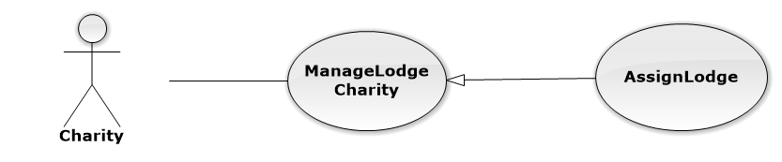

|  |  |  |  |  |
| --- | --- | --- | --- | --- |
| **USE CASE-UC031 SPECIFICATION** | | | | |
| **Use-case No.** | UC031 | **Use-case Version** | | 1.1 |
| **Use-case Name** | AssignLodge | | | |
| **Author** | Nguyễn Vinh Hiển | | | |
| **Date** | 11/5/2014 | **Priority** | Normal | |
| **Actor:** Charity  **Summary:** This use case is about how Charity assign a lodge  **Goal:** Assign lodge to charity exam successfully  **Triggers:** Charity click “Chọn” button to assign a car to charity exam  **Preconditions:** User login into charity’s role  **Post Conditions:**  *On success:* The lodge is assigned to the charity exam successfully with the rooms that charity choose  *On failure:* The error message is displayed  **Main Success Scenario:**   |  |  |  | | --- | --- | --- | |  | **User Action** | **System Response** | | 1. | User choose charity exam at “Kì thi” drop down list |  | | 2. |  | The charity exam that user chose in step 1 is displayed exactly in textbox | | 3. | User check on “ phòng” checkbox to choose the room that user want to use for charity exam |  | | 4. | User click “Chọn” button |  | | 5. |  | _ The lodge is assigned successfully with the rooms that user choose at step 3  _ “Quản lí nhà của hội từ thiện” page is displayed successfully with a lodge were assigned |   **Alternative Scenario: N/A**  **Exceptions: N/A**  **Relationships:** Manage Lodge Charity  **Business Rules:**Assign lodge When this lodge not assign for any exam before | | | | |

#### (Charity) Manage Lodge Charity – View on map

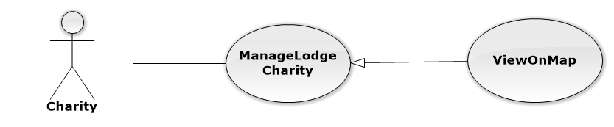

|  |  |  |  |  |
| --- | --- | --- | --- | --- |
| **USE CASE-UC032 SPECIFICATION** | | | | |
| **Use-case No.** | UC032 | **Use-case Version** | | 1.1 |
| **Use-case Name** | ViewOnMap | | | |
| **Author** | Trần Nguyễn Kim Vinh | | | |
| **Date** | 11/5/2014 | **Priority** | Normal | |
| **Actor:** Charity  **Summary:** This use case is about how charity view lodge on google map  **Goal:** View the place of lodge on google map successfully  **Triggers:** Chaity click on “Xem bản đồ” icon  **Preconditions:** User login into charity’s role  **Post Conditions:**  *On success:* New window is opened with google map and marker on map  *On failure:* The error message is displayed  **Main Success Scenario:**   |  |  |  | | --- | --- | --- | |  | **User Action** | **System Response** | | 1. | User click on “Xem bản đồ” icon |  | | 2. |  | _ The google map and the lodge’s marker with the right position is displayed |   **Alternative Scenario: N/A**  **Exceptions: N/A**  **Relationships:** Manage Lodge Charity  **Business Rules:** View On map when have exist this lodge on system | | | | |

#### (Charity) Mangage Lodge Charity – Add Room

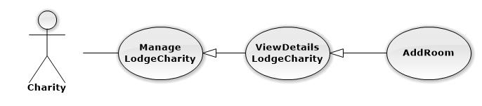

|  |  |  |  |  |
| --- | --- | --- | --- | --- |
| **USE CASE-UC033 SPECIFICATION** | | | | |
| **Use-case No.** | UC033 | **Use-case Version** | | 1.1 |
| **Use-case Name** | AddRoom | | | |
| **Author** | Trần Nguyễn Kim Vinh | | | |
| **Date** | 11/5/2014 | **Priority** | Normal | |
| **Actor:** Charity  **Summary:** This use case is about how Charity add a new room of the lodge  **Goal:** Add room to lodge successful that charity can use to assign to charity exam  **Triggers:** Charity click “Tạo” button to create a new room.  **Preconditions:** User login into charity’s role  User click “ xem chi tiết” at 1 lodge  **Post Conditions:**  *On success:* New room is displayed on room table successfully  *On failure:* The error message is displayed  **Main Success Scenario:**   |  |  |  | | --- | --- | --- | |  | **User Action** | **System Response** | | 1. | User fill information into test box |  | | 2. |  | The information that user filled in step 1 is displayed exactly in textbox | | 3. | User click on “Tạo” button |  | | 4. |  | __ The new room is added into the lodge successfully  _ “Chi tiết nhà ở” page is displayed successfully with new room in the table |   **Alternative Scenario: N/A**  **Exceptions:**   |  |  |  | | --- | --- | --- | |  | **User Action** | **System Response** | | 1. | User doesn’t fill into “Số chỗ” textbox |  | | 2. |  | The error message is displayed |   **Relationships:** ViewDetails Lodge Charity  **Business Rules:** The Room ID not exists before on system. | | | | |

#### Manage Lodge Charity – Edit Room

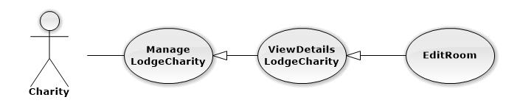

|  |  |  |  |  |
| --- | --- | --- | --- | --- |
| **USE CASE-UC034 SPECIFICATION** | | | | |
| **Use-case No.** | UC034 | **Use-case Version** | | 1.1 |
| **Use-case Name** | EditRoom | | | |
| **Author** | Trần Nguyễn Kim Vinh | | | |
| **Date** | 11/5/2014 | **Priority** | Normal | |
| **Actor:** Charity  **Summary:** This use case is about how Charity edit room of the lodge  **Goal:** Edit room to lodge successful that charity can use to assign to charity exam  **Triggers:** Charity click “Sửa” button to create a new room.  **Preconditions:** User login into charity’s role  User click “ xem chi tiết” at 1 lodge  **Post Conditions:**  *On success:* New room is displayed on room table successfully  *On failure:* The error message is displayed  **Main Success Scenario:**   |  |  |  | | --- | --- | --- | |  | **User Action** | **System Response** | | 1. | User fill information into test box |  | | 2. |  | The information that user filled in step 1 is displayed exactly in textbox | | 3. | User click on “Sửa” button |  | | 4. |  | __ The room is edited successfully  _ “Chi tiết nhà ở” page is displayed successfully with edited room in the table |   **Alternative Scenario: N/A**  **Exceptions:**   |  |  |  | | --- | --- | --- | |  | **User Action** | **System Response** | | 1. | User doesn’t fill into “Số chỗ” textbox |  | | 2. |  | The error message is displayed |   **Relationships:** ViewDetails Lodge Charity  **Business Rules:** Edit Room when this room not use for any chairty exam. | | | | |

#### (Charity) Mange Lodge – Delete Room

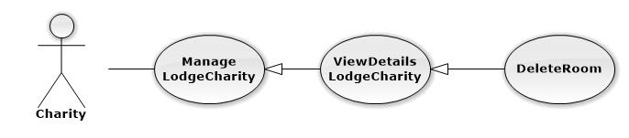

|  |  |  |  |  |
| --- | --- | --- | --- | --- |
| **USE CASE-UC035 SPECIFICATION** | | | | |
| **Use-case No.** | UC035 | **Use-case Version** | | 1.1 |
| **Use-case Name** | DeleteRoom | | | |
| **Author** | Trần Nguyễn Kim Vinh | | | |
| **Date** | 11/5/2014 | **Priority** | Normal | |
| **Actor:** Charity  **Summary:** This use case is about how Charity delete the room in lodge  **Goal:** Delete room in lodge  **Triggers:** Charity click “Xóa” icon at the same row of the room.  **Preconditions: _**User login into charity’s role  _ The room of lodge in charity exam that charity want to delete mustn’t used before  **Post Conditions:**  *On success:* The room is delete successfully and fade out the table  *On failure:* N/A  **Main Success Scenario:**   |  |  |  | | --- | --- | --- | |  | **User Action** | **System Response** | | 1. | User click “Xóa” icon at the same row of the room |  | | 2. |  | System display popup to confirm | | 3. | User click “Xác nhận” to delete |  | | 4. |  | The room is faded out of the table of lodge |   **Alternative Scenario:** N/A  **Exceptions:** N/A  **Relationships:** ViewDetails Lodge Charity  **Business Rules:** Delate Room when this room not use for any chairty exam. | | | | |

#### (Charity) Manage Car

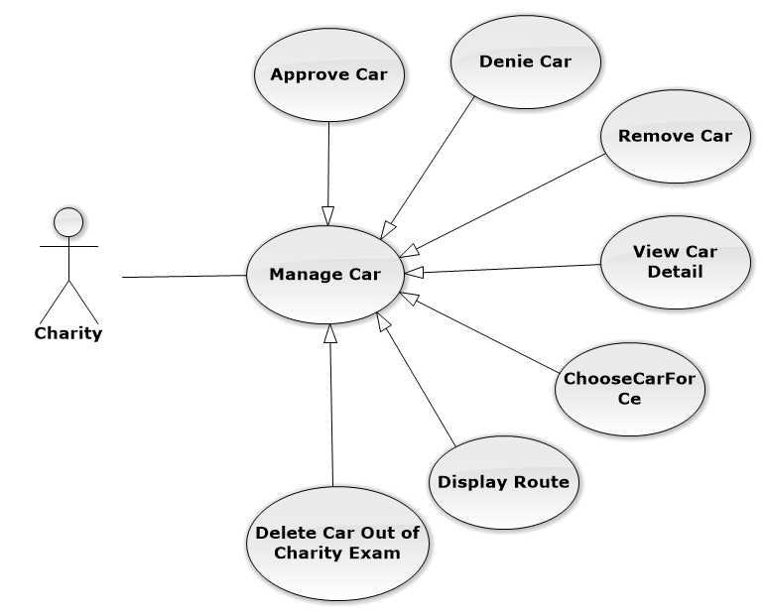

#### (Charity) Manage Car – Approve Car

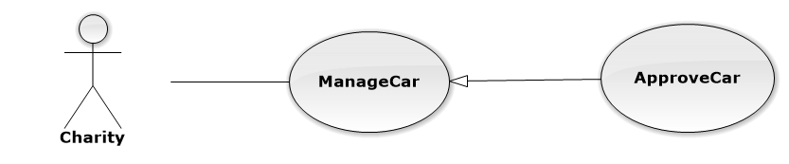

|  |  |  |  |  |
| --- | --- | --- | --- | --- |
| **USE CASE-UC036 SPECIFICATION** | | | | |
| **Use-case No.** | UC036 | **Use-case Version** | | 1.1 |
| **Use-case Name** | ApproveCar | | | |
| **Author** | Nguyễn Vinh Hiển | | | |
| **Date** | 11/5/2014 | **Priority** | Normal | |
| **Actor:** Charity  **Summary:** This use case is about how Charity approve the car that was sponsored by the Sponsor  **Goal:** Approve the car successful so charity can use this car for charity exam  **Triggers:** Charity click “Quản lý xe” button on “Chi tiết đợt thi” page.  **Preconditions:** User login into charity’s role  **Post Conditions:**  *On success:* The Car is displayed on table, status of car is :” Đã duyệt” and charity can use this car to assign to candidate  *On failure:* N/A  **Main Success Scenario:**   |  |  |  | | --- | --- | --- | |  | **User Action** | **System Response** | | 1. | User click “Xác nhận” icon at the same row of the car |  | | 2. |  | The status of the car will turn form “Chưa duyệt “ to “ Đã duyệt |   **Alternative Scenario:** N/A  **Exceptions:** N/A  **Relationships:** Manage Car | | | | |

#### (Charity) Manage Car – Denie Car

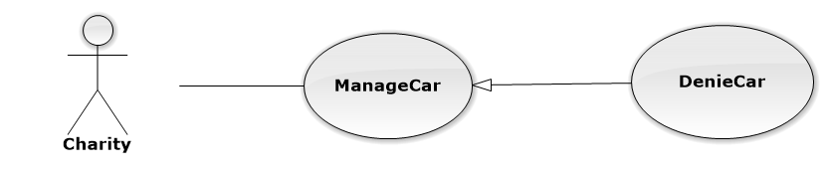

|  |  |  |  |  |
| --- | --- | --- | --- | --- |
| **USE CASE-UC037 SPECIFICATION** | | | | |
| **Use-case No.** | UC037 | **Use-case Version** | | 1.1 |
| **Use-case Name** | DenieCar | | | |
| **Author** | Nguyễn Vinh Hiển | | | |
| **Date** | 11/5/2014 | **Priority** | Normal | |
| **Actor:** Charity  **Summary:** This use case is about how Charity deny the car that was sponsored by the sponsor  **Goal:** Deny the car successful so the car will no longer exist on the table  **Triggers:** Charity click “Quản lý xe” button on “Chi tiết đợt thi” page.  **Preconditions:** User login into charity’s role  **Post Conditions:**  *On success:* The Car is Denie successfully and fade out the table  *On failure:* N/A  **Main Success Scenario:**   |  |  |  | | --- | --- | --- | |  | **User Action** | **System Response** | | 1. | User click “Từ chối” icon at the same row of the car |  | | 2. |  | The car is faded out of the table |   **Alternative Scenario:** N/A  **Exceptions:** N/A  **Relationships:** Manage Car  **Business Rules:** Denie Car out of Charity Exam when this car not assign for any candidate. | | | | |

#### (Charity) Manage Car – Delete Car Out Of Charity Exam



|  |  |  |  |  |
| --- | --- | --- | --- | --- |
| **USE CASE-UC039 SPECIFICATION** | | | | |
| **Use-case No.** | UC039 | **Use-case Version** | | 1.1 |
| **Use-case Name** | DeleteCarOutOfCharityExam | | | |
| **Author** | Nguyễn Vinh Hiển | | | |
| **Date** | 11/5/2014 | **Priority** | Normal | |
| **Actor:** Charity  **Summary:** This use case is about how Charity delete the car of charity exam  **Goal:** remove the car out of the system of charity exam  **Triggers:** Charity click “Quản lý xe” button on “Chi tiết đợt thi” page.  **Preconditions: _**User login into charity’s role  _ The car of charity exam that charity want to delete mustn’t used before  **Post Conditions:**  *On success:* The Car is delete successfully and fade out the table  *On failure:* N/A  **Main Success Scenario:**   |  |  |  | | --- | --- | --- | |  | **User Action** | **System Response** | | 1. | User click “Xóa” icon at the same row of the car |  | | 2. |  | The car is faded out of the table and no longer exist at the system of charity exam |   **Alternative Scenario:** N/A  **Exceptions:** N/A  **Relationships:** Manage Car  **Business Rules:** Delate Car out of Charity Exam when this car not assign for any candidate. | | | | |

#### (Charity) Manage Car – Display Route

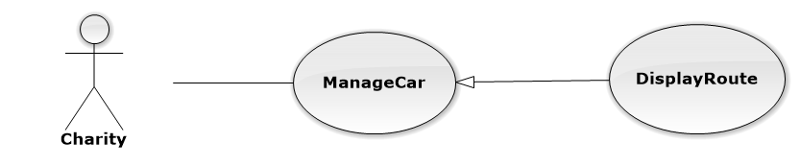

|  |  |  |  |  |
| --- | --- | --- | --- | --- |
| **USE CASE-UC040 SPECIFICATION** | | | | |
| **Use-case No.** | UC040 | **Use-case Version** | | 1.1 |
| **Use-case Name** | DisplayRoute | | | |
| **Author** | Nguyễn Vinh Hiển | | | |
| **Date** | 11/5/2014 | **Priority** | Normal | |
| **Actor:** Charity  **Summary:** This use case is about how Charity view the route that system suggest for  **Goal:** View the route that system suggest successfully and this route is the shortest route  **Triggers:** Charity click “Quản lý xe” button on “Chi tiết đợt thi” page.  **Preconditions: _**User login into charity’s role  _The car must be assigned to at least 1 candidate  _Have internet connection  **Post Conditions:**  *On success:* The route of the car is displayed successfully in new window  *On failure:* Return error mesage  **Main Success Scenario:**   |  |  |  | | --- | --- | --- | |  | **User Action** | **System Response** | | 1. | User click “Xem đường đi” icon at the same row of the car |  | | 2. |  | The new window with google map and shortest route is displayed successfully |   **Alternative Scenario:** N/A  **Exceptions:** N/A  **Relationships:** Manage Car  **Business Rules:** Display Route when have any candidate to assign for this car. | | | | |

#### (Charity) Manage Lodge

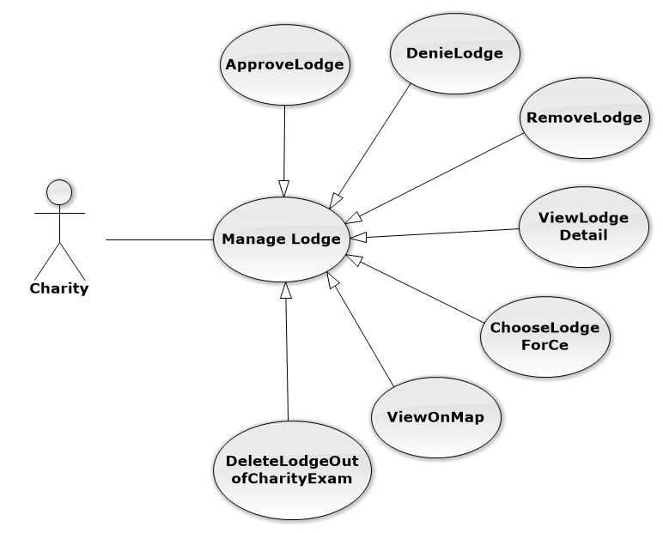

#### (Charity) Manage Lodge – Approve Lodge

|  |  |  |  |  |
| --- | --- | --- | --- | --- |
| **USE CASE-UC041 SPECIFICATION** | | | | |
| **Use-case No.** | UC041 | **Use-case Version** | | 1.1 |
| **Use-case Name** | ApproveLodge | | | |
| **Author** | Nguyễn Vinh Hiển | | | |
| **Date** | 11/5/2014 | **Priority** | Normal | |
| **Actor:** Charity  **Summary:** This use case is about how Charity approve the lodge  **Goal:** Approve the lodge successful  **Triggers:** Charity click “Xác nhận” icon at the same row of the lodge.  **Preconditions:** User login into charity’s role  **Post Conditions:**  *On success:* The lodge is displayed on table, status of lodge is ” Đã duyệt”  *On failure:* N/A  **Main Success Scenario:**   |  |  |  | | --- | --- | --- | |  | **User Action** | **System Response** | | 1. | User click “Xác nhận” icon at the same row of the lodge |  | | 2. |  | The status of the lodge will turn form “Chưa duyệt “ to “ Đã duyệt |   **Alternative Scenario:** N/A  **Exceptions:** N/A  **Relationships:** ManageLodge | | | | |

#### (Charity) Manage Lodge – Denie Lodge



|  |  |  |  |  |
| --- | --- | --- | --- | --- |
| **USE CASE-UC042 SPECIFICATION** | | | | |
| **Use-case No.** | UC042 | **Use-case Version** | | 1.1 |
| **Use-case Name** | DenieLodge | | | |
| **Author** | Nguyễn Vinh Hiển | | | |
| **Date** | 11/5/2014 | **Priority** | Normal | |
| **Actor:** Charity  **Summary:** This use case is about how Charity deny the lodge that was sponsored by the Sponsor  **Goal:** Deny the lodge successful so the volunteer will no longer exist on the table  **Triggers:** Charity click “Từ chối” icon at the same row of the lodge.  **Preconditions:** User login into charity’s role  **Post Conditions:**  *On success:* The lodge is denied successfully and fade out the table  *On failure:* Display error message  **Main Success Scenario:**   |  |  |  | | --- | --- | --- | |  | **User Action** | **System Response** | | 1. | User click “Từ chối” icon at the same row of the lodge |  | | 2. |  | System display popup to confirm | | 3. | User click “Xác nhận” to deny |  | | 4. |  | The lodge is faded out of the table |   **Alternative Scenario:** N/A  **Relationships:** ManageLodge | | | | |

#### (Charity) Manage Lodge – Remove Lodge

|  |  |  |  |  |
| --- | --- | --- | --- | --- |
| **USE CASE-UC043 SPECIFICATION** | | | | |
| **Use-case No.** | UC043 | **Use-case Version** | | 1.1 |
| **Use-case Name** | RemoveLodge | | | |
| **Author** | Nguyễn Vinh Hiển | | | |
| **Date** | 11/5/2014 | **Priority** | Normal | |
| **Actor:** Charity  **Summary:** This use case is about how Charity remove the lodge that was sponsored by the sponsor and be approved by the charity  **Goal:** Remove the lodge out of the system of charity exam  **Triggers:** Charity click “Xóa” icon at the same row of the lodge.  **Preconditions: _**User login into charity’s role  _ The car charity want to remove mustn’t used before  **Post Conditions:**  *On success:* The Car is remove successfully and fade out the table  *On failure:* Display error message  **Main Success Scenario:**   |  |  |  | | --- | --- | --- | |  | **User Action** | **System Response** | | 1. | User click “Xóa” icon at the same row of the lodge that was sponsored |  | | 2. |  | System display popup to confirm | | 3. | User click “Xác nhận” to remove |  | | 4. |  | The lodge is faded out of the table and no longer exist at the system of charity exam |   **Alternative Scenario:** N/A  **Exceptions:** N/A  **Relationships:** ManageLodge  **Business Rules:** Remove lodge when this lodge not assign for any candidate | | | | |

#### (Charity) Manage Lodge – Delete Lodge Out Of Charity Exam

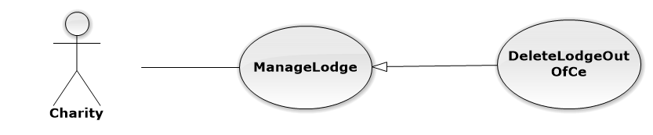

|  |  |  |  |  |
| --- | --- | --- | --- | --- |
| **USE CASE-UC044 SPECIFICATION** | | | | |
| **Use-case No.** | UC044 | **Use-case Version** | | 1.1 |
| **Use-case Name** | DeleteLodgeOutOfCharityExam | | | |
| **Author** | Nguyễn Vinh Hiển | | | |
| **Date** | 11/5/2014 | **Priority** | Normal | |
| **Actor:** Charity  **Summary:** This use case is about how Charity delete the lodge of charity exam  **Goal:** Delete the lodge out of the system  **Triggers:** Charity click “Xóa” icon at the same row of the lodge.  **Preconditions: _**User login into charity’s role  _ The lodge of charity exam that charity want to delete mustn’t used before  **Post Conditions:**  *On success:* The lodge is delete successfully and fade out the table  *On failure:* Display error message  **Main Success Scenario:**   |  |  |  | | --- | --- | --- | |  | **User Action** | **System Response** | | 1. | User click “Xóa” icon at the same row of the lodge |  | | 2. |  | System display popup to confirm | | 3. | User click “Xác nhận” to delete |  | | 4. |  | The lodge is faded out of the table and no longer exist at the system of charity exam |   **Alternative Scenario:** N/A  **Exceptions:** N/A  **Relationships:** ManageLodge  **Business Rules:** Delete lodge when this lodge not assign for any candidate | | | | |

#### (Charity) Manage Lodge – View Lodge Detail



|  |  |  |  |  |
| --- | --- | --- | --- | --- |
| **USE CASE-UC045 SPECIFICATION** | | | | |
| **Use-case No.** | UC045 | **Use-case Version** | | 1.1 |
| **Use-case Name** | ViewLodgeDetail | | | |
| **Author** | Nguyễn Vinh Hiển | | | |
| **Date** | 11/5/2014 | **Priority** | Normal | |
| **Actor:** Charity  **Summary:** This use case is about how charity view lodge of charity exam  **Goal: L**odge of charity is displayed successfully and exactly on the table  **Triggers:** Chaity click on “Xem chi tiết” icon  **Preconditions:** User login into charity’s role  **Post Conditions:**  *On success:* The detail of lodge with room’s table is displayed successfully  *On failure:* The error message is displayed  **Main Success Scenario:**   |  |  |  | | --- | --- | --- | |  | **User Action** | **System Response** | | 1. | User click on “Xem chi tiết” icon |  | | 2. |  | _ The “Chi tiết nhà ở “ page is displayed with detail and room’s table successfully |   **Alternative Scenario: N/A**  **Exceptions: N/A**  **Relationships:** ManageLodge  **Business Rules:** View Lodge Detail when this lodge exist on system | | | | |

#### (Charity) Manual assign candidate to room

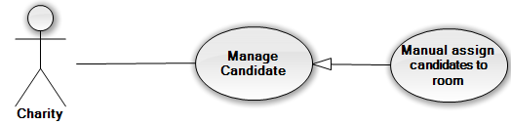

|  |  |  |  |  |
| --- | --- | --- | --- | --- |
| **USE CASE-UC046 SPECIFICATION** | | | | |
| **Use-case No.** | UC046 | **Use-case Version** | | 1.1 |
| **Use-case Name** | Manual assign candidates to room | | | |
| **Author** | Trần Nguyễn Kim Vinh | | | |
| **Date** | 12/5/2014 | **Priority** | High | |
| **Actor:**  Charity  **Summary:**  This use case allow charity can assign candidates registered at a lodge to room in that lodge.  **Goal:** Assign candidates to room.  **Triggers:**  In assign room page of charity, user click “Sắp tay”.  **Preconditions:** The user is already logged in with an account in charity role.  List candidates not assign to any room.  **Post Conditions:**  *On success:* Candidate will be assigned to room in registered lodge.  *On failure:* An error message is displayed. The content of the error message will be specified in the Exception Scenario section based on the type of failure.  **Main Success Scenario:**   |  |  |  | | --- | --- | --- | | **Step** | **User Action** | **System Response** | | 1. | Click button “Sắp tay” at assign room page. |  | | 2. |  | Displays a form that divided in to three sections. The first section includes the list of candidates not assign in any room. The second and third section include the list room that candidate will be assign in. | | 3. | Choose lodge at combo box. |  | | 4. |  | Display list candidates is not assign to room of that lodge in selected box “Thí sinh chưa xếp phòng”. | | 5. | Choose room in list room of lodge. |  | | 6. |  | Display list candidates was assigned in that room. If room have no candidates, nothing display in list box of that room. | | 7. | Choose one or more candidate on list candidate not assign in that lodge.  Click “Chuyển phòng” |  | | 8. |  | Move selected candidates to room was selected | | 9. | Click “Lưu lại” |  | | 10. |  | Candidate selected is assign to room selected and save into database, redirect to assign room page. | |  |  |  |   **Alternative Scenario:**   |  |  |  |  | | --- | --- | --- | --- | | **No** | **Step** | **User Action** | **System Response** | | 1. | 1. | Choose room in of lodge on top. |  | | 2. |  | Display list candidates was assigned in that room. If room have no candidates, nothing display in list box of that room. | | 3. | Choose room in of lodge on bottom. |  | | 4. |  | Display list candidates was assigned in that room. If room have no candidates, nothing display in list box of that room. | | 5. | Choose one or more candidate on list candidate not assign in that lodge.  Click “Chuyển phòng” button |  | | 6. |  | Move selected candidates to room was selected | |  | 7. | Click “Lưu lại” | Candidate selected is assign to room selected and save into database, redirect to assign room page. | |  | 8. |  |  |   **Exceptions:**   |  |  |  | | --- | --- | --- | | **No** | **User Action** | **System Response** | | 1. | Choose a list selected candidates are larger than quantity of room  Click ‘Chuyển phòng’ button | Show popup message “Không thể sắp thí sinh vượt quá giớ hạn của phòng”. |   **Relationships:**  Assign to room  **Business Rules:** After charity auto assign to car or volunteer. | | | | |

#### (Charity) Manual Assign Candidate to car or volunteer

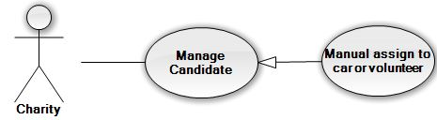

|  |  |  |  |  |
| --- | --- | --- | --- | --- |
| **USE CASE-UC047 SPECIFICATION** | | | | |
| **Use-case No.** | UC047 | **Use-case Version** | | 1.1 |
| **Use-case Name** | Manual assign candidates to car or volunteer | | | |
| **Author** | Trần Nguyễn Kim Vinh | | | |
| **Date** | 12/5/2014 | **Priority** | High | |
| **Actor:**  Charity  **Summary:**  This use case allow charity can assign candidates registered at a lodge to car of charity exam or volunteer.  **Goal:** Assign candidates to room.  **Triggers:**  In assign car page of charity, user click “Sắp tay”.  **Preconditions:** The user is already logged in with an account in charity role.  List candidates not assign to any car or volunteer.  **Post Conditions:**  *On success:* Candidate will be assigned to car of registered lodge or volunteer.  *On failure:* An error message is displayed. The content of the error message will be specified in the Exception Scenario section based on the type of failure.  **Main Success Scenario:**   |  |  |  | | --- | --- | --- | | **Step** | **User Action** | **System Response** | | 1. | Click button “Sắp tay” at assign car page. |  | | 2. |  | Displays a form that divided in to three sections. The first section includes the list of candidates not assign in any car. The second and third section include the list car or volunteer that candidate will be assign in. | | 3. | Choose lodge at combo box. |  | | 4. |  | Display list candidates is not assign to car of that lodge in select box “Thí sinh chưa xếp xe”. | | 5. | Choose car in list car of charity exam. |  | | 6. |  | Display list candidates was assigned in that room. If room have no candidates, nothing display in list box of that room. | | 7. | Choose one or more candidate on list candidate not assign in that lodge.  Click “Xếp xe” |  | | 8. |  | Move selected candidates to car was selected | | 9. | Click “Lưu lại” |  | | 10. |  | Candidate selected is assign to car selected and save into database, redirect to assign car page. | |  |  |  |   **Alternative Scenario:**   |  |  |  | | --- | --- | --- | | **Step** | **User Action** | **System Response** | | 1. | Click button “Sắp tay” at assign car page. |  | | 2. |  | Displays a form that divided in to three sections. The first section includes the list of candidates not assign in any car. The second and third section include the list car or volunteer that candidate will be assign in. | | 3. | Choose lodge at combo box. |  | | 4. |  | Display list candidates is not assign to car of that lodge in select box “Thí sinh chưa xếp xe”. | | 5. | Choose volunteer in list volunteer of charity exam. |  | | 6. |  | Display candidate was assigned to this volunteer. If volunteer wasn’t assign a candidate, nothing display in list box of this volunteer. | | 7. | Choose one candidate on list candidates not assign in that lodge.  Click “Xếp xe” |  | | 8. |  | Move selected candidates to volunteer was selected | | 9. | Click “Lưu lại” |  | | 10. |  | Candidate selected is assign to volunteer selected and save into database, redirect to assign car page. | |  |  |  |   **Exceptions:**   |  |  |  | | --- | --- | --- | | **No** | **User Action** | **System Response** | | 1. | Choose a list candidates are larger than quantity of car  Click ‘Chuyển phòng’ button | Show popup message “Không thể sắp thí sinh vượt quá giớ hạn của phòng”. | | 2. | Choose a volunteer  Choose more candidates in list candidates not assign.  Click ‘Chuyển phòng’ button | Show popup message “Tình nguyện viên chỉ có thể chở 1 người”. |   **Relationships:**  Assign to car  **Business Rules:** After charity auto assign to car or volunteer. | | | | |

#### (Charity) Manage Fund – Approve Fund

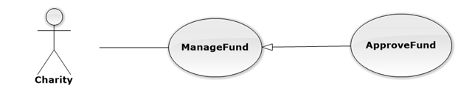

|  |  |  |  |  |
| --- | --- | --- | --- | --- |
| **USE CASE-UC048 SPECIFICATION** | | | | |
| **Use-case No.** | UC048 | **Use-case Version** | | 1.1 |
| **Use-case Name** | ApproveFund | | | |
| **Author** | Trần Nguyễn Kim Vinh | | | |
| **Date** | 11/5/2014 | **Priority** | Normal | |
| **Actor:** Charity  **Summary:** This use case is about how Charity approve the fund that was sponsored by the Sponsor  **Goal:** Approve the fund successful  **Triggers:** Charity click “Xác nhận” icon at the same row of the fund.  **Preconditions:** User login into charity’s role  **Post Conditions:**  *On success:* The Fund is displayed on table, status of fund is ” Đã duyệt”  *On failure:* Display error message on page  **Main Success Scenario:**   |  |  |  | | --- | --- | --- | |  | **User Action** | **System Response** | | 1. | User click “Xác nhận” icon at the same row of the fund |  | | 2. |  | The status of the fund will turn form “Chưa duyệt “ to “ Đã duyệt |   **Alternative Scenario:** N/A  **Exceptions:** N/A  **Relationships:** Manage fund | | | | |

#### (Charity) Manage Volunteer – Approve Volunteer

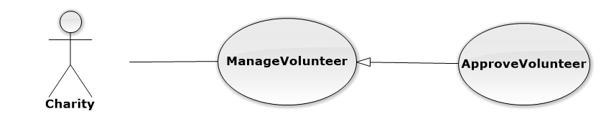

|  |  |  |  |  |
| --- | --- | --- | --- | --- |
| **USE CASE-UC050 SPECIFICATION** | | | | |
| **Use-case No.** | UC050 | **Use-case Version** | | 1.1 |
| **Use-case Name** | ApproveVolunteer | | | |
| **Author** | Trần Nguyễn Kim Vinh | | | |
| **Date** | 11/5/2014 | **Priority** | Normal | |
| **Actor:** Charity  **Summary:** This use case is about how Charity approve the volunteer  **Goal:** Approve the volunteer successful  **Triggers:** Charity click “Xác nhận” icon at the same row of the volunteer.  **Preconditions:** User login into charity’s role  **Post Conditions:**  *On success:* The Volunteer is displayed on table, status of volunteer is ” Đã duyệt”  *On failure:* Error message is displayed  **Main Success Scenario:**   |  |  |  | | --- | --- | --- | |  | **User Action** | **System Response** | | 1. | User click “Xác nhận” icon at the same row of the volunteer |  | | 2. |  | The status of the volunteer will turn form “Chưa duyệt “ to “ Đã duyệt |   **Alternative Scenario:** N/A  **Exceptions:** N/A  **Relationships:** Manage volunteer  **Business Rules:** voluntter sends request join in charity exam to chairty. | | | | |

#### (Charity) Manage Volunteer – Denie Volunteer

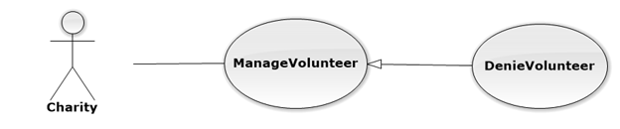

|  |  |  |  |  |
| --- | --- | --- | --- | --- |
| **USE CASE-UC051 SPECIFICATION** | | | | |
| **Use-case No.** | UC051 | **Use-case Version** | | 1.1 |
| **Use-case Name** | DeniedVolunteer | | | |
| **Author** | Trần Nguyễn Kim Vinh | | | |
| **Date** | 11/5/2014 | **Priority** | Normal | |
| **Actor:** Charity  **Summary:** This use case is about how Charity deny the volunteer that was sponsored by the Sponsor  **Goal:** Deny the volunteer successful so the volunteer will no longer exist on the table  **Triggers:** Charity click “Từ chối” icon at the same row of the volunteer.  **Preconditions:** User login into charity’s role  **Post Conditions:**  *On success:* The Volunteer is denied successfully and fade out the table  *On failure:* Error message is displayed  **Main Success Scenario:**   |  |  |  | | --- | --- | --- | |  | **User Action** | **System Response** | | 1. | User click “Từ chối” icon at the same row of the volunteer |  | | 2. |  | System display popup to confirm | | 3. | User click “Xác nhận” to deny |  | | 4. |  | The volunteer is faded out of the table |   **Alternative Scenario:** N/A  **Exceptions:** N/A  **Relationships:** Manage volunteer  **Business Rules:** To denie volunteer must have this voluntter exist on system | | | | |

#### (Charity) Manage Volunteer – Remove Volunteer



|  |  |  |  |  |
| --- | --- | --- | --- | --- |
| **USE CASE-UC052 SPECIFICATION** | | | | |
| **Use-case No.** | UC052 | **Use-case Version** | | 1.1 |
| **Use-case Name** | RemoveVolunteer | | | |
| **Author** | Trần Nguyễn Kim Vinh | | | |
| **Date** | 11/5/2014 | **Priority** | Normal | |
| **Actor:** Charity  **Summary:** This use case is about how Charity remove the volunteer that was sponsored by the sponsor and be approved by the charity  **Goal:** Remove the volunteer out of the system of charity exam  **Triggers:** Charity click “Xóa” icon at the same row of the volunteer that was sponsored.  **Preconditions: _**User login into charity’s role  _ The volunteer charity want to remove mustn’t used before  **Post Conditions:**  *On success:* The volunteer is remove successfully and fade out the table  *On failure:* Error message is displayed  **Main Success Scenario:**   |  |  |  | | --- | --- | --- | |  | **User Action** | **System Response** | | 1. | User click “Xóa” icon at the same row of the volunteer that was sponsored |  | | 2. |  | System display popup up to confirm | | 3. | User click “Xác nhận” to remove |  | | 4. |  | The volunteer is faded out of the table and no longer exist at the system of charity exam |   **Alternative Scenario:** N/A  **Exceptions:** N/A  **Relationships:** Manage volunteer  **Business Rules:** To remove volunteer must have this voluntter exist on system | | | | |

#### (Charity) Manage Candidate – View Candiate



|  |  |  |  |  |
| --- | --- | --- | --- | --- |
| **USE CASE-UC053 SPECIFICATION** | | | | |
| **Use-case No.** | UC053 | **Use-case Version** | | 1.1 |
| **Use-case Name** | View Candidate | | | |
| **Author** | Lê Nguyễn Hữu Trí | | | |
| **Date** | 12/5/2014 | **Priority** | Normal | |
| **Actor:** Charity  **Summary:**  This use case is about how to view candidate  **Goal:** User can view cadidate  **Triggers:**  In “Details charity exam” page, user clicks “Quản lý thí sinh”.  **Preconditions:** User logged in with Charity role  **Post Conditions:**  *On success:* User can view charity sucessfull  *On failure:* An error message is displayed. The content of the error message will be specified in the Exception Scenario section based on the type of failure.  **Main Success Scenario:**   |  |  |  | | --- | --- | --- | | **Step** | **User Action** | **System Response** | | 1. | In the “Details charity exam” page, user clicks “ Quản lý thí sinh” |  | | 2. |  | System will redirect to”manage candidate” page with list of candidate  Sắp xếp phòng : button  Sắp xếp xe : button |   **Alternative Scenario:**  User can click “ Quản lý thí sinh” in the “ CharitySidebar” on the left  **Exceptions: N/A**  **Relationships:** Manage candidate  **Business Rules: N/A** | | | | |

#### (Charity) View Statistics

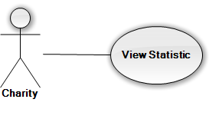

|  |  |  |  |  |
| --- | --- | --- | --- | --- |
| **USE CASE-UC054 SPECIFICATION** | | | | |
| **Use-case No.** | UC054 | **Use-case Version** | | 1.1 |
| **Use-case Name** | View Statistic | | | |
| **Author** | Nguyễn Đình Tuấn | | | |
| **Date** | 12/5/2014 | **Priority** | Normal | |
| **Actor:** Charity  **Summary:**  This use case is about how to view statistic resource  **Goal:** User can view statistic resource.  **Triggers:**  In “Home” page, user clicks “Xem Thống Kê”.  **Preconditions:** User logged in with Charity role  **Post Conditions:**  *On success:* User can view statistic sucessfull  *On failure:* An error message is displayed. The content of the error message will be specified in the Exception Scenario section based on the type of failure.  **Main Success Scenario:**   |  |  |  | | --- | --- | --- | | **Step** | **User Action** | **System Response** | | 1. | In the Home page of Charity, user clicks “ Xem Thống Kê” |  | | 2. |  | System will redirect to”View Statistic” page | | 3. | User choose (Kì thi) want to see and click “Xem thống Kê” |  | | 4. |  | System will show with information of car, lodge, fund and Statistic |   **Alternative Scenario:**  User can click “ Xem Thống Kê” in the “ CharitySidebar” on the left  **Exceptions: N/A**  **Relationships:** Login  **Business Rules:** View Statistic when have data. | | | | |

#### (Charity) Manage Candiate – Assign to room

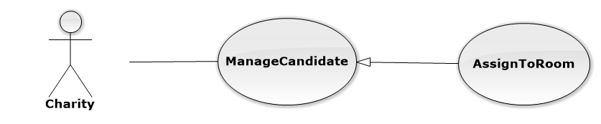

|  |  |  |  |  |
| --- | --- | --- | --- | --- |
| **USE CASE-UC055 SPECIFICATION** | | | | |
| **Use-case No.** | UC055 | **Use-case Version** | | 1.1 |
| **Use-case Name** | AssignToRoom | | | |
| **Author** | Nguyễn Duy Khoa | | | |
| **Date** | 12/5/2014 | **Priority** | Normal | |
| **Actor:** Charity  **Summary:**  This use case is about how to assign room  **Goal:** User can assign room for candidate.  **Triggers:**  In “View Cadidate” page, user clicks “Sắp xếp phòng”icon.  **Preconditions:** User logged in with Charity role  **Post Conditions:**  *On success:* User can assign room for candidate sucessfull  *On failure:* An error message is displayed. The content of the error message will be specified in the Exception Scenario section based on the type of failure.  **Main Success Scenario:**   |  |  |  | | --- | --- | --- | | **Step** | **User Action** | **System Response** | | 1. | In the View Candidate page , user clicks “ Sắp xếp phòng” |  | | 2. |  | System will redirect to”Assign room” page with information of candidate | | 3. | User click “Sắp xếp phòng” |  | | 4. |  | System will automatic assign room for candidate |   **Alternative Scenario: N/A**  **Exceptions: N/A**  **Relationships:**  Manage candidate  **Business Rules:** Have any room in the system to assign car for candidate successfully. | | | | |

#### (Charity) Manage Candidate – Assign To Car

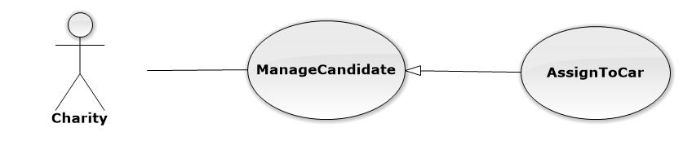

|  |  |  |  |  |
| --- | --- | --- | --- | --- |
| **USE CASE-UC056 SPECIFICATION** | | | | |
| **Use-case No.** | UC056 | **Use-case Version** | | 1.1 |
| **Use-case Name** | AssignToCar | | | |
| **Author** | Nguyễn Duy Khoa | | | |
| **Date** | 12/5/2014 | **Priority** | Normal | |
| **Actor:** Charity  **Summary:**  This use case is about how to assign vehicle  **Goal:** User can assign car for candidate.  **Triggers:**  In “View Candidate” page, user clicks “Sắp xếp xe”icon.  **Preconditions:** User logged in with Charity role  **Post Conditions:**  *On success:* User can assign car for candidate successfully  *On failure:* An error message is displayed. The content of the error message will be specified in the Exception Scenario section based on the type of failure.  **Main Success Scenario:**   |  |  |  | | --- | --- | --- | | **Step** | **User Action** | **System Response** | | 1. | In the View Candidate page , user clicks “ Sắp xếp xe” |  | | 2. |  | System will redirect to”Assign To Car” page with information of candidate | | 3. | User click “Sắp xếp xe” |  | | 4. |  | System will automatic assign vehicle for candidate |   **Alternative Scenario: N/A**  **Exceptions: N/A**  **Relationships:**  Manage candidate  **Business Rules:** Have the cars in the system to assign car for candidate successfully. | | | | | |

#### (Sponsor) Manage Sponsor’s Car

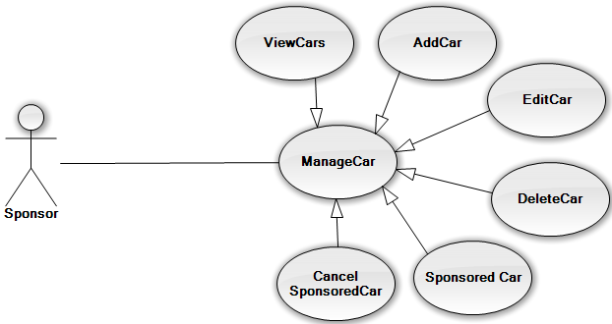

#### (Sponsor) Manage Sponsor’s Car – Add New Car

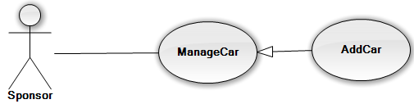

|  |  |  |  |  |
| --- | --- | --- | --- | --- |
| **USE CASE-UC058 SPECIFICATION** | | | | |
| **Use-case No.** | UC058 | **Use-case Version** | | 1.1 |
| **Use-case Name** | Add new car | | | |
| **Author** | Nguyễn Đình Tuấn | | | |
| **Date** | 12/5/2014 | **Priority** | Normal | |
| **Actor:** Sponsor  **Summary:**  This use case is about how to add new car  **Goal:** User can add new car  **Triggers:**  In “Manage Car” page, user clicks “Tạo mới ” icon.  **Preconditions:** The user is already logged in with an account in sponsor role. The Manage Car is being display.  **Post Conditions:**  *On success:* A new car is added into database.  *On failure:* An error message is displayed. The content of the error message will be specified in the Exception Scenario section based on the type of failure.  **Main Success Scenario:**   |  |  |  | | --- | --- | --- | | **Step** | **User Action** | **System Response** | | 1. | In the “Manage Car” page, user clicks “Tạo mới” icon. |  | | 2. |  | Displays a form that has the following items:   * “Biển số Xe” (textbox; required; max length 50) * “Tổng số chỗ ngồi” (textbox; required,) * “Tên tài xế” (textbox; required, max length 50 ) * “Số điện thoại tài xế” (textbox; required, max length 50 ) | | 3. | Fills out the form with relevant values. |  | | 4. | Clicks the button “Tạo”. |  | | 5. |  | Saves the new car information to the database, redirects the user to the manage car page. |   **Alternative Scenario: N/A**  **Exceptions:**   |  |  |  | | --- | --- | --- | | **No** | **Use Action** | **System Response** | | 1. | Input “Biển số xe” same with existed car.  Click “Tạo” button. | Shows error message at “Biển Số Xe”: “Xe này đã được tạo, Vui lòng tạo xe khác” | | 2. | Input “Biển số xe” is empty.  Click “Tạo” button. | Shows error message at “Biển Số Xe”: “Vui lòng nhập biển số xe”. | | 3. | Input “Số Chỗ Ngồi” is empty.  Click “Tạo” button. | Shows error message at “Số chỗ ngồi”: “Vui lòng nhập số chỗ ngồi”. |   **Relationships:**  Manage car  **Business Rules:** Cannot add new car have numberplate as same as the car exist in database | | | | |

#### (Sponsor) Manage Sponsor’s Car – Edit Car

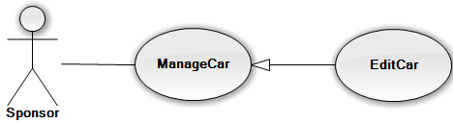

|  |  |  |  |  |
| --- | --- | --- | --- | --- |
| **USE CASE-UC059 SPECIFICATION** | | | | |
| **Use-case No.** | UC059 | **Use-case Version** | | 1.1 |
| **Use-case Name** | Edit car | | | |
| **Author** | Nguyễn Đình Tuấn | | | |
| **Date** | 12/5/2014 | **Priority** | Normal | |
| **Actor:** Sponsor  **Summary:**  This use case allows sponsor can edit existing car information.  **Goal:** Edited car information exist in database.  **Triggers:**  In “Manage Car” page, user clicks “Chỉnh sửa” icon of that car.  **Preconditions:** The user is already logged in with an account in sponsor role. The manage car is being display.  **Post Conditions:**  *On success:* The selected car is updated in database. The user redirected to manage car page.  *On failure:* An error message is displayed. The content of the error message will be specified in the Exception Scenario section based on the type of failure.  **Main Success Scenario:**   |  |  |  | | --- | --- | --- | | **Step** | **User Action** | **System Response** | | 1. | In the “Manage Car” page, user clicks “Chỉnh sửa” icon of that car |  | | 2. |  | System will redirect to”Edit Car” page.  Displays all information of the selected car and filled in form that has the following items:   * “Biển số Xe” (textbox; required; max length 50) * “Tổng số chỗ ngồi” (textbox; required,) * “Tên tài xế” (textbox; required, max length 50 ) * “Số điện thoại tài xế” (textbox; required, max length 50 ) | | 3. | Changes the existing information with relevant values. |  | | 4. | Clicks the button “Lưu”. |  | | 5. |  | Saves the car information to the database, redirects the user to the manage car page. |   **Alternative Scenario: N/A**  **Exceptions:**   |  |  |  | | --- | --- | --- | | **No** | **Use Action** | **System Response** | | 1. | Input “Biển số xe” same with existed car.  Click “Tạo” button. | Shows error message at “Biển Số Xe”: “Xe này đã được tạo, Vui lòng tạo xe khác” | | 2. | Input “Biển số xe” is empty.  Click “Tạo” button. | Shows error message at “Biển Số Xe”: “Vui lòng nhập biển số xe”. | | 3. | Input “Số Chỗ Ngồi” is empty.  Click “Tạo” button. | Shows error message at “Số chỗ ngồi”: “Vui lòng nhập số chỗ ngồi”. |   **Relationships:** Manage Car  **Business Rules:** Sponsor just edit car when charity not confirm for exam. | | | | |

#### (Sponsor) Manage Sponsor’s Car – Delete Car

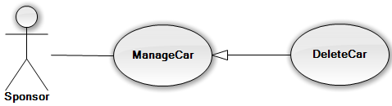

|  |  |  |  |  |
| --- | --- | --- | --- | --- |
| **USE CASE-UC060 SPECIFICATION** | | | | |
| **Use-case No.** | UC060 | **Use-case Version** | | 1.1 |
| **Use-case Name** | Delete car | | | |
| **Author** | Nguyễn Đình Tuấn | | | |
| **Date** | 12/5/2014 | **Priority** | Low | |
| **Actor:** Sponsor  **Summary:**  This use case allows sponsor can delete a selected car.  **Goal:** Deleted selected car from database.  **Triggers:**  In manage post page of sponsor, user click button “Xóa Xe” at car user want delete.  **Preconditions:** The user is already logged in with an account in sponsor role. The manage car is being display.  **Post Conditions:**  *On success:* Car is deleted from database.  *On failure:* An error message is displayed. The content of the error message will be specified in the Exception Scenario section based on the type of failure.  **Main Success Scenario:**   |  |  |  | | --- | --- | --- | | **Step** | **User Action** | **System Response** | | 1. | In the “Manage Car” page.  Click button “Xóa xe” on the row that contains the car to be deleted. |  | | 2. |  | Shows a popup to ask the user to confirm the action. | | 3. | Click “Xác Nhận” to continue to delete the car. |  | | 4. |  | Marks the selected car as deleted in the database and redirect to manage car page |   **Alternative Scenario:**   |  |  |  |  | | --- | --- | --- | --- | | **No** | **Step** | **User Action** | **System Response** | | 1. | 1. | Clicks on the button “Hủy bỏ”. |  | | 2. |  | Hides the popup message. |   **Exceptions:** When status of “Trạng thái” is “Đã duyệt” or “Chờ Xác Nhận”, the icon “ Xóa xe” will be hidden.  **Relationships:** Manage Car  **Business Rules**: Sponsor just delete car when charity not confirm for exam. | | | | |

#### (Sponsor) Manage Sponsor’s Car – Sponsored Car

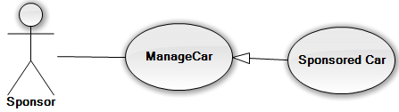

|  |  |  |  |  |
| --- | --- | --- | --- | --- |
| **USE CASE-UC061 SPECIFICATION** | | | | |
| **Use-case No.** | UC061 | **Use-case Version** | | 1.1 |
| **Use-case Name** | Sponsored Car | | | |
| **Author** | Nguyễn Đình Tuấn | | | |
| **Date** | 12/5/2014 | **Priority** | Normal | |
| **Actor:** Sponsor  **Summary:**  This use case allows sponsor can sponsored car.  **Goal:** Sponsored car to charity.  **Triggers:**  In manage post page of sponsor, user click button “Tài trợ” at car user want sponsored.  **Preconditions:** The user is already logged in with an account in sponsor role. The manage car is being display.  **Post Conditions:**  *On success:* Car is sponsored car successful to charity.  *On failure:* An error message is displayed. The content of the error message will be specified in the Exception Scenario section based on the type of failure.  **Main Success Scenario:**   |  |  |  | | --- | --- | --- | | **Step** | **User Action** | **System Response** | | 1. | In the “Manage Car” page.  Click button “Tài trợ” on the row that contains the ar to be sponsored. |  | | 2. |  | System will redirect to”Sponsored Car” page.  Displays a form that has the following items:   * “Kì Thi” (selecttbox; required) * “Tài trợ” (selectbox; required)   Displays all information of this car | | 3. | Fills out the form with relevant alues. |  | | 4. | Clicks the button “Tài trợ”. |  | | 5. |  | Saves the car information to the database, redirects the user to the manage car page. |   **Alternative Scenario: N/A**  **Exceptions:** When status of “Trạng thái” is “Đã duyệt”, the icon “ Tài Trợ” will be hidden.   |  |  |  | | --- | --- | --- | | **No** | **Use Action** | **System Response** | | 1. | Input “Biển số xe” same with existed car.  Click “Tạo” button. | Shows error message at “Biển Số Xe”: “Xe này đã được tạo, Vui lòng tạo xe khác” | | 2. | Input “Kì Thi” is not select.  Click “Tạo” button. | Shows error message at “Kì Thi”: “Vui lòng chọn kì thi”. | | 3. | Input “Tài trợ cho” is not select.  Click “Tạo” button. | Shows error message at “Tài trợ cho”: “Vui lòng chọn tài trợ cho”. |   **Relationships:** Manage car  **Business Rules:** Sponsored Car when this car not use for any charity exam. | | | | |

#### (Sponsor) Manage Sponsor’s Car – Sponsored All Car

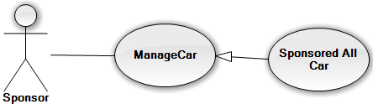

|  |  |  |  |  |
| --- | --- | --- | --- | --- |
| **USE CASE-UC062 SPECIFICATION** | | | | |
| **Use-case No.** | UC062 | **Use-case Version** | | 1.1 |
| **Use-case Name** | Sponsored All Car | | | |
| **Author** | Nguyễn Đình Tuấn | | | |
| **Date** | 12/5/2014 | **Priority** | Normal | |
| **Actor:** Sponsor  **Summary:**  This use case allows sponsor can sponsored all car.  **Goal:** Sponsored all car to charity.  **Triggers:**  In manage car page of sponsor, user click button “Tài Trợ Nhiều xe” .  **Preconditions:** The user is already logged in with an account in sponsor role. The manage car is being display.  **Post Conditions:**  *On success:* Lodge is sponsored many car successful to charity.  *On failure:* An error message is displayed. The content of the error message will be specified in the Exception Scenario section based on the type of failure.  **Main Success Scenario:**   |  |  |  | | --- | --- | --- | | **Step** | **User Action** | **System Response** | | 1. | In the “Manage Car” page.  Click button “Tài trợ nhiều xe” on the row that contains the car to be sponsored. |  | | 2. |  | System will redirect to”Sponsored All Car” page.  Displays a form that has the following items:   * “Kì Thi” (selecttbox; required) * “Tài trợ” (selectbox; required)   Displays all information of all car not sponsored. | | 3. | Fills out the form with relevant values.  Check on check box of car want to sponsored car. |  | | 4. | Clicks the button “Tài trợ”. |  | | 5. |  | Saves the car information to the database, redirects the user to the manage car page. |   **Alternative Scenario: N/A**  **Exceptions:** When status of “Trạng thái” is “Đã duyệt” or “Đang Xác Nhận”, the icon “Tài Trợ” will be hidden.   |  |  |  | | --- | --- | --- | | **No** | **Use Action** | **System Response** | | 1. | Input “Kì Thi” is not select.  Click “Tạo” button. | Shows error message at “Kì Thi”: “Vui lòng chọn kì thi”. | | 2. | Input “Tài trợ cho” is not select.  Click “Tạo” button. | Shows error message at “Tài trợ cho”: “Vui lòng chọn tài trợ cho”. | | 3. | User don’t check any car | Popup will show ”hãy chọn xe để tài trợ”. |   **Relationships:** Managecar  **Business Rules:** The button” Sponsored All Car” appears when more than two cars in resource exist. | | | | |

#### (Sponsor) Manage Sponsor’s Car – Cancel Sponsored Car

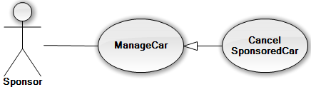

|  |  |  |  |  |
| --- | --- | --- | --- | --- |
| **USE CASE-UC063 SPECIFICATION** | | | | |
| **Use-case No.** | UC063 | **Use-case Version** | | 1.1 |
| **Use-case Name** | Cancel sponsored car | | | |
| **Author** | Nguyễn Đình Tuấn | | | |
| **Date** | 12/5/2014 | **Priority** | High | |
| **Actor:**  Sponsor  **Summary:**  This use case allows sponsor can cancel sponsored car.  **Goal:** Sponsor can cancel sponsored car  **Triggers:**  In “Manage Car” page, user clicks “Hủy tài trợ” icon of that car.  **Preconditions:** The user is already logged in with an account in sponsor role.  **Post Conditions:**  *On success:* Car is cancel sponsored car successful  *On failure:* An error message is displayed. The content of the error message will be specified in the Exception Scenario section based on the type of failure.  **Main Success Scenario:**   |  |  |  | | --- | --- | --- | | **Step** | **User Action** | **System Response** | | 1. | In the “Manage Car” page.  Click button “Hủy Tài trợ” on the row that contains the ca to be cancel sponsored car. |  | | 2. |  | Shows a popup to ask the user to confirm the action. | | 3. | Click “Xác Nhận” to continue to cancel sponsored the car. |  | | 4. |  | Marks the selected car as cancel sponsored car in the database and redirect to manage car page |   **Alternative Scenario:**   |  |  |  | | --- | --- | --- | | **Step** | **User Action** | **System Response** | | 1. | Clicks on the button “Hủy bỏ”. |  | | 2. |  | Hides the popup message. |   **Exceptions :** When status of “Trạng thái” is “Đã duyệt”, the icon “ Tài Trợ” will be hidden.  **Relationships:** Manager car  **Business Rules:** Cancel sponsored car when charity not confirm this car. | | | | |

#### (Sponsor) Manage Sponsor’s Funds

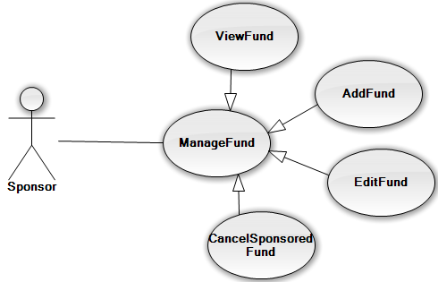

#### (Sponsor) Manage Sponsor’s Fund – Add New Funds

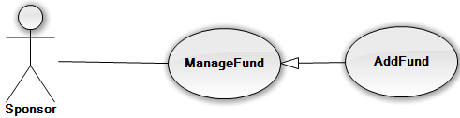

|  |  |  |  |  |
| --- | --- | --- | --- | --- |
| **USE CASE-UC065 SPECIFICATION** | | | | |
| **Use-case No.** | UC065 | **Use-case Version** | | 1.1 |
| **Use-case Name** | Add new fund | | | |
| **Author** | Nguyễn Đình Tuấn | | | |
| **Date** | 12/5/2014 | **Priority** | Normal | |
| **Actor:** Sponsor  **Summary:**  This use case is about how to add new fund  **Goal:** User can add new fund  **Triggers:**  In “Manage Fund” page, user clicks “Tài trợ tiền” icon.  **Preconditions:** The user is already logged in with an account in sponsor role. The Manage Fund is being display.  **Post Conditions:**  *On success:* A new fund is added into database.  *On failure:* An error message is displayed. The content of the error message will be specified in the Exception Scenario section based on the type of failure.  **Main Success Scenario:**   |  |  |  | | --- | --- | --- | | **Step** | **User Action** | **System Response** | | 1. | In the “Manage Fund” page, user clicks “Tài Trợ Tiền” icon. |  | | 2. |  | Displays a form that has the following items:   * “Tài trợ cho” (selectbox; required) * “Tổ Chức” (selectbox; required) * “Số tiền” (textbox; required, max length 50 ) * “Hình Thức” (selectbox, required) | | 3. | Fills out the form with relevan values. |  | | 4. | Clicks the button “Taì Trợ” |  | | 5. |  | Saves the new fund information to the database, redirects the user to the manage fund page. |   **Alternative Scenario: N/A**  **Exceptions:**   |  |  |  | | --- | --- | --- | | **No** | **Use Action** | **System Response** | | 1. | Input “Số tiền” in empty.  Click “Tạo” button. | Shows error message at “Số Tiền”: “Vui lòng nhập số tiền tài trợ” | | 2. | Input “Hình Thức” is not select.  Click “Tạo” button. | Shows error message at “Hình Thức”: “Vui lòng chọn hình thức tài trợ”. | | 3. | Input “Kì Thi” is not select.  Click “Tạo” button. | Shows error message at “Kì Thi”: “Vui lòng chọn kì thi”. | | 4. | Input “Tài trợ cho” is not select.  Click “Tạo” button. | Shows error message at “Tài trợ cho”: “Vui lòng chọn tài trợ cho”. | | 4. | User don’t check any car | Popup will show ”hãy chọn xe để tài trợ”. |   **Relationships:** Manage fund  **Business Rules:** User login with sponsored role | | | | |

#### (Sponsor) Manage Sponsor’s Fund – Edit Fund

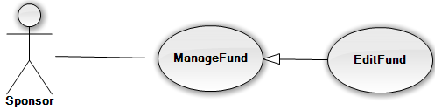

|  |  |  |  |  |
| --- | --- | --- | --- | --- |
| **USE CASE-UC066 SPECIFICATION** | | | | |
| **Use-case No.** | UC066 | **Use-case Version** | | 1.1 |
| **Use-case Name** | Edit fund | | | |
| **Author** | Nguyễn Đình Tuấn | | | |
| **Date** | 12/5/2014 | **Priority** | Normal | |
| **Actor:** Sponsor  **Summary:**  This use case allows sponsor can edit existing fund information.  **Goal:** Edited fund information exist in database.  **Triggers:**  In “Manage Fund” page, user clicks “Chỉnh sửa” icon of that fund.  **Preconditions:** The user is already logged in with an account in sponsor role. The manage fund is being display.  **Post Conditions:**  *On success:* The selected fund is updated in database. The user redirected to manage fund page.  *On failure:* An error message is displayed. The content of the error message will be specified in the Exception Scenario section based on the type of failure.  **Main Success Scenario:**   |  |  |  | | --- | --- | --- | | **Step** | **User Action** | **System Response** | | 1. | In the “Manage Fund” page, user clicks “Chỉnh sửa” icon of that fund |  | | 2. |  | System will redirect to”Edit Fund” page.  Displays all information of the selected fund and filled in form that has the following items:   * “Số tiền” (textbox; required, max length 50 ) * “Hình Thức” (selectbox, required) | | 3. | Changes the existing information with relevant values. |  | | 4. | Clicks the button “Lưu”. |  | | 5. |  | Saves the fund information to the database, redirects the user to the manage fund page. |   **Alternative Scenario: N/A**  **Exceptions:**   |  |  |  | | --- | --- | --- | | **No** | **Use Action** | **System Response** | | 1. | Input “Số tiền” in empty.  Click “Tạo” button. | Shows error message at “Số Tiền”: “Vui lòng nhập số tiền tài trợ” | | 2. | Input “Hình Thức” is not select.  Click “Tạo” button. | Shows error message at “Hình Thức”: “Vui lòng chọn hình thức tài trợ”. |   **Relationships:** Manage fund  **Business Rules:** Cancel Sponsored Fund when charity not conform this fund. | | | | |

#### (Sponsor) Manage Sponsor’s Fund – Cancel Sponsored Fund

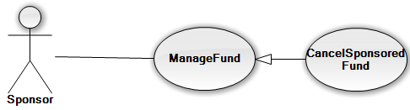

|  |  |  |  |  |
| --- | --- | --- | --- | --- |
| **USE CASE-UC067 SPECIFICATION** | | | | |
| **Use-case No.** | UC067 | **Use-case Version** | | 1.1 |
| **Use-case Name** | Cancel sponsored fund | | | |
| **Author** | Nguyễn Đình Tuấn | | | |
| **Date** | 12/5/2014 | **Priority** | High | |
| **Actor:**  Sponsor  **Summary:**  This use case allows sponsor can cancel sponsored fund.  **Goal:** Sponsor can cancel sponsored fund  **Triggers:**  In “Manage Fund” page, user clicks “Hủy tài trợ” icon of that fund.  **Preconditions:** The user is already logged in with an account in sponsor role.  **Post Conditions:**  *On success:* Fund is cancel sponsored fund successful  *On failure:* An error message is displayed. The content of the error message will be specified in the Exception Scenario section based on the type of failure.  **Main Success Scenario:**   |  |  |  | | --- | --- | --- | | **Step** | **User Action** | **System Response** | | 1. | In the “Manage Fund” page.  Click button “Hủy Tài trợ” on the row that contains the fund to be cancel sponsored fund. |  | | 2. |  | Shows a popup to ask the user to confirm the action. | | 3. | Click “Xác Nhận” to continue to cancel sponsored fund. |  | | 4. |  | Marks the selected fund as cancel sponsored fund in the database and redirect to manage fun page |   **Alternative Scenario:**   |  |  |  | | --- | --- | --- | | **Step** | **User Action** | **System Response** | | 1. | Clicks on the button “Hủy bỏ”. |  | | 2. |  | Hides the popup message. |   **Exceptions:** When status of fund is “Đã gửi”, the icon “Hủy tài trợ” will be hidden.  **Relationships:** Manage fund  **Business Rules:** Cancel Sponsored Fund when charity not conform this fund. | | | | |

#### (Sponsor) Manage Lodge

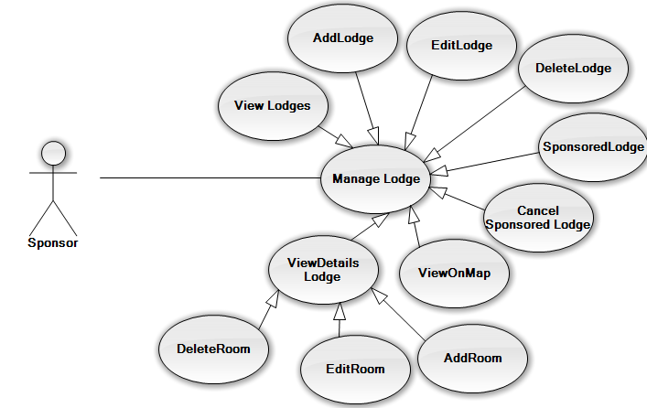

#### (Sponsor) Manage Sponsor’s Lodge – View Lodge

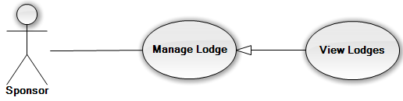

|  |  |  |  |  |
| --- | --- | --- | --- | --- |
| **USE CASE-UC068 SPECIFICATION** | | | | |
| **Use-case No.** | UC068 | **Use-case Version** | | 1.1 |
| **Use-case Name** | View lodge | | | |
| **Author** | Nguyễn Đình Tuấn | | | |
| **Date** | 12/5/2014 | **Priority** | High | |
| **Actor:** Sponsor  **Summary:**  This use case is about how to view lodge resource  **Goal:** User can view lodge resource.  **Triggers:**  In “Home Sponsor” page, user clicks “Quản lý chỗ ở”.  **Preconditions:** The user is already logged in with an account in sponsor role.  **Post Conditions:**  *On success:* Sponsor can view lodge resource successful.  *On failure:* An error message is displayed. The content of the error message will be specified in the Exception Scenario section based on the type of failure.  **Main Success Scenario:**   |  |  |  | | --- | --- | --- | | **Step** | **User Action** | **System Response** | | 1. | In the Home page of Sponsor, user clicks “ Quản lý chỗ ở” |  | | 2. |  | System will redirect to”Manage Lodge” page with information of lodgeresource |   **Alternative Scenario:** User can click “ Quản Lý Chỗ Trọ” in the “ SponsorSidebar” on the left  **Exceptions: N/A**  **Relationships: N/A** | | | | |

#### (Sponsor) Manage Sponsor’s Lodge – View Details Lodge

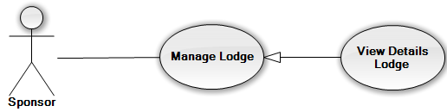

|  |  |  |  |  |
| --- | --- | --- | --- | --- |
| **USE CASE-UC069 SPECIFICATION** | | | | |
| **Use-case No.** | UC069 | **Use-case Version** | | 1.1 |
| **Use-case Name** | View details lodge | | | |
| **Author** | Trần Nguyễn Kim Vinh | | | |
| **Date** | 12/5/2014 | **Priority** | High | |
| **Actor:** Sponsor  **Summary:**  This use case is about how to view details lodge resource  **Goal:** User can view details lodge resource.  **Triggers:**  In “manage Lodge” page, user clicks “xem chi tiết” icon.  **Preconditions:** The user is already logged in with an account in sponsor role.  **Post Conditions:**  *On success:* Sponsor can view details lodge resource successful.  *On failure:* An error message is displayed. The content of the error message will be specified in the Exception Scenario section based on the type of failure.  **Main Success Scenario:**   |  |  |  | | --- | --- | --- | | **Step** | **User Action** | **System Response** | | 1. | In the “Manage Lodge” page, user clicks “ Xem Chi Tiết” |  | | 2. |  | System will redirect to”Details Lodge” page with information of lodge and room resource |   **Alternative Scenario:** N/A  **Exceptions: N/A**  **Relationships:** Manage lodge  **Business Rules:** View details lodge when lodge exit in the system. | | | | |

#### (Sponsor) Manage Sponsor’s Lodge – View Google Map

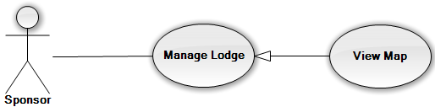

|  |  |  |  |  |
| --- | --- | --- | --- | --- |
| **USE CASE-UC070 SPECIFICATION** | | | | |
| **Use-case No.** | UC070 | **Use-case Version** | | 1.1 |
| **Use-case Name** | View map | | | |
| **Author** | Nguyễn Đình Tuấn | | | |
| **Date** | 12/5/2014 | **Priority** | High | |
| **Actor:** Sponsor  **Summary:**  This use case allows sponsor can view lodge on google map.  **Goal:** View location of lodge on google map.  **Triggers:**  In “Manage Lodge” page, user clicks “Xem bản đồ”.  **Preconditions:** The user is already logged in with an account in sponsor role.  **Post Conditions:**  *On success:* User can view lodge resource on google map successful  *On failure:* An error message is displayed. The content of the error message will be specified in the Exception Scenario section based on the type of failure.  **Main Success Scenario:**   |  |  |  | | --- | --- | --- | | **Step** | **User Action** | **System Response** | | 1. | In the “Manage Lodge” page, user clicks “ Xem bản đồ” |  | | 2. |  | Display a new window popup with Google maps of lodge. |   **Alternative Scenario: N/A**  **Relationships:** Manage lodge  **Business Rules:** View map lodge when lodge exit in the system. | | | | |

#### (Sponsor) Manage Sponsor’s Lodge – Add New Lodge

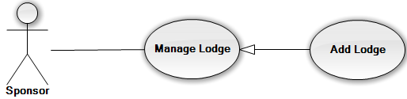

|  |  |  |  |  |
| --- | --- | --- | --- | --- |
| **USE CASE-UC071 SPECIFICATION** | | | | |
| **Use-case No.** | UC071 | **Use-case Version** | | 1.1 |
| **Use-case Name** | Add new lodge | | | |
| **Author** | Nguyễn Đình Tuấn | | | |
| **Date** | 12/5/2014 | **Priority** | Normal | |
| **Actor:** Sponsor  **Summary:**  This use case is about how to add new lodge  **Goal:** User can add new lodge  **Triggers:**  In “Manage Lodge” page, user clicks “Tạo mới” icon.  **Preconditions:** The user is already logged in with an account in sponsor role. The Manage Lodge is being display.  **Post Conditions:**  *On success:* A new lodge is added into database.  *On failure:* An error message is displayed. The content of the error message will be specified in the Exception Scenario section based on the type of failure.  **Main Success Scenario:**   |  |  |  | | --- | --- | --- | | **Step** | **User Action** | **System Response** | | 1. | In the “Manage Lodge” page, user clicks “Tạo mới” icon. |  | | 2. |  | Displays a form that has the following items:   * “Địa Chỉ” (textbox; required, length 50) | | 3. | Fills out the form with relevant values. |  | | 4. | Clicks the button “Đi tới địa chỉ này” |  | | 5. |  | Display address of lodge on google map with red marker. | | 6 | Clicks the button “Thêm”. |  | |  |  | Saves the lodge information to the database, redirects the user to the manage room. |   **Alternative Scenario: move marker**   |  |  |  | | --- | --- | --- | | **Step** | **User Action** | **System Response** | | 1. | In the “Manage Lodge” page, user clicks “Tạo mới” icon. |  | | 2. |  | Displays a form that has the following items:   * “Địa Chỉ” (textbox; required, length 50) | | 3. | Move the marker to choose the location of lodge |  | | 4. | Clicks the button “Thêm”. |  | | 5. |  | Saves the lodge information to the database, redirects the user to the manage room. |   **Exceptions:**   |  |  |  | | --- | --- | --- | | **No** | **Use Action** | **System Response** | | 1. | Input “Địa Chỉ” is empty. | Shows error message at “Địa chỉ”: “Vui lòng nhập địa chỉ nhà”. |   **Relationships:** Manage lodge  **Business Rules:** Cannot add new lodge have address as same as the car exist in database | | | | |

#### (Sponsor) Manage Sponsor’s Lodge – Edit Lodge

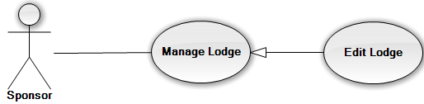

|  |  |  |  |  |
| --- | --- | --- | --- | --- |
| **USE CASE-UC072 SPECIFICATION** | | | | |
| **Use-case No.** | UC072 | **Use-case Version** | | 1.1 |
| **Use-case Name** | Edit lodge | | | |
| **Author** | Nguyễn Đình Tuấn | | | |
| **Date** | 12/5/2014 | **Priority** | Normal | |
| **Actor:** Sponsor  **Summary:**  This use case allows sponsor can edit existing lodge information.  **Goal:** Edited lodge information exist in database.  **Triggers:**  In “Manage Lodge” page, user clicks “Chỉnh sửa” icon of that lodge.  **Preconditions:** The user is already logged in with an account in sponsor role. The manage lodge is being display.  **Post Conditions:**  *On success:* The selected lodge is updated in database. The user redirected to manage lodge page.  *On failure:* An error message is displayed. The content of the error message will be specified in the Exception Scenario section based on the type of failure.  **Main Success Scenario:**   |  |  |  | | --- | --- | --- | | **Step** | **User Action** | **System Response** | | 1. | In the “Manage Lodge” page, user clicks “Chỉnh sửa địa chỉ” icon of that lodge. |  | | 2. |  | Displays a form that has the following items:   * “Địa Chỉ” (textbox; required, length 50) | | 3. | Changes the existing information with relevant values. |  | | 4. | Clicks the button “Đi tới địa chỉ này” |  | | 5. |  | Display address of lodge on google map with red marker. | | 6. | Clicks the button “Thêm”. |  | | 7. |  | Saves as the lodge information to the database, redirects the user to the manage room. |   **Alternative Scenario:**   |  |  |  | | --- | --- | --- | | **Step** | **User Action** | **System Response** | | 1. | In the “Manage Lodge” page, user clicks “Chỉnh sửa địa chỉ” icon. |  | | 2. |  | Displays a form that has the following items:   * “Địa Chỉ” (textbox; required, length 50) | | 3. | Move the marker to choose the location of lodge |  | | 4. | Clicks the button “Thêm”. |  | | 5. |  | Saves as the lodge information to the database, redirects the user to the manage room. |   **Exceptions:**   |  |  |  | | --- | --- | --- | | **No** | **Use Action** | **System Response** | | 1. | Input “Địa Chỉ” is empty. | Shows error message at “Địa chỉ”: “Vui lòng nhập địa chỉ nhà”. |   **Relationships:** manage lodge  **Business Rules:** Just edit lodge when this not charity confirm lodge. | | | | |

#### (Sponsor) Manage Sponsor’s Lodge – Sponsored Lodge

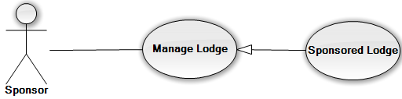

|  |  |  |  |  |
| --- | --- | --- | --- | --- |
| **USE CASE-UC074 SPECIFICATION** | | | | |
| **Use-case No.** | UC074 | **Use-case Version** | | 1.1 |
| **Use-case Name** | Sponsored Lodge | | | |
| **Author** | Nguyễn Đình Tuấn | | | |
| **Date** | 12/5/2014 | **Priority** | Normal | |
| **Actor:** Sponsor  **Summary:**  This use case allows sponsor can sponsored lodge.  **Goal:** Sponsored lodge to charity.  **Triggers:**  In manage lodge page of sponsor, user click button “Tài Trợ” at lodge user want sponsored lodge.  **Preconditions:** The user is already logged in with an account in sponsor role. The manage car is being display.  **Post Conditions:**  *On success:* Lodge is sponsored car successful to charity.  *On failure:* An error message is displayed. The content of the error message will be specified in the Exception Scenario section based on the type of failure.  **Main Success Scenario:**   |  |  |  | | --- | --- | --- | | **Step** | **User Action** | **System Response** | | 1. | In the “Manage Lodge” page.  Click button “Tài trợ” on the row that contains the lodge to be sponsored. |  | | 2. |  | System will redirect to”Sponsored Lodge” page.  Displays a form that has the following items:   * “Kì Thi” (selecttbox; required) * “Tài trợ” (selectbox; required)   Displays all information of this lodge and room | | 3. | Fills out the form with relevant values.  Check on check box of rooms want to sponsored lodge. |  | | 4. | Clicks the button “Tài trợ”. |  | | 5. |  | Saves the car information to the database, redirects the user to the manage lodge page. |   **Alternative Scenario: N/A**  **Exceptions:** When status of “Trạng thái” is “Đã duyệt” or “Đang Xác Nhận”, the icon “Tài Trợ” will be hidden.   |  |  |  | | --- | --- | --- | | **No** | **Use Action** | **System Response** | | 1. | Input “Kì Thi” is not select.  Click “Tạo” button. | Shows error message at “Kì Thi”: “Vui lòng chọn kì thi”. | | 2. | Input “Tài trợ cho” is not select.  Click “Tạo” button. | Shows error message at “Tài trợ cho”: “Vui lòng chọn tài trợ cho”. |   **Relationships:** manage lodge  **Business Rules:**sponsored lodge when this lodge have rooms. | | | | |

#### (Sponsor) Manage Sponsor’s Lodge – Cancel Sponsored Lodge

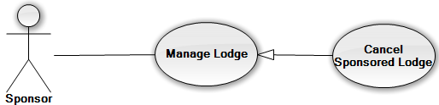

|  |  |  |  |  |
| --- | --- | --- | --- | --- |
| **USE CASE-UC075 SPECIFICATION** | | | | |
| **Use-case No.** | UC075 | **Use-case Version** | | 1.1 |
| **Use-case Name** | Cancel sponsored lodge | | | |
| **Author** | Nguyễn Đình Tuấn | | | |
| **Date** | 12/5/2014 | **Priority** | High | |
| **Actor:**  Sponsor  **Summary:**  This use case allows sponsor can cancel sponsored lodge.  **Goal:** Sponsor can cancel sponsored fund  **Triggers:**  In “Manage Lodge” page, user clicks “Hủy tài trợ” icon of that lodge.  **Preconditions:** The user is already logged in with an account in sponsor role.  **Post Conditions:**  *On success:* lodge is cancel sponsored lodge successful  *On failure:* An error message is displayed. The content of the error message will be specified in the Exception Scenario section based on the type of failure.  **Main Success Scenario:**   |  |  |  | | --- | --- | --- | | **Step** | **User Action** | **System Response** | | 1. | In the “Manage Lodge” page.  Click button “Hủy Tài trợ” on the row that contains the lodge to be cancel sponsored lodge. |  | | 2. |  | Shows a popup to ask the user to confirm the action. | | 3. | Click “Xác Nhận” to continue to cancel sponsored lodge. |  | | 4. |  | Marks the selected lodge as cancel sponsored lodge in the database and redirect to manage lodge page |   **Alternative Scenario:**   |  |  |  | | --- | --- | --- | | **Step** | **User Action** | **System Response** | | 1. | Clicks on the button “Hủy bỏ”. |  | | 2. |  | Hides the popup message. |   **Exceptions:** When status of “Trạng thái” is “Đã duyệt” or “Chưa tài trợ”, the icon “Hủy Tài Trợ” will be hidden.  **Relationships:** manage lodge  **Business Rules:**Cancel sponsored Loge when Charity not confirm this lodge | | | | |

#### (Sponsor) Manage Sponsor’s Lodge – View Room

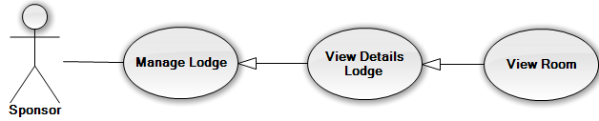

|  |  |  |  |  |
| --- | --- | --- | --- | --- |
| **USE CASE-UC076 SPECIFICATION** | | | | |
| **Use-case No.** | UC076 | **Use-case Version** | | 1.1 |
| **Use-case Name** | View room | | | |
| **Author** | Nguyễn Đình Tuấn | | | |
| **Date** | 12/5/2014 | **Priority** | High | |
| **Actor:** Sponsor  **Summary:**  This use case is about how to view room resource  **Goal:** User can view room resource.  **Triggers:**  In “Details Lodge” page, user clicks “xem danh sách phòng” icon.  **Preconditions:** The user is already logged in with an account in sponsor role.  **Post Conditions:**  *On success:* Sponsor can view room resource successful.  *On failure:* An error message is displayed. The content of the error message will be specified in the Exception Scenario section based on the type of failure.  **Main Success Scenario:**   |  |  |  | | --- | --- | --- | | **Step** | **User Action** | **System Response** | | 1. | In the”Details Lodge” page, user clicks “ Xem Danh Sách Phòng” |  | | 2. |  | System will show the table with information of lodge and room resource |   **Alternative Scenario:** N/A  **Exceptions:**   |  |  |  | | --- | --- | --- | | **No** | **Use Action** | **System Response** | | 1. | When this lodge don’t have any room created | The message will show “Bạn chưa tạo phòng! Vui lòng nhấn vào nút “tạo phòng” để tạo phòng mới “ |   **Relationships:** View Details Lodge  **Business Rules:** Sponsor canadd view room when this romm exit in lodge. | | | | |

#### (Sponsor) Manage Sponsor’s Lodge – Add New Room

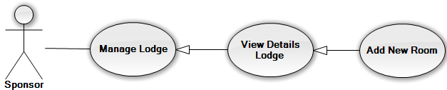

|  |  |  |  |  |
| --- | --- | --- | --- | --- |
| **USE CASE-UC077 SPECIFICATION** | | | | |
| **Use-case No.** | UC077 | **Use-case Version** | | 1.1 |
| **Use-case Name** | Add new room | | | |
| **Author** | Nguyễn Đình Tuấn | | | |
| **Date** | 12/5/2014 | **Priority** | Normal | |
| **Actor:** Sponsor  **Summary:**  This use case is about how to add new room  **Goal:** User can add new room  **Triggers:**  In “Details” page, user clicks “Tạo mới phòng” icon.  **Preconditions:** The user is already logged in with an account in sponsor role. The Manage Lodge is being display.  **Post Conditions:**  *On success:* A new room is added into database.  *On failure:* An error message is displayed. The content of the error message will be specified in the Exception Scenario section based on the type of failure.  **Main Success Scenario:**   |  |  |  | | --- | --- | --- | | **Step** | **User Action** | **System Response** | | 1. | In the “Details Lodge” page, user clicks “Tạo mới phòng” icon. |  | | 2. |  | Displays a form that has the following items:   * “Tên Phòng” (textbox; required, length 50) * “Số Chỗ” (textbox; required, length 50) | | 3. | Fills out the form with relevant values. |  | | 4. | Clicks the button “Tạo Mới” |  | | 5. |  | Saves the room information to the database, redirects the user to the details lodge. |   **Alternative Scenario: move marker**  **Exceptions:**   |  |  |  | | --- | --- | --- | | **No** | **Use Action** | **System Response** | | 1. | Input “Tên Phòng” is empty.  Click “Tạo” button. | Shows error message at “Tên Phòng”: “Vui lòng nhập tên phòng”. | | 2. | Input “Số Chỗ ” is empty.  Click “Tạo” button. | Shows error message at “Số chỗ ngồi”: “Vui lòng nhập số chỗ”. |   When inputs require information (Tên Phòng, Số Chỗ) is invalid format or missed require information, the system will notify and require input again.  **Relationships:** View Details Lodge  **Business Rules:** Sponsor canadd new room with this lodge. | | | | |

#### (Sponsor) Manage Sponsor’s Lodge – Delete Room

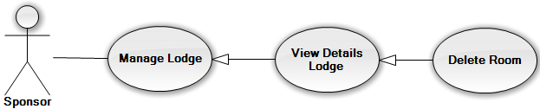

|  |  |  |  |  |
| --- | --- | --- | --- | --- |
| **USE CASE-UC079 SPECIFICATION** | | | | |
| **Use-case No.** | UC079 | **Use-case Version** | | 1.1 |
| **Use-case Name** | Delete room | | | |
| **Author** | Nguyễn Đình Tuấn | | | |
| **Date** | 12/5/2014 | **Priority** | Low | |
| **Actor:** Sponsor  **Summary:**  This use case allows sponsor can delete a selected room.  **Goal:** Deleted selected room from database.  **Triggers:**  In details lodge page of sponsor, user click button “Xóa phòng” at room user want delete.  **Preconditions:** The user is already logged in with an account in sponsor role. The manage lodge is being display.  **Post Conditions:**  *On success:* room is deleted from database.  *On failure:* An error message is displayed. The content of the error message will be specified in the Exception Scenario section based on the type of failure.  **Main Success Scenario:**   |  |  |  | | --- | --- | --- | | **Step** | **User Action** | **System Response** | | 1. | In the “Manage Room” page.  Click button “Xóa phòng” on the row that contains the room to be deleted. |  | | 2. |  | Shows a popup to ask the user to confirm the action. | | 3. | Click “Xác Nhận” to continue to delete the room. |  | | 4. |  | Marks the selected room as deleted in the database and redirect to details lodge page |   **Alternative Scenario:**   |  |  |  |  | | --- | --- | --- | --- | | **No** | **Step** | **User Action** | **System Response** | | 1. | 1. | Clicks on the button “Hủy bỏ”. |  | | 2. |  | Hides the popup message. |   **Exceptions:** When status of “Trạng thái” is “Đã duyệt” or “Chờ Xác Nhận”, the icon “ Xóa phòng” will be hidden.  **Relationships:** View details Lodge  **Business Rules:** Sponsor can delete room when this room was not use for exam. | | | | |

#### (Sponsor) View Statistics

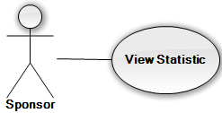

|  |  |  |  |  |
| --- | --- | --- | --- | --- |
| **USE CASE-UC080 SPECIFICATION** | | | | |
| **Use-case No.** | UC080 | **Use-case Version** | | 1.1 |
| **Use-case Name** | View Statistic | | | |
| **Author** | Nguyễn Đình Tuấn | | | |
| **Date** | 12/5/2014 | **Priority** | Normal | |
| **Actor:** Sponsor  **Summary:**  This use case is about how to view statistic resource  **Goal:** User can view statistic resource.  **Triggers:**  In “Home Sponsor” page, user clicks “Xem Thống Kê”.  **Preconditions:** User logged in with Sponsor role  **Post Conditions:**  *On success:* User can view statistic sucessfull  *On failure:* An error message is displayed. The content of the error message will be specified in the Exception Scenario section based on the type of failure.  **Main Success Scenario:**   |  |  |  | | --- | --- | --- | | **Step** | **User Action** | **System Response** | | 1. | In the Home page of Sponsor, user clicks “ Xem Thống Kê” |  | | 2. |  | System will redirect to”View Statistic” page | | 3. | User choose (Kì thi, Tổ Chức) want to see and click “Xem thống Kê” |  | | 4. |  | System will show with information of car, lodge, fund and Statistic |   **Alternative Scenario:**  User can click “ Xem Thống Kê” in the “ SponsorSidebar” on the left  **Exceptions: N/A**  **Relationships:** Login  **Business Rules:** Sponsor can view Statistic when this resource was charity confirm and used for exam. | | | | |

#### (Sponsor) Manage Sponsor’s Resource – Sponsored Resource

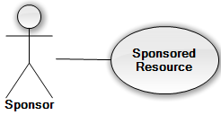

|  |  |  |  |  |
| --- | --- | --- | --- | --- |
| **USE CASE-UC081 SPECIFICATION** | | | | |
| **Use-case No.** | UC081 | **Use-case Version** | | 1.1 |
| **Use-case Name** | Sponsored resource | | | |
| **Author** | Nguyễn Đình Tuấn | | | |
| **Date** | 12/5/2014 | **Priority** | Normal | |
| **Actor:** Sponsor  **Summary:**  This use case is about how to sponsor resource  **Goal:** User can sponsored resource  **Triggers:**  In “Home Sponsor” page, user clicks “Ủng Hộ Tài Nguyên”.  **Preconditions:** The user is already logged in with an account in sponsor role.  **Post Conditions:**  *On success:* User can sponsor resource sucessfull  *On failure:* An error message is displayed. The content of the error message will be specified in the Exception Scenario section based on the type of failure.  **Main Success Scenario:**   |  |  |  | | --- | --- | --- | | **Step** | **User Action** | **System Response** | | 1. | In the Home page of Sponsor, user clicks “ Ủng Hộ Tài Nguyên” |  | | 2. |  | System will redirect to”Add Resource” page | | 3. | User choose (Kì thi, Tổ Chức) want to sponsored resource |  | |  | User choose type of resource (car, lodge, fund) |  | | 4. |  | System will show with information of car, lodge, fund correspond with user chossed | | 5. | User clicks “Tài trợ” button. |  | | 6. |  | Saves the new resource to the database and redirects the user to the sponsored resource page. |   **Alternative Scenario: N/A**  **Exceptions:**   |  |  |  | | --- | --- | --- | | **No** | **Use Action** | **System Response** | | 1. | When don’t have any car,lodge not sponsored | The message will show” bạn không còn tài nguyên để tài trợ” |   **Relationships:** Login  **Business Rules:** Sponsor can sponsored resource with exit (car, lodge) on their system. | | | | |

#### (Volunteer) Register Charity Examination

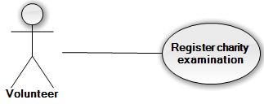

|  |  |  |  |  |
| --- | --- | --- | --- | --- |
| **USE CASE-UC082 SPECIFICATION** | | | | |
| **Use-case No.** | UC082 | **Use-case Version** | | 1.1 |
| **Use-case Name** | Register charity examination | | | |
| **Author** | Trần Nguyễn Kim Vinh | | | |
| **Date** | 12/5/2014 | **Priority** | High | |
| **Actor:** Volunteer  **Summary:**  This use case allows volunteer can register into a Charity Examination.  **Goal:** Registered Charity Examination.  **Triggers:**  In main page of volunteer, user click “Đăng kí”.  **Preconditions:** The user is already logged in with an account in volunteer role.  User don’t register in any charity examination  **Post Conditions:**  *On success:* The information of volunteer registered into charity examination and wait for approve. The user is redirected home page of volunteer with. If user register in more than one charity exam, user will join in that charity exam approve first.  *On failure:* An error message is displayed. The content of the error message will be specified in the Exception Scenario section based on the type of failure.  **Main Success Scenario:**   |  |  |  | | --- | --- | --- | | **Step** | **User Action** | **System Response** | | 1. | Click button “Đăng kí” in home page of volunteer. |  | | 2. |  | Display a form divided in to two select box. The first section allow user choose examination, the second section allow user choose charity examination. | | 3. | Click on “Kỳ thi” to choose examination. |  | | 4. | Click on “Hội từ thiện” to choose charity examination user want to join. |  | | 5. |  | Display all lodges of that charity examination. | | 6. | Click “Đăng kí” button. |  | | 7. |  | Registered to that charity examination and back to home page of volunteer. |   **Alternative Scenario: N/A**  **Exceptions: N/A**  **Relationships:** Register to charity exam  **Business Rules:** Volunteer can join one charity exam for each examination | | | | |

#### (Volunteer) View Schedule

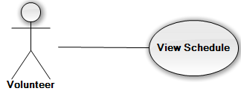

|  |  |  |  |  |
| --- | --- | --- | --- | --- |
| **USE CASE-UC083 SPECIFICATION** | | | | |
| **Use-case No.** | UC083 | **Use-case Version** | | 1.1 |
| **Use-case Name** | View schedule | | | |
| **Author** | Trần Nguyễn Kim Vinh | | | |
| **Date** | 12/5/2014 | **Priority** | High | |
| **Actor:** Volunteer  **Summary:**  This use case allows volunteer can view him/her schedule to pick up and bring candidate to venue.  **Goal:** View schedule of volunteer.  **Triggers:**  In main page of volunteer, user click “Xem lịch trình”.  **Preconditions:** The user is already logged in with an account in volunteer role.  User have registered in a charity examination.  Charity in that charity examination assigned volunteer to pick up a candidate.  **Post Conditions:**  *On success:* Volunteer see him/her schedule with Name of candidate and date time to pick up that candidate.  *On failure:* An error message is displayed. The content of the error message will be specified in the Exception Scenario section based on the type of failure.  **Main Success Scenario:**   |  |  |  | | --- | --- | --- | | **Step** | **User Action** | **System Response** | | 1. | Click button “Xem lịch trình” in dashboard of page. |  | | 2. |  | Display a table content about candidate will be picked up, date time. |   **Alternative Scenario: N/A**  **Exceptions: N/A**  **Relationships:** Join charity exam  **Business Rules:**  Volunteer only click view schedule when joined one or more charity exam in each examination and was schedule a candidate. | | | | |

#### (Volunteer) View Map

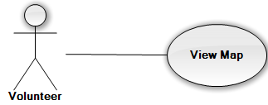

|  |  |  |  |  |
| --- | --- | --- | --- | --- |
| **USE CASE-UC084 SPECIFICATION** | | | | |
| **Use-case No.** | UC084 | **Use-case Version** | | 1.1 |
| **Use-case Name** | View map | | | |
| **Author** | Trần Nguyễn Kim Vinh | | | |
| **Date** | 12/5/2014 | **Priority** | High | |
| **Actor:** Volunteer  **Summary:**  This use case allows volunteer can view Google map and view route.  **Goal:** View schedule of volunteer.  **Triggers:**  In view schedule page of volunteer, user click “Hiển thị bản đồ”.  **Preconditions:** The user is already logged in with an account in volunteer role.  User have registered in a charity examination.  Charity in that charity examination assigned volunteer to pick up a candidate.  **Post Conditions:**  *On success:* Volunteer see him/her route in Google map.  *On failure:* An error message is displayed. The content of the error message will be specified in the Exception Scenario section based on the type of failure.  **Main Success Scenario:**   |  |  |  | | --- | --- | --- | | **Step** | **User Action** | **System Response** | | 1. | Click button “Hiển thị bản đồ” in view detail page. |  | | 2. |  | Display a new window popup with Google maps and the route of volunteer will be drives. |   **Alternative Scenario: N/A**  **Exceptions: N/A**  **Relationships:** Join charity exam  **Business Rules:**  Volunteer only click view map when joined one or more charity exam in each examination and was assigned to carrying a candidate. | | | | |

#### (Volunteer) Add new post



|  |  |  |  |  |
| --- | --- | --- | --- | --- |
| **USE CASE-UC085 SPECIFICATION** | | | | |
| **Use-case No.** | UC085 | **Use-case Version** | | 1.1 |
| **Use-case Name** | Add new post | | | |
| **Author** | Trần Nguyễn Kim Vinh | | | |
| **Date** | 12/5/2014 | **Priority** | Normal | |
| **Actor:** Volunteer, Admin  **Summary:**  This use case allows volunteer or admin can create a new post.  **Goal:** Add new post.  **Triggers:**  In manage post page of volunteer, user click “Tạo bài viết mới”.  In manage post page of admin, user click “Tạo bài viết mới”.  **Preconditions:** The user is already logged in with an account in volunteer or admin role.  **Post Conditions:**  *On success:* A new post is added in to system and wait for approve.  *On failure:* An error message is displayed. The content of the error message will be specified in the Exception Scenario section based on the type of failure.  **Main Success Scenario:**   |  |  |  | | --- | --- | --- | | **Step** | **User Action** | **System Response** | | 1. | Click button “Tạo bài viết mới” in dashboard of page. |  | | 2. |  | Display a form with all content of post as: Title, content, summary, category, and image. | | 3. | Fills out the form with relevant values. |  | | 4. | Clicks the button “Lưu lại”. |  | | 5. |  | Saves the new post to the database and wait for approve, redirects the user to the manage post page. |   **Alternative Scenario: N/A**  **Exceptions:**   |  |  |  | | --- | --- | --- | | **No** | **User Action** | **System Response** | | 1. | Don’t input anything or input missing require fields? Click “Tạo” button. | Show error message at one or all require fields. |   **Relationships:** Manage news  **Business Rules:** Admin and volunteer can add new post into the system. | | | | |

#### (Volunteer) Edit post



|  |  |  |  |  |
| --- | --- | --- | --- | --- |
| **USE CASE-UC086 SPECIFICATION** | | | | |
| **Use-case No.** | UC086 | **Use-case Version** | | 1.1 |
| **Use-case Name** | Edit post | | | |
| **Author** | Trần Nguyễn Kim Vinh | | | |
| **Date** | 12/5/2014 | **Priority** | Normal | |
| **Actor:** Volunteer, Admin  **Summary:**  This use case allows volunteer or admin can edit a post.  **Goal:** Edit post.  **Triggers:**  In manage post page of volunteer, user click “Chỉnh sửa” at post user want edit.  In manage post page of admin, user click “Chỉnh sửa” at post user want edit.  **Preconditions:** The user is already logged in with an account in volunteer or admin role.  Post added into database and status is not approve.  **Post Conditions:**  *On success:* Post is edited and wait for approve.  *On failure:* An error message is displayed. The content of the error message will be specified in the Exception Scenario section based on the type of failure.  **Main Success Scenario:**   |  |  |  | | --- | --- | --- | | **Step** | **User Action** | **System Response** | | 1. | Click button “Chỉnh sửa” on the row that contains the post to be edited. |  | | 2. |  | Display a form with all content of post as: Title, content, summary, category, and image. All the fields are filled with the corresponding information of the selected post. | | 3. | Changes the existing information with relevant values. |  | | 4. | Clicks the button “Lưu lại”. |  | | 5. |  | Saves the new post to the database and wait for approve, redirects the user to the manage post page. |   **Alternative Scenario: N/A**  **Exceptions: N/A**  **Relationships:** Manage post  **Business Rules:** can edit post when this post was not approved. | | | | |

#### (Volunteer) Delete post



|  |  |  |  |  |
| --- | --- | --- | --- | --- |
| **USE CASE-UC087 SPECIFICATION** | | | | |
| **Use-case No.** | UC087 | **Use-case Version** | | 1.1 |
| **Use-case Name** | Delete post | | | |
| **Author** | Trần Nguyễn Kim Vinh | | | |
| **Date** | 12/5/2014 | **Priority** | Normal | |
| **Actor:** Volunteer, Admin  **Summary:**  This use case allows volunteer or admin can delete a post.  **Goal:** Edit post.  **Triggers:**  In manage post page of volunteer, user click “Xóa” at post user want delete.  In manage post page of admin, user click “Xóa” at post user want delete.  **Preconditions:** The user is already logged in with an account in volunteer or admin role.  Post added into database and status is not approve.  **Post Conditions:**  *On success:* Post is deleted from database.  *On failure:* An error message is displayed. The content of the error message will be specified in the Exception Scenario section based on the type of failure.  **Main Success Scenario:**   |  |  |  | | --- | --- | --- | | **Step** | **User Action** | **System Response** | | 1. | Click button “Xóa” on the row that contains the post to be deleted. |  | | 2. |  | Shows a popup to ask the user to confirm the action. | | 3. | Click “OK” to continue to delete the post. |  | | 4. |  | Marks the selected post as deleted in the database and redirect to manage post page |   **Alternative Scenario:**   |  |  |  |  | | --- | --- | --- | --- | | **No** | **Step** | **User Action** | **System Response** | | 1. | 1. | Clicks on the button “Hủy bỏ”. |  | | 2. |  | Hides the popup message. |   **Exceptions: N/A**  **Relationships:** Manage news  **Business Rules**: If a post is approved, user cannot delete that post | | | | |

#### (Candidate) Create Exam Paper



|  |  |  |  |  |
| --- | --- | --- | --- | --- |
| **USE CASE-UC088 SPECIFICATION** | | | | |
| **Use-case No.** | UC088 | **Use-case Version** | | 1.1 |
| **Use-case Name** | Create Exampaper | | | |
| **Author** | Lê Nguyễn Hữu Trí | | | |
| **Date** | 12/5/2014 | **Priority** | Normal | |
| **Actor:** Candidate  **Summary:**  This use case is about how candidate create an exam paper  **Goal:** Create an exam paper successfully that candidate can join to charity exam  **Triggers:**  Candidate click “Tạo” button at “Tạo giấy thi” page to create an exam paper.  **Preconditions:** Login with role “Candidate” successfully  **Post Conditions:**  *On success:* Exam paper of candidate is created successfully  *On failure:* An error message is displayed. The content of the error message will be specified in the Exception Scenario section based on the type of failure.  **Main Success Scenario:**   |  |  |  | | --- | --- | --- | | **Step** | **User Action** | **System Response** | | 1. | Candidate choose Exam, University and Venue at “Kì thi”, “Trường đại học” and “Địa điểm thi” drop down list |  | | 2. |  | The information that candidate choose in step 1 is displayed correctly | | 3. | Click “Tạo” button to create an exam paper |  | | 4. |  | The exam paper of candidate is created and added to the system successfully |   **Alternative Scenario:**  **Exceptions:**   |  |  |  | | --- | --- | --- | | **Step** | **User Action** | **System Response** | | 1. | Candidate choose Exam that candidate already have exam paper |  | | 2. |  | Candidate can’t create an exam paper |   **Relationships:** Manage ExaminationPaper  **Business Rules**: Candidate create exam paper, maximum is 3 exam papers in 1 year and cannot have 2 exam papers with the same exam | | | | |

#### (Candidate) Join In Charity Exam

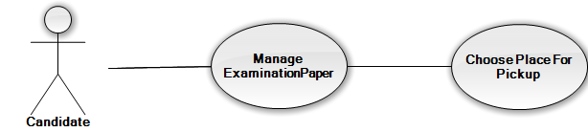

|  |  |  |  |  |
| --- | --- | --- | --- | --- |
| **USE CASE-UC089 SPECIFICATION** | | | | |
| **Use-case No.** | UC089 | **Use-case Version** | | 1.1 |
| **Use-case Name** | Choose place for pickup | | | |
| **Author** | Nguyễn Đình Tuấn | | | |
| **Date** | 12/5/2014 | **Priority** | Normal | |
| **Actor:** Candidate  **Summary:**  This use case is about how candidate choose place for pickup  **Goal:** Charity can easy make plan to pickup candidate with this place who chosse.  **Triggers:**  Candidate choose “ Đăng ký đưa đón” to chosse place to coming.  **Preconditions: _**Login with role “Candidate” successfully  **Post Conditions:**  *On success:* Candidate chosse palce and submit successful this information.  *On failure:* An error message is displayed. The content of the error message will be specified in the Exception Scenario section based on the type of failure.  **Main Success Scenario:**   |  |  |  | | --- | --- | --- | | **Step** | **User Action** | **System Response** | | 1. | Candidate choose Place and Time at “”, “Nơi đến” and “Giờ đến” drop down list |  | | 2. |  | The information that candidate choose in step 1 is displayed correctly | | 3. | Click “Lưu thông tin” button |  | | 4. |  | The information about time and place is created and added to the system successfully |   **Alternative Scenario: N/A**  **Exceptions: N/A**  **Relationships:** Manage ExaminationPaper,  **Business Rules**: Candidate, who are already register with information about place and time to pick up, can’t change their information. | | | | |

#### (Candidate) Invite Friend



|  |  |  |  |  |
| --- | --- | --- | --- | --- |
| **USE CASE-UC090 SPECIFICATION** | | | | |
| **Use-case No.** | UC090 | **Use-case Version** | | 1.1 |
| **Use-case Name** | Invite Friend | | | |
| **Author** | Lê Nguyễn Hữu Trí | | | |
| **Date** | 12/5/2014 | **Priority** | Normal | |
| **Actor:** Candidate  **Summary:**  This use case is about how candidate invite friend who stay in same lodge of group to their group  **Goal:** Give a request to another candidate to invite them join in group  **Triggers:**  Candidate click on “Mời vào nhóm” to invite candidate join in group  **Preconditions: _**Login with role “Candidate” successfully  _ Candidate must have group  **Post Conditions:**  *On success:* Candidate send request to another candidate successfully  *On failure:* An error message is displayed. The content of the error message will be specified in the Exception Scenario section based on the type of failure.  **Main Success Scenario:**   |  |  |  | | --- | --- | --- | | **Step** | **User Action** | **System Response** | | 1. | Candidate click on “Mời vào nhóm” |  | | 2. |  | The request is sent to this candidate |   **Alternative Scenario: N/A**  **Exceptions: N/A**  **Relationships:** Manage ExaminationPaper, DetailExamPaper.  **Business Rules**: Candidate who are already in a group can invite another candidate that doesn’t have group, same gender, stay in same lodge to group | | | | |

#### (Candidate) Accept Group



|  |  |  |  |  |
| --- | --- | --- | --- | --- |
| **USE CASE-UC091 SPECIFICATION** | | | | |
| **Use-case No.** | UC091 | **Use-case Version** | | 1.1 |
| **Use-case Name** | Accept Group | | | |
| **Author** | Lê Nguyễn Hữu Trí | | | |
| **Date** | 12/5/2014 | **Priority** | Normal | |
| **Actor:** Candidate  **Summary:**  This use case is about how candidate accept the invite to join group of their friend  **Goal:** Give a request to another candidate to invite them join in group  **Triggers:**  Candidate click on “Đồng ý” to to join in group  **Preconditions: _**Login with role “Candidate” successfully  _ Candidate must have at least 1 invite’s request  **Post Conditions:**  *On success:* Candidate accept the invite’s request and join in to group successfully  *On failure:* An error message is displayed. The content of the error message will be specified in the Exception Scenario section based on the type of failure.  **Main Success Scenario:**   |  |  |  | | --- | --- | --- | | **Step** | **User Action** | **System Response** | | 1. | Candidate click on “Đồng ý” button |  | | 2. |  | Candidate join in group successfully |   **Alternative Scenario: N/A**  **Exceptions: N/A**  **Relationships:** Manage ExaminationPaper, DetailExamPaper.  **Business Rules**: Candidate that wasn’t in any group can accept the invitation to join in group | | | | |

## **Software System Attributes**

### Reliability

* Accurate: 95%

### Availability

* N/A

### Security

* Each role of user has a specific permission to interact with system
* TSMT system always checks authorization and authenticated before do anything

### Maintainability

* All the errors should be logged, supporting for bug fixing and maintenance

### Portability

* TMST should be accessible to anyone, with a personal computer that connects to the Internet and has a web browser

### Performance

* N/A

## **Entity Relationship Diagram**

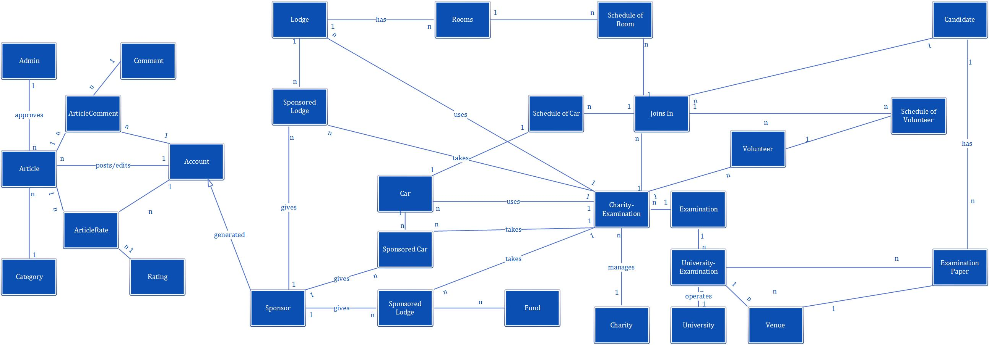

# **REPORT NO.4: SYSTEM DESIGN DESCRIPTION (SDD)**

## **Design Overview**

This part describes the detailed design of the TSMT website. It includes the system architectural design, component details and sequence diagrams. It also describes the graphical user interface and data structures of the system. This is to give the reader, a better understanding of the design process and procedure for this web application.

* The system architecture design describes the overview architecture of the system, the applied design pattern.
* Component diagram design describes the connection and integration of the system. It does not describe the functionality of the system but it describes the components used to make those functionalities.
* Detailed description of components describes static and dynamic structure for each component and function. It includes class diagrams and class diagram explanation.
* Sequence diagram describes the interactions between objects in the sequential order that those interactions occur. It depicts the objects and classes involved in the scenario and the messages exchanged between the objects needed to carry out the functionality of the scenario.
* User interface design demonstrates the layout of the system and graphical user interface in form of screen shots. It will also describe types of input, output element and the used action for each screen shot.

## **System Architectural Design**

MVC stands for model – view – controller pattern, was first introduced in the 1970s by Trygve Reenskaug. MVC is a software architecture pattern which separates the representation of information from user’s interaction with it. The model consists of application data, business rules, logic and functions. A view can be any output representation of data, such as a chart or a diagram. Multiple views of the same data are possible, such as bar chart for management and a tabular view for accountants. The controller mediates input, converting it to commands for the model or view. The central ideas behind MVC are code reusability and separation of concerns.

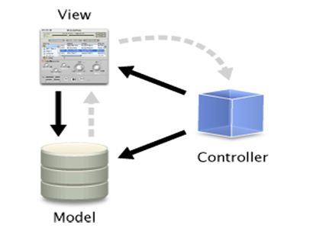

In addition to dividing the application into three kinds of components, the MVC design defines the interactions between them:

* A controller: can send commands to its associated view to changes the view’s presentation of model. It can also send commands to the model to update the model’s state
* A view: requests from the model information that it needs to generate an output representation to the user
* A model: notifies its associated views and controllers when there has been a change in its state. This notification allows the views to produce updated output, and the controllers to change the available set of commands.

## **Component Diagram**

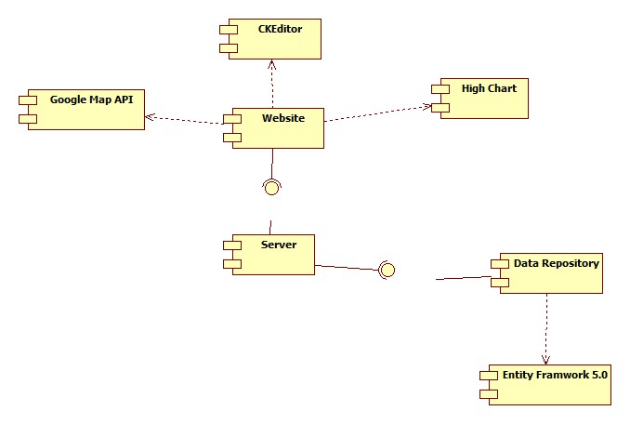

The TSMT system include the following major components:

* **Entity Framework 5.0:** An object-relational mapper that enables working with relational data persistence using domain-specific objects;
* **Data Repository:** A data store that provides data access, using the Entity Framework to communicates with the database;
* **Server:** module is important, it has task of processing and returns the results to the user when they interact to the system;
* **Google maps API:** using a library to display and suggest route in system.
* **High chart:** a library using for display statistic in system.
* **CKEditor;** a library using for inputing in system.
* **Website:** A web-application that helps expose all the functionalities to end-users.

## **Class diagram**

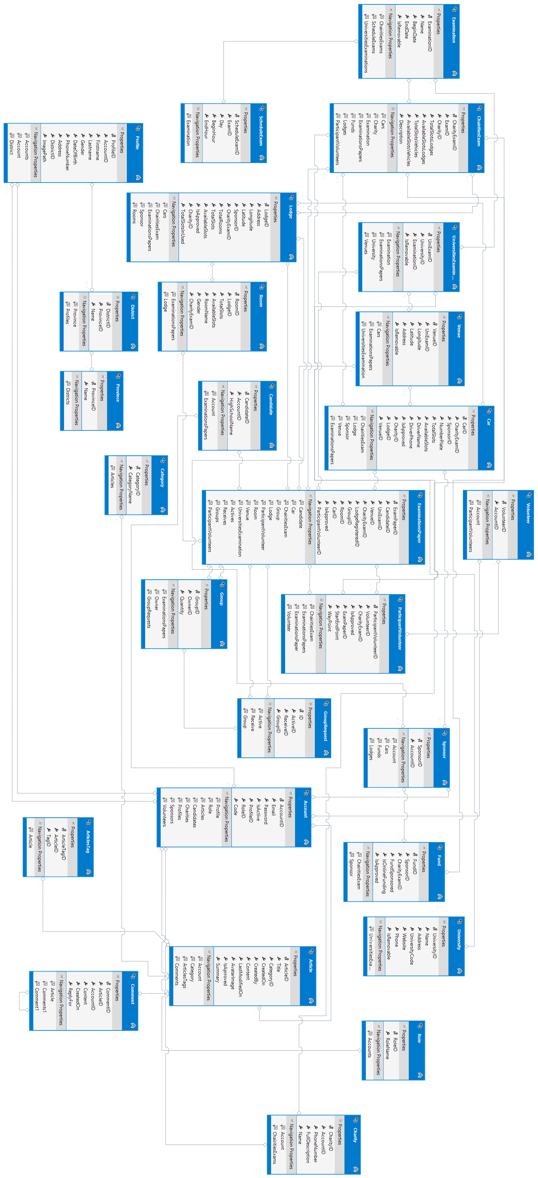

## **Behavioral Diagrams**

### **State Machine Diagram: The status transition of registering into a charity of candidate**

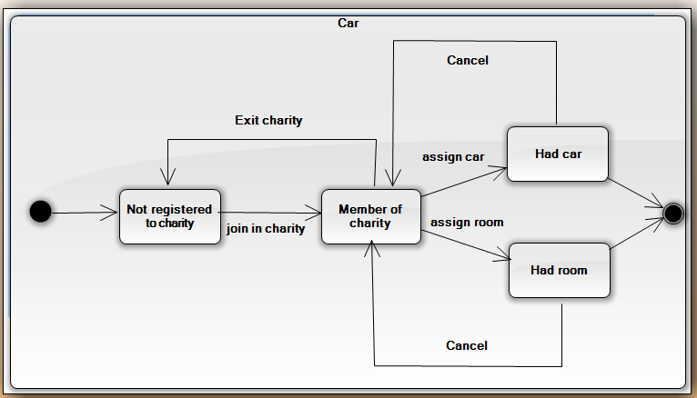

### **State Machine Diagram: The status transition of car being sponsored**

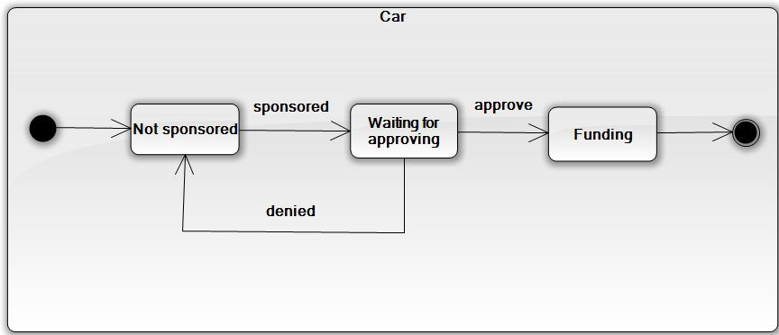

### **State Machine Diagram: The status transition of registering into charity of volunteer**

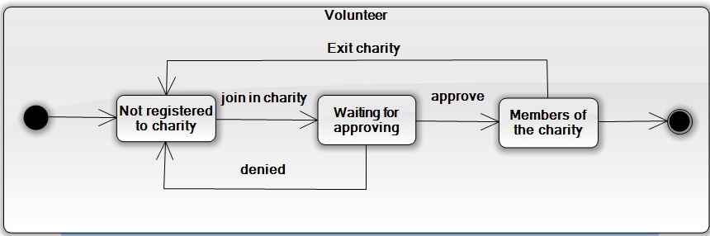

### **Sequence diagram: Add Post (Admin)**

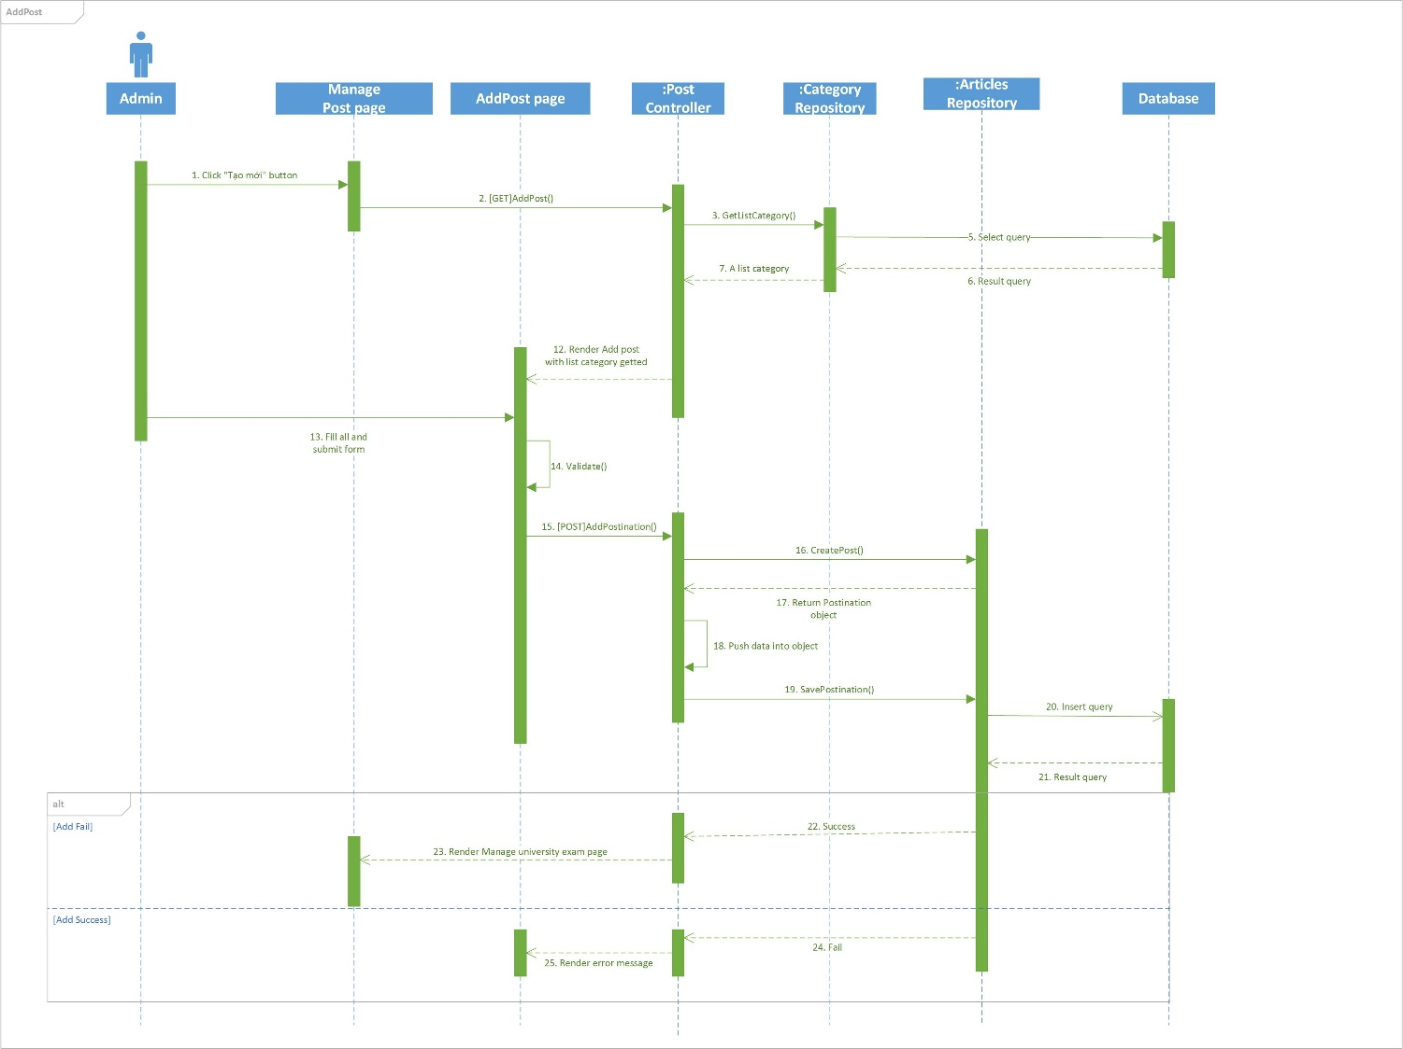

### **Sequence diagram: Edit Post (Admin)**

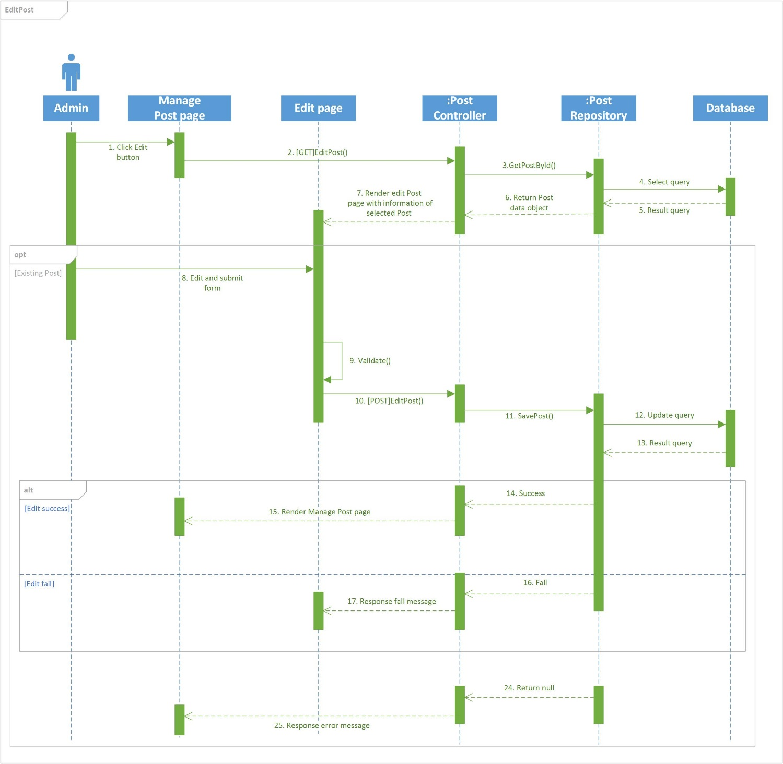

### **Sequence diagram: Delete Post (Admin)**

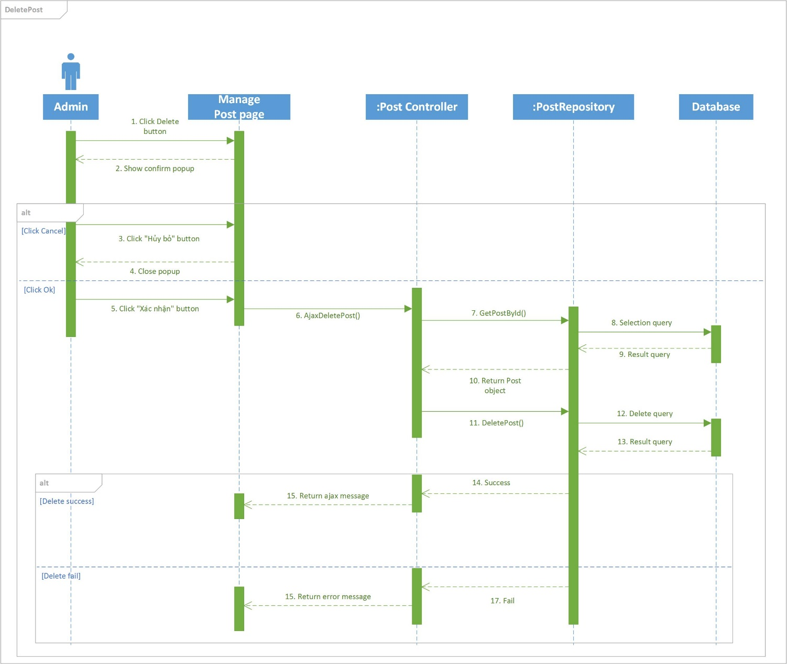

### **Sequence diagram: View News (Admin)**

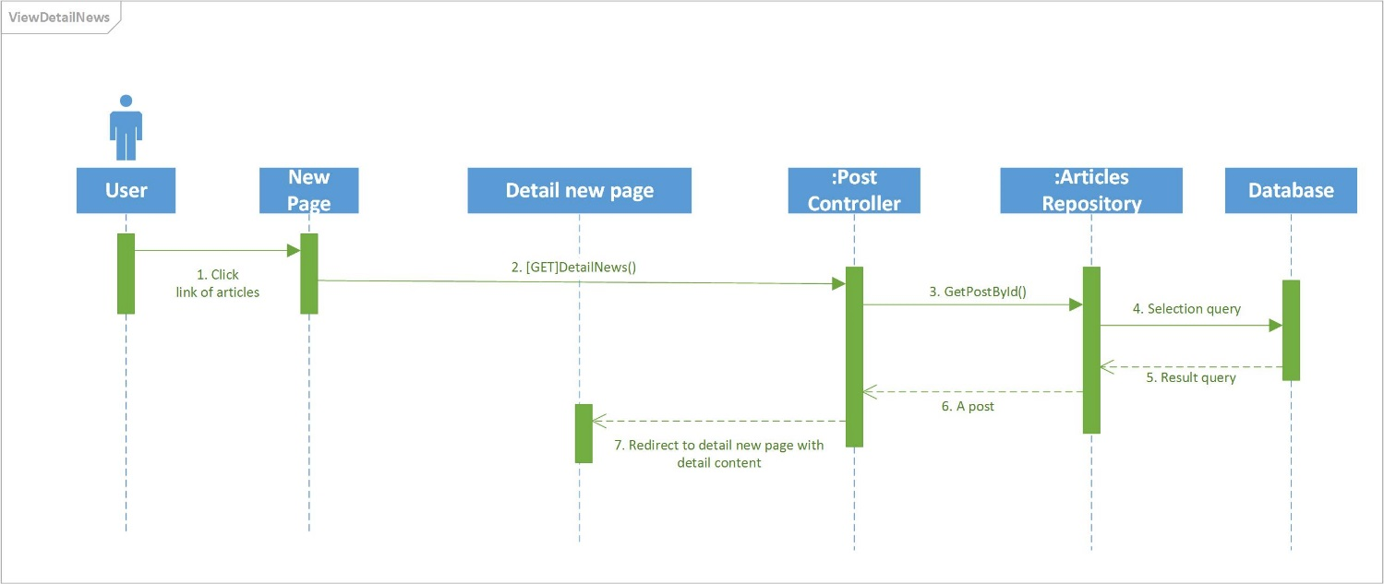

### **Sequence diagram: Add University (Admin)**

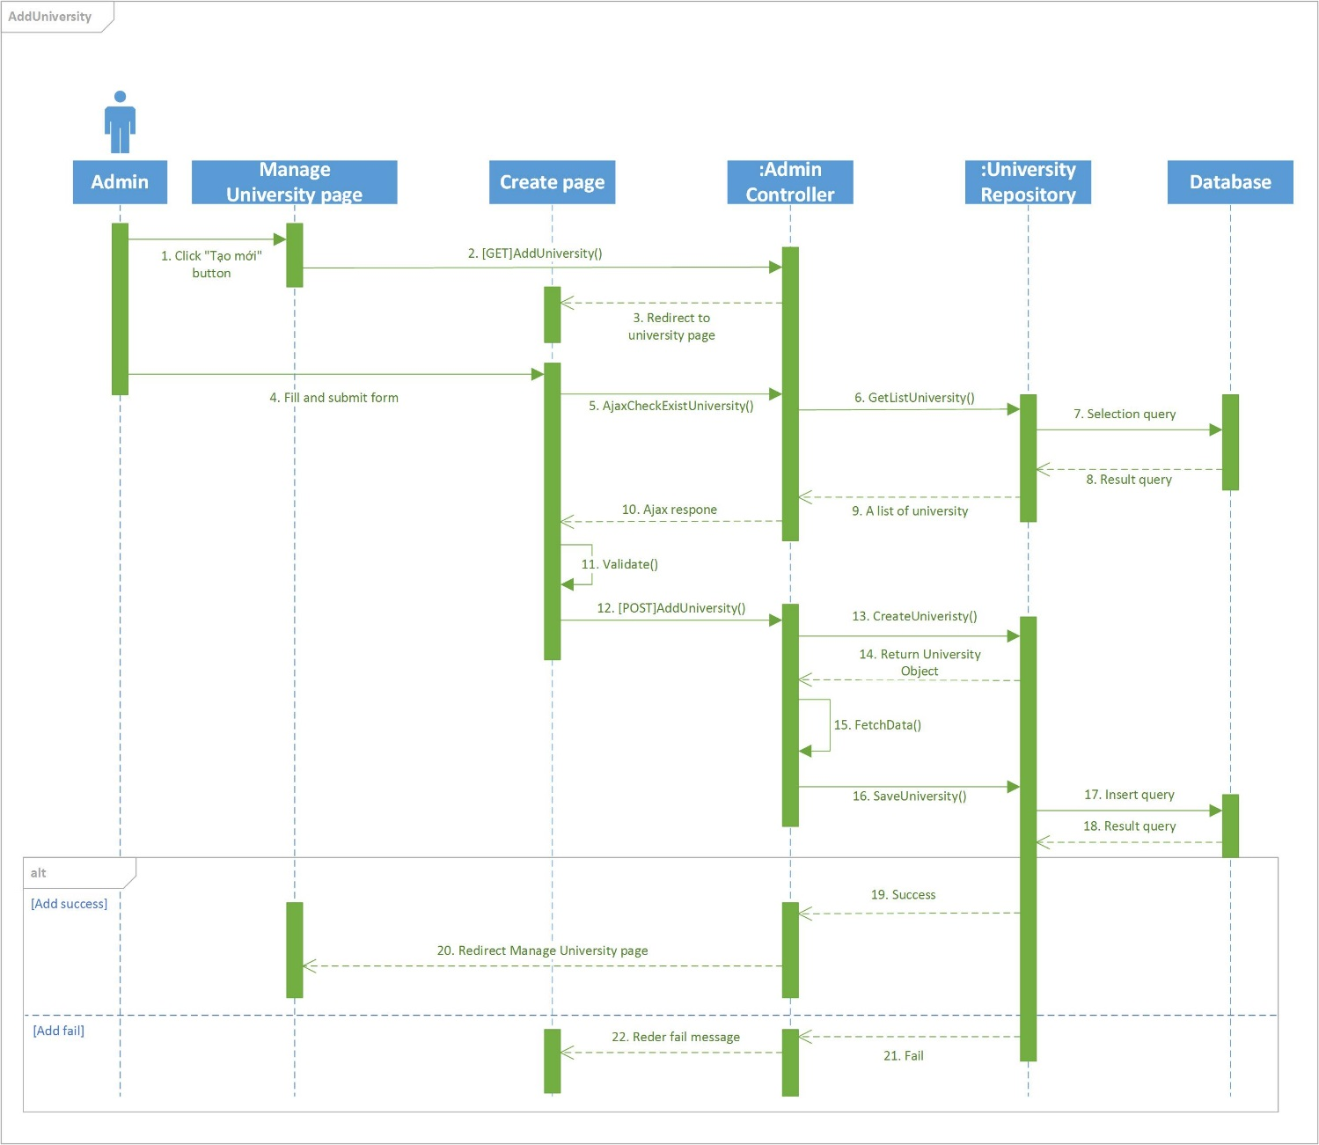

### **Sequence diagram: Edit University (Admin)**

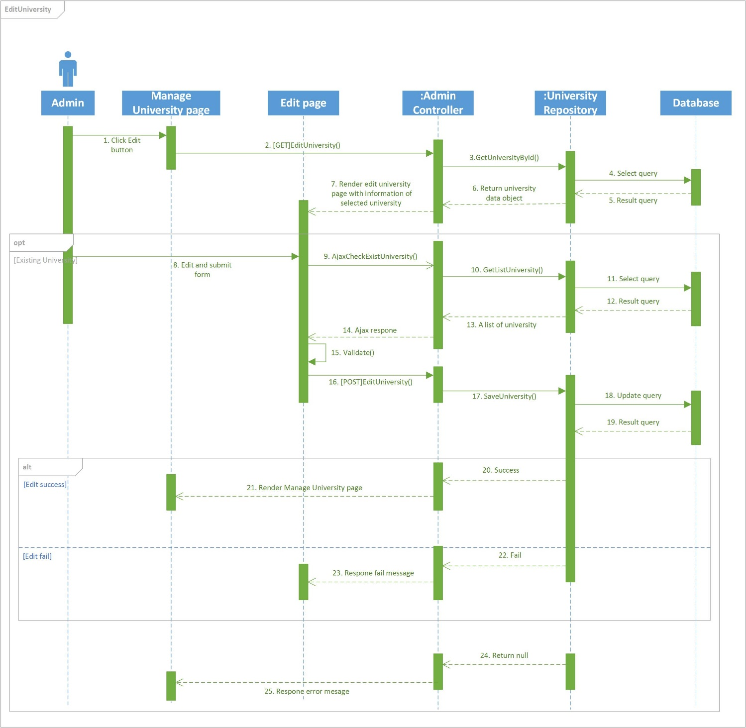

### **Sequence diagram: Delete University (Admin)**

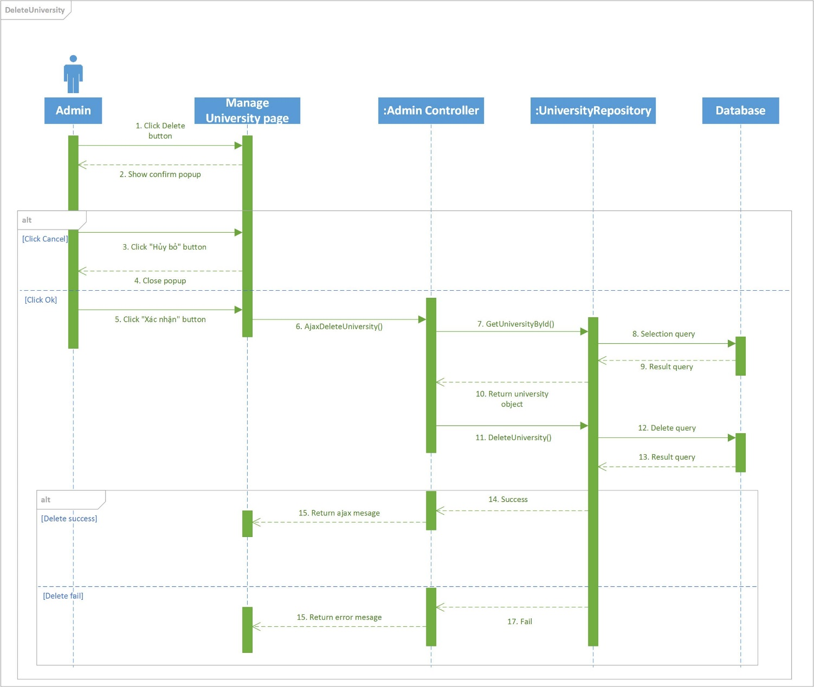

### **Sequence diagram: View University (Admin)**

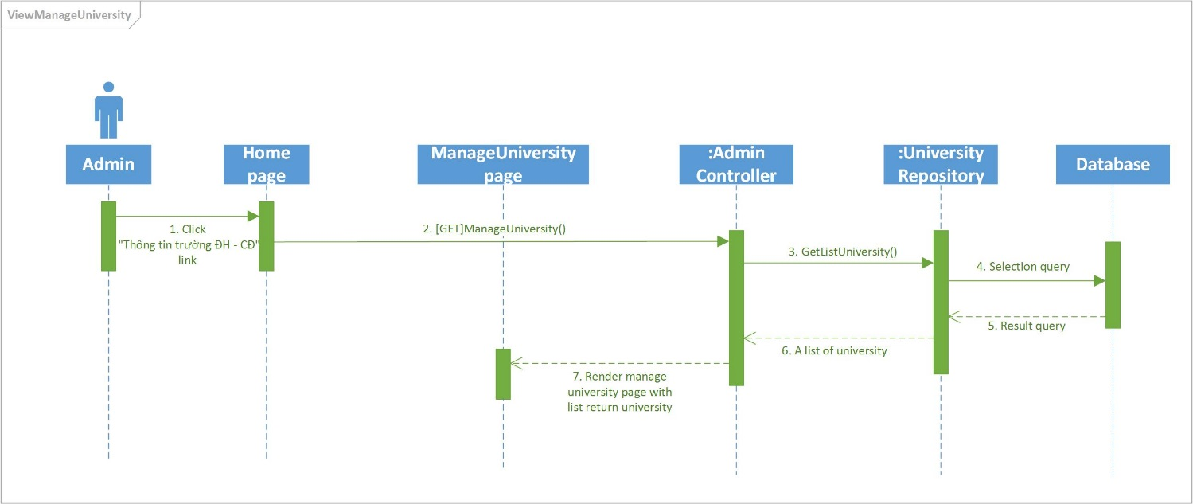

### **Sequence diagram: Delete University Examination (Admin)**

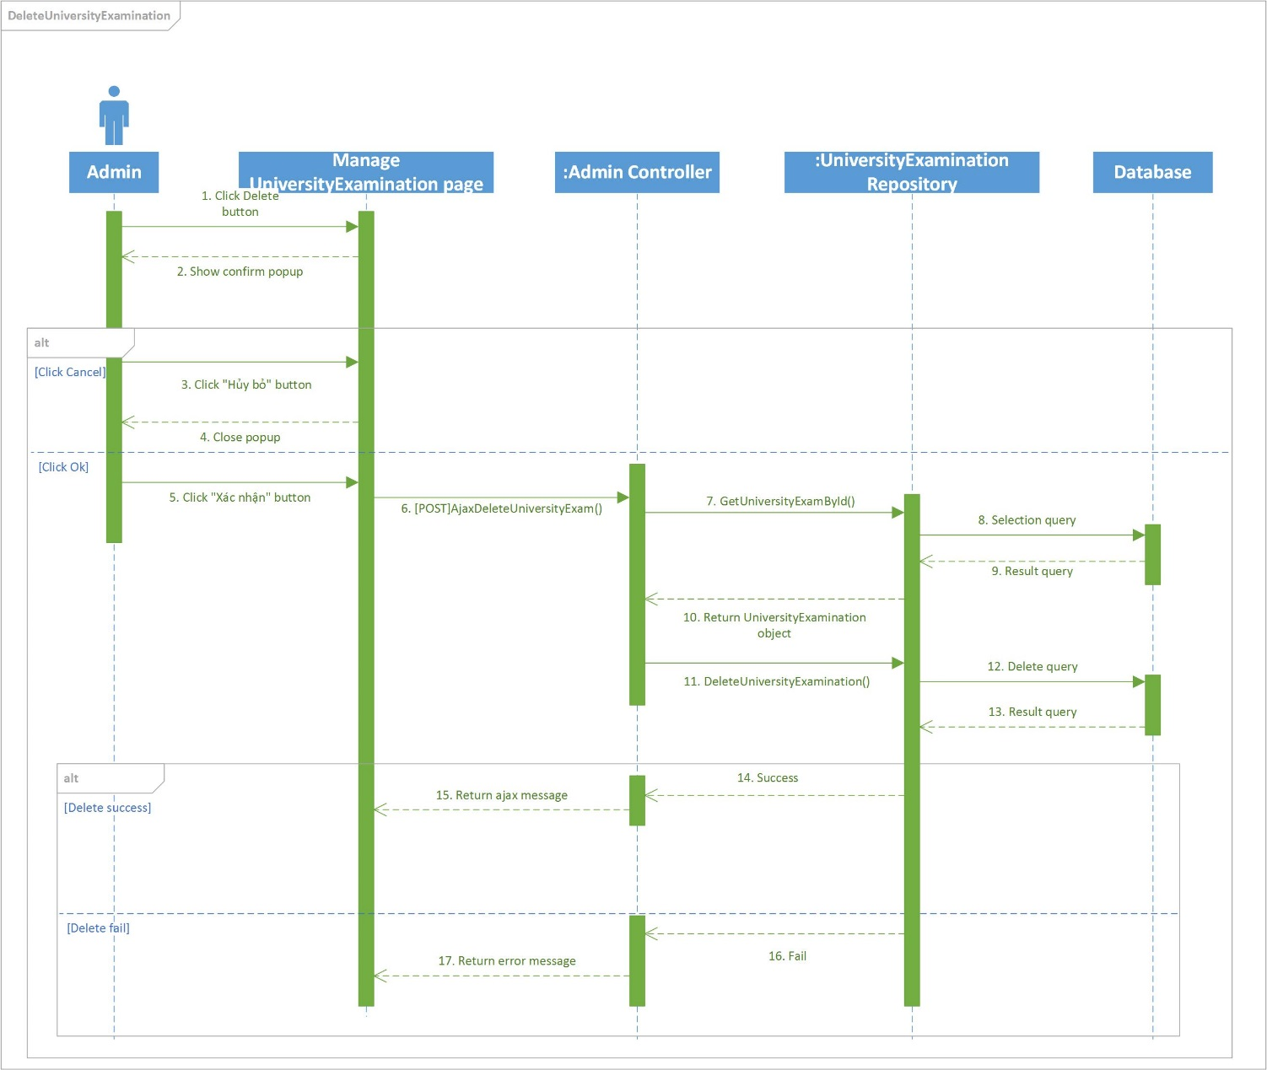

### **Sequence diagram: View University Examination (Admin)**

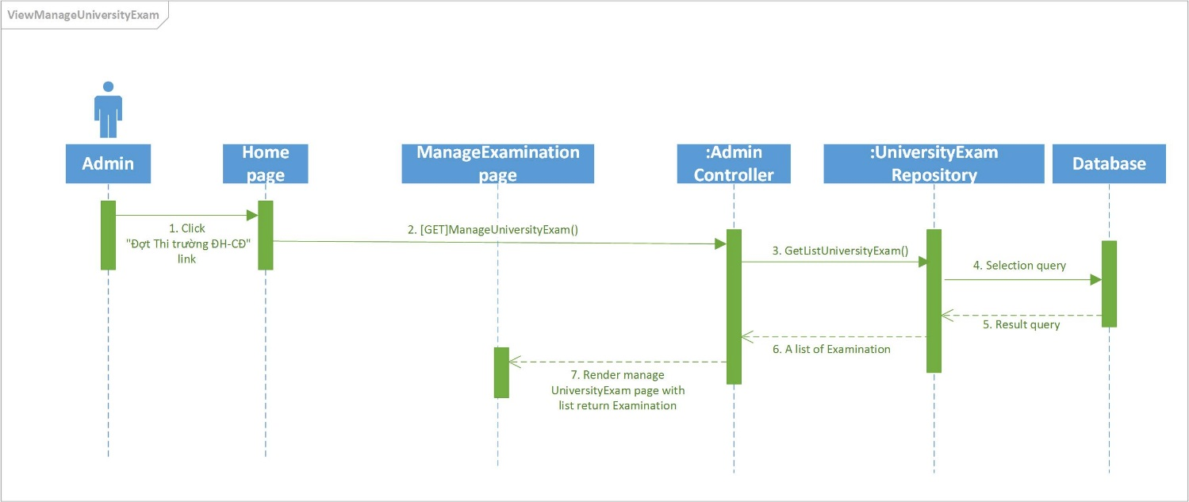

### **Sequence diagram: Add Examination Venue (Admin)**

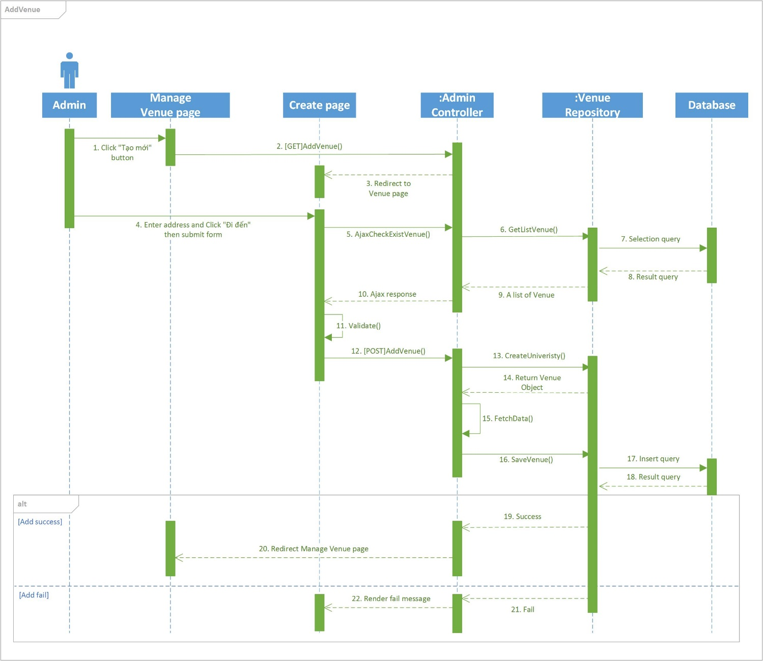

### **Sequence diagram: Edit Examination Venue (Admin)**

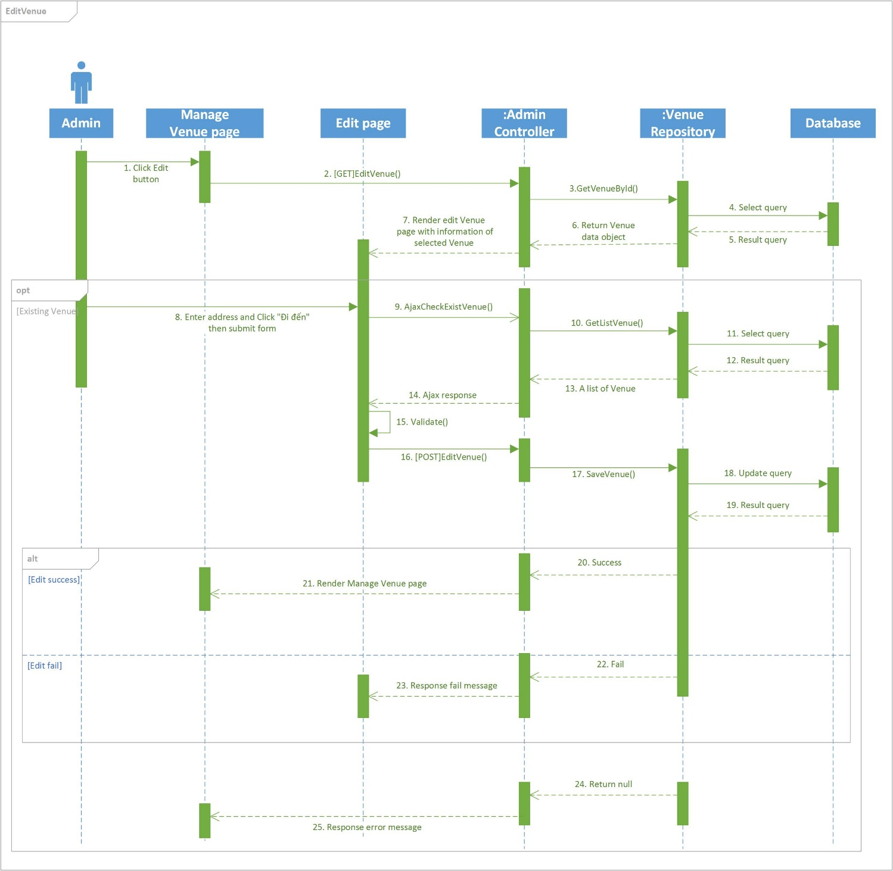

### **Sequence diagram: View List Examination Venue (Admin)**

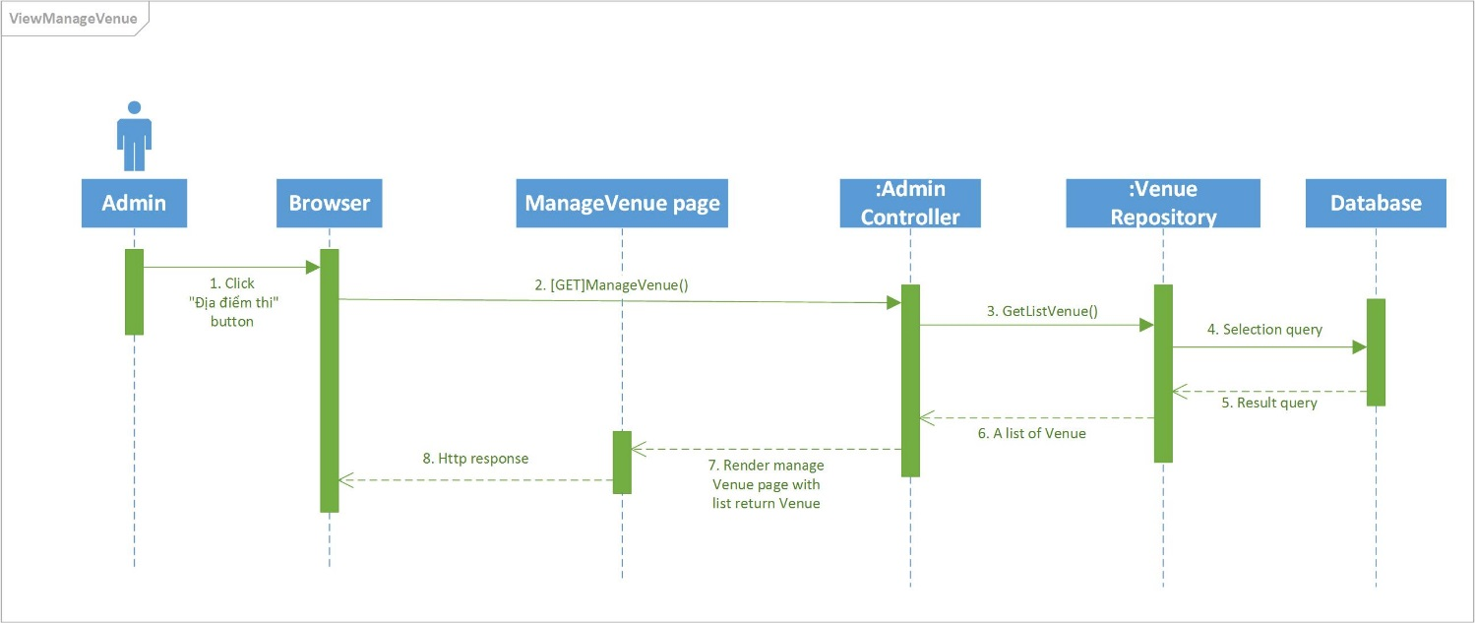

### **Sequence diagram: Approve Friend Request (Candidate)**

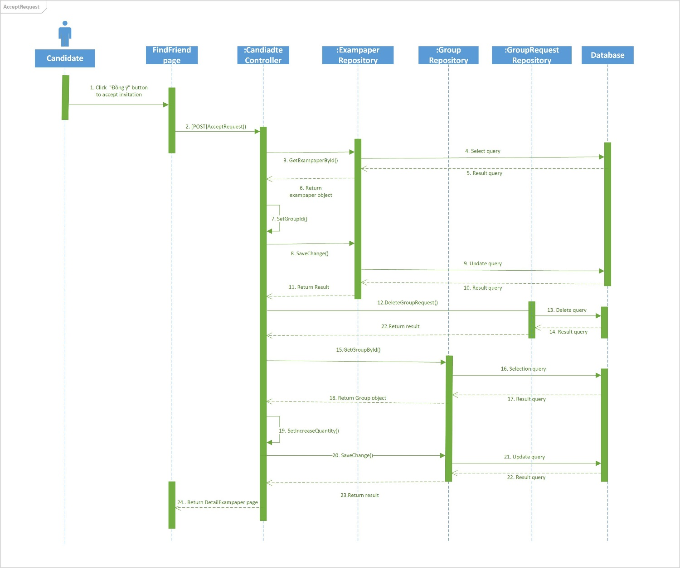

### **Sequence diagram: Ask To Join Group (Candidate)**

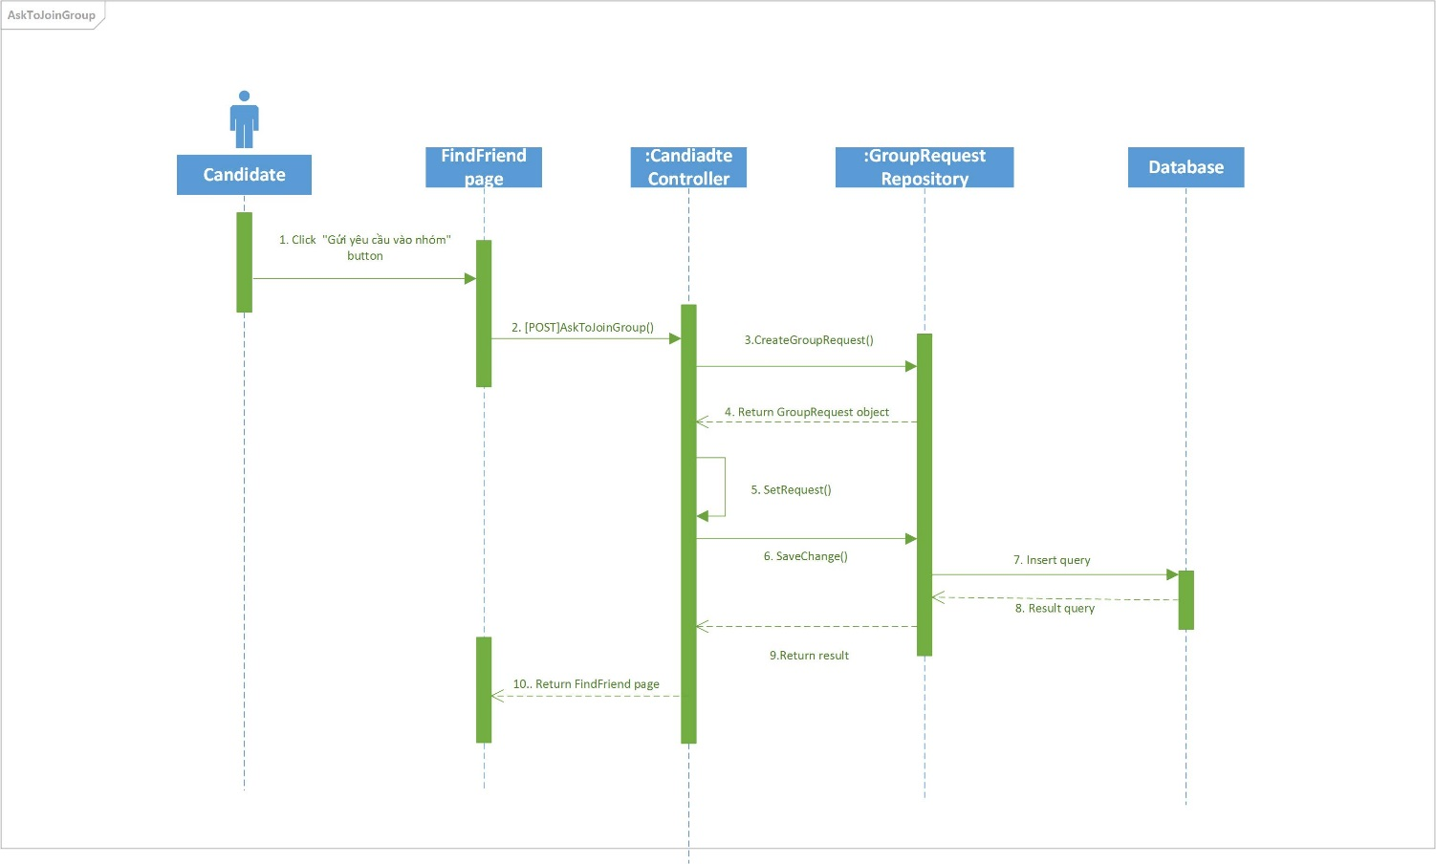

### **Sequence diagram: Deny Friend’s Request (Candidate)**

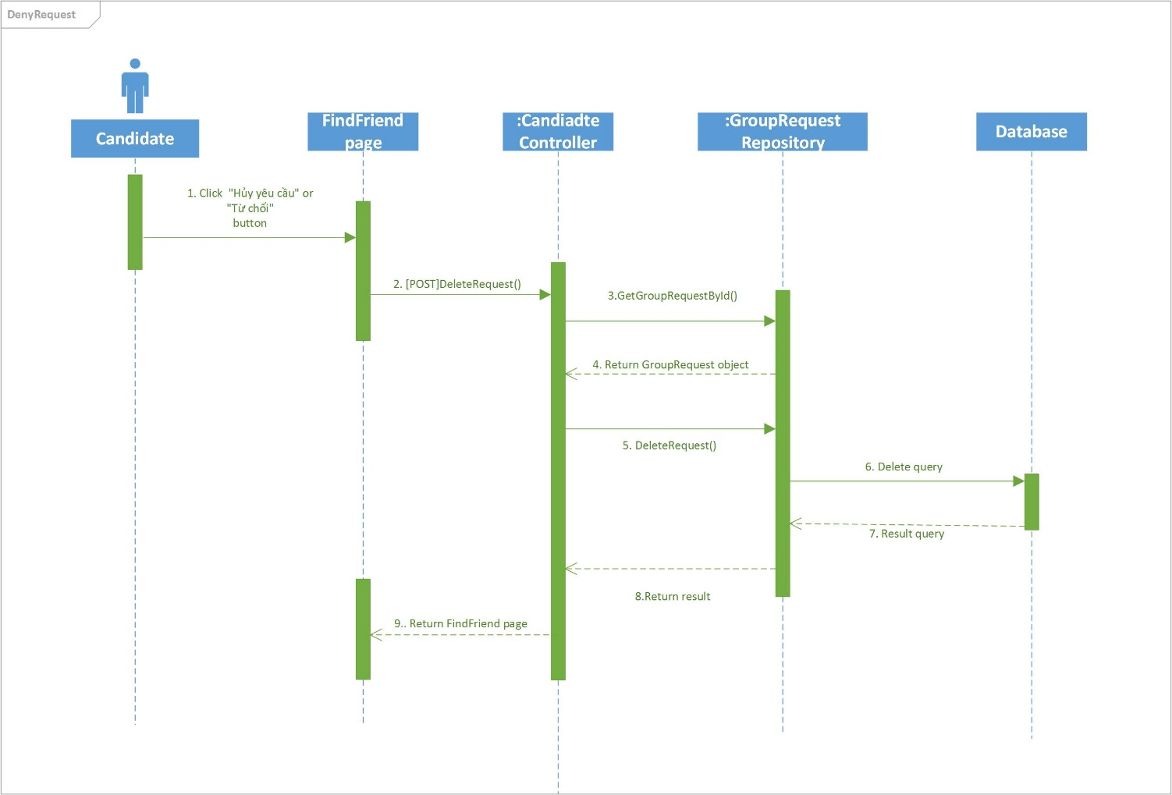

### **Sequence diagram: Invite to Group (Candidate)**

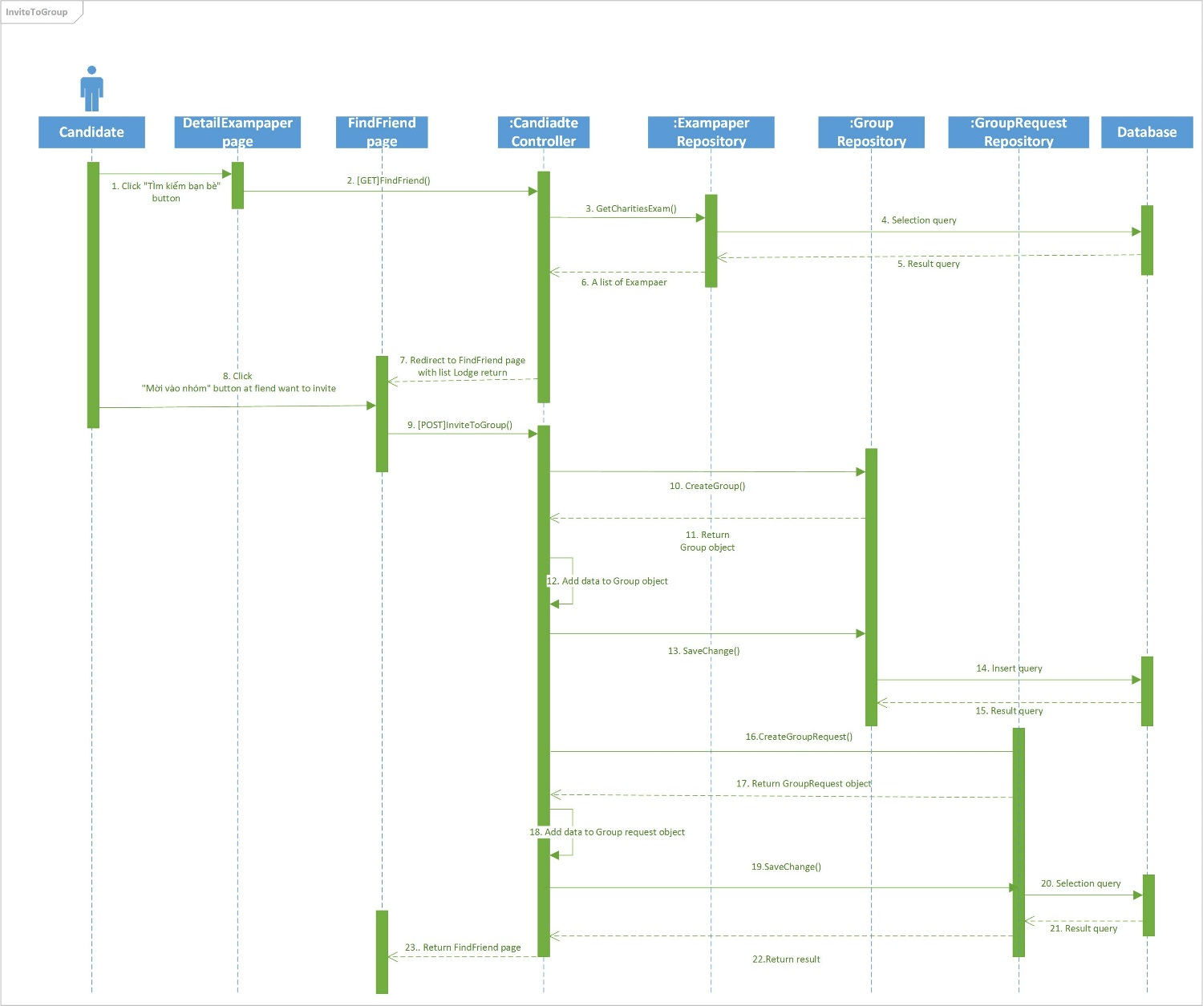

### **Sequence diagram: Join in Charity Exam (Candidate)**

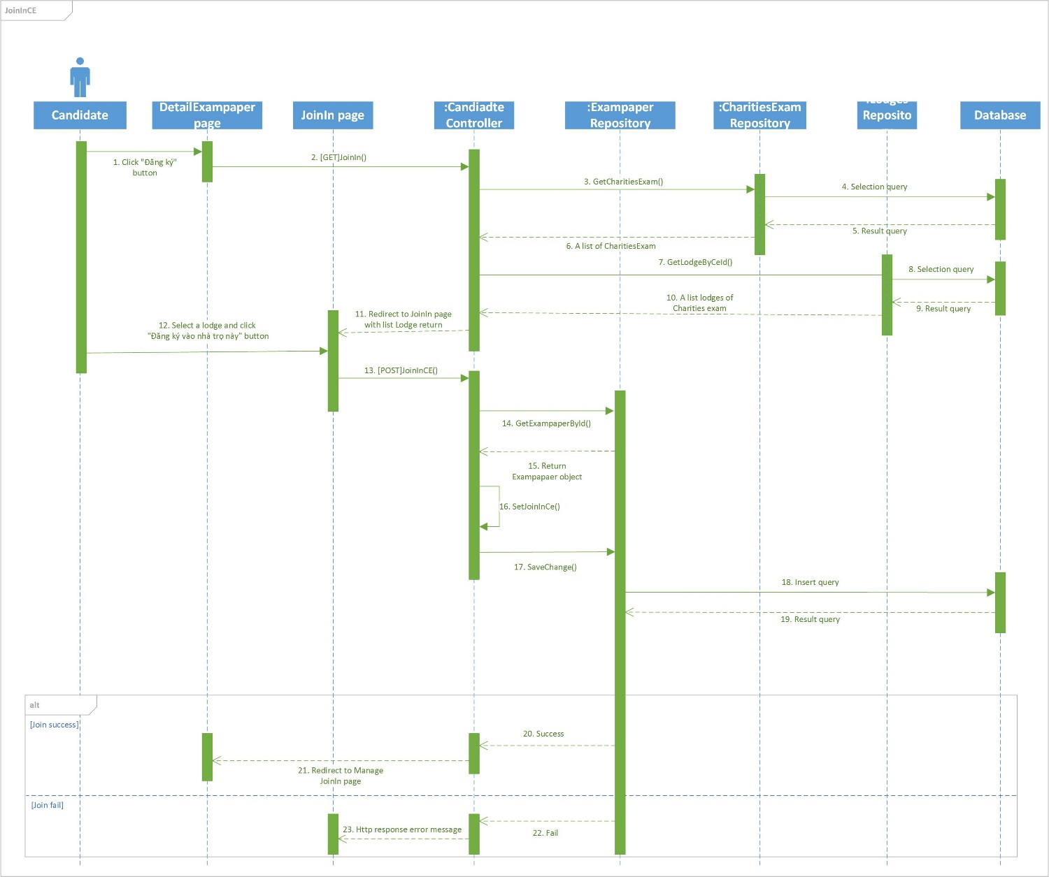

### **Sequence diagram: Leave Charity Exam (Candidate)**

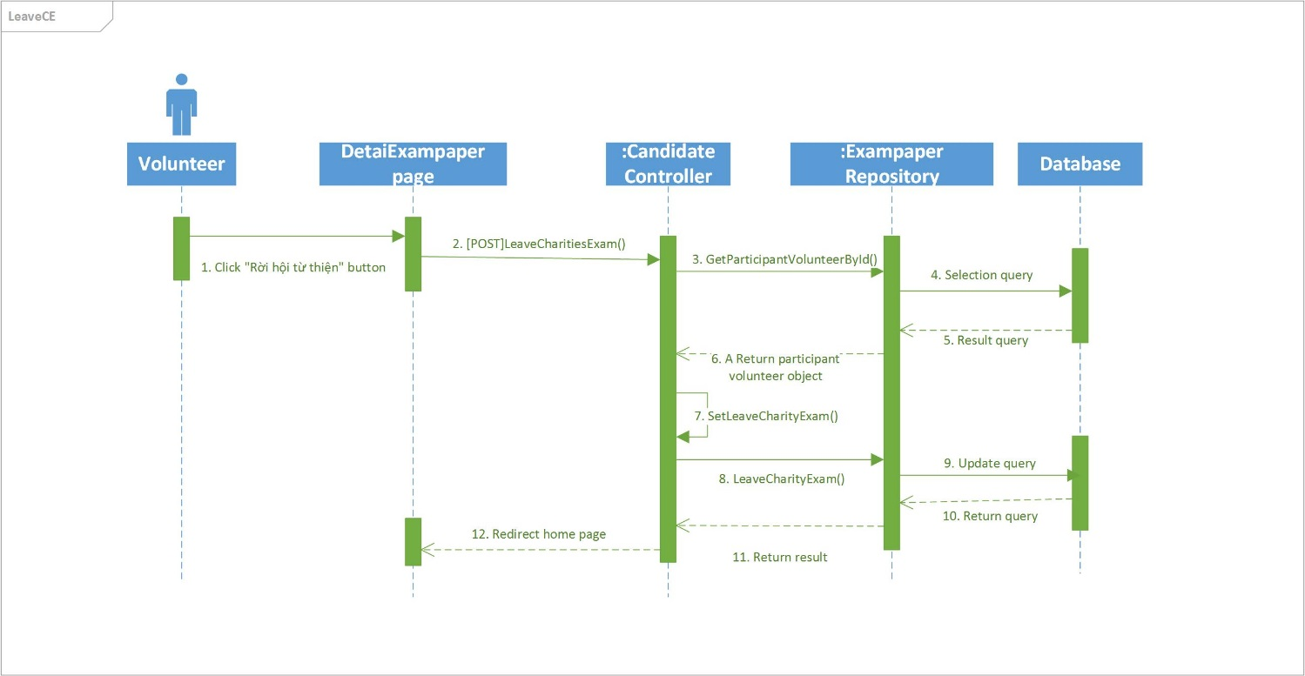

### **Sequence diagram: Add Car (Charity)**

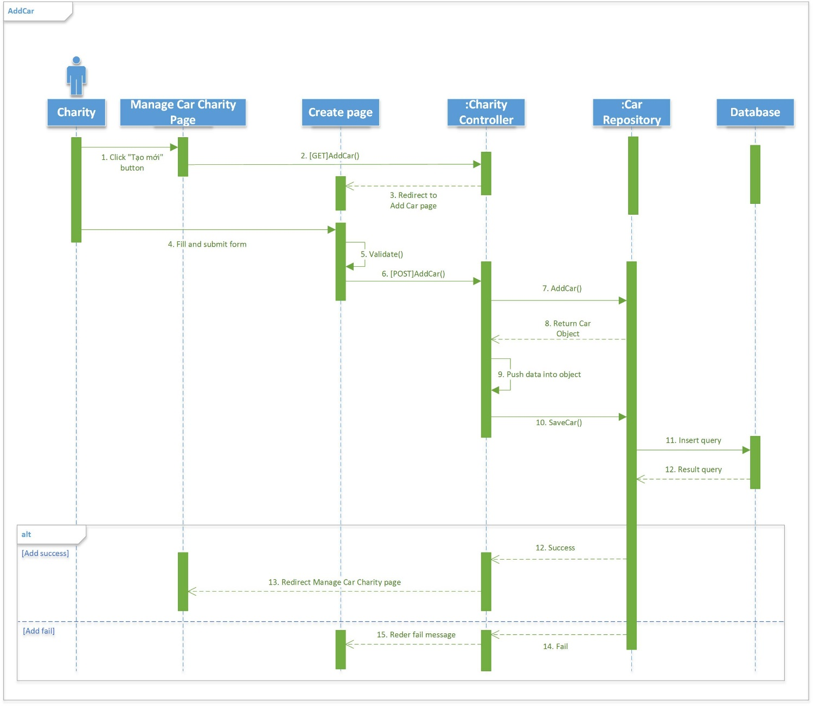

### **Sequence diagram: Approve Car (Charity)**

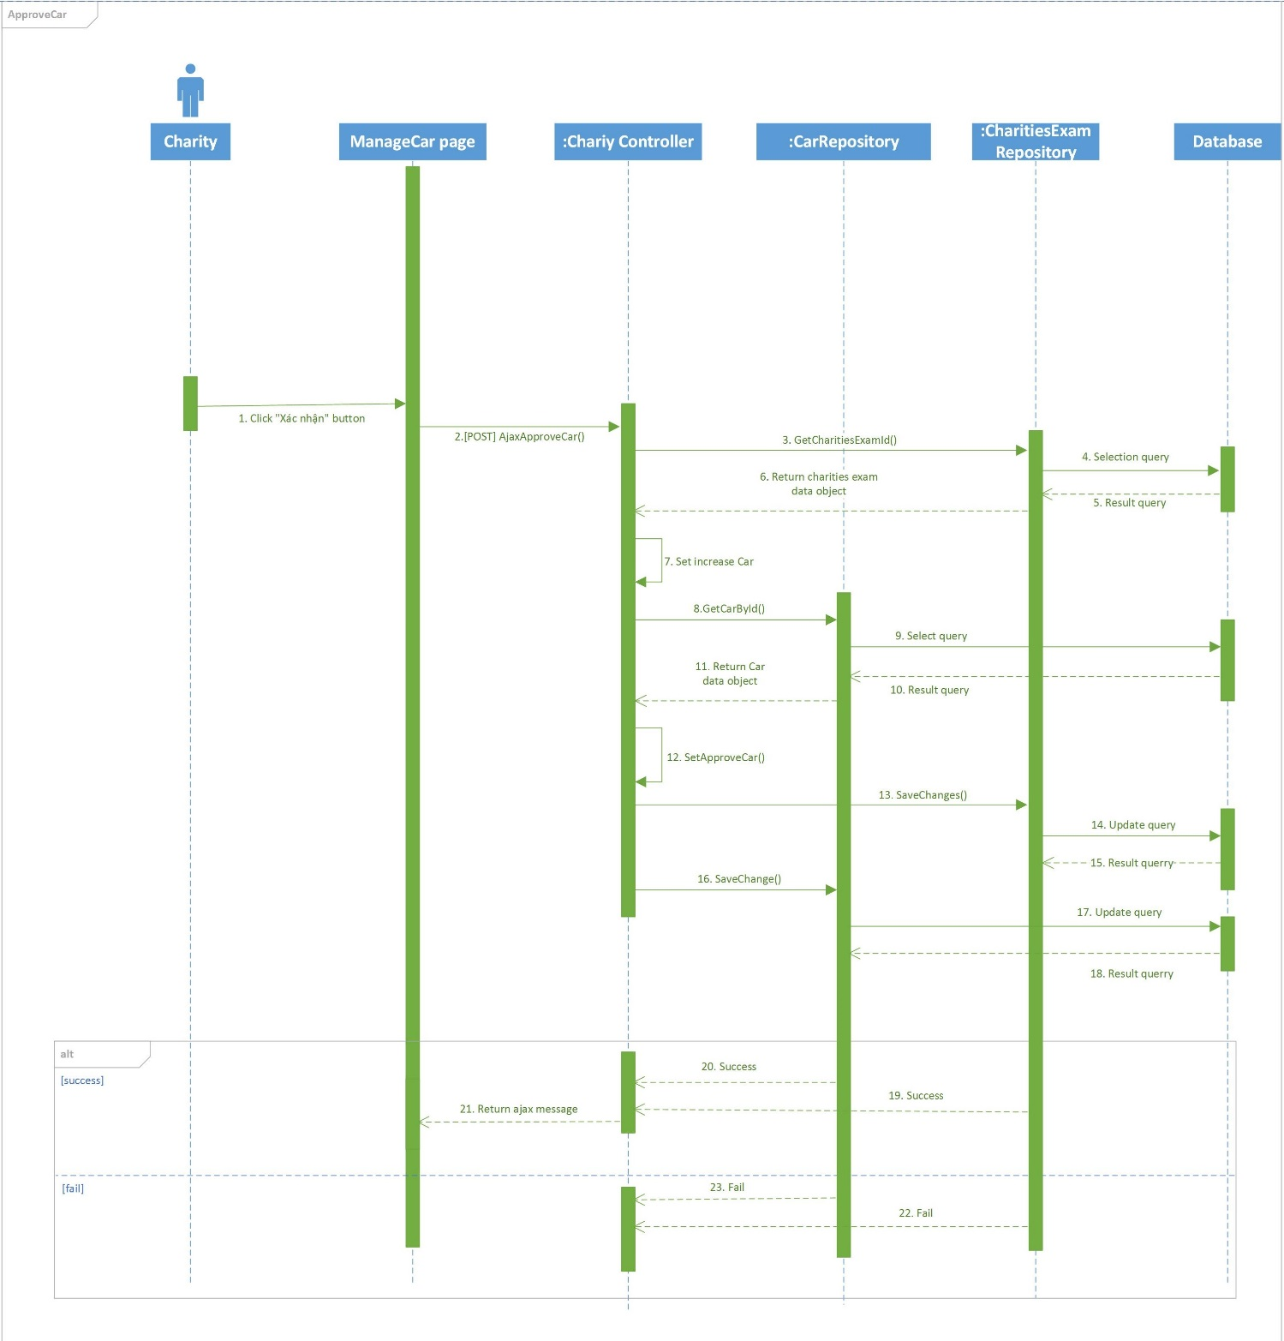

### **Sequence diagram: Approve Lodge (Charity)**

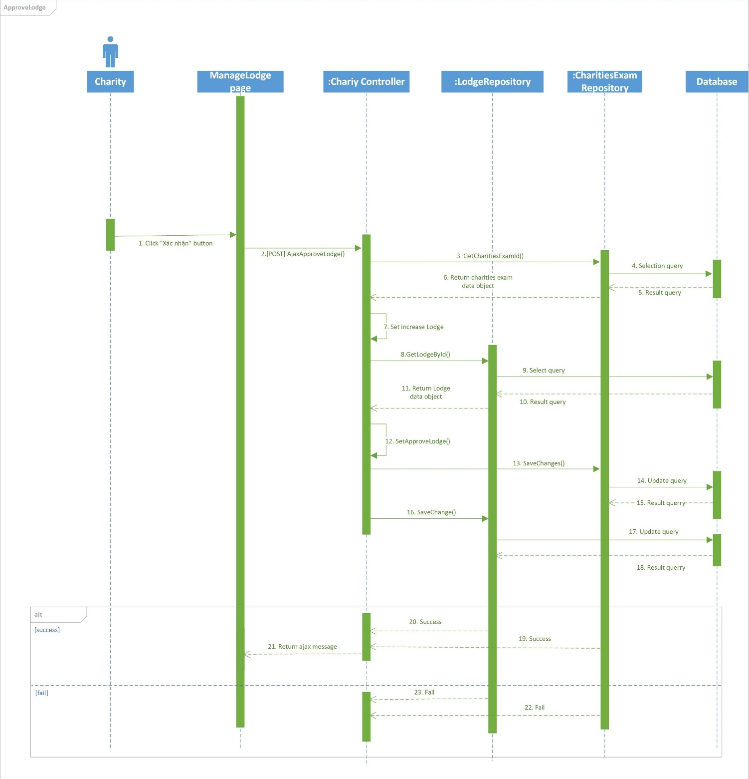

### **Sequence diagram: Assign Car to Charity Exam (Charity)**

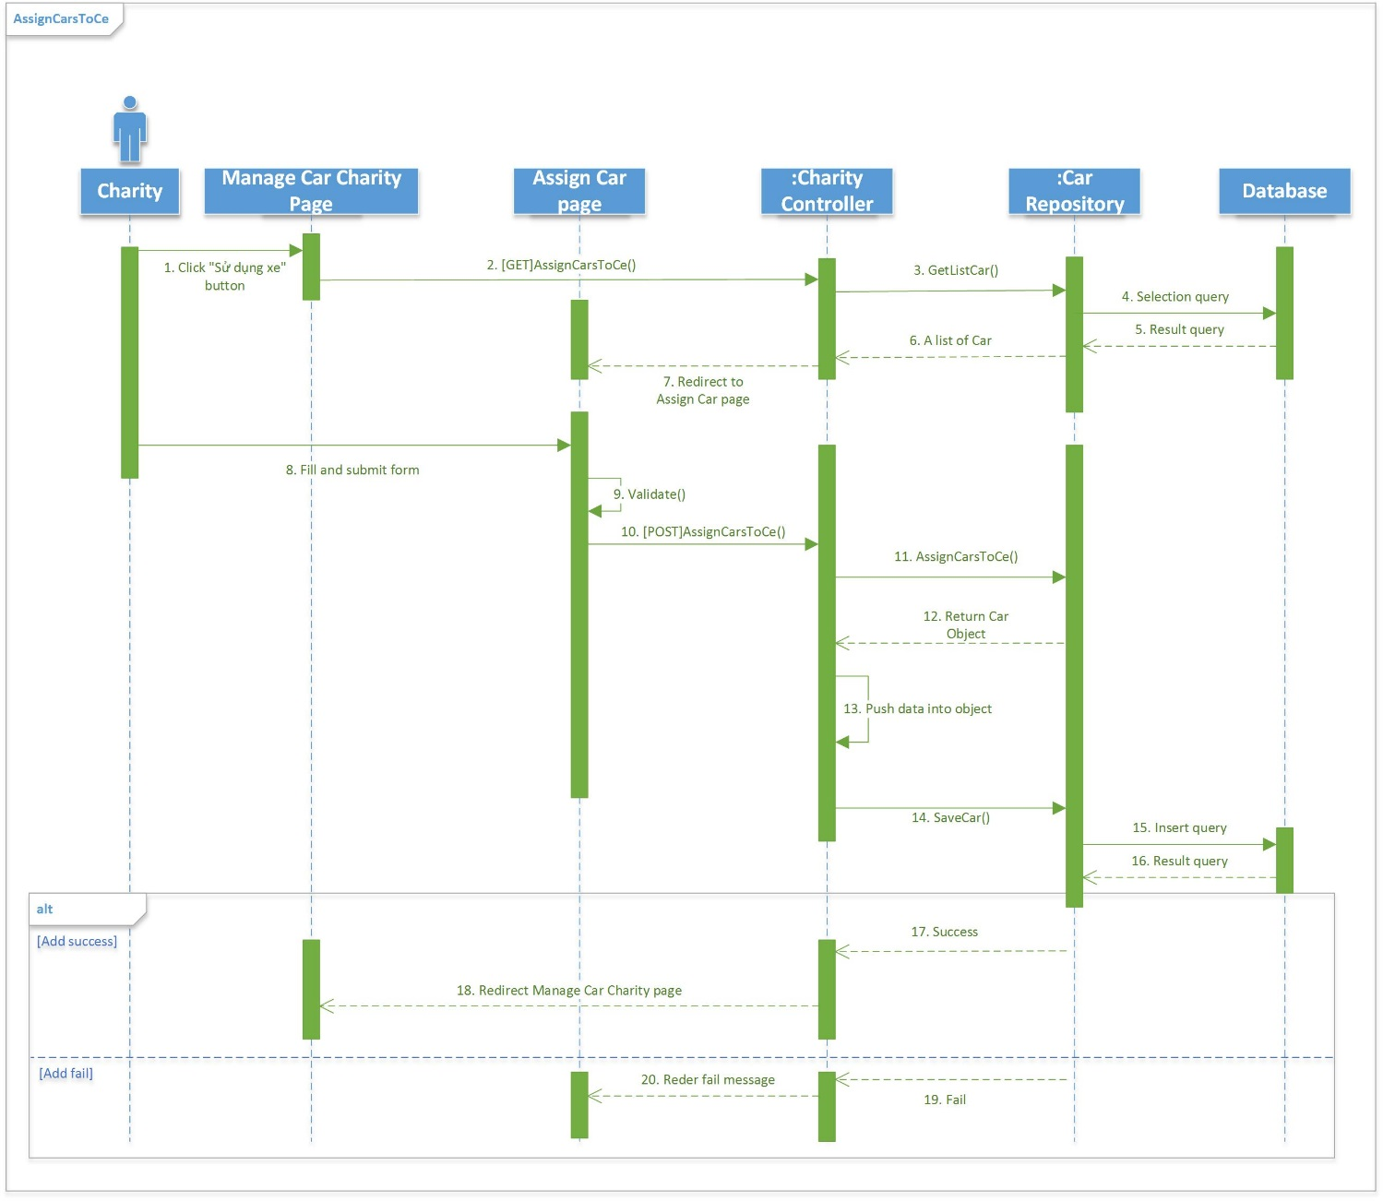

### **Sequence diagram: Assign Lodge to Charity Exam (Charity)**

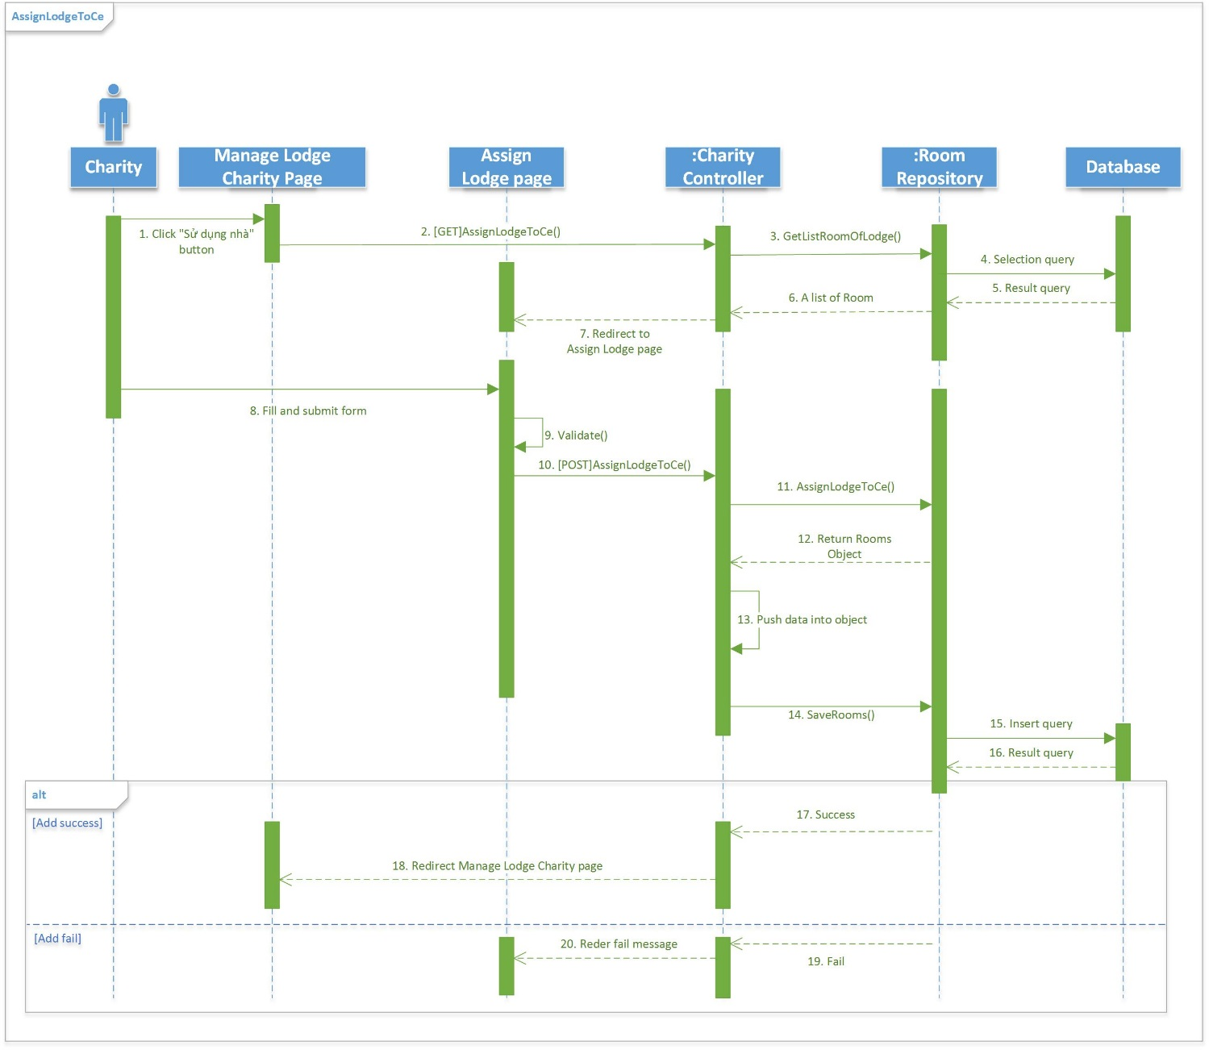

### **Sequence diagram: Delete Lodge (Charity)**

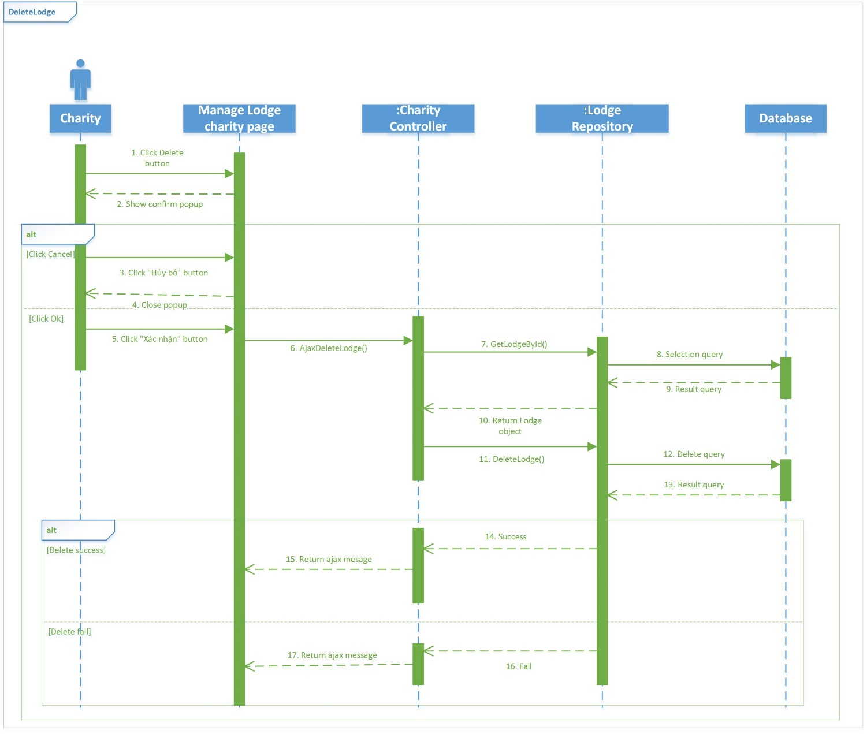

### **Sequence diagram: Denie Car (Charity)**

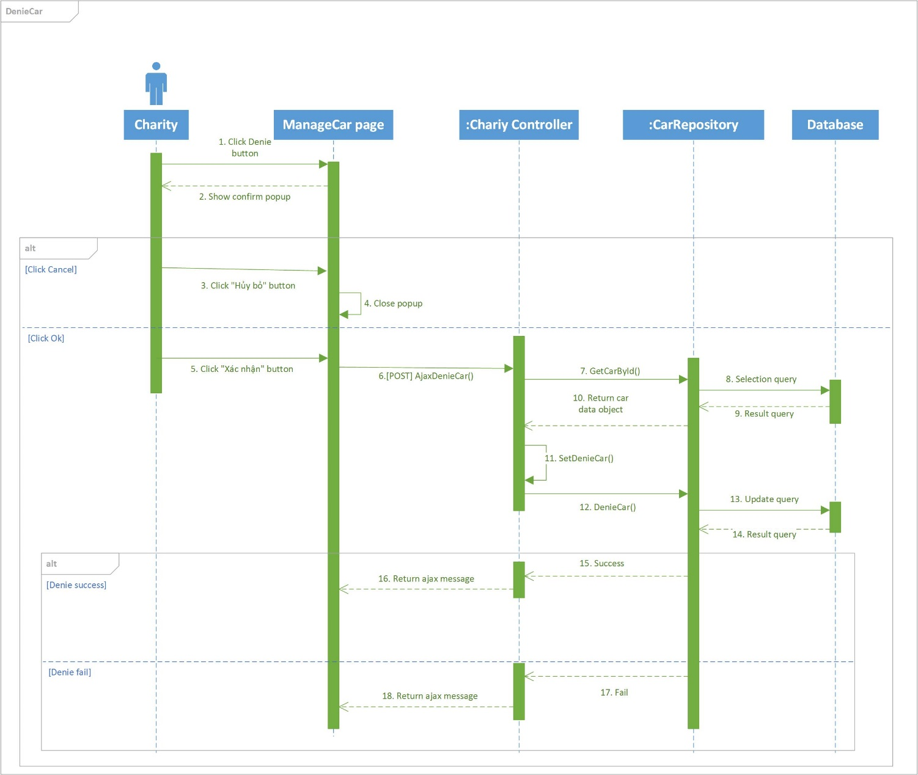

### **Sequence diagram: Denie Lodge (Charity)**

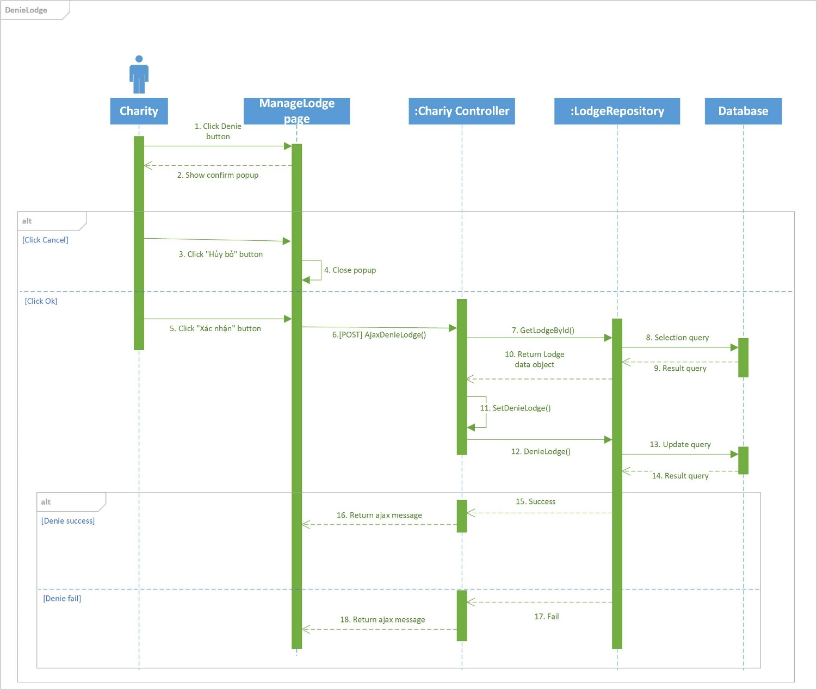

### **Sequence diagram: Edit Lodge (Charity)**

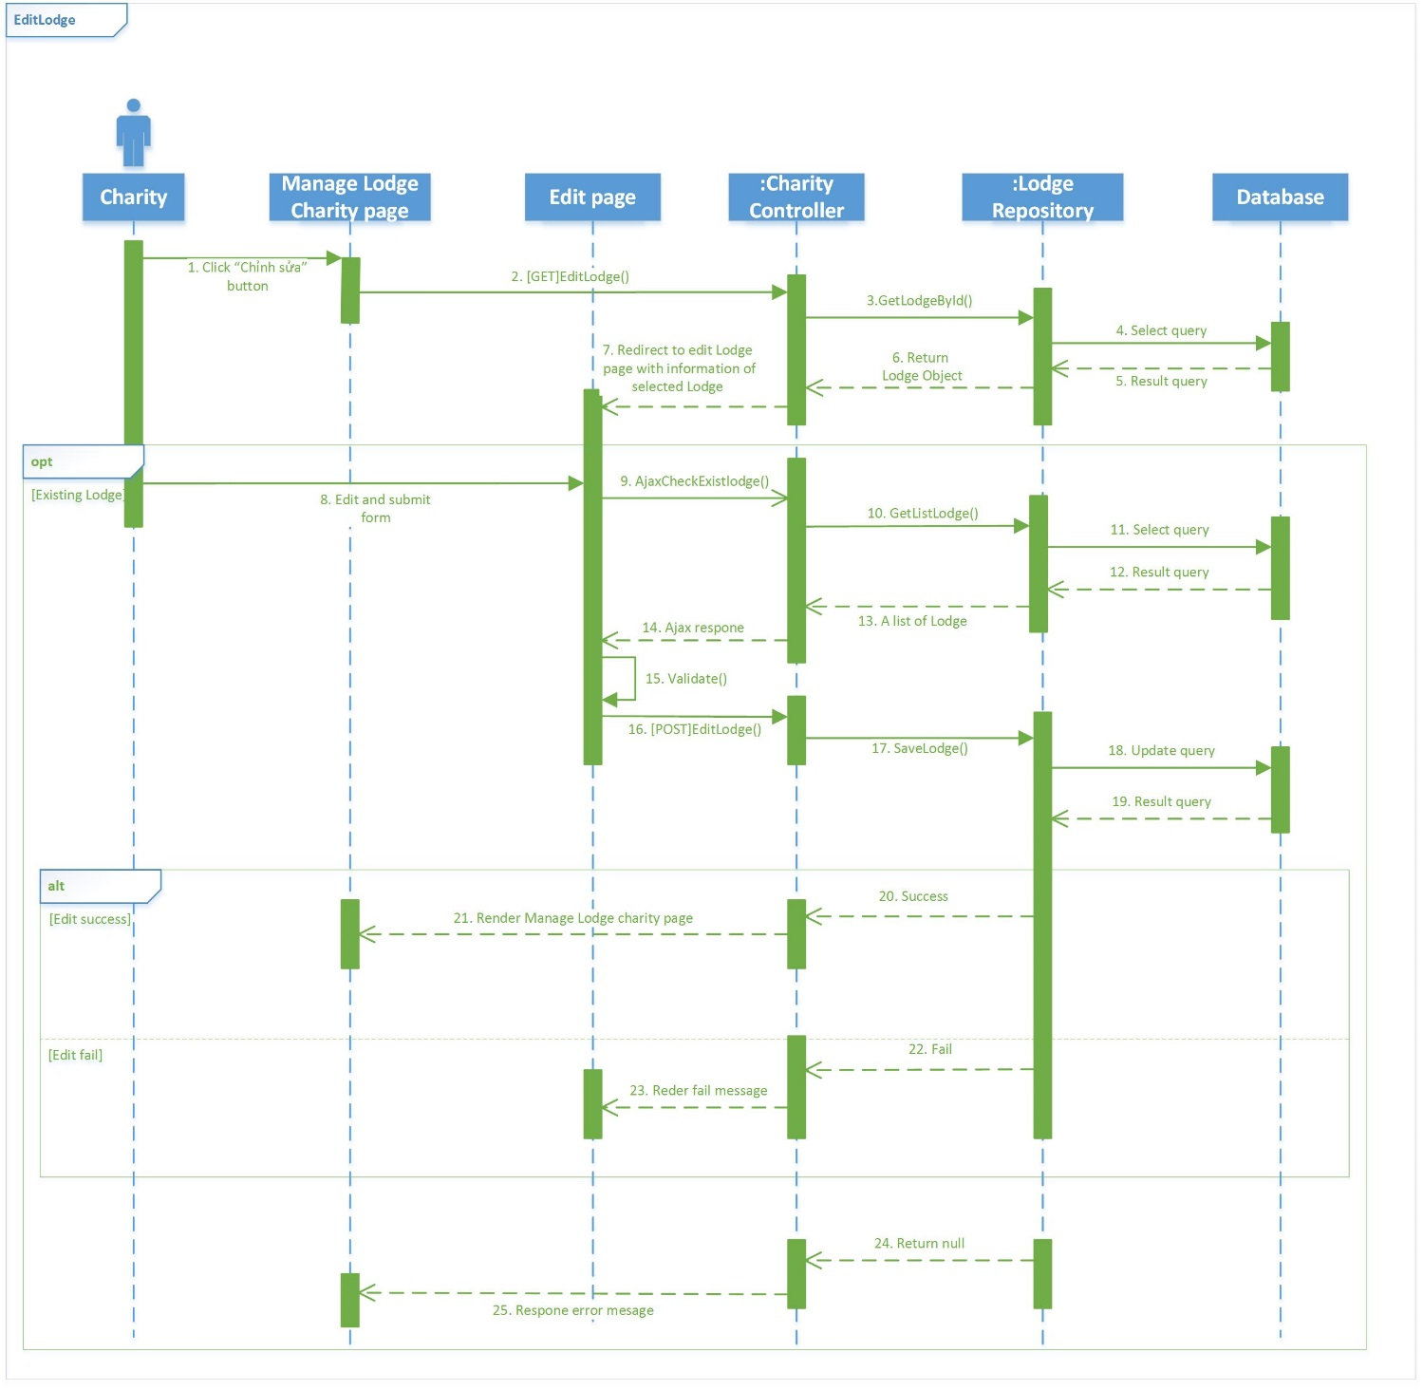

### **Sequence diagram: Remove Car (Charity)**

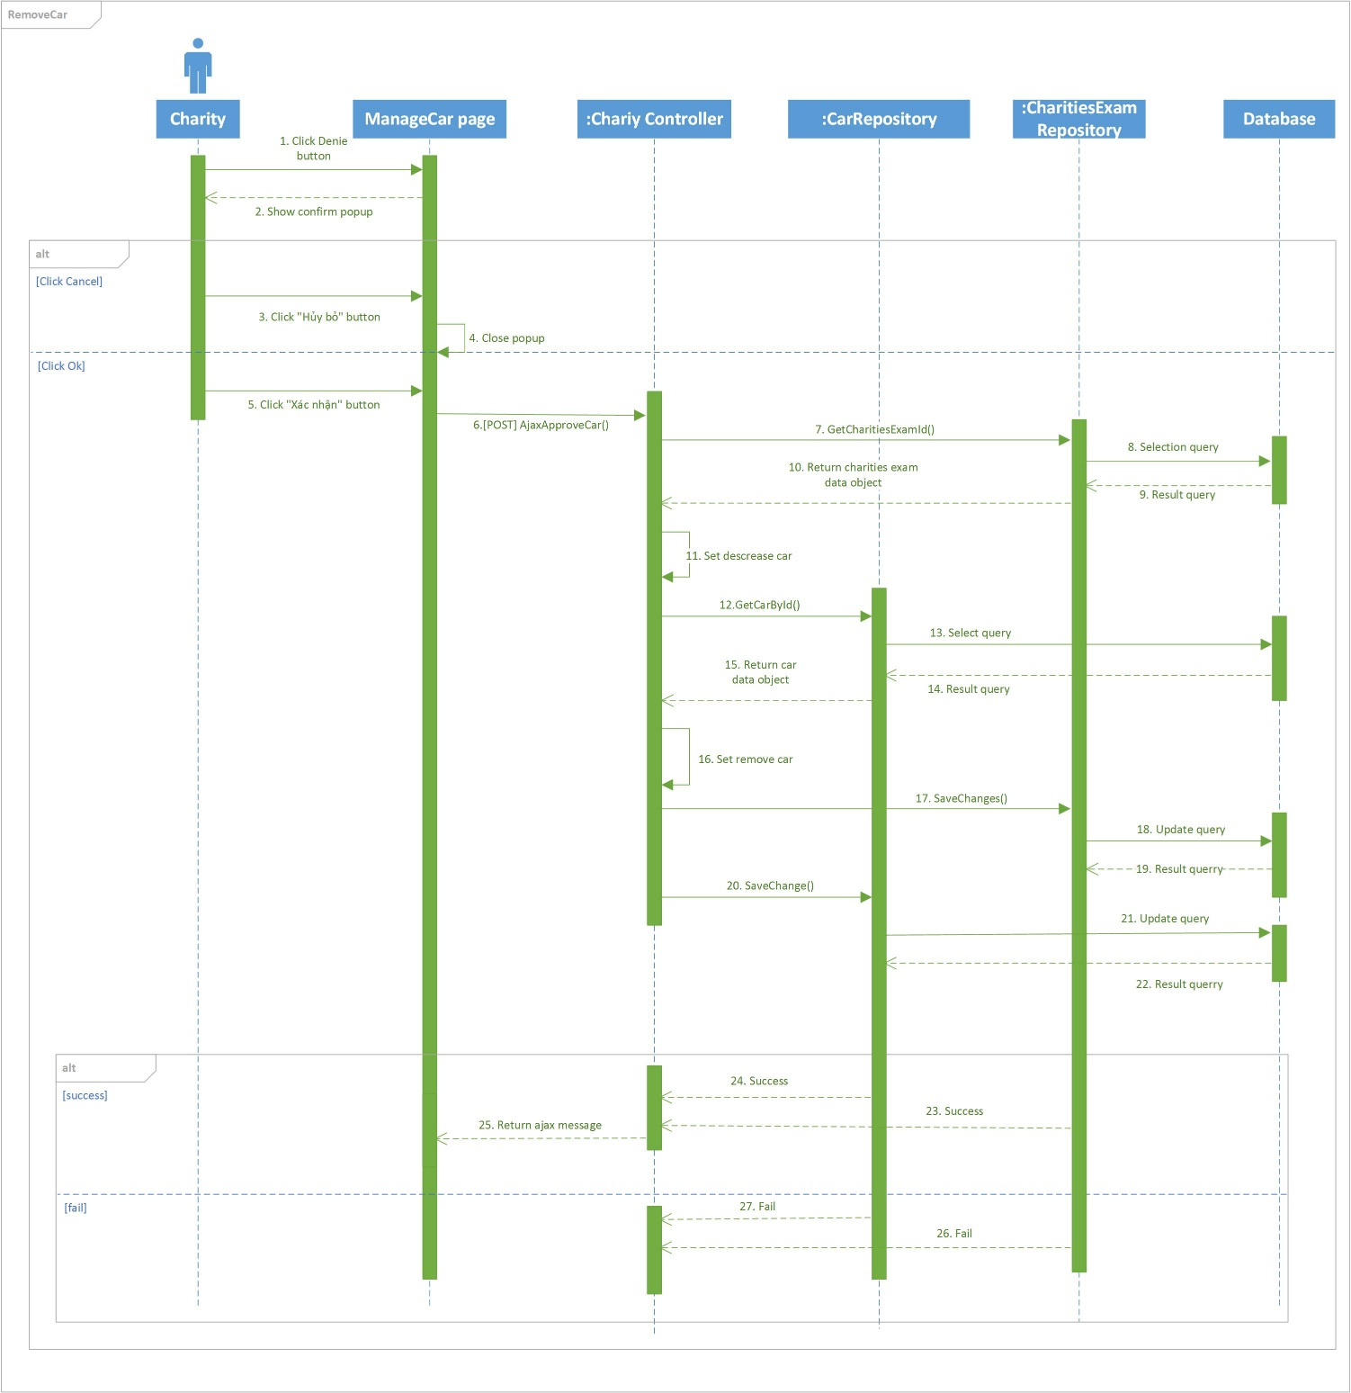

### **Sequence diagram: Add Car (Sponsor)**

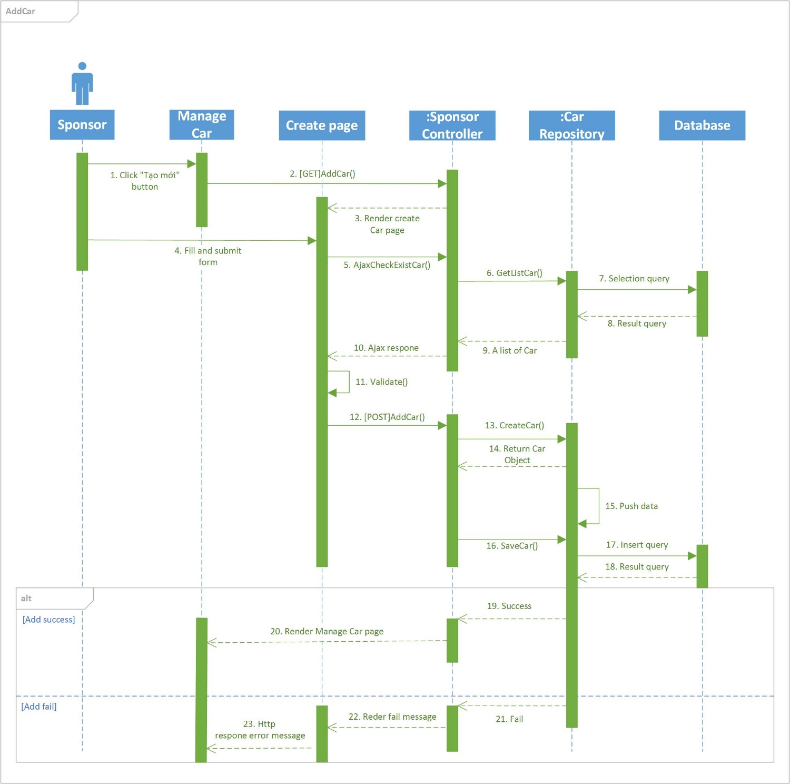

### **Sequence diagram: Edit Car (Sponsor)**

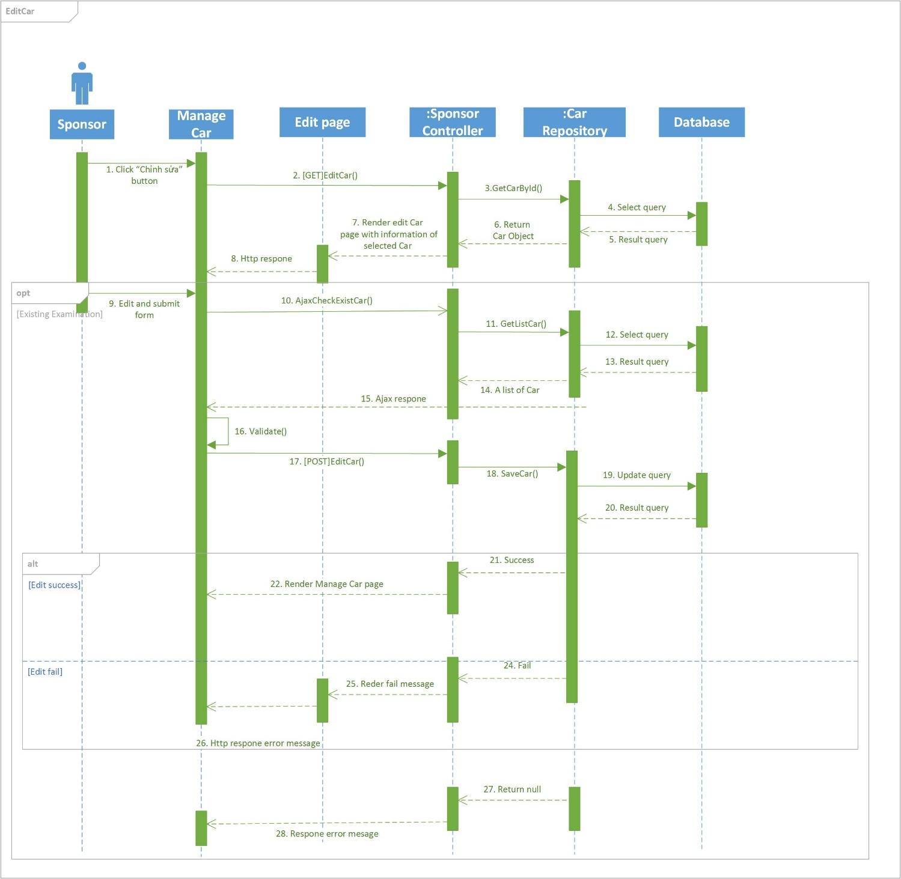

### **Sequence diagram: Delete Car (Sponsor)**

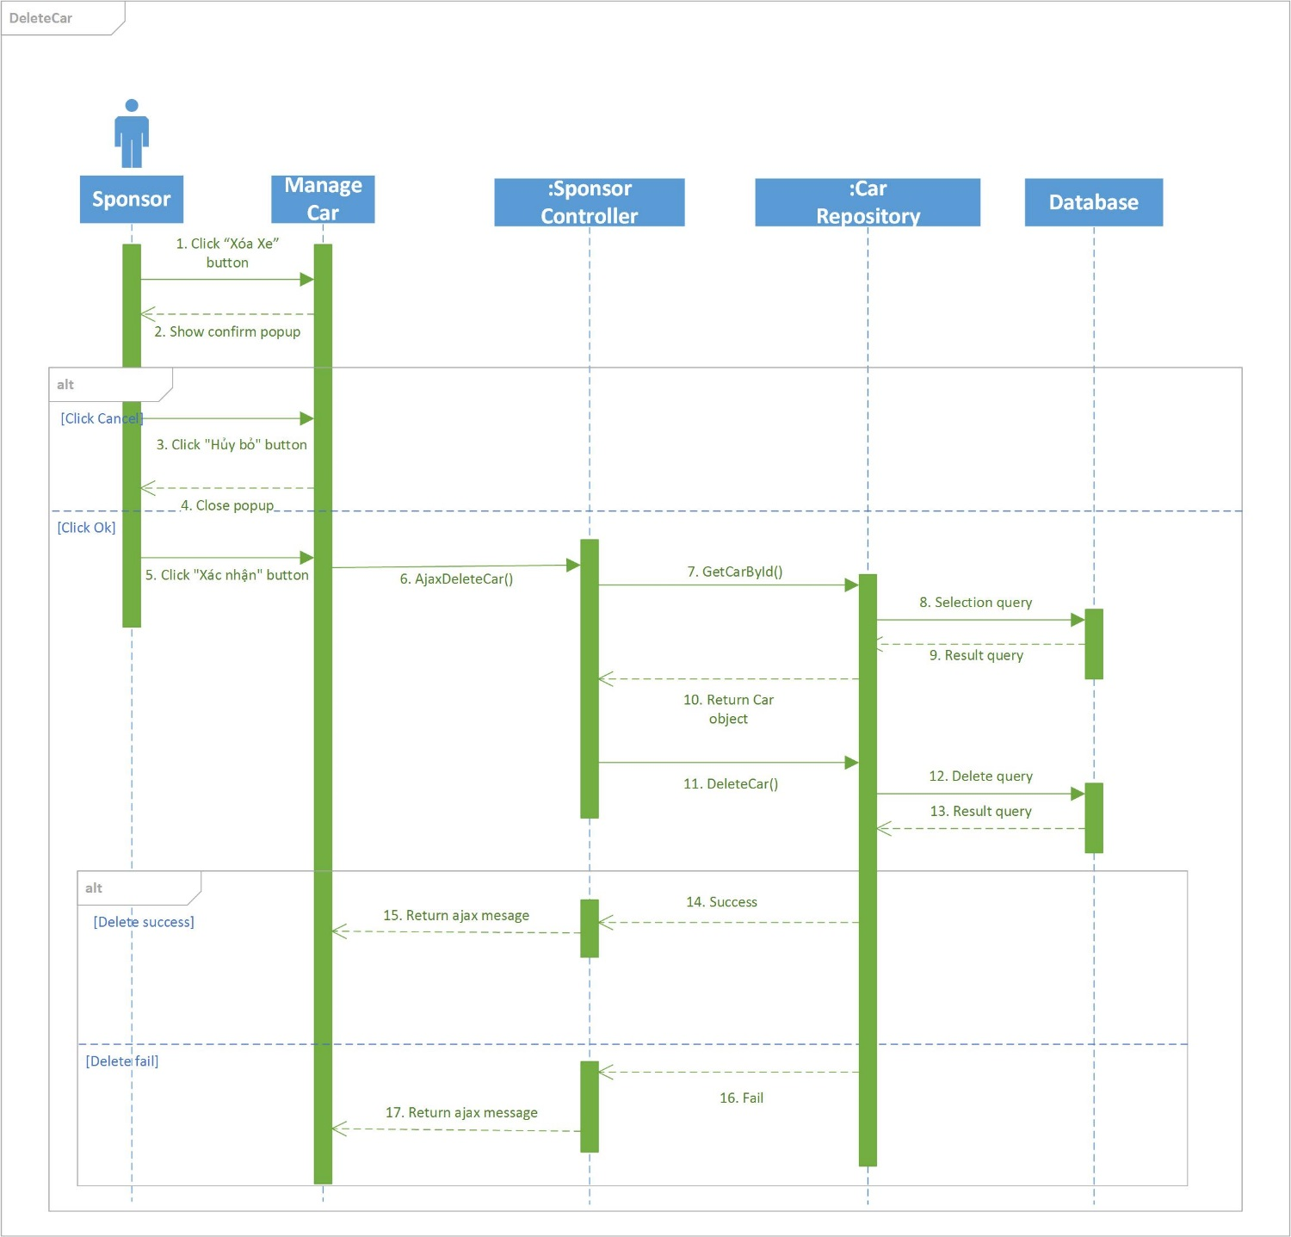

### **Sequence diagram: View Car (Sponsor)**

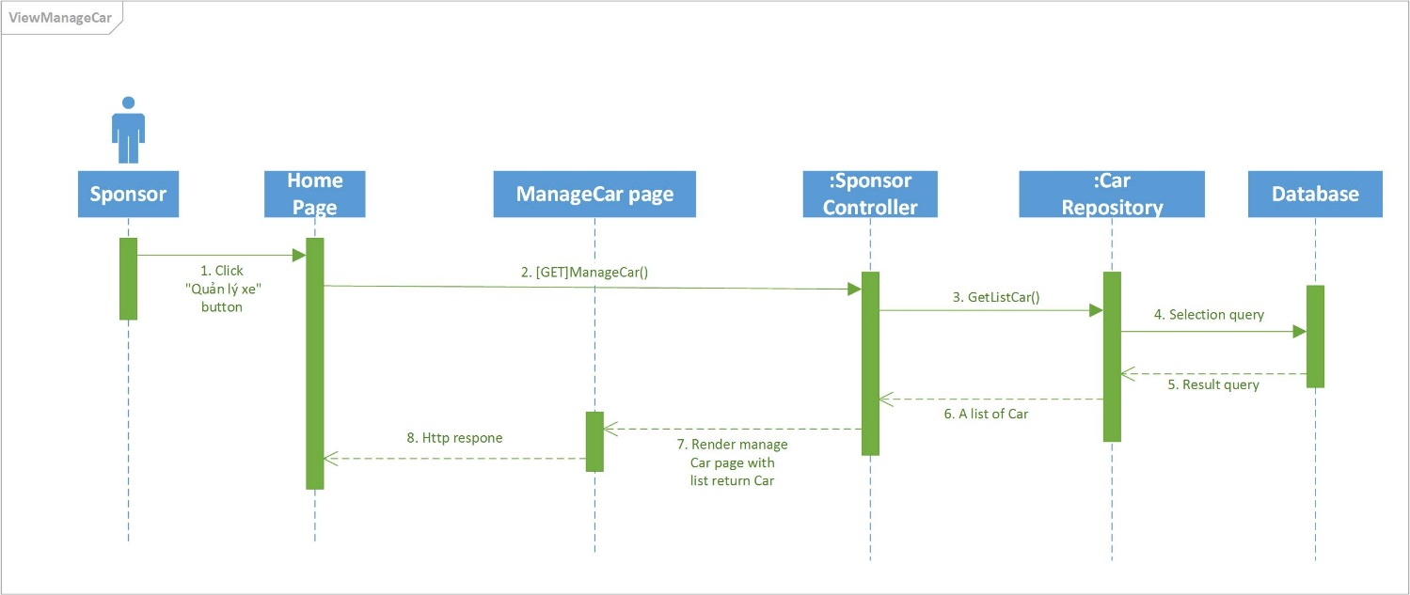

### **Sequence diagram: Add Lodge (Sponsor)**

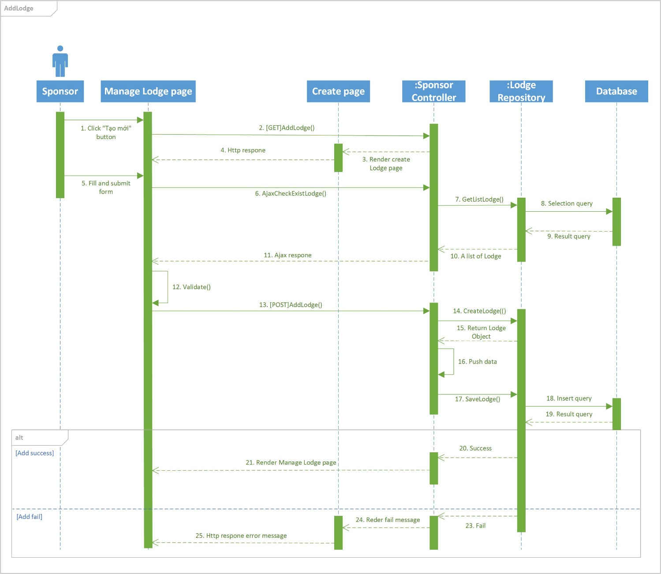

### **Sequence diagram: Edit Lodge (Sponsor)**

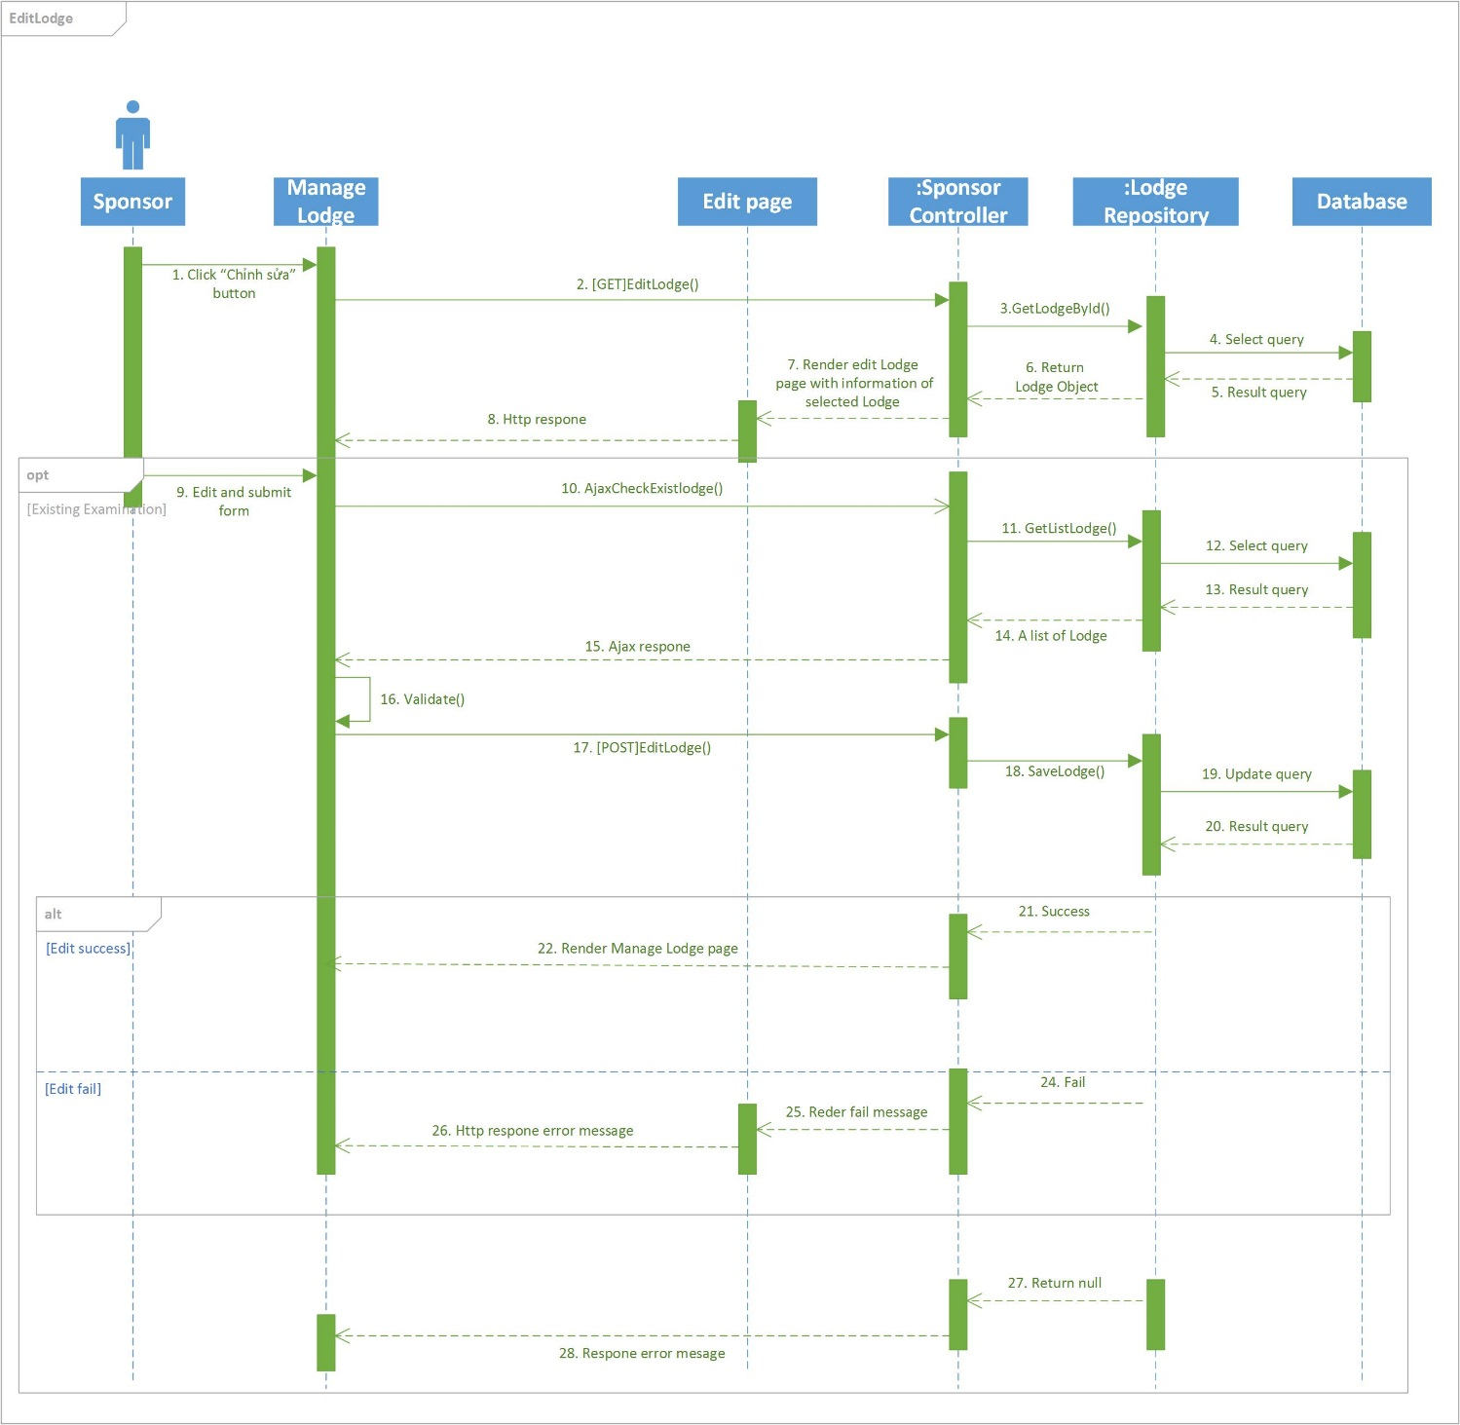

### **Sequence diagram: Delete Lodge (Sponsor)**

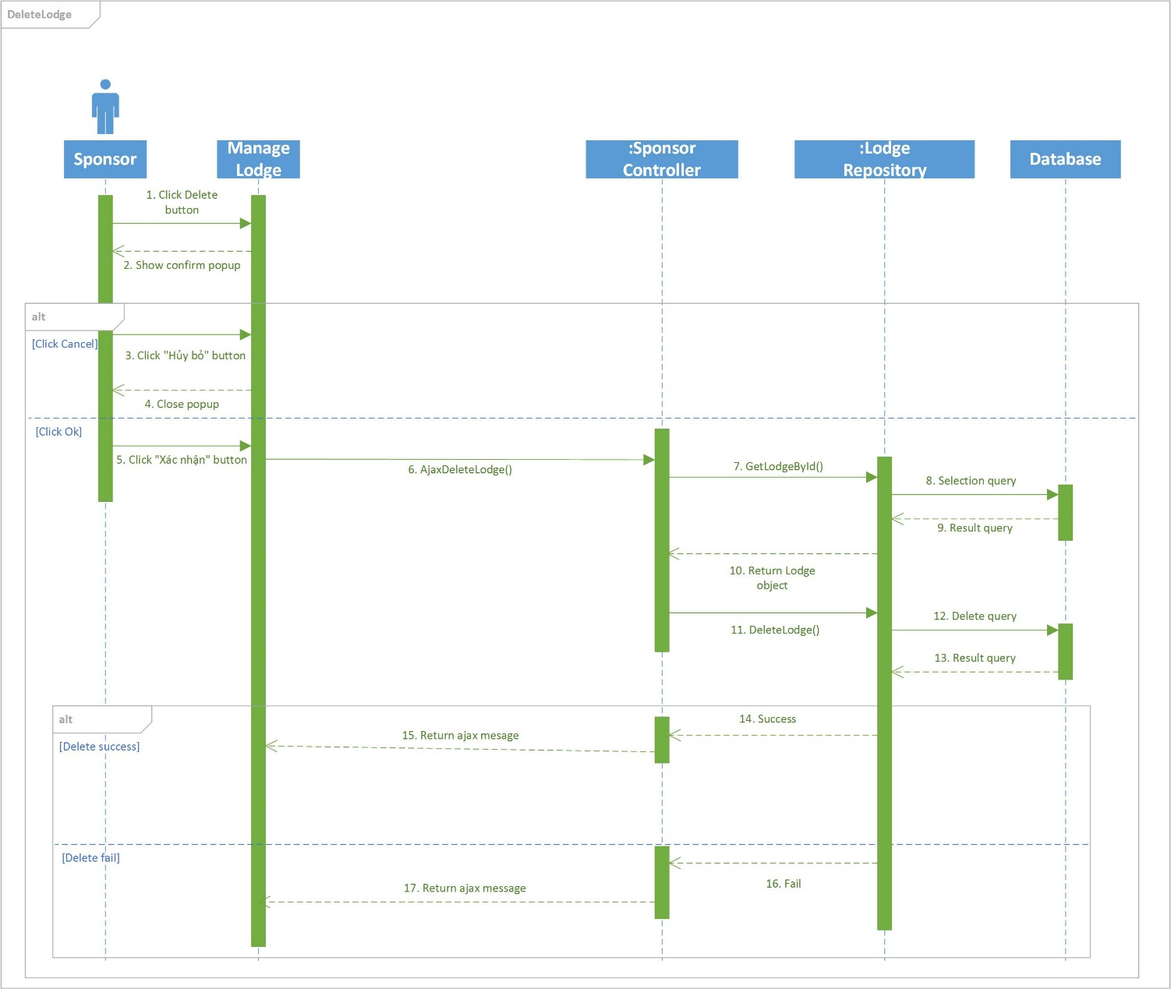

### **Sequence diagram: View Lodge (Sponsor)**

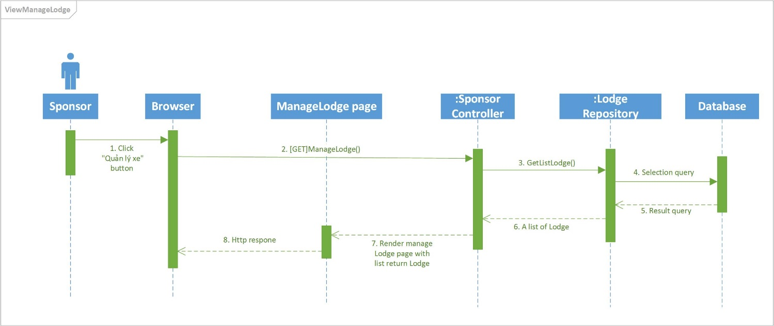

### **Sequence diagram: View Detail Lodge (Sponsor)**



### **Sequence diagram: Add Room (Sponsor)**

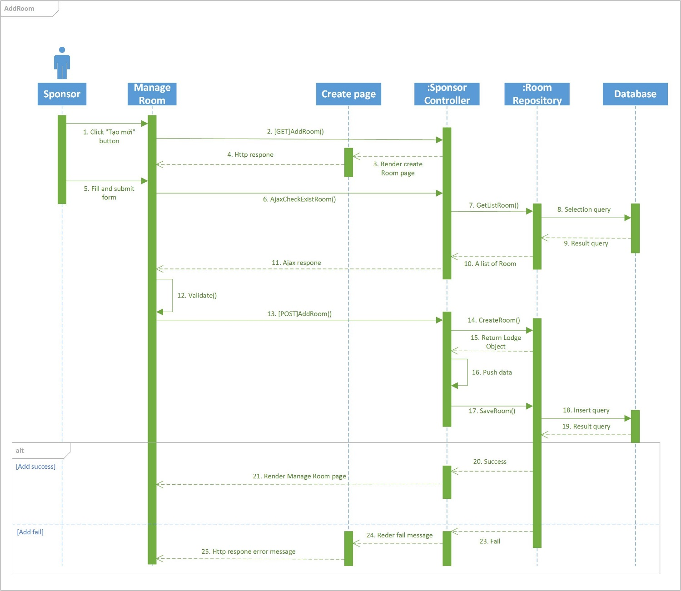

### **Sequence diagram: Delete Room (Sponsor)**

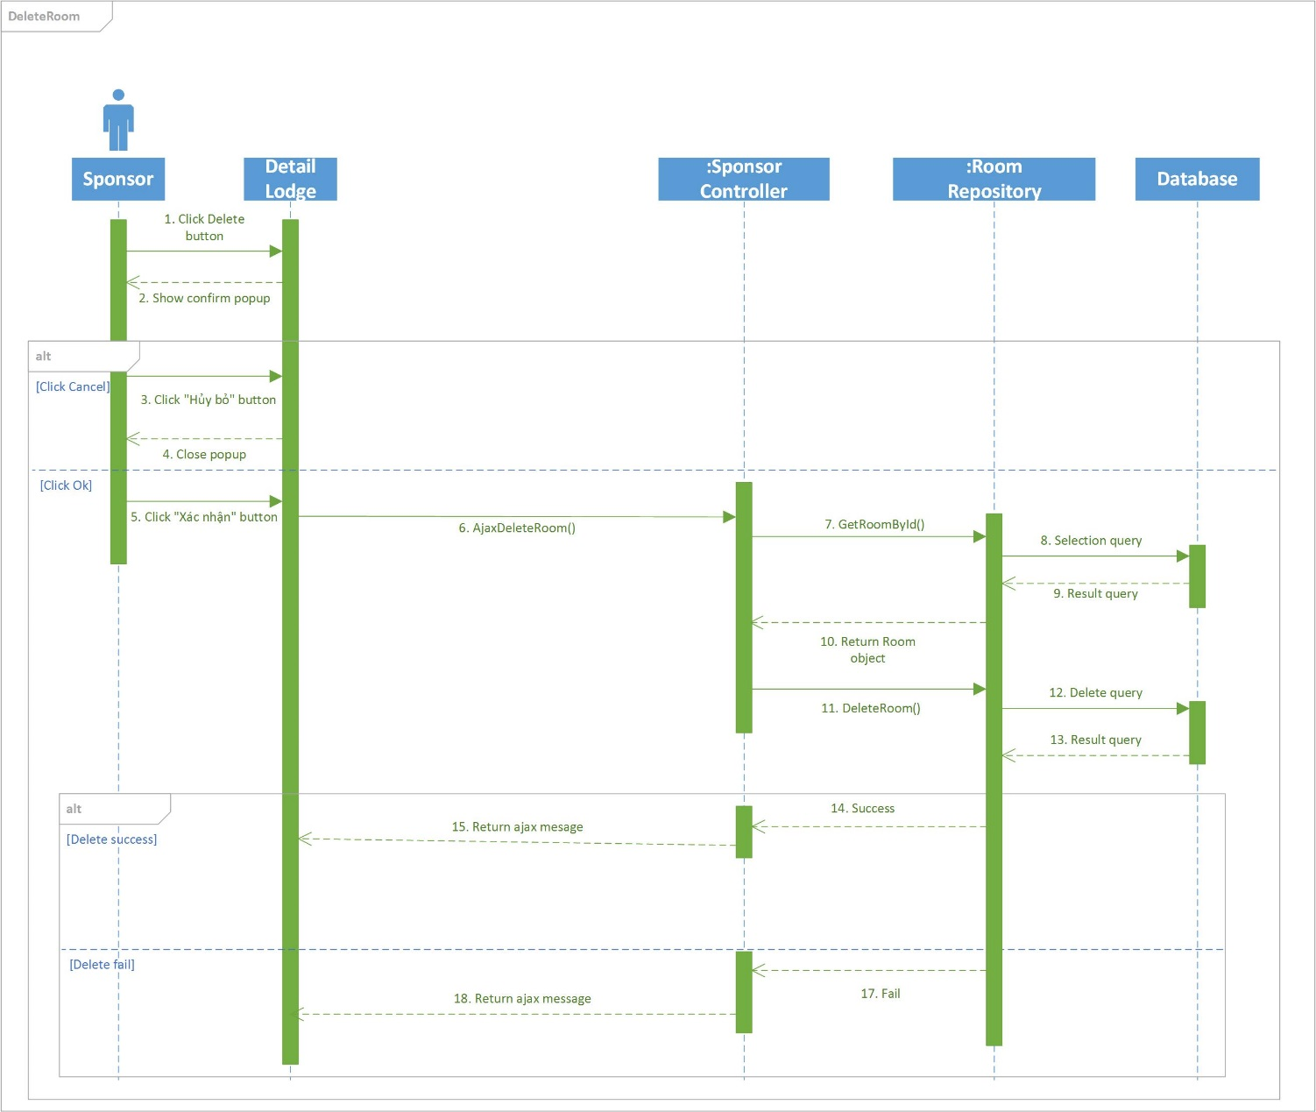

### **Sequence diagram: View Fund (Sponsor)**

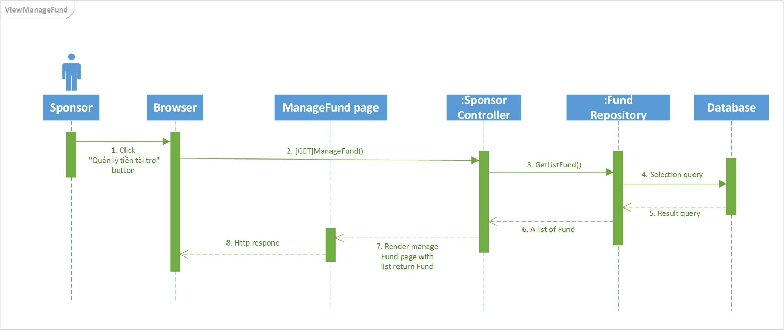

### **Sequence diagram: View Statistic (Sponsor)**

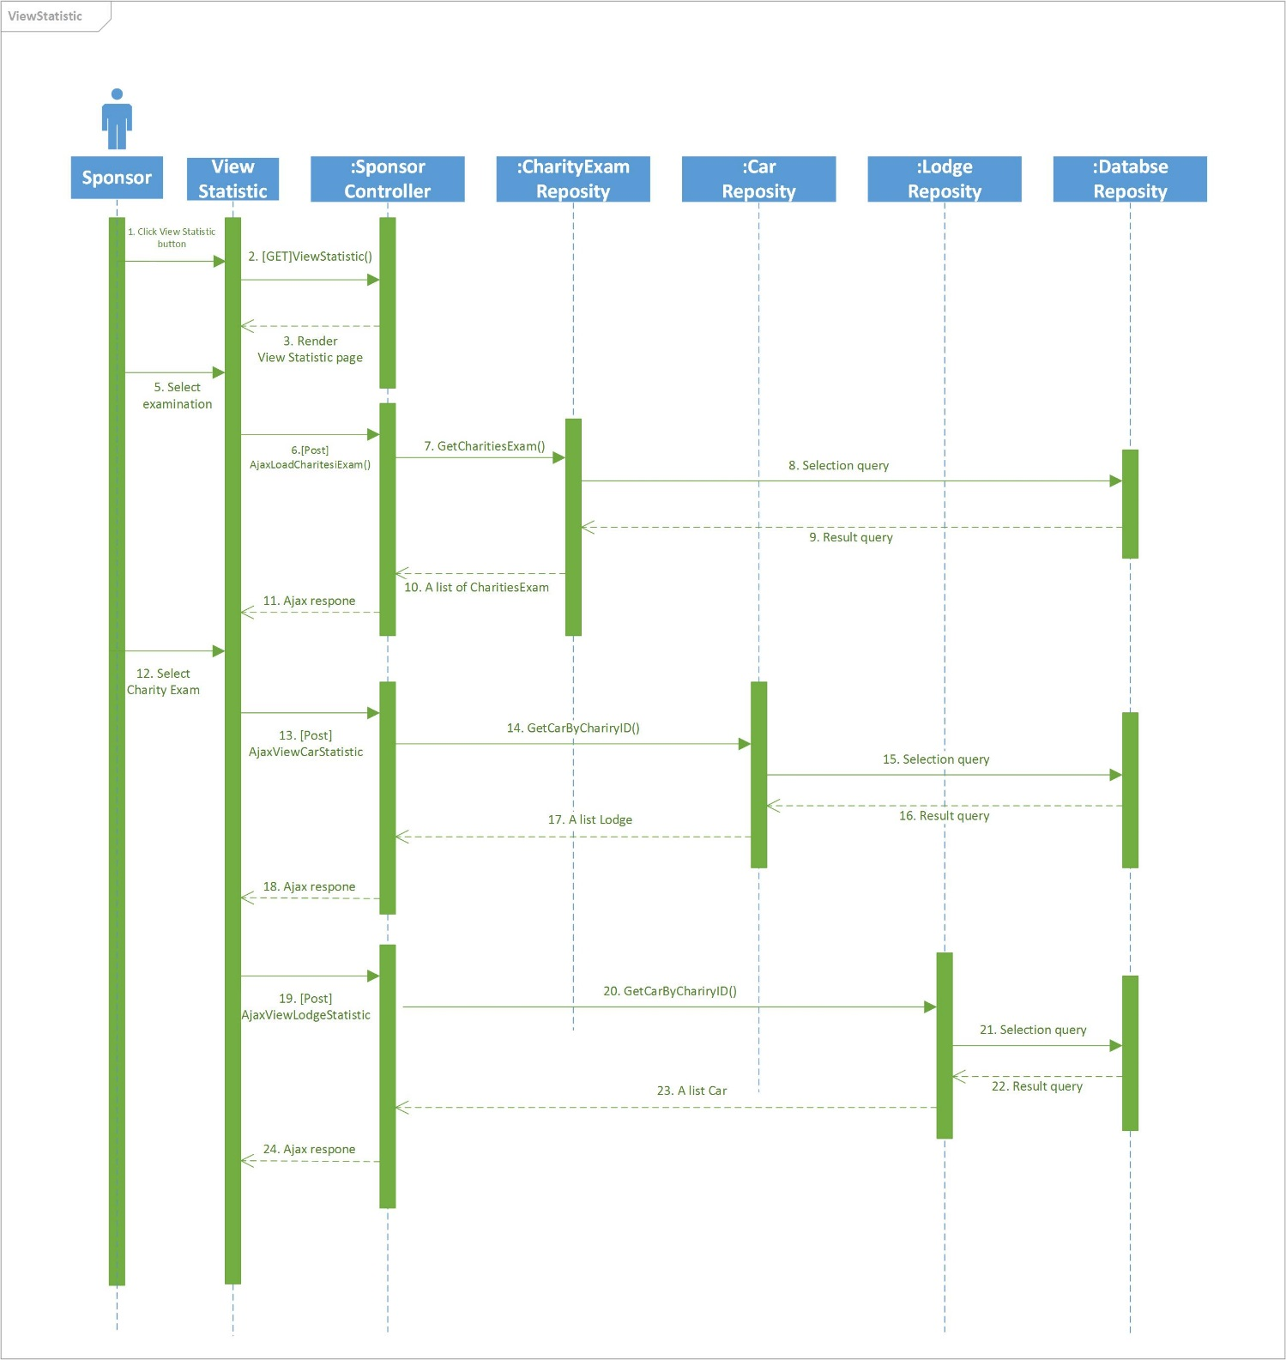

### **Sequence diagram: Sponsored Resource (Sponsor)**

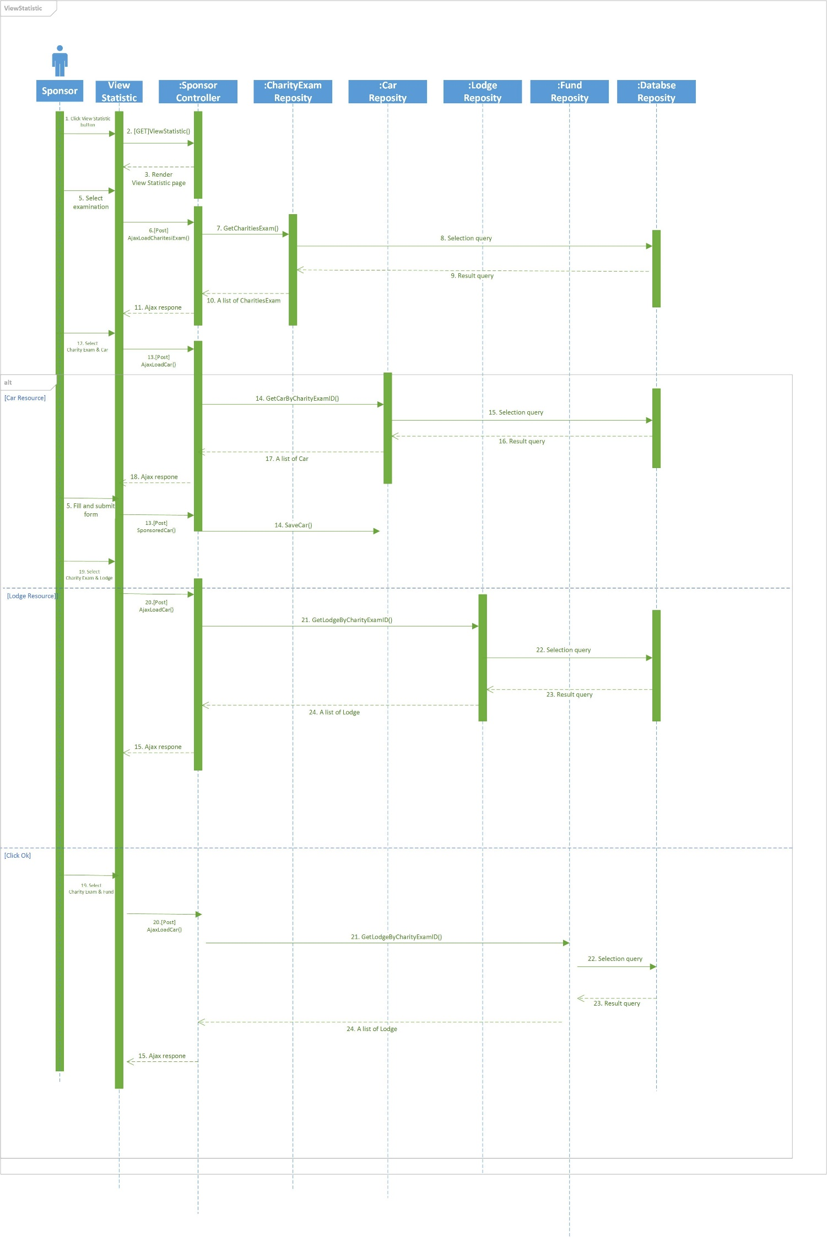

### **Sequence diagram: Cancel Sponsored Car (Sponsor)**

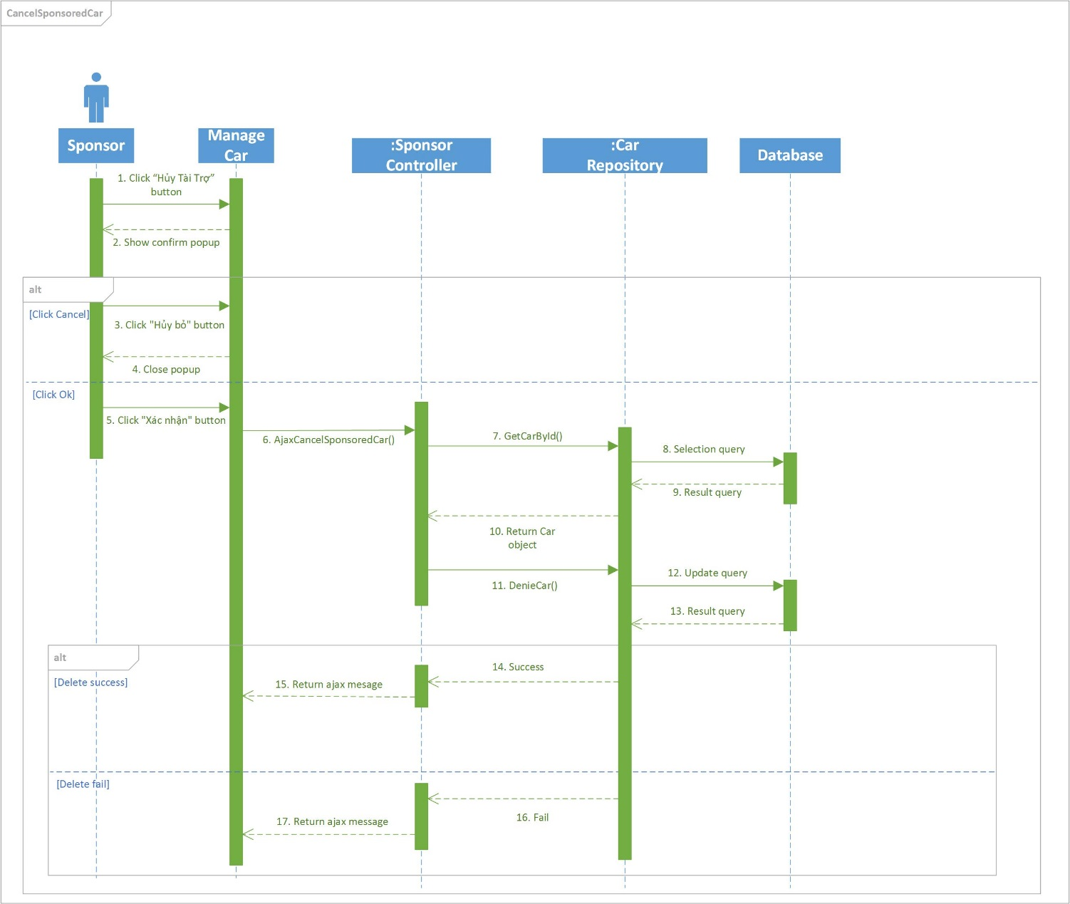

### **Sequence diagram: Join Charity Examination (Volunteer)**

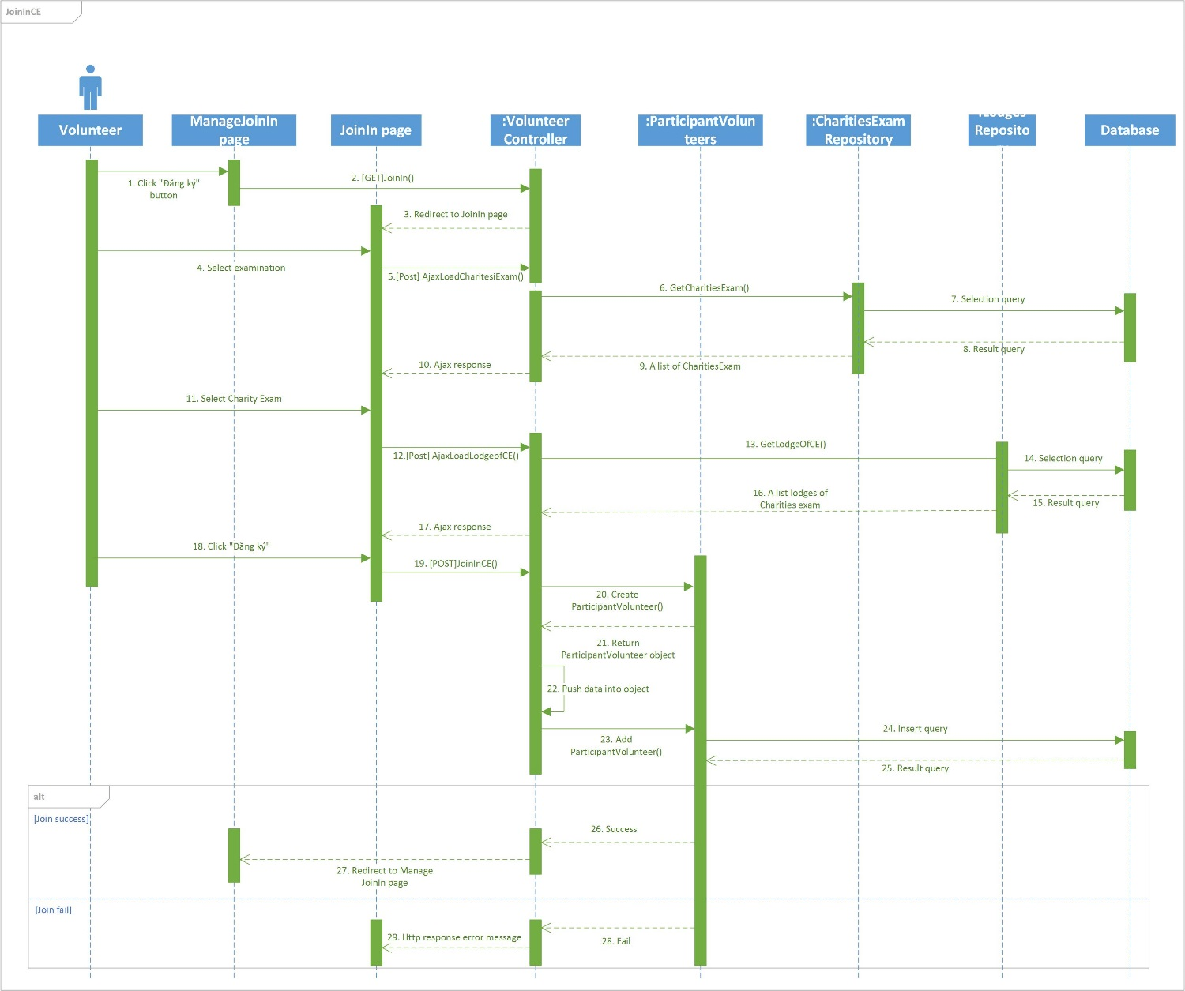

### **Sequence diagram: Leave Charity Examination (Volunteer)**

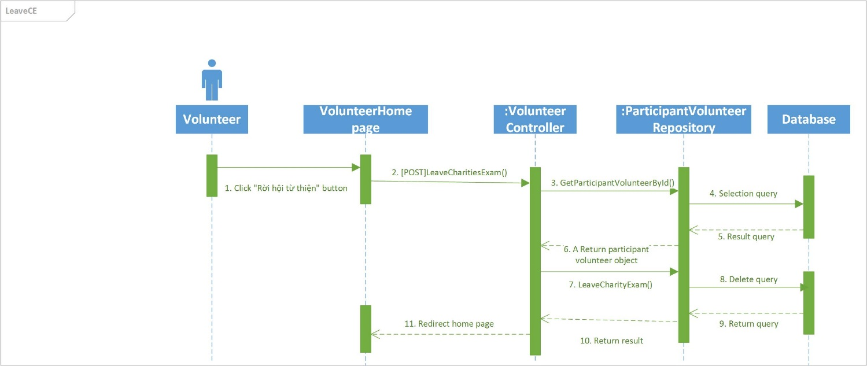

## **Database Design**

### **Logical Database Design**

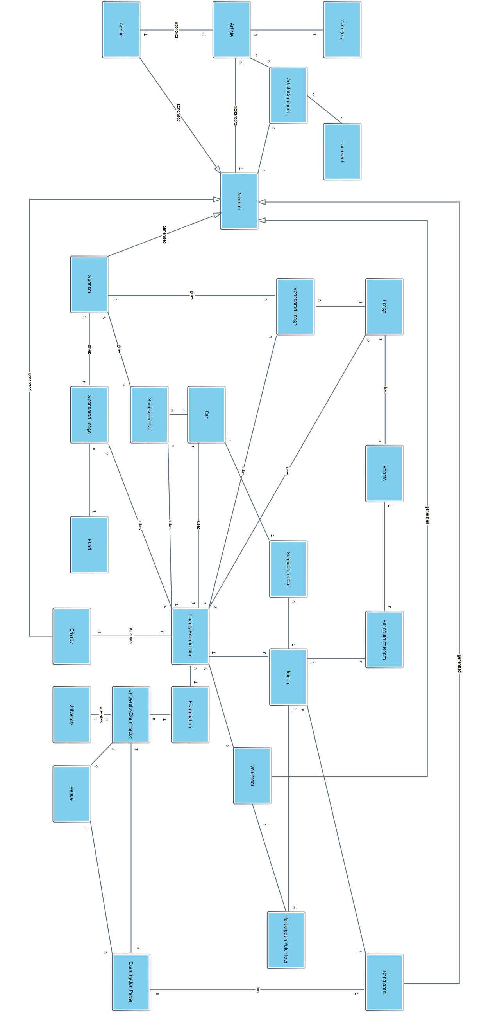

### **Accounts**

|  |  |  |  |  |  |  |
| --- | --- | --- | --- | --- | --- | --- |
| Field Name | Type | Nullable | Unique | Key | Default | Description |
| *AccountID* | int |  | 🗹 | PK |  | Unique id that identity each account from the others |
| *Email* | nvarchar(50) |  |  |  |  | Email of each account use to logged in the system |
| *Password* | nvarchar(20) |  |  |  |  | Password of each account use to logged in the system |
| *IsActive* | bit |  |  |  |  | State of account is active or not |
| *ProfileID* | int | 🗹 |  | FK |  | Id of the profile that belongs account |
| *RoleID* | int |  |  | FK |  | Id of the user in that role |

### **Articles**

|  |  |  |  |  |  |  |
| --- | --- | --- | --- | --- | --- | --- |
| Field Name | Type | Nullable | Unique | Key | Default | Description |
| *ArticleID* | int |  | 🗹 | PK |  | Unique id that identity each article from others |
| *Title* | nvarchar(200) |  |  |  |  | Title of article |
| *CategoryID* | int |  |  | FK |  | Id of the category type belongs article |
| *CreatedOn* | datetime |  |  |  |  | Date created article |
| *CreatedBy* | int |  |  | FK |  | Id of account who creates article |
| *[Content]* | nvarchar(MAX) |  |  |  |  | Content of article |
| *LastModifiedOn* | datetime | 🗹 |  |  |  | Date in last modify by user |
| *AvatarImage* | nvarchar(MAX) | 🗹 |  |  |  | Url of the avatar image for the article |
| *IsAprroved* | bit |  |  |  |  | Whether the article is approved or not |
| *Summary* | nvarchar(MAX) | 🗹 |  |  |  | Summary content of article |

### **Candidates**

|  |  |  |  |  |  |  |
| --- | --- | --- | --- | --- | --- | --- |
| Field Name | Type | Nullable | Unique | Key | Default | Description |
| *CandidateID* | int |  | 🗹 | PK |  | Unique id that identity each candidate from others |
| *AccountID* | int |  |  | FK |  | Id of account of candidate |

### **Cars**

|  |  |  |  |  |  |  |
| --- | --- | --- | --- | --- | --- | --- |
| Field Name | Type | Nullable | Unique | Key | Default | Description |
| *CarID* | int |  | 🗹 | PK |  | Unique id that identity each car from others |
| *CharityExamID* | int | 🗹 |  | FK |  | Id of the charity exam when car join in |
| *SponsorID* | int | 🗹 |  | FK |  | Id of the sponsor who own this car |
| *NumberPlate* | nvarchar(20) | 🗹 |  |  |  | The plate of car |
| *TotalSlots* | int |  |  |  |  | Number of slots in car |
| *AvailableSlots* | int |  |  |  |  | Number of slot available to seat |
| *DriverName* | nvarchar(50) | 🗹 |  |  |  | Driver’ name of car |
| *DriverPhone* | nvarchar(50) | 🗹 |  |  |  | Driver’s phone of car |
| *IsApproved* | bit |  |  |  |  | Whether the car is approved or not |
| *CharityID* | int | 🗹 |  | FK |  | Id of the charity who own this car |
| *LodgeID* | int | 🗹 |  | FK |  | Id of lodge where car service |
| *VenueID* | int | 🗹 |  | FK |  | Id of venue where car service |

### **Categories**

|  |  |  |  |  |  |  |
| --- | --- | --- | --- | --- | --- | --- |
| Field Name | Type | Nullable | Unique | Key | Default | Description |
| *CategoryID* | int |  | 🗹 | PK |  | Unique id that identity each category from others |
| *CategoryName* | nvarchar(50) |  |  |  |  | Name of category |

### **CharitiesExams**

|  |  |  |  |  |  |  |
| --- | --- | --- | --- | --- | --- | --- |
| Field Name | Type | Nullable | Unique | Key | Default | Description |
| *CharityExamID* | int |  | 🗹 | PK |  | Unique id that identity each charity exam from others |
| *ExamID* | int |  |  | FK |  | Id of examination which charity exam organize |
| *CharityID* | int |  |  | FK |  | Id of the charity who organize charity exam |
| *TotalSlotsLodges* | int |  |  |  |  | Number of slots for candidate join |
| *AvailableSlotsLodges* | int |  |  |  |  | Number of available slots candidate can register |
| *TotalSlotsVehicles* | int |  |  |  |  | Number of total slot vehicle |
| *AvailableSlotsVehicles* | int |  |  |  |  | Number of available slots vehicle can be seat. |

### **Charities**

|  |  |  |  |  |  |  |
| --- | --- | --- | --- | --- | --- | --- |
| Field Name | Type | Nullable | Unique | Key | Default | Description |
| *CharityID* | int |  | 🗹 | PK |  | Unique id that identity each charity from others |
| *AccountID* | int |  |  | FK |  | Id of account of charity |
| *Description* | nvarchar(MAX) |  |  |  |  | Description about charity |
| *Name* | nvarchar(50) |  |  |  |  | Name of charity |

### **Comments**

|  |  |  |  |  |  |  |
| --- | --- | --- | --- | --- | --- | --- |
| Field Name | Type | Nullable | Unique | Key | Default | Description |
| *CommentID* | int |  | 🗹 | PK |  | Unique id that identity each comment from others |
| *ArticleID* | int |  |  | FK |  | Id of the article that comment display in |
| *AccountID* | int |  |  | FK |  | Id of account who create the comment |
| *[Content]* | nvarchar(MAX) |  |  |  |  | Content of comment |
| *CreatedOn* | datetime |  |  |  |  | Date time create comment |
| *ReplyFor* | Int |  |  |  |  | Id of comment that comment reply |

### **Districts**

|  |  |  |  |  |  |  |
| --- | --- | --- | --- | --- | --- | --- |
| Field Name | Type | Nullable | Unique | Key | Default | Description |
| *DistrictID* | int |  | 🗹 | PK |  | Unique id that identity each district from others |
| *ProvinceID* | int |  |  | FK |  | Id of the province where district locates in |
| *Name* | nvarchar(50) |  |  |  |  | Name of district |

### **Examinations**

|  |  |  |  |  |  |  |
| --- | --- | --- | --- | --- | --- | --- |
| Field Name | Type | Nullable | Unique | Key | Default | Description |
| *ExaminationID* | int |  | 🗹 | PK |  | Unique id that identity each examination from others |
| *Name* | int |  |  |  |  | Name of examination |
| *BeginDate* | datetime |  |  |  |  | The begin date of examination |
| *EndDate* | datetime |  |  |  |  | The end date of examination |
| *IsRemovable* | bit |  |  |  |  | Whether the examination is available for delete or not |

### **ExaminationPapers**

|  |  |  |  |  |  |  |
| --- | --- | --- | --- | --- | --- | --- |
| Field Name | Type | Nullable | Unique | Key | Default | Description |
| *ExamPaperID* | int |  | 🗹 | PK |  | Unique id that identity each exam paper from others |
| *CandidateID* | int |  |  | FK |  | Id of candidate who owns this exam paper |
| *UniExamID* | int |  |  | FK |  | Id of the university exam that candidate join in |
| *VenueID* | int |  |  | FK |  | Id of venue where candidate registers |
| *CharityExamID* | int | 🗹 |  | FK |  | Id of charity exam that candidate registers |
| *LodgeRegisteredID* | int | 🗹 |  | FK |  | Id of lodge of charity exam where candidate registers in |
| *GroupID* | int | 🗹 |  | FK |  | Id of the group of candidate |
| *RoomID* | int | 🗹 |  | FK |  | Id of room where candidate stays in |
| *CarID* | int | 🗹 |  | FK |  | Id of car that carries candidate to venue |
| *ParticipantVolunteerID* | int | 🗹 |  | FK |  | Id of participant volunteer who will carries candidate to venue |
| *IsApproved* | bit |  |  |  |  | Whether the exam paper is deleted or not |

### **Funds**

|  |  |  |  |  |  |  |
| --- | --- | --- | --- | --- | --- | --- |
| Field Name | Type | Nullable | Unique | Key | Default | Description |
| *FundID* | int |  | 🗹 | PK |  | Unique id that identity each fund from others |
| *SponsorID* | int |  |  | FK |  | Id of the sponsor who sponsored this fund |
| *CharityExamID* | int | 🗹 |  | FK |  | Id of the charity exam that sponsor sponsored |
| *FundSponsored* | float |  |  |  |  | Quantity of money sponsored |
| *IsOnlineFunding* | bit |  |  |  |  | Whether the fund is online funding or not |
| *IsApproved* | bit |  |  |  |  | Whether the fund is approved or not |

### **GroupRequest**

|  |  |  |  |  |  |  |
| --- | --- | --- | --- | --- | --- | --- |
| Field Name | Type | Nullable | Unique | Key | Default | Description |
| *GroupRequestID* | int |  | 🗹 | PK |  | Unique id that identity each group request from others |
| *ActiveID* | int |  |  | FK |  | Id of the activation of that group request |
| *ReceiveID* | int |  |  | FK |  | Id of the receiver of that group request |
| *GroupID* | int |  |  | FK |  | Id of group of the request |

### **Groups**

|  |  |  |  |  |  |  |
| --- | --- | --- | --- | --- | --- | --- |
| Field Name | Type | Nullable | Unique | Key | Default | Description |
| *GroupID* | int |  | 🗹 | PK |  | Unique id that identity each group from others |
| *OwnerID* | int |  |  | FK |  | Id of the candidate who owns this group |
| *Quantity* | int |  |  |  |  | Quantity of this group |

### **Lodges**

|  |  |  |  |  |  |  |
| --- | --- | --- | --- | --- | --- | --- |
| Field Name | Type | Nullable | Unique | Key | Default | Description |
| *LodgeID* | int |  | 🗹 | PK |  | Unique id that identity each lodge from others |
| *Address* | nvarchar(200) |  |  |  |  | Address of this lodge |
| *Longitude* | nvarchar(20) |  |  |  |  | Longitude of the lodge’s address |
| *Latitude* | nvarchar(20) |  |  |  |  | Latitude of the lodge’s address |
| *SponsorID* | int | 🗹 |  | FK |  | Id of the sponsor who owns this lodge |
| *CharityExamID* | int | 🗹 |  | FK |  | Id of charity exam which used that lodge |
| *TotalRooms* | int |  |  |  |  | Number of total rooms in this lodge |
| *TotalSlots* | int |  |  |  |  | Number of total slots in this lodge |
| *AvailableSlots* | int |  |  |  |  | Number of available slots in this lodge |
| *IsApproved* | bit |  |  |  |  | Whether the fund is approved or not |
| *CharityID* | int | 🗹 |  | FK |  | Id of the charity who owns this lodge |
| *TotalSlotsInUsed* | int |  |  |  |  | Number of total slots used |

### **ParticipantVolunteer**

|  |  |  |  |  |  |  |
| --- | --- | --- | --- | --- | --- | --- |
| Field Name | Type | Nullable | Unique | Key | Default | Description |
| *ParticipantVolunteerID* | int |  | 🗹 | PK |  | Unique id that identity each participant volunteer from others |
| *VolunteerID* | int |  |  | FK |  | Id of the volunteer who has participant in charity exam |
| *CharityExamID* | int |  |  | FK |  | Id of the charity exam that volunteer joins |
| *IsApproved* | bit |  |  |  |  | Whether the participant is approved or not |
| *ExamPaperID* | int | 🗹 |  | FK |  | Id of exam paper that volunteer will be support |
| *StartEndPoint* | nvarchar(MAX) | 🗹 |  |  |  | Start and end point when volunteer carries candidate |
| *WayPoint* | nvarchar(MAX) | 🗹 |  |  |  | The route help volunteer easily to go |

### **Profiles**

|  |  |  |  |  |  |  |
| --- | --- | --- | --- | --- | --- | --- |
| Field Name | Type | Nullable | Unique | Key | Default | Description |
| *ProfileID* | int |  | 🗹 | PK |  | Unique id that identity each profile from others |
| *AccountID* | int |  |  | FK |  | Id of the account that owns this profile |
| *Firstname* | nvarchar(20) |  |  |  |  | First name of the user has this profile |
| *Lastname* | nvarchar(20) |  |  |  |  | Last name of the user has this profile |
| *Gender* | bit |  |  |  |  | Gender of the user has this profile |
| *DateOfBirth* | date | 🗹 |  |  |  | Birthday of the user has this profile |
| *PhoneNumber* | varchar(13) | 🗹 |  |  |  | The number phone of user has this profile |
| *Address* |  | 🗹 |  |  |  | Address of user |
| *DistrictID* | int | 🗹 |  |  |  | Id of the district of user |
| *ImagePath* | nvarchar(200) | 🗹 |  |  |  | Url of image of user |

### **Provinces**

|  |  |  |  |  |  |  |
| --- | --- | --- | --- | --- | --- | --- |
| Field Name | Type | Nullable | Unique | Key | Default | Description |
| *ProvinceID* | int |  | 🗹 | PK |  | Unique id that identity each province from others |
| *Name* | nvarchar(50) |  |  |  |  | Name of this province |

### **Roles**

|  |  |  |  |  |  |  |
| --- | --- | --- | --- | --- | --- | --- |
| Field Name | Type | Nullable | Unique | Key | Default | Description |
| *RoleID* | int |  | 🗹 | PK |  | Unique id that identity each account |
| *RoleName* | nvarchar(50) |  |  |  |  | Id of the user who makes the booking |

### **Rooms**

|  |  |  |  |  |  |  |
| --- | --- | --- | --- | --- | --- | --- |
| Field Name | Type | Nullable | Unique | Key | Default | Description |
| *RoomID* | int |  | 🗹 | PK |  | Unique id that identity each room from others |
| *LodgeID* | int |  |  | FK |  | Id of the lodge that has this room |
| *TotalSlots* | int |  |  |  |  | Number of total slots of room |
| *AvailableSlots* | int |  |  |  |  | Number of available slots of room |
| *RoomName* | nvarchar(10) |  |  |  |  | Name of this room |
| *Gender* | bit | 🗹 |  |  |  | The type of room is for men or women |
| *CharityExamID* | int | 🗹 |  | FK |  | Id of the charity exam that room uses for |

### **ScheduleExams**

|  |  |  |  |  |  |  |
| --- | --- | --- | --- | --- | --- | --- |
| Field Name | Type | Nullable | Unique | Key | Default | Description |
| *ScheduleExamID* | int |  | 🗹 | PK |  | Unique id that identity each schedule exam from others |
| *ExamID* | int |  |  | FK |  | Id of the examination of this schedule exam |
| *Day* | datetime |  |  |  |  | Day of schedule exam |
| *BeginHour* | datetime |  |  |  |  | Begin time in a day |
| *EndHour* | datetime |  |  |  |  | End time in a day |

### **Sponsors**

|  |  |  |  |  |  |  |
| --- | --- | --- | --- | --- | --- | --- |
| Field Name | Type | Nullable | Unique | Key | Default | Description |
| *SponsorID* | int |  | 🗹 | PK |  | Unique id that identity each sponsor from others |
| *AccountID* | Int |  |  | FK |  | Id of the account of this sponsor |

### **Universities**

|  |  |  |  |  |  |  |
| --- | --- | --- | --- | --- | --- | --- |
| Field Name | Type | Nullable | Unique | Key | Default | Description |
| *UniversityID* | int |  | 🗹 | PK |  | Unique id that identity each university from others |
| *Name* | nvarchar(100) |  |  |  |  | Name of university |
| *Address* | nvarchar(150) |  |  |  |  | Address of university |
| *UniversityCode* | nvarchar(50) |  |  |  |  | The code of university |
| *Website* | nvarchar(50) | 🗹 |  |  |  | Website of university |
| *Phone* | float | 🗹 |  |  |  | Number phone of university |
| *IsRemovable* | bit |  |  |  |  | Whether the university is available for delete or not |

### **UniversitiesExaminations**

|  |  |  |  |  |  |  |
| --- | --- | --- | --- | --- | --- | --- |
| Field Name | Type | Nullable | Unique | Key | Default | Description |
| *UniExamID* | int |  | 🗹 | PK |  | Unique id that identity each university exam from others |
| *UniversityID* | int |  |  | FK |  | Id of the university that has this university exam |
| *ExaminationID* | int |  |  | FK |  | Id of the examination of this university exam |
| *IsRemovable* | bit |  |  |  |  | Whether the university exam is available for delete or not |

### **Venues**

|  |  |  |  |  |  |  |
| --- | --- | --- | --- | --- | --- | --- |
| Field Name | Type | Nullable | Unique | Key | Default | Description |
| *VenueID* | int |  | 🗹 | PK |  | Unique id that identity each account |
| *UniExamID* | int |  |  | FK |  | Id of the user who makes the booking |
| *Longitude* | nvarchar(20) |  |  |  |  | Longitude of the venue’s address |
| *Latitude* | nvarchar(20) |  |  |  |  | Latitude of the venue’s address |
| *Address* | nvarchar(200) |  |  |  |  | Address of this venue |
| *IsRemovable* | bit |  |  |  |  | Whether the venue is available for delete or not |

### **Physical Database Design**

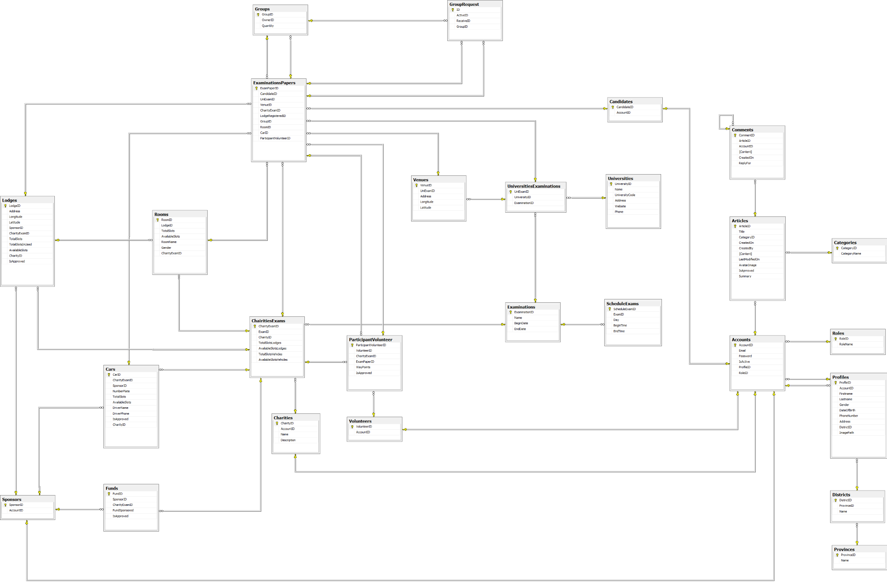

## **Algorithms**

### **Arrange candidates into room**

#### Criteria

The solution to arrange candidate into room must be a logical, fast and effective way. In the other hand, it must satisfy some criteria as follow:

* Everyone in a group should be arranged into the same room.
* Girls and boys do not allowed to be arranged in the same room.
* Girls should have higher priority to be arranged than boys.
* A bigger group should have higher priority to be arranged than a smaller one.

#### Description

* Due to above criteria, we decided to implement the algorithm with recursive technique.
* When a group cannot be arranged into any room, at first find the best room which have the same gender with the group, and have the biggest available slots. Then try to split the group into two smaller groups: the former has its quantity of members equal to the suitable room, the ladder has its quantity of members equal to the rest.
* Turn by turn recursive the above method with the former and the ladder group.
* At last, if a group cannot split into smaller (the ladder quantity equal to zero), then it come to the result that there is not enough room to arrange candidate into.

#### Workflow

### **Arrange candidates into vehicle**

#### Criteria

The solution to arrange candidate into car must be a logical, fast and effective way. In the other hand, it must satisfy some criteria as follow:

* A car will pick candidates up in only a place, where the candidates stay at (because moving from a lodge to another lodge to pick candidates up is a waste of time)
* A car will not carry candidates to more than 3 venues (because the limitation of the Routing algorithm and in fact, move through more than 4 places will take hours!)
* A bigger group should have higher priority to be arranged than a smaller one.
* A group at least 5 candidates should be arranged into a car. If not, try to find volunteers to carry them.

#### Description

* + In the scope of this algorithm, there are few similarities criteria. However, the algorithm can be implemented by a way of reduction of recursively. In order to solve that, we are using an array of venues being sorted with suitable conditions and use it like a priority queue, one by one try to arrange venues into cars, or volunteers also.
  + When a group cannot be arranged into any car, at first find the best car which have the same destination with the group, and have the biggest available slots. Then try to split the group into two smaller groups: the former has its quantity of members equal to the suitable car, the ladder has its quantity of members equal to the rest.
  + Because the former venue can be fit to the car, then arrange candidates of the venue into that car. The ladder venue, put it into the queue to be solved later.
  + If a group of candidates cannot be arranged to volunteers, then it come to the result that there is not enough vehicles to transport candidates.

#### Workflow

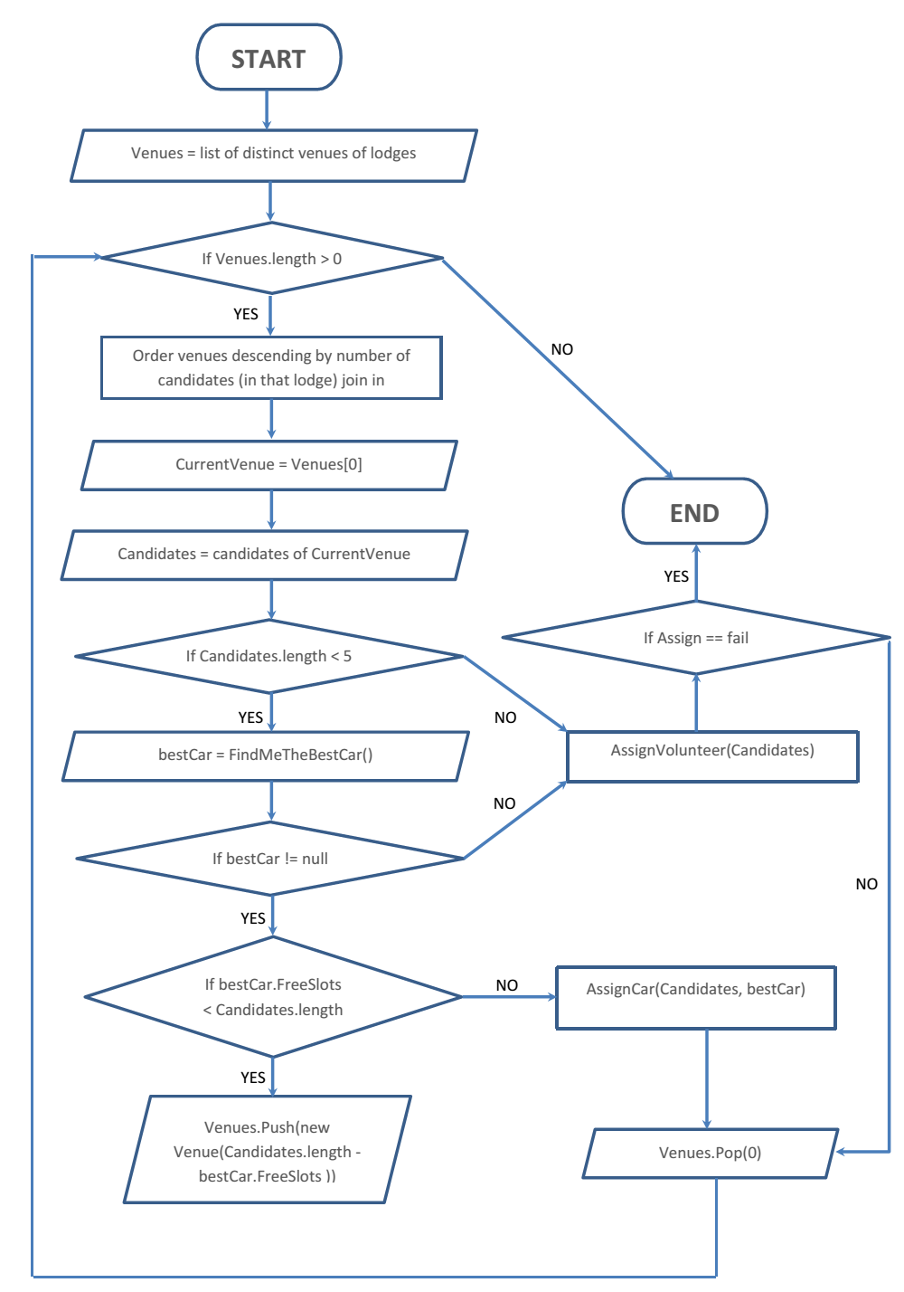

### **Routing ways for vehicle**

#### Criteria

The solution to arrange candidate into car must be a logical, fast and effective way. In the other hand, it must satisfy some criteria as follow:

* A car will pick candidates up in only a place, where the candidates stay at (because moving from a lodge to another lodge to pick candidates up is a waste of time)
* A car will not carry candidates to more than 3 venues (because the limitation of the Routing algorithm the google map is only take 10 access with 1 request , so with 4 venues , this will take 4! = 24 access, with 3 is 3! = 6 request and in fact, move through more than 4 places will take hours!)
* A bigger group should have higher priority to be arranged than a smaller one.

#### Description

* First collect all permutation of way point by send request to google map, the start point is the lodge where the candidate stay. The number of permutation is n! ( with n is the total venue of all candidate)
* Then calculate a distance of the route of once permutation
* At last, compare the distance and find the shortest route. When the shortest route is found, the google map is display with the arrange of way point and end point that make the route is shortest

#### Workflow

* This workflow is reference to <http://cntt.epu.edu.vn/images/book_LeMinhHoang.pdf>

# **REPORT NO.5: SYSTEM IMPLEMENTATION & TEST (SIT)**

## **Introduction**

### **System Overview**

This section provides in detail all necessary information about test plans, test cases, test result, test environments, pass/fail/criteria and risks estimations as well as a checklist to cover all cases of TSMT

### **Test Approach**

* Goal: To find all remain bugs in TSMT system
* Method: Black box testing

## **Test Plan**

### **Feature to be tested**

|  |  |  |
| --- | --- | --- |
| No. | Feature | Description |
| 1 | Add an university – Admin | Test if admin can add an university |
| 2 | Add an university exam - Admin | Test if admin can add an university exam |
| 3 | Join charity exam – Volunteer | Test if volunteer can register a charity and waiting for receiving charity’s respone |
| 4 | Leave charity exam – Volunteer | Test if volunteer can leave a charity exam in case, volunteer doesn’t assign to support any candidates |
| 5 | Add a charity exam – Charity | Test if charity can add a charity exam and not allow to coincide with existing charity exam. |
| 6 | Add a lodge – Charity | Test if charity can add a lodge |
| 7 | Add room for lodge – Charity | Test if charity can add a room for lodge |
| 8 | Use lodge for charity exam - Charity | Test if charity can use lodge in each charity exam |
| 9 | Add a car – Charity | Test if charity can add a car |
| 10 | Use car for a charity exam - Charity | Test if charity can use that car in charity exam |
| 11 | Approve sponsor car – Charity | Test if charity can approve cars which sponsored from sponsors |
| 12 | Approve sponsor lodge – Charity | Test if charity can approve lodges which sponsored from sponsors |
| 13 | Assign Vehicle – Charity | Test if charity can assign vehicles for candidates |
| 14 | Assign Lodge – Charity | Test if charity can assign lodges for candidates |
| 15 | Join in charity – Candidate | Test if candidate can register a charity successfully |
| 16 | Search for friends – Candidate | Test if candidate can search friends which stay at the same lodge |
| 17 | Invite to group – Candidate | Test if candidate can invite friend to groups |
| 18 | Remove invitation - Candidate | Test if candidate can remove invitation |
| 19 | Add new exam paper - Candiadate | Test if candidate can add new exam paper and obey all contraints |
| 20 | Delete a car – Sponsor | Test if sponsor can delete a car correctly |
| 21 | Sponsored car – Sponsor | Test if sponsor can register their car to charity in exams |
| 22 | Cancel sponsored car - Sponsor | Test if sponsor can cancel cars which are sponsored when charity don’t assign to assit for those cars |
| 23 | Sponsored many cars – Sponsor | Test if sponsor can register many cars to charity |
| 24 | Sponsored lodge and room of lodge – Sponsor | Test if sponsor can register their lodge and rôm in lodge to charity in exams successfully. |
| 25 | Sponsored resource - Sponsor | Test if sponsor can register their resources to charity to support candidates in exams. |
| 26 | View statistics - Sponsor | Test if the statistics information for sponsor is displayed correctly |

### **Feature not to be tested**

## **Test Cases**

### **Admin Test Case**

#### Add an university

|  |  |  |  |  |  |  |  |
| --- | --- | --- | --- | --- | --- | --- | --- |
| Test case ID | Test Case Description | Test Case Procedure | Expected Output | Inter-Test Case Dependence | Result | Test Date | Note |
|  | **Pre-condition: 1.** Log in the system with Admin role  **2.** Click on the “Quản lý trường ĐH - CĐ” link in the menu bar  **3.** Click on “Tạo mới” button | | | | | | |
| [AU-1] | Try to add an university with incorrect input | * Make one or more validation errors when entering the information for the university. * Click the “Tạo” button. | The corresponding message will be shown next to the fields that have errorneous input. |  | Passed | 15/3/2014 |  |
| [AU-2] | Add an university with validated input | * Fill in all fields with validated input; * Click the “Tạo” button. | The university is saved into the database. The user is redirected to the Manage university page. |  | Passed | 15/3/2014 |  |

#### Add an university exam

|  |  |  |  |  |  |  |  |
| --- | --- | --- | --- | --- | --- | --- | --- |
| Test case ID | Test Case Description | Test Case Procedure | Expected Output | Inter-Test Case Dependence | Result | Test Date | Note |
|  | **Pre-condition: 1.** Log in the system with Admin role  **2.** Click on the “Đợt thi - trường ĐH-CĐ” link in the menu bar  **3.** Click on “Tạo mới” button  **4.** Have university and examination in database | | | | | | |
| [AUE-1] | Add an university exam with validated input | Add an university exam with validated input | Add an university exam with validated input |  | Pass | 15/3/2014 |  |
| [AUE-2] | Add an university exam with invalidated input | Add an university exam with invalidated input | Add an university exam with invalidated input |  | Pass | 15/3/2014 |  |

### **Volunteer Test Case**

#### Join and leave charity exam

|  |  |  |  |  |  |  |  |
| --- | --- | --- | --- | --- | --- | --- | --- |
| Test case ID | Test Case Description | Test Case Procedure | Expected Output | Inter-Test Case Dependence | Result | Test Date | Note |
|  | **Pre-condition: 1.** Log in the system with Volunteer role  **2**. User never register any charity exam  **3.** Click on the “Đăng ký” button | | | | | | |
| [JCE-1] | Volunteer join charity exam with validated input | * Click to choose exam * Click to choose charity exam * Click Term and condition * Click “Đăng ký” button | Registered to that charity exam and redirect to home page of volunteer with status register is “Chưa xác nhận”. |  | Pass | 15/3/2014 |  |
| [JCE-2] | Leave charity exam | User can leave charity exam when charity do not approve volunteer or volunteer not assign to carrying candidate   * Click “Hủy đăng ký” button | Remove request join charity exam and delete row contain register information. |  | Pass | 15/3/2014 |  |

### **Charity Test Case**

|  |  |  |  |  |  |  |  |
| --- | --- | --- | --- | --- | --- | --- | --- |
| Test case ID | Test Case Description | Test Case Procedure | Expected Output | Inter-Test Case Dependence | Result | Test Date | Note |
|  | **Pre-condition: 1.** Log in the system with Charity role | | | | | | |
| [CH-1] | Add a charity exam | * Click on the “Quản lý thông tin kỳ thi” link in the menu bar * Click on “Tạo mới” button * Click to choose examination; * Click the “Tạo” button. | The charity exam created and save into database, user redirect to Manage charity exam page. |  | Passed | 15/3/2014 |  |
| [CH-2] | Add a lodge | * Click on the “Quản lý chỗ trọ” link in the menu bar * Click on “Tạo mới” button * Enter address of lodge * Click “Đi đến” * Click the “Tạo” button. | The Lodge created and save into database, user redirect to Detail lodge page. |  | Passed | 15/3/2014 |  |
| [CH-3] | Add room for lodge | * At detail of lodge * Click “Tạo phòng” button * Enter all field * Click “Tạo mới” | The room created and save into database, user redirect to detail page. |  | Passed | 15/3/2014 |  |
| [CH-4] | View lodge on maps | * At Manage Lodge Charity page * Click button View map at the row of lodge user want to view | Open new window and show this lodge in Google maps. |  | Passed | 15/3/2014 |  |
| [CH-5] | Use lodge for charity exam | * At Manage Lodge Charity page * Click “Sử dụng” button * Click to choose examination * Click to choose room use for this examination * Click “Lưu” button | Rooms of lodge assigned to use in selected exam and save it into database. User redirected to Manage Lodge Charity page. |  | Passed | 15/3/2014 |  |
| [CH-6] | Add a car | * Click on the “Quản lý xe” link in the menu bar * Click on “Tạo mới” button * Enter all require fields * Click the “Tạo” button. | The car created and save into database, user redirect to Manage car charity page. |  | Passed | 15/3/2014 |  |
| [CH-7] | Use car for charity exam | * At Manage car charity page * Click “Sử dụng” button * Click to choose examination * Click to choose car use for this examination * Click “Lưu” button | Car assigned to use in selected exam and save it into database. User redirected to Manage car charity page. |  | Passed | 15/3/2014 |  |
| [CH-8] | Approve sponsor car that sponsored for charity exam | * Sponsor A sponsored a car for a charity exam * At Detail Charity Exam click “Quản lý xe” * Click “Xe được tài trợ” * Click Approve button | The car approved to use in charity exam and save it into database. Car’ status is “Đã duyệt”.  In Manage Car of Sponsor this car status is “Đã duyệt”. |  | Passed | 15/3/2014 |  |
| [CH-9] | Approve sponsor lodge that sponsored for charity exam | * Sponsor A sponsored a lodge for a charity exam * At Detail Charity Exam click “Quản lý chỗ trọ” * Click “Xe được tài trợ” * Click Approve button | The lodge approved to use in charity exam and save it into database.  In Manage Lodge of Sponsor this car status is “Đã duyệt”. |  | Passed | 15/3/2014 |  |

### **Candidate Test Case**

|  |  |  |  |  |  |  |  |
| --- | --- | --- | --- | --- | --- | --- | --- |
| Test case ID | Test Case Description | Test Case Procedure | Expected Output | Inter-Test Case Dependence | Result | Test Date | Note |
|  | **Pre-condition:** **1**. Log in the system with Candidate role | | | | | | |
| [CA-1] | Candidate join in Charity | * Click on the “Thông tin phiếu báo thi” link in the menu bar * Click on “Xem” button * Click on” Đăng ký ngay” button * Choose address of charity on google map and click “Đăng ký” | Candidate jon in charity was selected. And redirected to Manage Exam Paper page |  | Passed | 15/3/2014 |  |
| [CA-2] | Candidate use “ Tìm kiếm bạn bè” function | * Click on the “Thông tin phiếu báo thi” link in the menu bar * Click on “Xem” button * Click on” Tìm kiếm bạn bè button | Candidate see the all member of lodge with status “ Mời vào nhóm” |  | Passed | 15/3/2014 |  |
| [CA-3] | Candidate use “Mời vào nhóm” function | * Click on the “Thông tin phiếu báo thi” link in the menu bar * Click on “Xem” button * Click on”Tìm kiếm bạn bè” button * Click on “Mời vào nhóm” | Redirected to Find Friends page and status of member who was invited by candidate is “ Hủy lời mời” |  | Passed | 15/3/2014 |  |
| [CA-4] | Candidate use “Hủy lời mời” function | * Click on the “Thông tin phiếu báo thi” link in the menu bar * Click on “Xem” button * Click on”Tìm kiếm bạn bè” button * Click on “Hủy lời mời” | Redirected to Find Friends page and status of member who was invited by candidate is “ Mời vào nhóm” |  | Passed | 15/3/2014 |  |
| [CA-5] | Add new exam paper | * Click on the “Thông tin phiếu báo thi” link in the menu bar * Click on “Tạo mới” button * Select “kỳ thi”, “trường”, “Địa điểm thi” * Click on “Tạo mới” | The new exampaper created and save into database, user redirect to Manage Exampaper page. |  | Passed | 15/3/2014 |  |
| [CA-6] | Add new exam paper | * Click on the “Thông tin phiếu báo thi” link in the menu bar * Click on “Tạo mới” button * Do Not Select “Kỳ thi”, “Trường”, “Địa điểm thi”   Click on “Tạo mới” | * The corresponding message will be shown next to the fields Do Not Select “Kỳ thi”, “Trường”, “Địa điểm thi” |  | Passed | 15/3/2014 |  |

### **Sponsor Test Case**

#### Delete a car

|  |  |  |  |  |  |  |  |
| --- | --- | --- | --- | --- | --- | --- | --- |
| Test case ID | Test Case Description | Test Case Procedure | Expected Output | Inter-Test Case Dependence | Result | Test Date | Note |
|  | **Pre-condition: 1.** Log in the system with Sponsor role  **2.** Click on the “Quản lý xe” link in the menu bar  **3.** Click on “Xóa xe” icon | | | | | | |
| [DEC-1] | Delete a car | * Click OK when popup show up. | The car was removed from the database. The user is redirected to the Manage car page. |  | Passed | 15/3/2014 |  |
| [DEC-2] | Delete a car | * Click Cancel button when popup show up. | .Popup is close and user still in manage car page. |  | Passed | 15/3/2014 |  |

#### Sponsored Car

|  |  |  |  |  |  |  |  |
| --- | --- | --- | --- | --- | --- | --- | --- |
| Test case ID | Test Case Description | Test Case Procedure | Expected Output | Inter-Test Case Dependence | Result | Test Date | Note |
|  | **Pre-condition: 1.** Log in the system with Sponsor role  **2.** Click on the “Quản lý xe” link in the menu bar  **3.** Click on “Tài trợ xe” icon | | | | | | |
| [SPC-1] | Sponsored Car | * Click to choose an examination and charity to sponsored car * Click “Tài trợ” button | The car was sponsored for organization selected. The user is redirected to the Manage car page. |  | Passed | 15/3/2014 |  |
| [SPC-2] | Sponsored Car | * Not selected any organization * Click “Tài trợ” button | The corresponding message will be shown next to the fields Organization. |  | Passed | 15/3/2014 |  |

#### Cancel sponsored Car

|  |  |  |  |  |  |  |  |
| --- | --- | --- | --- | --- | --- | --- | --- |
| Test case ID | Test Case Description | Test Case Procedure | Expected Output | Inter-Test Case Dependence | Result | Test Date | Note |
|  | **Pre-condition: 1.** Log in the system with Sponsor role  **2.** Click on the “Quản lý xe” link in the menu bar  **3.** Click on “Hủy tài trợ” icon | | | | | | |
| [CSC-1] | Cancel sponsored Car | * Click OK when popup show up. | The car is no longer funding for any organization. The user is redirected to the Manage car page. |  | Passed | 15/3/2014 |  |
| [CSC-2] | Cancel sponsored Car | * Click Cancel button when popup show up. | Popup is close and user still in manage car page. |  | Passed | 15/3/2014 |  |

#### Sponsored many cars

|  |  |  |  |  |  |  |  |
| --- | --- | --- | --- | --- | --- | --- | --- |
| Test case ID | Test Case Description | Test Case Procedure | Expected Output | Inter-Test Case Dependence | Result | Test Date | Note |
|  | **Pre-condition: 1.** Log in the system with Sponsor role  **2.** Click on the “Quản lý xe” link in the menu bar  **3.** Click on “Tài trợ nhiều xe” icon | | | | | | |
|  | Sponsored Cars | * Click to choose a examination and charity to sponsored car * Do not selected any resource * Click “ Tài trợ” button | The cars were selected and sponsored for organization selected. . The user is redirected to the Manage car page. |  | Passed | 15/3/2014 |  |
|  | Sponsored Cars | * Click to choose a examination and charity to sponsored car * Do not check any checkbox for any cars. * Click “ Tài trợ” button | Popup is will show “ Vui lòng chọn xe để tài trợ” |  | Passed | 15/3/2014 |  |

#### Sponsored lodge and room of lodge

|  |  |  |  |  |  |  |  |
| --- | --- | --- | --- | --- | --- | --- | --- |
| Test case ID | Test Case Description | Test Case Procedure | Expected Output | Inter-Test Case Dependence | Result | Test Date | Note |
|  | **Pre-condition: 1.** Log in the system with Sponsor role  **2.** Click on the “Quản lý chỗ ở” link in the menu bar | | | | | | |
| [SLR-1] | Sponsored Lodge and room of lodge | * Click to choose a examination and charity to sponsored car * Do not check any checkbox for any cars. * Click “ Tài trợ” button | Popup is will show “ Vui lòng chọn phòng để tài trợ” |  | Pass | 07/04/2014 |  |
| [SLR-2] | Sponsored Lodge and room of lodge | * Do not click choose any examination and charity to sponsored car * . Click “ Tài trợ” button | The corresponding message will be shown next to the fields examination , charity. |  | Pass |  |  |

#### Sponsored Resource

|  |  |  |  |  |  |  |  |
| --- | --- | --- | --- | --- | --- | --- | --- |
| Test case ID | Test Case Description | Test Case Procedure | Expected Output | Inter-Test Case Dependence | Result | Test Date | Note |
|  | **Pre-condition: 1.** Log in the system with Sponsor role  **2.** Click on the “Ủng hộ tài nguyên” link in the menu bar | | | | | | |
| [SRE-1] | Sponsored Resource | * Click to choose a examination and charity to sponsored resource * Do not selecte any resource type. * Click “ Tài trợ” button | The corresponding message will be shown next to the fields Resource. |  | Passed | 15/3/2014 |  |
| [SRE-2] | Sponsored Resource | * Do not select examination and charity. * Click “ Tài trợ” button | The corresponding message will be shown next to the fields organization. |  | Passed | 15/3/2014 |  |
| [SRE-3] | Sponsored Resource | * Click to choose a university and examination to sponsored car * Choose type is car * Do not choose numberplate * Click “ Tài trợ” button | The corresponding message will be shown next to the fields numberpalte. |  | Passed | 15/3/2014 |  |
| [SRE-4] | Sponsored Resource | * Click to choose a university and examination to sponsored lodge * Choose type lodge * Do not choose address * Click “ Tài trợ” button | The corresponding message will be shown next to the fields address. |  | Passed | 15/3/2014 |  |
| [SRE-5] | Sponsored Resource | * Click to choose a university and examination to sponsored fund * Choose type is fund * Do not input fundSponsored * Click “ Tài trợ” button | The corresponding message will be shown next to the fields FundSponsored. |  | Passed | 15/3/2014 |  |
| [SRE-6] | Sponsored Resource | * Click to choose a university and examination to sponsored resource * Choose type of resource * Sponsored resource with validate input * Click “ Tài trợ” button | Sponsored resource for organization selected. . The user is redirected to the Manage with the resource page. |  | Passed | 15/3/2014 |  |

#### View statistic

|  |  |  |  |  |  |  |  |
| --- | --- | --- | --- | --- | --- | --- | --- |
| Test case ID | Test Case Description | Test Case Procedure | Expected Output | Inter-Test Case Dependence | Result | Test Date | Note |
|  | **Pre-condition: 1.** Log in the system with Sponsor role  **2.** Click on the “Xem thống kê” link in the menu bar | | | | | | |
| [VSS-1] | View statistic | * Do not select examination and charity. * Click “ Tài trợ” button | The corresponding message will be shown next to the fields organization. |  | Passed | 15/3/2014 |  |
| [VSS-2] | View statistic | * Select examination and charity. * Click “ Xem bản đồ” button | The chart show in the View Statistic page |  | Passed | 15/3/2014 |  |

# **REPORT NO.6: SYSTEM USER’S MANUAL (SUM)**

## **Installation Guide**

### **Server Side**

* Server must support ASP.NET 4.0, and Microsoft SQL Server 2008 R2
* Run file script TSMT.sql in SQL Server

### **Client Side**

* Work best with the Mozilla Firefox and Google Chrome browser

## **User’s Guide**

### **Minimum System Requirements**

* Personal computer for minimum configuration: 2 GB of RAM, 50 GB of hard disk, Core 2 Duo 2.0 GHz
* Microsoft Windows 7 or higher.
* At least 100MB for the application resources, and another 100MB for data storage.
* Internet connection
* Web server: IIS 7.0 or higher
* Database: SQL Server 2008 R2 or higher
* .NET Framework 4.5

### **Guide for guests and authorized users**

#### Search charity’s information

This function to allow user to search charity which registered to support in each exams

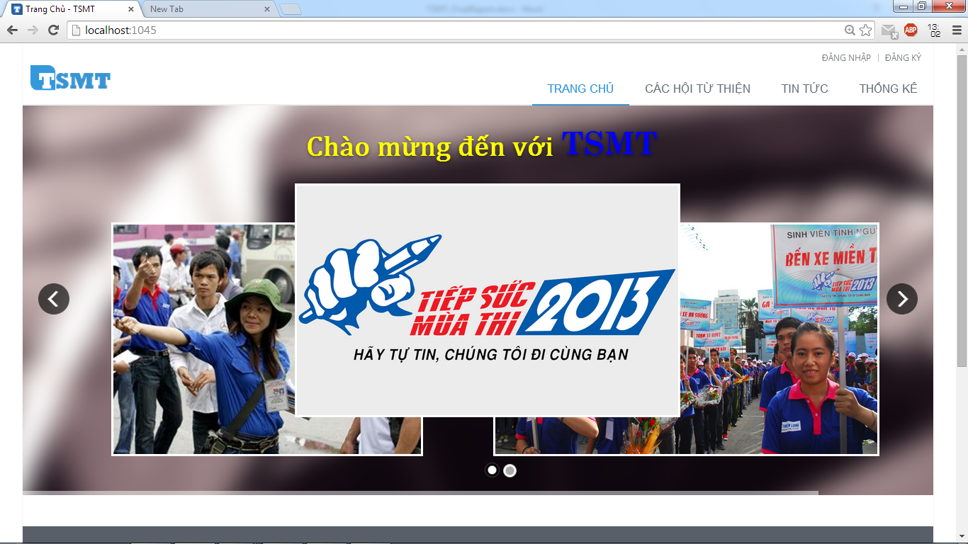

1

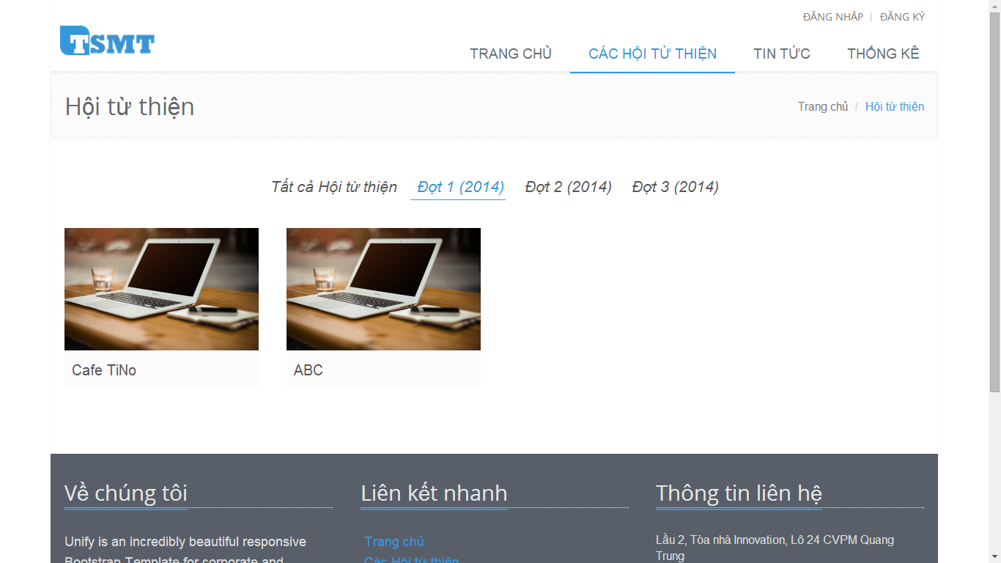

2

|  |  |
| --- | --- |
| Step | Instruction |
| 1 | Click “CÁC HỘI TỪ THIỆN” link on the main menu, you will be redirected to page to view all charities are register to support in each exams. |
| 2 | Click on   * “**Tất cả Hội từ thiện**” link, you will see all charities which registered to support in TSMT system * “**Đợt 1(2014)**”, “**Đợt 2(2014)**”, “**Đợt 3(2014)**” link, you can only view charities which registered to support in that examination. |

#### View information detail of charity

This function to help you view the detail information of charity. 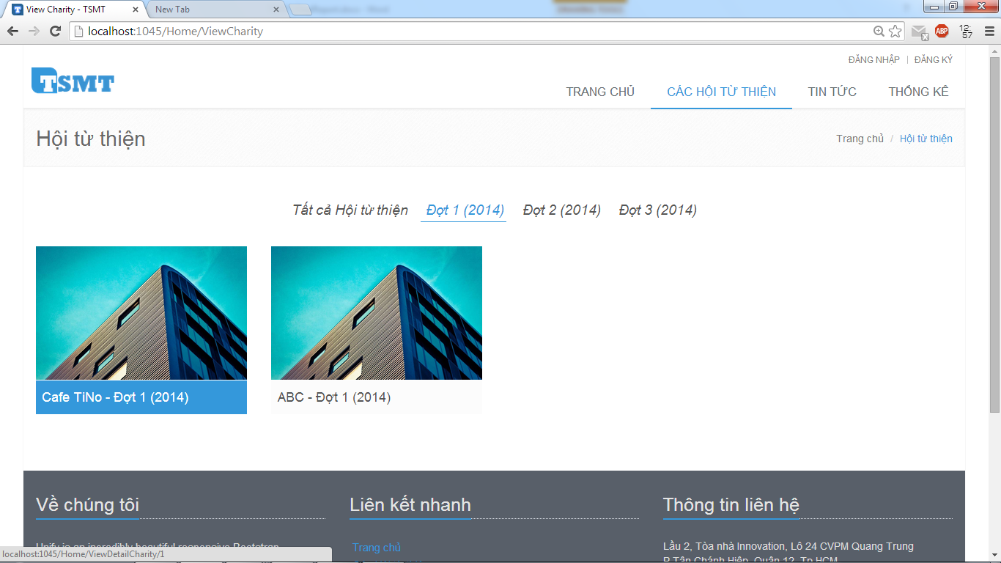

1

|  |  |
| --- | --- |
| Step | Instruction |
| 1 | When you move your mouse in one charity, that charity will be hover, then you click on it and you will be redirected to the page to view detail information of charity |

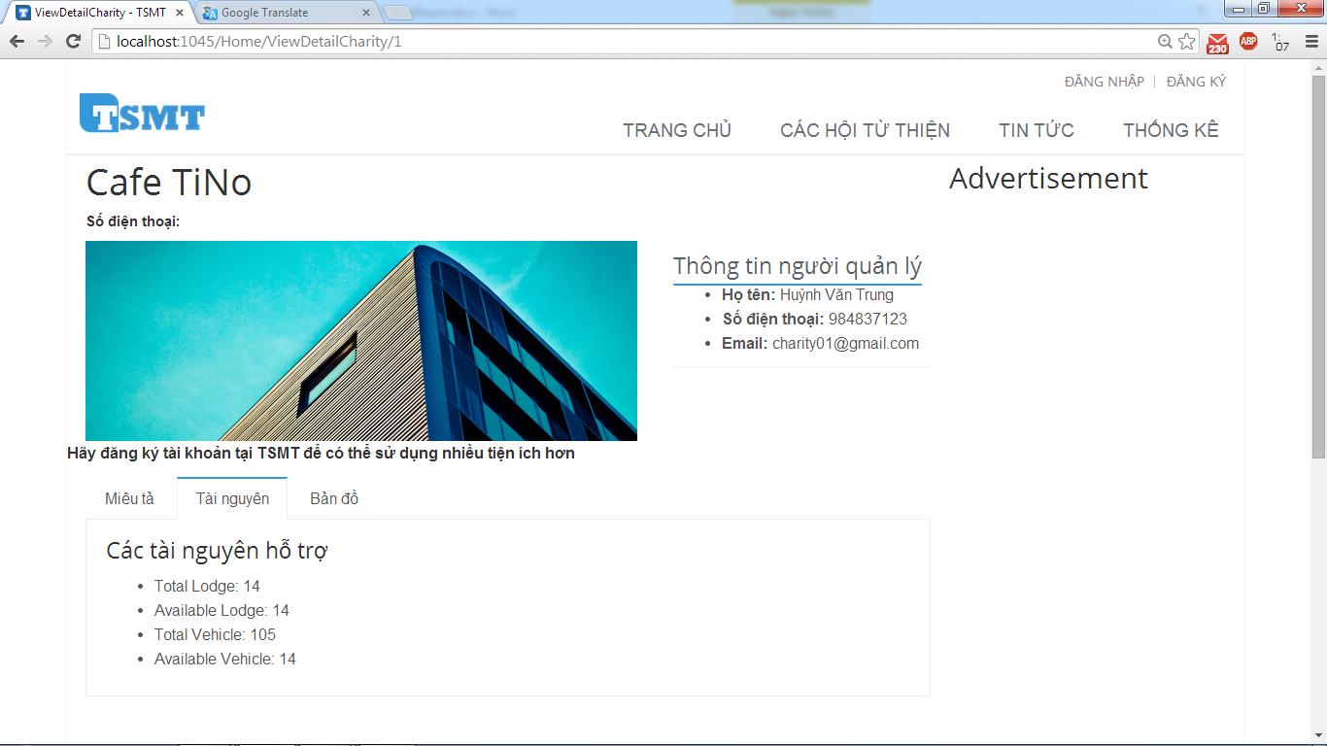

1

#### Register an account

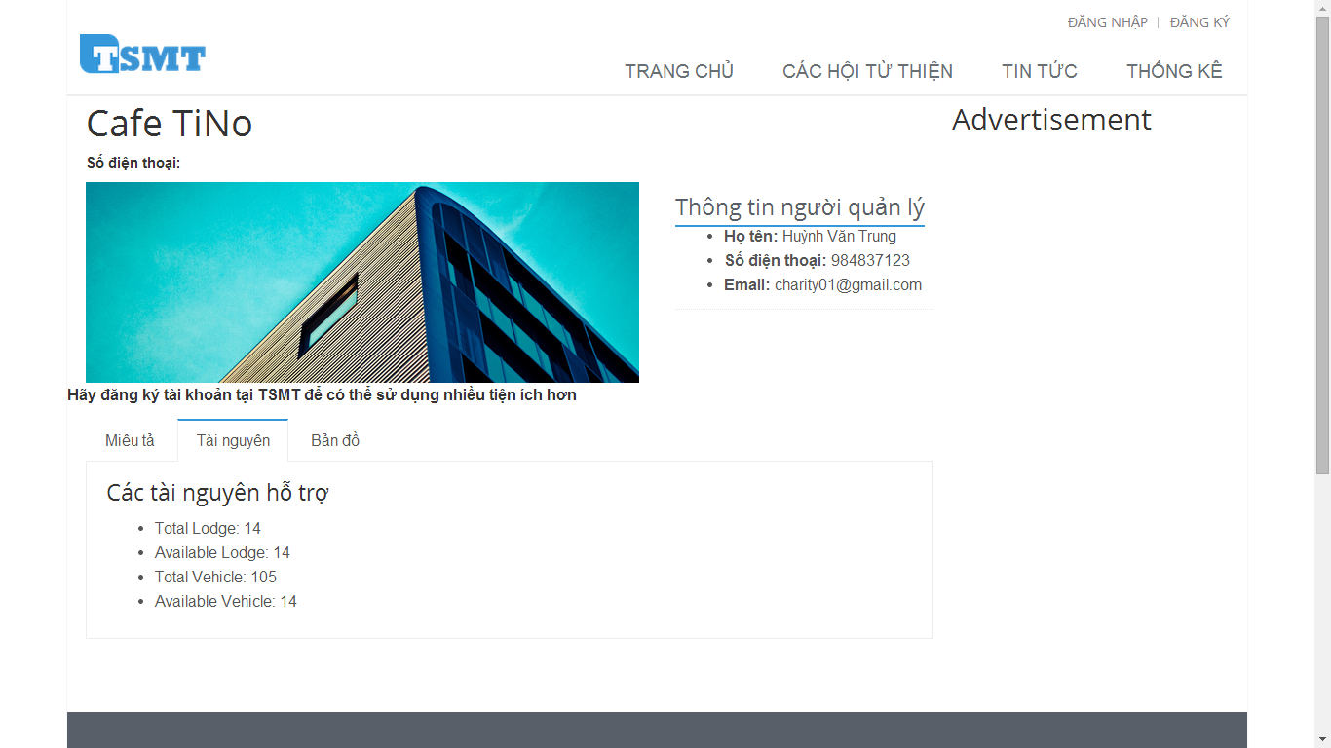

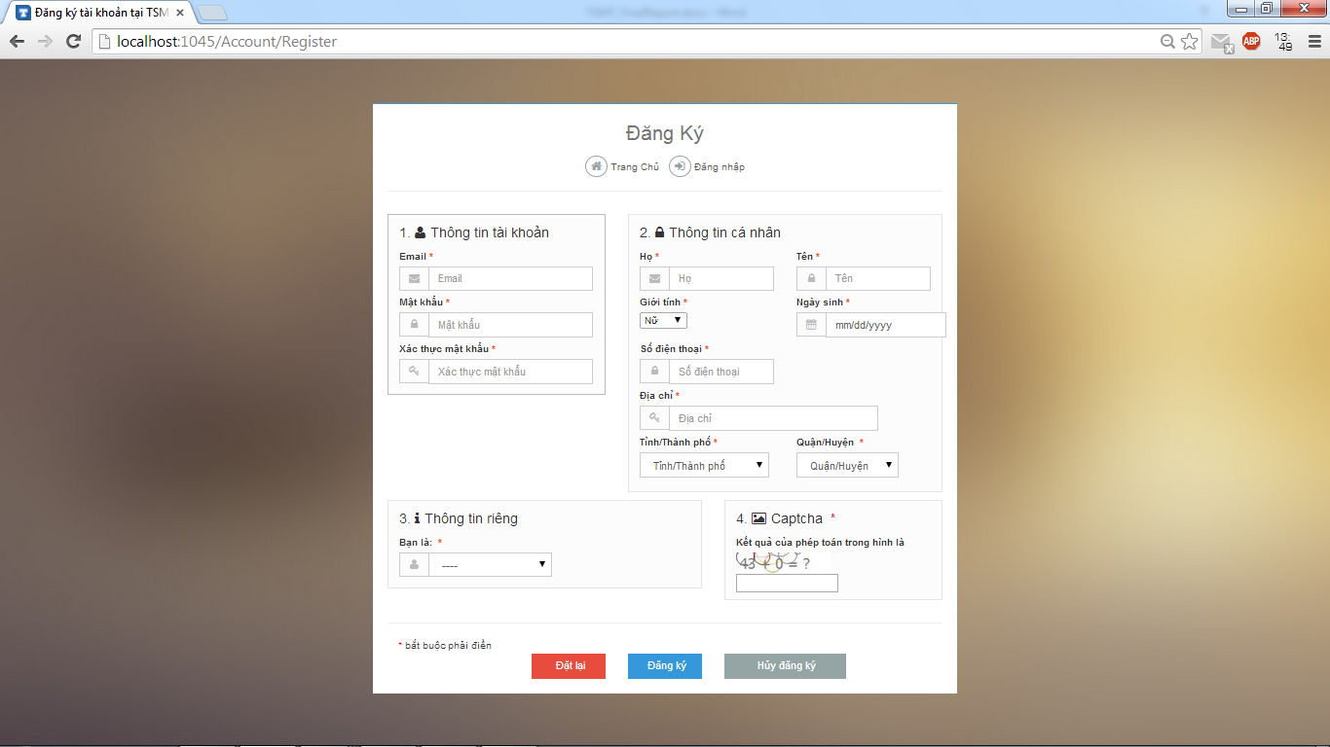

7

6

5

4

3

2

|  |  |
| --- | --- |
| Step | Instruction |
| 1 | Click on “Đăng ký” link, you will be redirected to the page to register an account in TSMT system |
| 2 | * Fill in the fields: “Email” with your email address, “Mật khẩu” with your password, “Xác thực mật khẩu” with your password which you filled on the “Mật khẩu” fields, “Họ” with your last name, middle name, “Tên” with your first name, “Số điện thoại” with your telephone number, “Địa chỉ” with your address * And choose value in combo box: “Giới tính”, “Ngày sinh”, “Tỉnh/Thành phố”, “Quận/Huyện”. * Then you choose the role which you want to register in TSTM system at combo box: “Bạn là:” * Finally, you fill the result of the captcha image with correct number. |
| 3 | Click the button “Đăng ký” to proceed to register your account.  If registered successfully, you will be directed to “Đăng nhập” page to login with the newly created account |
| 4 | [Optional] Click “Đặt lại” button to clear all fields and you must type again |
| 5 | [Optional] Click “Hủy đăng ký” button to cancel register and you will be redirected homepage |
| 6 | [Optional] Click “Trang chủ” link, you will be redirected the homepage |
| 7 | [Optional] Click “Đăng nhập” link, you will be redirected the log in page |

### **Guide for members**

1

#### Log in to the system



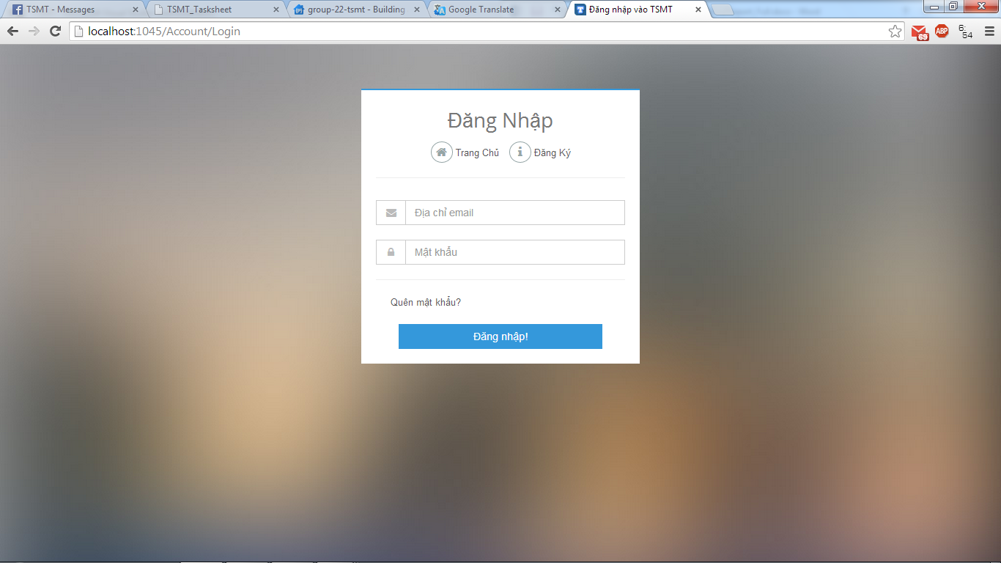

7

4

3

2

6

5

|  |  |
| --- | --- |
| Step | Instruction |
| 1 | Click “Đăng nhập” link on the top menu, you will be redirected to the Login page |
| 2 | Fill the registered account in the “Địa chỉ Email” field, textbox has icon mail |
| 3 | Fill the password in the “Mật khẩu” |
| 4 | Click “Đăng nhập” button |
| 5 |  |
| 6 |  |

#### Log out to the system

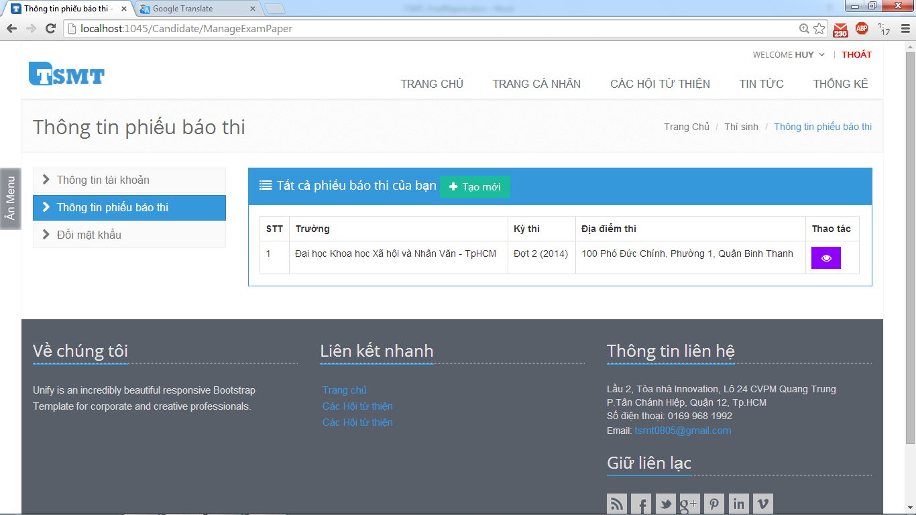

|  |  |
| --- | --- |
| Step | Instruction |
| 1 | When you move your move on |

### **Guide for candidates**

#### Register examination paper

#### Search lodges

#### Register into charities

#### View

### **Guide for sponsors**

#### Home page

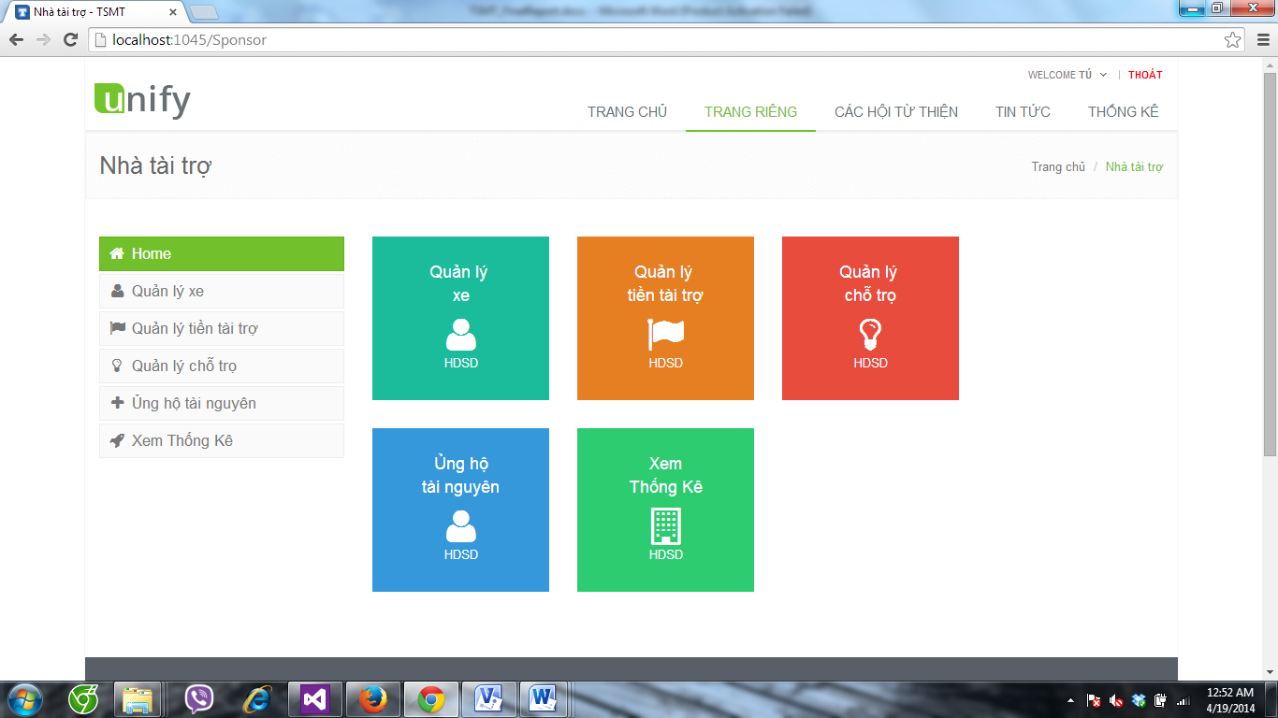

5

4

1

3

2

2

3

5

4

1

|  |  |
| --- | --- |
| Step | Instruction |
| 1 | Click on “Quản lý xe” link, you will be redirected to the Manage Car page |
| 2 | Click on “Quản lý tiền tài trợ” link, you will be redirected to the Manage Fund page |
| 3 | Click on “Quản lý chỗ trọ” link, you will be redirected to the Manage Lodge page |
| 4 | Click on “Ủng hộ tài nguyên” link, you will be redirected to the Sponsored Resource page |
| 5 | Click on “Xem thống kê” link, you will be redirected to the View Statistic page |

#### Manage Car

1

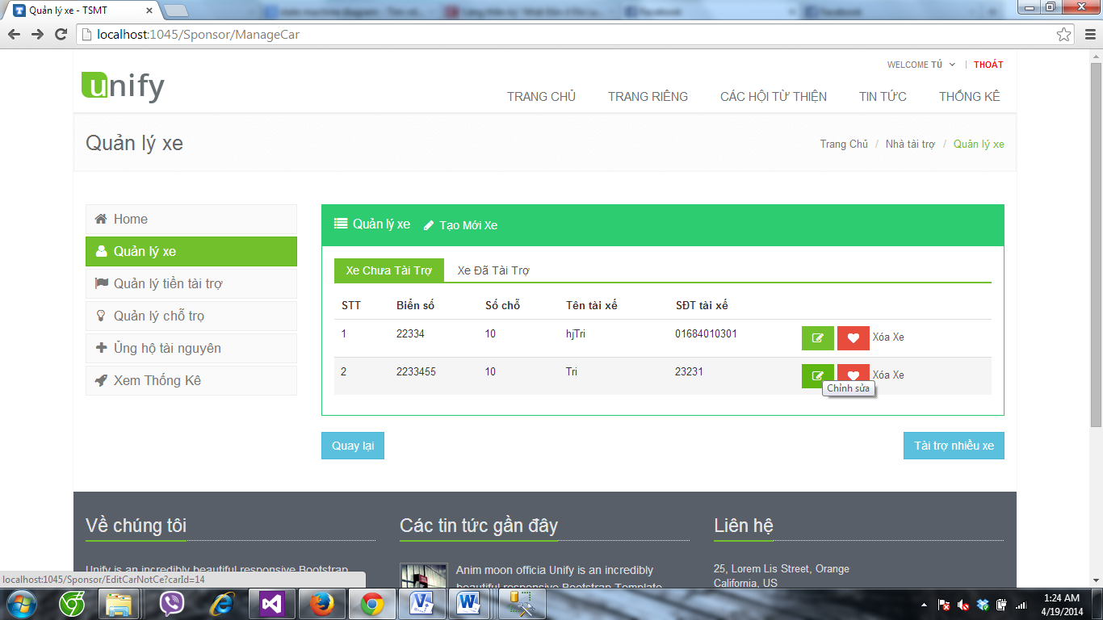

8

5

3

2

4

6

7

|  |  |
| --- | --- |
| Step | Instruction |
| 1 | Click on “Tạo mới xe” link, you will be redirected to the add new Car page |
| 2 | Click on “Xe chưa tài trợ” tab, you will see the table of all car that not sponsored |
| 3 | Click on “Xe đã tài trợ” tab, you will see the table of all car that sponsored |
| 4 | Click on “Chỉnh sửa” icon, you will be redirected to the Edit Car page |
| 5 | Click on “Tài trợ” icon, you will be redirected to the Spomsored Car page |
| 6 | Click on “Quay lại” button, you will be redirected to the Home page |
| 7 | Click on “Tài trợ nhiều xe” button, you will be redirected to the Sponsored many Car page |

#### Sponsored Lodge

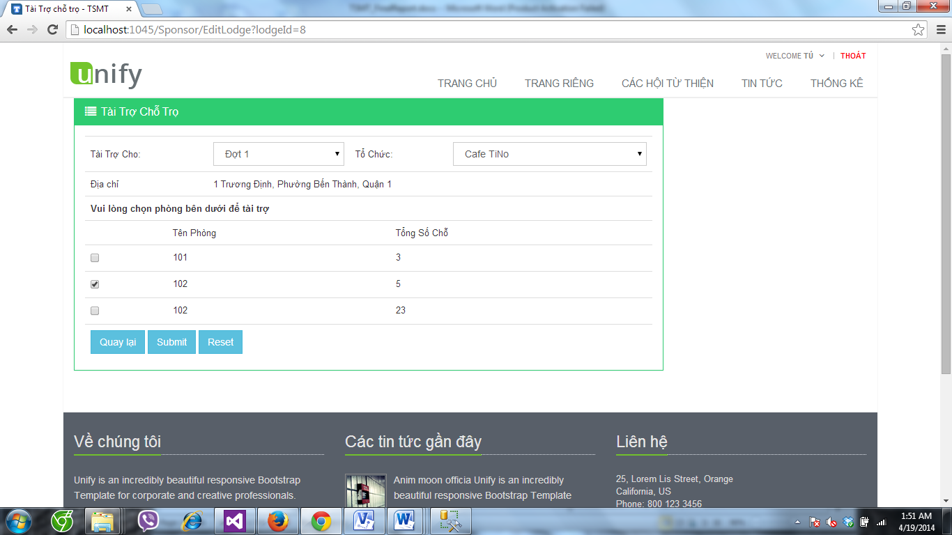

6

5

44

3

2

1

|  |  |
| --- | --- |
| Step | Instruction |
| 1 | Select on “Tài trợ cho” selectbox, to choosethe exam you want to sponsored |
| 2 | Select on “Tổ chức” selectbox, to choose the charity you want to sponsored |
| 3 | Check on “checkbox” to choose the room you want sponsored |
| 4 | Click on “Làm mới” icon, the value in selectbox is empty |
| 5 | Click on “Quay lại” icon, you will be redirected to the Manage Loge page |
| 6 | Click on Submit button, the room and lodge will sponsored for this charity you seected. |

#### Sponsored Resource

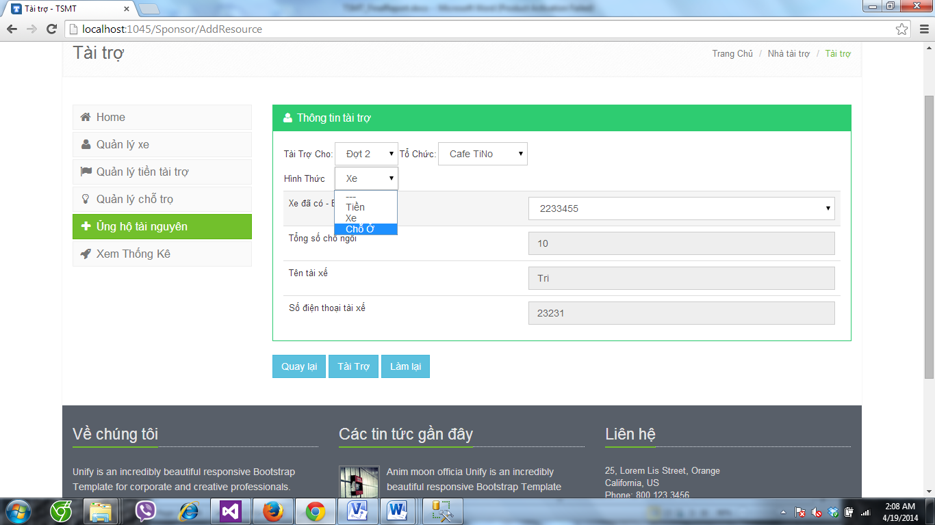

7

6

5

4

3

2

1

|  |  |
| --- | --- |
| Step | Instruction |
| 1 | Select on “Tài trợ cho” selectbox, to choosethe exam you want to sponsored |
| 2 | Select on “Tổ chức” selectbox, to choose the charity you want to sponsored |
| 3 | Select on “Hình thức” selectbox, to choose the type of resource that you want to sponsored |
| 4 | Select on “Biển số xe” selectbox, to choose car you want sponsored |
| 5 | Click on “Làm mới” icon, the value in selectbox is empty |
| 6 | Click on “Quay lại” icon, you will be redirected to the Manage Loge page |
| 7 | Click on Submit button, the room and lodge will sponsored for this charity you seected. |

### **Guide for charities**

#### Home Page

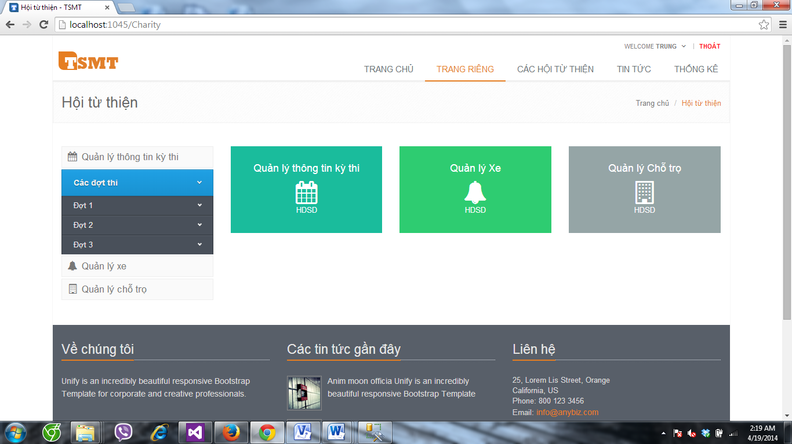

3

2

1

4

3

2

1

|  |  |
| --- | --- |
| Step | Instruction |
| 1 | Click on “Quản lý tông tin kỳ thi” link, you will be redirected to the Manage Exam page |
| 2 | Click on “Quản lý xe” link, you will be redirected to the Manage Car page |
| 3 | Click on “Quản lý chỗ trọ” link, you will be redirected to the Manage Lodge page |
| 4 | Click on “Các đợt thi” link, the list of examinations will be appear |

#### Manage charity Exam

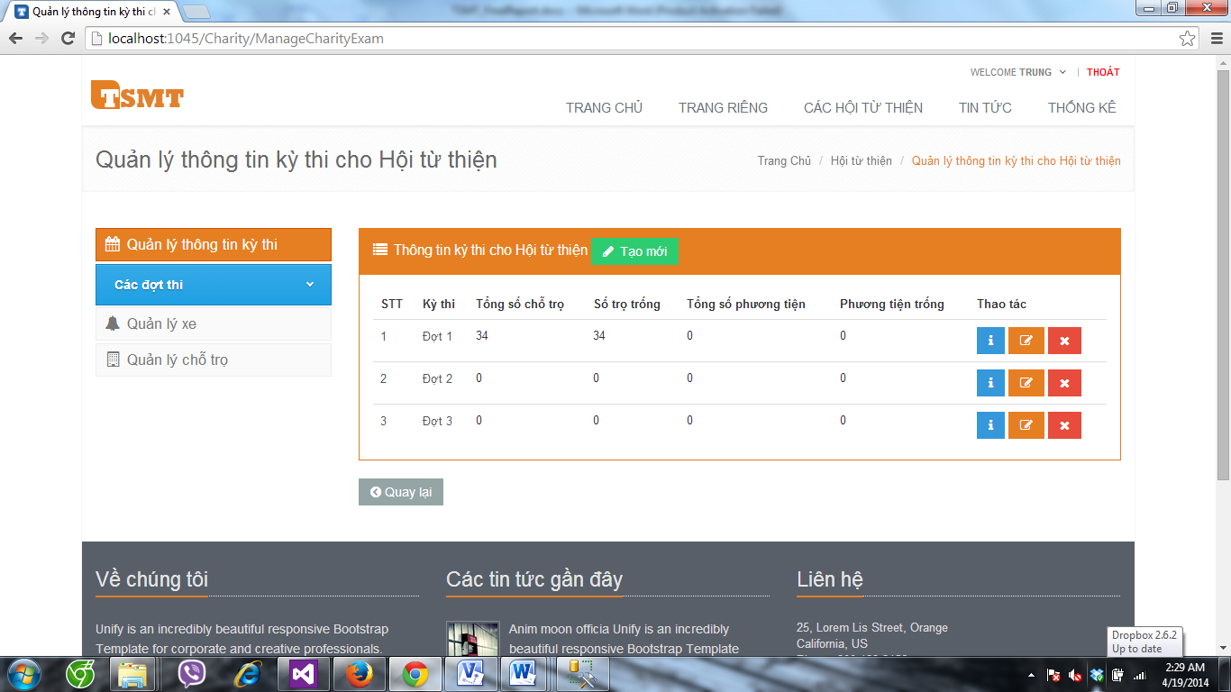

3

4

5

2

1

|  |  |
| --- | --- |
| Step | Instruction |
| 1 | Click on “Tạo mới” link, you will be redirected to the Add charity exam page |
| 2 | Click on “Chi tiết”icon, you will be redirected to the Details of charity exam page |
| 3 | Click on “Xóa”icon, the charity exam will be remove |
| 4 | Click on “Chỉnh sửa” icon, you will be redirected to the Edit Car page |
| 5 | Click on “Quay lại” button, you will be redirected to the Home page |

#### Details Charity exam

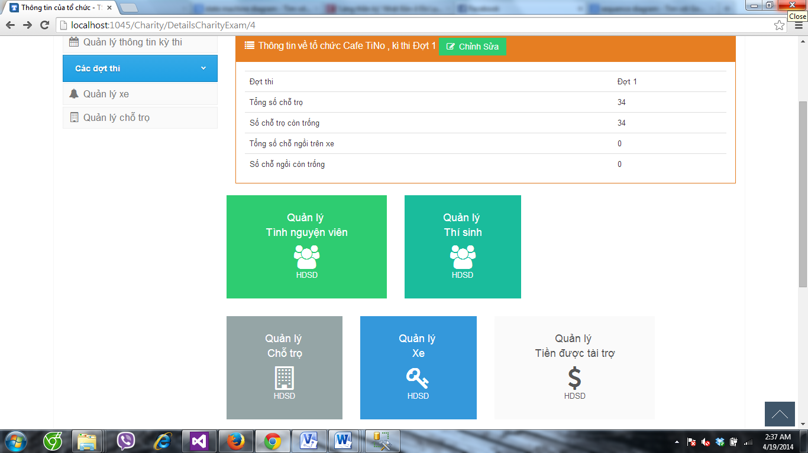

2

1

666

55

45

3

|  |  |
| --- | --- |
| Step | Instruction |
| 1 | Click on “Chỉnh sửa” link, you will be redirected to the Edit Charityexam page |
| 2 | Click on “Quản lý tình nguyện viên” link, you will be redirected to the Manage Volunteer page |
| 3 | Click on “Quản lý thí sinh” link, you will be redirected to the Manage Candidate page |
| 4 | Click on “Quản lý chỗ trọ” link, you will be redirected to the Manage Lodge page |
| 5 | Click on “Quản lý xe” link, you will be redirected to the Manage Car page |
| 6 | Click on “Quản lý tiền được tài trợ” link, you will be redirected to the Manage Car page |

#### Assign Room

|  |  |
| --- | --- |
| Step | Instruction |
| 1 | Click on “Sắp phòng” link, Candidate will assign to each room relative |
| 2 | Click on “Hủy sắp phòng” link, all candidate will be do not assigh room |
| 3 | Click on “Quay lại” link, you will be redirected to the Manage Candidate page |

# **APPENDIX**

## Reference

<http://en.wikipedia.org/wiki/Model-view-controller>

<http://www.visual-paradigm.com/product/vpuml/tutorials/>

<http://en.wikipedia.org/wiki/Waterfall_model>

<http://www.asp.net/mvc/tutorials/mvc-4>

<http://msdn.microsoft.com/en-us/library/vstudio/ff926074.aspx>

<http://www.uml-diagrams.org/>

<http://en.wikipedia.org/wiki/Database_design>